

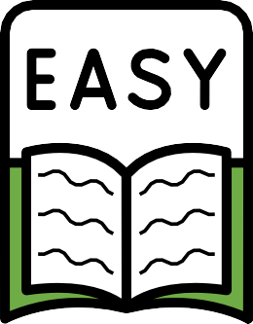


Get help to contact us

Department of Transport and Main Roads

About this book


This book will help you with

interpreter services.


Interpreter services help you
talk and listen to us if you
- Speak another language
- Find it difficult to hear
- Find it difficult to speak


Using an interpreter service is free but you might pay for the phone call. Ask your phone company how much it costs.


The Translating and Interpreting Service can help you talk to someone in your language.

For help in your language


Call 13 14 50

Or if you are outside of Australia
call +61 3 9268 8332

Ask them to call Transport and Main Roads on 13 23 80

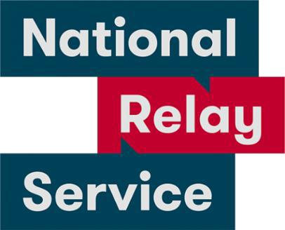
The National Relay Service can help if you are Deaf, hard of hearing or have a speech impairment.

For help if you find it difficult to hear or speak

Voice Relay number 1300 555 727
TTY (teletypewriter) number 13 36 77
SMS relay number 0423 677 767

Ask them to call Transport and Main
Roads on 13 23 80


Call us

Other ways to contact us

13 23 80


Our website

www.tmr.qld.gov.au/Contact-us


Go to a Customer Service Centre

This website shows where to find one

qld.gov.au/transport/contacts/centres

