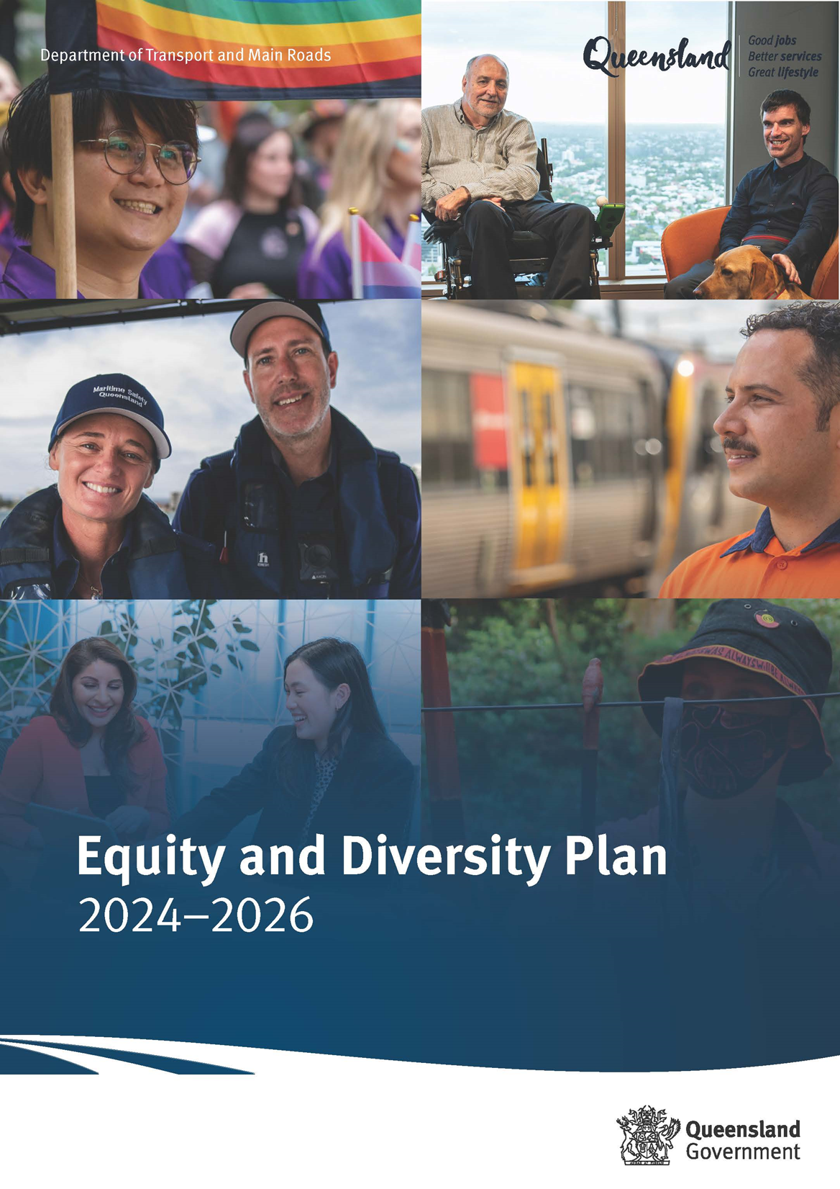





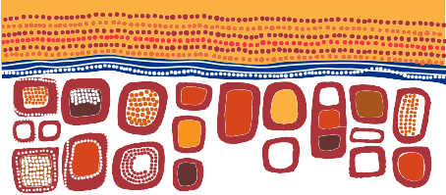
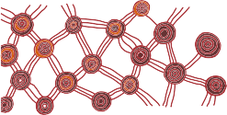

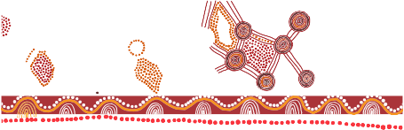







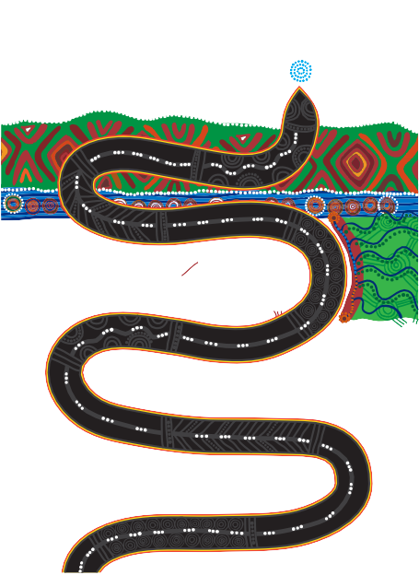
Acknowledgement of Traditional Owners
The Department of Transport and Main Roads acknowledges the Traditional Owners of the land and waterways. We also acknowledge their ancestors and Elders both past and present. The Department of Transport and Main Roads is committed to reconciliation amongst all Australians.

Creative Commons information
Copyright: This publication is protected by the Copyright Act 1968. © State of Queensland, 2024.
Third party copyright: Third party material that is not licensed under a Creative Commons licence is referenced within this document: all photographs are all rights reserved. Please contact the Department of Transport and Main Roads (the copyright owner) if you wish to use this material.
The material in this work is licensed by the Department of Transport and Main Roads under a Creative Commons Attribution 4.0 International licence (CC BY 4.0), with the exception of:

- the Queensland Coat of Arms
- this department’s logo
- any third party material, and
- any material protected by a trademark.
More information on the CC BY licence is set out as follows:
- Creative Commons website –www.creativecommons.org
- Attribution 4.0 international (CC BY 4.0)–https://creativecommons.org/licenses/by/4.0/

“Travelling” by Gilimbaa

Disclaimer: While every care has been taken in preparing this publication, the State of Queensland accepts no responsibility for decisions or actions taken as a result of any data, information, statement of advice, expressed or implied, contained within. To the best of our knowledge, the content was correct at the time of publishing.

Translating and interpreting assistance
If you need an interpreter call the Translating and Interpreting Service (TIS National) on 131 450. If you are deaf or have a hearing or speech impairment, contact us through the National Relay Service: www.relayservice.gov.au.

Table of contents
Foreword 4
Welcome from our employee networks 5
About the plan 6
Beneficiaries and intended impact 7
How we developed the actions 8
We examined the data
We leveraged existing plans
We collaborated with stakeholders
How we will measure our progress 10
Equity and Diversity Action Plan 11




Foreword
I’m pleased to present the Department of Transport and Main Roads’ (TMR) Equity and Diversity Plan for 2024–2026.
I believe our diversity is a major strength for TMR, and we are dedicated to building a strong framework for equity, diversity, and inclusion across the department. This plan underpins our unwavering commitment to making TMR a great place to work and bringing out the best in both our current and future employees.
As Director-General, I am fully committed to fulfilling my obligations under the Public Sector Act 2022 and I’m proud to champion a workplace culture built on respect and inclusion. Working closely with my executive team, I will provide the necessary leadership to embed these values across all areas of our business.
Over the past year, we have made significant progress on the initiatives outlined in our inaugural Equity and Diversity Plan. This has included a thorough review of our action plan, leading to updates that will further enhance and support our growth as a department.
This Equity and Diversity Plan consolidates our current actions and lays the groundwork to reflect on our future needs. Our extensive conversations with the broader business have been instrumental in ensuring accountability and developing an evidence- based, co-designed plan that aligns with our commitment to equity and diversity.

Sally Stannard
Director-General
Department of Transport and Main Roads

Welcome from our employee networks



Christina French
OneTMR Pride Network
The Equity and Diversity Plan 2024–2026 heralds a transformative era for diversity and inclusion. As a regional employee and a member of the OneTMR Pride Network, I am excited about the strong commitment to inclusivity, particularly through inclusive recruitment and capability uplift.
This plan is not just a policy; it is a pathway to enhanced representation, accountability, and a psychologically sound workplace, resonating with my personal values. It endorses a holistic approach, offering me—and the wider community—the tools and support necessary to truly thrive. Together, we’re paving the way to a more equitable, diverse, and empowered future.

As one of the newest members of the AIAN network and TMR team, I was grateful for the chance to participate in the collective discussions and decision-making that shaped the Equity and Diversity Plan. The process was characterised by thoughtful consideration, attentiveness, and transparent dialogue, assuring both myself and fellow networks within TMR that each of our voices is heard and appreciated.
The plan introduces defined responsibilities, highlighting our path and unwavering dedication to advancing equity and diversity. It represents a significant stride forward for the network, the community, and a personal milestone in our journey towards inclusive excellence.


Julia Fazio Access and Inclusion Advocacy Network

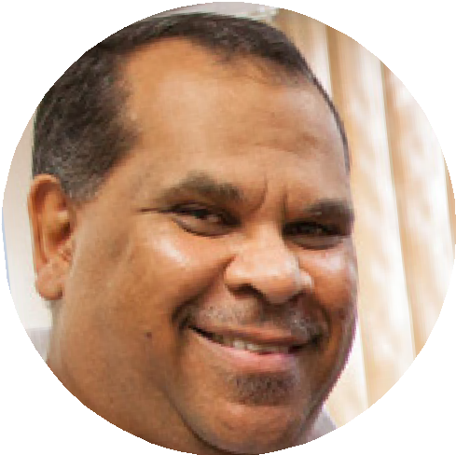
Frank Waria Indigenous Employee Network / First Nations Reference Group
As a member of the Indigenous Employee Network and First Nations Reference Group, I believe the key for First Nations people is to obtain good sustainable employment and income.
As an employer we can provide this. By providing this we can change not only an individual’s life but the immediate community they live in.
The key to improving First Nations recruitment is understanding that there are many ways to improve, so we must do a bit of everything, and we must do it continually. By doing things continually we will be able to see what is working and what is not, and this will allow us to alter actions to get the best outcomes.
We need to have targets and we need to be held accountable and be rewarded when we meet them.

About the plan
The Department of Transport and Main Roads’ (TMR) Equity and Diversity Plan (the Plan) aims to enhance equity and diversity (E&D) in employment matters for diverse cohorts, and helps clarify how TMR’s E&D initiatives fit together and complement each other. In this plan, TMR refers to:
Intersectionality recognises the interconnection of social categories (such as gender, race, sexuality) in shaping an individual’s experiences of discrimination and privilege.
Gender refers to the social, cultural, and behavioural attributes, roles, and expectations that a society considers appropriate for men, women, and individuals of other gender identities. Unlike biological sex, which is assigned at birth, gender isa complex and fluid concept that encompasses a spectrum of identities beyond the binary framework of male and female. This audit uses gendered,
often binary language. Consideration of non-binary people’s experiences as part of this audit has been limited by insufficient data.
People with disability refers to the condition where an individual experiences physical, cognitive, sensory, psychological, or developmental impairments that may impact their daily activities and participation in society. A person has disability if they have a limitation, restriction or impairment which has lasted, or is likely to last, for at least six months and may restrict everyday activities.
Different kinds of disability, usually resulting from accidents, illness, or genetic disorders, may include:
- Physical – affects a person’s mobility, dexterity, stamina/fatigue, speech.
- Sensory – affects a person’s ability to hear, see, touch, smell or concentrate.
- Intellectual – affects a person’s abilities to learn.
- Mental illness – affects a person’s thinking processes, including post-traumatic stress disorder (PTSD), anxiety disorders, depression.

- Receiving treatment or medication for any other long-term conditions or ailments but still may be restricted in everyday activities.
- Receiving treatment or medication for any other long-term conditions or ailments but still may be restricted in everyday activities.
- Neurological – affects the person’s brain and central nervous system and/or autonomic nervous system (for example, stroke, acquired brain injury).
- Any other long-term conditions resulting in a restriction in everyday activities.
First Nations refers to the diverse indigenous peoples who are the original custodians of the land.
Aboriginal and Torres Strait Islander collectively refers to the indigenous peoples of Australia.
Aboriginal specifically includes the original inhabitants of the Australian mainland, while Torres Strait Islander encompasses the indigenous communities residing in the Torres Strait Islands.
Language other than English at home (LOTEAH), formerly known as CALD, refers to individuals or communities with diverse cultural backgrounds and languages. This term recognises the importance of acknowledging and embracing the cultural richness and linguistic diversity within a given population.
LGBTIQ+ is an acronym that represents a diverse range of sexual orientations and gender identities. It stands for lesbian, gay, bisexual, transgender, queer, intersex and the ‘+’ includes additional identities such as asexual, nonbinary and others.
Age pertains to the chronological age diversity among employees, encompassing different generations. Managing age diversity contributes to a dynamic workplace, promoting knowledge exchange and inclusive practices.
Neurodiversity refers to individuals who exhibit or are characterised by neurological patterns of thought or behaviour that differ from what is considered typical or neurotypical, such as those associated with autism or other atypical neurological conditions.

Beneficiaries and intended impact
Recognising intersectional barriers, the Plan builds from the previous equity and diversity departmental framework, aiming to go beyond compliance with section 28 of the Public Sector Act 2022, to create a more inclusive workplace. The Plan seeks to:
  - Foster a workplace culture where all employees feel valued, respected, and included, regardless of their background, identity, or status.
  - Actively recruit, retain, and promote a diverse workforce that reflects the broader community, including underrepresented groups.
  - Identify and address systemic barriers, biases, and discriminatory practices in hiring, promotion, and day-to-day operations.
  - Improve the cultural awareness, sensitivity, and competence of all employees through training and education, ensuring they can work effectively with diverse colleagues and clients.
  - Ensure that all employees have equal access to opportunities for development, advancement, and leadership, regardless of their background or personal characteristics.
  - Create policies and practices that support the mental, physical, and emotional well- being of all employees, particularly those from marginalised groups.
  - Establish clear metrics and accountability mechanisms to track progress toward diversity and equity goals, ensuring continuous improvement.
  - Promote a human rights culture, focusing on upholding the dignity, equality, and freedom of each individual employee.

The Plan focuses on building a shared understanding of equity, diversity, and inclusion to promote sustainable cultural change.
We recognise that achieving the full intent of the Public Sector Act 2022 is a long-term goal. We understand that genuine progress will be in the accountability of actions and outcomes which focus on building the workplace culture to support sustainable change. Our priority is to build a collective understanding of equity, diversity, and inclusion to address the causes rather than the symptoms of inequity and exclusion.

How we developed the actions

We examined the data
In early 2024, we conducted an equity and diversity audit as a critical initial step in evaluating the annual progress of our Equity and Diversity Plan, in accordance with the Public Sector Act 2022. By understanding our employees’ experience through available data, we evaluated our current workforce diversity and compared it with the diversity targets set by the Public Sector Commission. This analysis provided a clear measure of the progress required to achieve our 2026 diversity targets. Additionally, insights from employee surveys, including the Working for Queensland Survey 2022 and the Accessibility and Inclusion Survey, established a benchmark to gauge the impact of our Plan’s actions on employee experiences.
To attain the established diversity targets by 2026, intentional and sustainable efforts are required. In consideration of the analysis of TMR’s current state, empirical research, industry benchmarks and sector-wide comparisons drawn on to undertake the audit, the following opportunities were proposed:
- Recruitment and selection
- Development of diverse cohorts
- Monitoring and evaluation
- Awareness through to allyship
- Policy development and alignment
This plan has been structured based on these five opportunities to ensure we address them directly.

We leveraged existing plans
The Equity and Diversity Plan is the overarching workforce approach which has been developed by responding to existing legislation, along with internally focused plans to embed a culture of respect and inclusion across the TMR workforce.

Legislation

Equity and Diversity Plan 2024–2026
Divisional workforce plans
Corporate deliverables
Public Sector Act 2022
  - Human Rights Act
  - Anti-Discrimination Act
TMR Strategic Workforce
Plan 2024–2027

Government Commitments
  - Queensland Government Reconciliation Action Plan
  - Multicultural Action Plan
  - Disability Services Plan

TMR context
  - TMR Strategic Plan
  - Accessibility and Inclusion Strategy
  - Indigenous Strategy Roadmap and Action Plan
  - Working for Queensland survey results
  - Employee networks

National and global
  - Best practice/research

We collaborated with stakeholders
The actions in this plan have been drawn from existing plans and were developed through stakeholder collaboration and consultation across all divisions of TMR and with our employee reference groups. New actions in this plan have been included to address gaps identified in the audit and have been framed to continue stakeholder collaboration and co-design over the coming years.

How we will measure our progress
As part of our commitment to progressing towards a culture of respect and inclusion, it is paramount that we conduct an annual audit to track the progress of the actions in this plan, to improve equity and diversity in relation to employment matters through a range of mechanisms as outlined below. These channels, which provide both quantitative and qualitative data, will provide a holistic perspective on the department’s journey towards achieving the objectives of this plan. While each specific initiative or action item will have a range of detailed metrics such as engagement rates, employee feedback and statistics and analytics, for the purpose of this plan, the following metrics will be used overall:
- Working for Queensland Survey results
- Equal Employment Opportunity data
- Accessibility and Inclusion Survey results (2020, 2022 and 2023)
- Australian Network on Disability Access and Inclusion Index data and results
- Qualitative evaluation data from employee experiences and centrally led programs
- Key performance indicators and evaluation tools
- Cultural Inclusion Academic Research - Transport Academic Partnerships Program (TAP) report
- Workforce diversity targets 2022–2026.
Workforce targets are one strategy that provide focus for our initiatives aimed at increasing workforce diversity. The targets have been developed by the Queensland Public Sector Commission using benchmark data in 2022, diversity workforce reporting surveys, and Equal Employment Opportunity data. The targets are used to ensure we grow a public sector that represents and reflects the diverse views, experiences, and backgrounds of the people of Queensland. The following table provides an overview of the department’s 2026 workforce targets:

Categories | Workforce targets
Women in leadership | 50%
Aboriginal people and Torres Strait Islander people | 4%
People with disability | 12%
Culturally and linguistically diverse  (Language other than English spoken at home) | 15%

Equity and Diversity Action Plan 2024–2026
This Action Plan details specific actions for the ELT and SLT to integrate into their programs and processes to foster an inclusive, safe, and respectful workplace. This plan complements the ongoing improvement efforts of existing processes, programs and initiatives across the employee lifecycle, dedicated to continuously enhancing the organisation’s culture and work environment.

Recruitment and selection | Action |  | Action description | Embedded by | Achieved by
Inclusive recruitment and selection strategies  Goal: Creating a diverse and equitable workforce that reflects the community and brings a wide range of perspectives, skills, and experiences to the organisation.  Supported by: Corporate, ATN, IST, local HR | Action 1 | Inclusive recruitment, advertisement, branding, and identified roles | - Consider every vacancy as they arise to determine if there is an occupational need for the role to be identified.  - Use fit-for-purpose advertising channels or targeted recruitment processes to attract diverse talent pools.  - Leverage the #WeAreTMR employer branding. | SLT SLT  Corp HRB | Q4 2026  Q4 2026  Q4 2026
 | Action 2 | Unconscious bias | - Offer training and embed opportunities to increase awareness around unconscious bias in recruitment and selection. (New initiative) | Corp HRB | Q4 2026
Development of diverse cohorts
Capability uplift programs for diverse cohorts  Goal: To create a well-informed, engaged, and motivated workforce that benefits from inclusive development opportunities for diverse cohorts.  Supported by: Corporate, ATN, IST | Action 3  Action 4 | Support for employees throughout their career  Retention strategies for First Nations employees | - Regular performance and development discussions between managers and employees to better understand desires and aspirations of our diverse cohorts.  - Supporting employees transitioning to retirement with employment options and information. (New initiative)  - Analyse and identify opportunities to address career disparities among First Nations employees including providing retention opportunities. (New initiative) | SLT  Corp HRB  IST | Q4 2026  Q4 2025  Q3 2025
Monitoring and evaluation | Action |  | Action description | Embedded by | Achieved by
Data transparency, communication and impact assessment  Goal: Build trust, enhance accountability, and drive informed decision-making through clear, accessible insights by measuring and communicating the effectiveness and value of programs and initiatives.  Supported by: Corporate, local HR, ATN, IST, ODG, Facilities | Action 5 | Improve oversight on diverse cohorts and their employee experience | - Establish divisional strategic workforce plans that establish expectations and embed local diversity actions. (New initiative)  - Explore the barriers preventing employees from disclosing Equal Employment Opportunity (EEO) diversity data. (New initiative)  - Examine a cohort-specific indexation and benchmarking to improve data capturing processes for LGBTIQ+ cohort. (New initiative)  - Using Integrum to capture confidential diversity data on psychosocial incidents and grievances for diverse cohorts. | ELT  Corp HRB  Corp HRB  Corp HRB | Q3 2025  Q4 2024  Q1 2026  Q4 2026
 | Action 6 | Cultural inclusion research | - Continue to review and implement the recommendations outlined in the recent TAP report regarding the experience of Aboriginal and Torres Strait Islander employees.  - Research best practice for implementation of initiatives around creating cultural and psychologically safe workplaces for LOTEAH employees. (New initiative) | IST  Corp HRB | Q3 2025  Q4 2025
 | Action 7 | Accessible and inclusive wellbeing initiatives | - Engage employees with disabilities to understand how to improve their wellbeing in the workplace. (New initiative)  - Update the Performance Agreement template to include objectives related to access and inclusion of every employee. (New initiative)  - Improve the accessibility of TMR’s workplaces and understanding the employee experience by conducting ongoing reviews, including accommodation audits and employee satisfaction surveys. | ATN  Corp HRB  Corp HRB, Facilities | Q2 2025  Q2 2025  Q4 2026

Awareness through to allyship | Action |  | Action description | Embedded by | Achieved by
Culture, wellbeing, and psychosocial safety  Goal: Foster an inclusive, supportive, and psychologically safe workplace where all employees feel valued, respected, and empowered.  Supported by: Corporate, local HR, Pride Network, IEN, FNRG, VCN, ATN, IST | Action 8 | Ensure TMR’s workplaces and services are culturally safe through cultural improvements within the workplace | - Engage members of employee reference groups through new engagement activities and initiatives.  - Deliver important messaging to employees to improve storytelling in line with reconciliation.  - Enable senior leaders to strengthen cultural awareness, inclusive mindsets, and embed accessibility requirements.  - Support, promote, acknowledge, and celebrate days of significance for diverse cohorts. | Corp HRB, ATN, IST  IST  SLT  SLT | Q4 2026  Q4 2024  Q1 2026  Q4 2026
 | Action 9 | Training to enhance the cultural capabilities of the workplace | - Refresh anti-racism, human rights, workplace bullying, sexual harassment and unlawful discrimination training for all staff.  - Refresh and deliver annual mandatory training relating to accessibility and inclusion.  - A 12-month pilot training program to enhance employee relationships through Respectful Relationship Training. (New initiative)  - Deliver training to people leaders designed to cultivate a psychosocially and culturally safe environment.  - Indigenous Procurement training developed in collaboration with Indigenous businesses. (New initiative) | Corp HRB  ATN  Corp HRB  Corp HRB  Corp F&P | Q4 2026  Q4 2026  Q4 2025  Q4 2026  Q4 2025

Policy development and alignment | Action |  | Action description | Embedded by | Achieved by
Proactive preparation and collaboration across the organisation  Goal: Develop comprehensive frameworks that foster consistency, efficiency, and effectiveness by leveraging co-design principles, building strong partnerships, ensuring accountability across the organisation to address shared challenges and seize opportunities.  Supported by: IST, ATN, Corporate | Action 10 | Whole of Government and Legislative requirements | - Develop a ‘reframing the relationship’ plan in line with the Queensland Government Reconciliation Action Plan.  - Implement agreed actions outlined in the Disability Services Plan.  - Implement the Preventing and responding to workplace sexual harassment policy.  - Develop TMR’s accessibility and inclusion policy.  - Implement agreed actions outlined in the Queensland Multicultural Action Plan 2024–2027. | IST  SLT  SLT  ATN  SLT | Q4 2025  Q4 2026  Q4 2026  Q4 2026  Q4 2026

