Department of Transport and Main Roads
Strategic Plan 2023–2027 reviewed 2025-2026
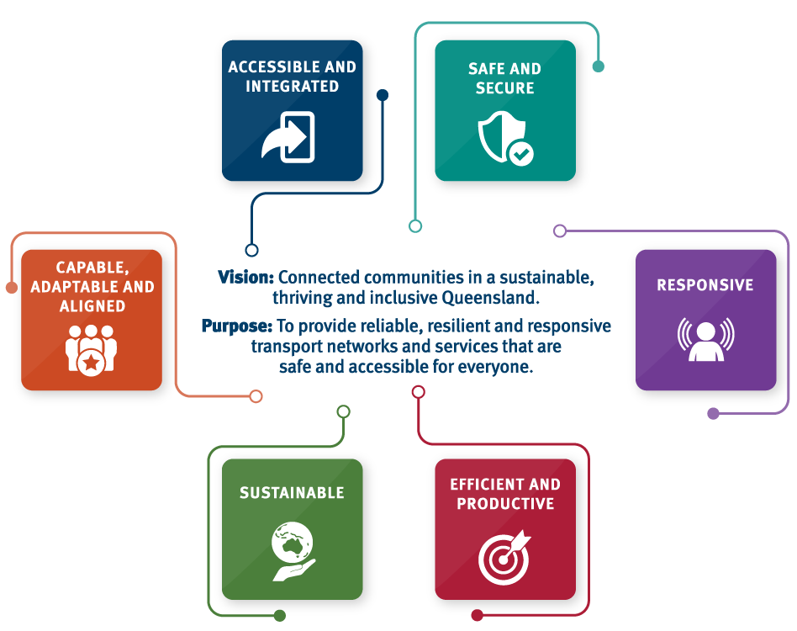

The Department of Transport and Main Roads (TMR) supports the government’s objectives for the community:
- A better lifestyle through a stronger economy.
- A plan for Queensland’s future.

The strategic plan is underpinned by the 30-year Queensland Transport Strategy.
Our commitment to Human Rights: We will respect, protect and promote human rights in our decision-making and actions.
The Department of Transport and Main Roads acknowledges the Traditional Owners of the land and waterways. We also acknowledge their ancestors and Elders both past and present. The Department of Transport and Main Roads is committed to reconciliation amongst all Australians.

Department of Transport and Main Roads
Strategic Plan 2023–2027 reviewed 2025-2026

Vision: Connected communities in a sustainable, thriving and inclusive Queensland.
Purpose: To provide reliable, resilient and responsive transport networks and services that are safe and accessible for everyone.

Principles | Objectives | Performance indicators | Strategies | Our contribution to the Queensland Government’s objectives for the community
Accessible and integrated | - A transport system that is accessible and connects customers and communities | - Accessible and integrated transport services and infrastructure  - Affordable and diverse transport options | - Take a movement and place-based approach to transport planning, designing and operations  - Develop our partnerships with industry and government  - Strengthen our collaboration and co-design approach with our customers  - Expand the application of universal design thinking  - Harness emerging technologies and data to drive integration across the transport ecosystem  - Enhance access and mobility throughout Queensland  - Use the government Champion Network for First Nations communities  - Deliver cost of living relief through registration reduction and lower transport fares | - A better lifestyle through a stronger economy  - A plan for Queensland’s future
Safe and secure | - A transport system that is safe and secure for customers and goods | - Safety and security of customers and goods  - Customer and community trust in the transport system | - Build on a safe system approach for transport safety  - Educate the community on their role in safety  - Nurture partnerships to deliver a safe and secure transport system  - Embed cyber security to protect information assets and personal data | - A plan for Queensland’s future
Responsive | - A transport system that is responsive and resilient to the changing environment | - Operations and reliability of the transport system  - Responsive to unplanned events and opportunities  - Responsive and resilient services | - Continue to proactively manage network disruptions and disaster recovery  - Build on operational excellence and local planning of services to enhance network resilience  - Build our multi-modal network management capability  - Enable, support and regulate emerging technologies to enhance mobility services  - Commit to continuous improvement in our services, communications and digital capabilities  - Adopt a whole-of-system perspective when designing the transport system | - A better lifestyle through a stronger economy  - A plan for Queensland’s future
Efficient and productive | - A transport system that is a key enabler of economic activity | - Efficiency and reliability in the movement of goods and services  - Procurement from small businesses and First Nations suppliers | - Invest in infrastructure and services delivered in partnership with industry  - Maintain assets efficiently to maximise productivity  - Invest in research to lower capital and operational costs  - Integrated and coordinated approach to prioritise investment in high value projects  - Increase the use of rail freight along strategic corridors  - Embrace smart planning and innovative financing  - Leverage digital opportunities to deliver innovative services | - A better lifestyle through a stronger economy  - A plan for Queensland’s future
Sustainable | - A transport system that contributes to environmental, economic and social sustainability | - Minimal impact on the natural environment  - Fiscal sustainability  - Active and shared transport modes | - Embed sustainability in whole-of-life and whole-of-system decision making  - Commit to low and zero emissions transport technologies, modes and materials where possible  - Integrate circular economy principles into transport network design and delivery  - Implement programs to encourage changes in customers’ travel and freight patterns  - Increase investment in active and sustainable transport modes | - A better lifestyle through a stronger economy  - A plan for Queensland’s future
Capable, adaptable and aligned | - A positive, effective and accountable organisation | - Effective leadership  - Inclusive, diverse and safe workforce  - Learning and development opportunities  - Employee satisfaction | - Attract, develop and retain a diverse and capable workforce that is safe and thriving  - Cultivate digitally connected employees and workplaces  - Manage and develop our resources effectively to support the work of the organisation  - Deliver best practice corporate services and optimise business processes and systems | - A better lifestyle through a stronger economy  - A plan for Queensland’s future

TMR publishes a set of strategic plan measures that align to our performance indicators.
Our risks:
- Maintaining a safe transport system for our customers and community
- Providing an accessible and integrated transport system
- Developing workforce skills, capability and adaptability to meet TMR’s future needs
- Adapting to climate change, reducing emissions and maintaining an environmentally sustainable transport system
- Reducing the impact of supply chain disruption and unavailability of skilled labour
- Maintaining sustainable ICT systems and protecting against cyber threats
- Funding and sustaining essential transport services and infrastructure
- Planning and responding to deliverability and affordability of critical transport infrastructure projects and future major events
Our opportunities:
- Maximising the value from data to improve planning and operational efficiency
- Optimising our capacity and capability in multi-modal network and major event management

