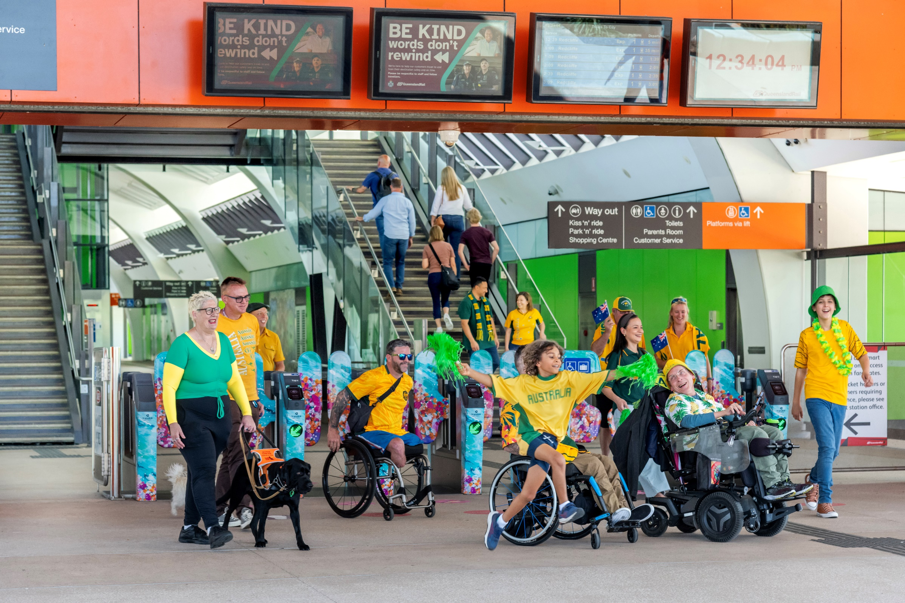
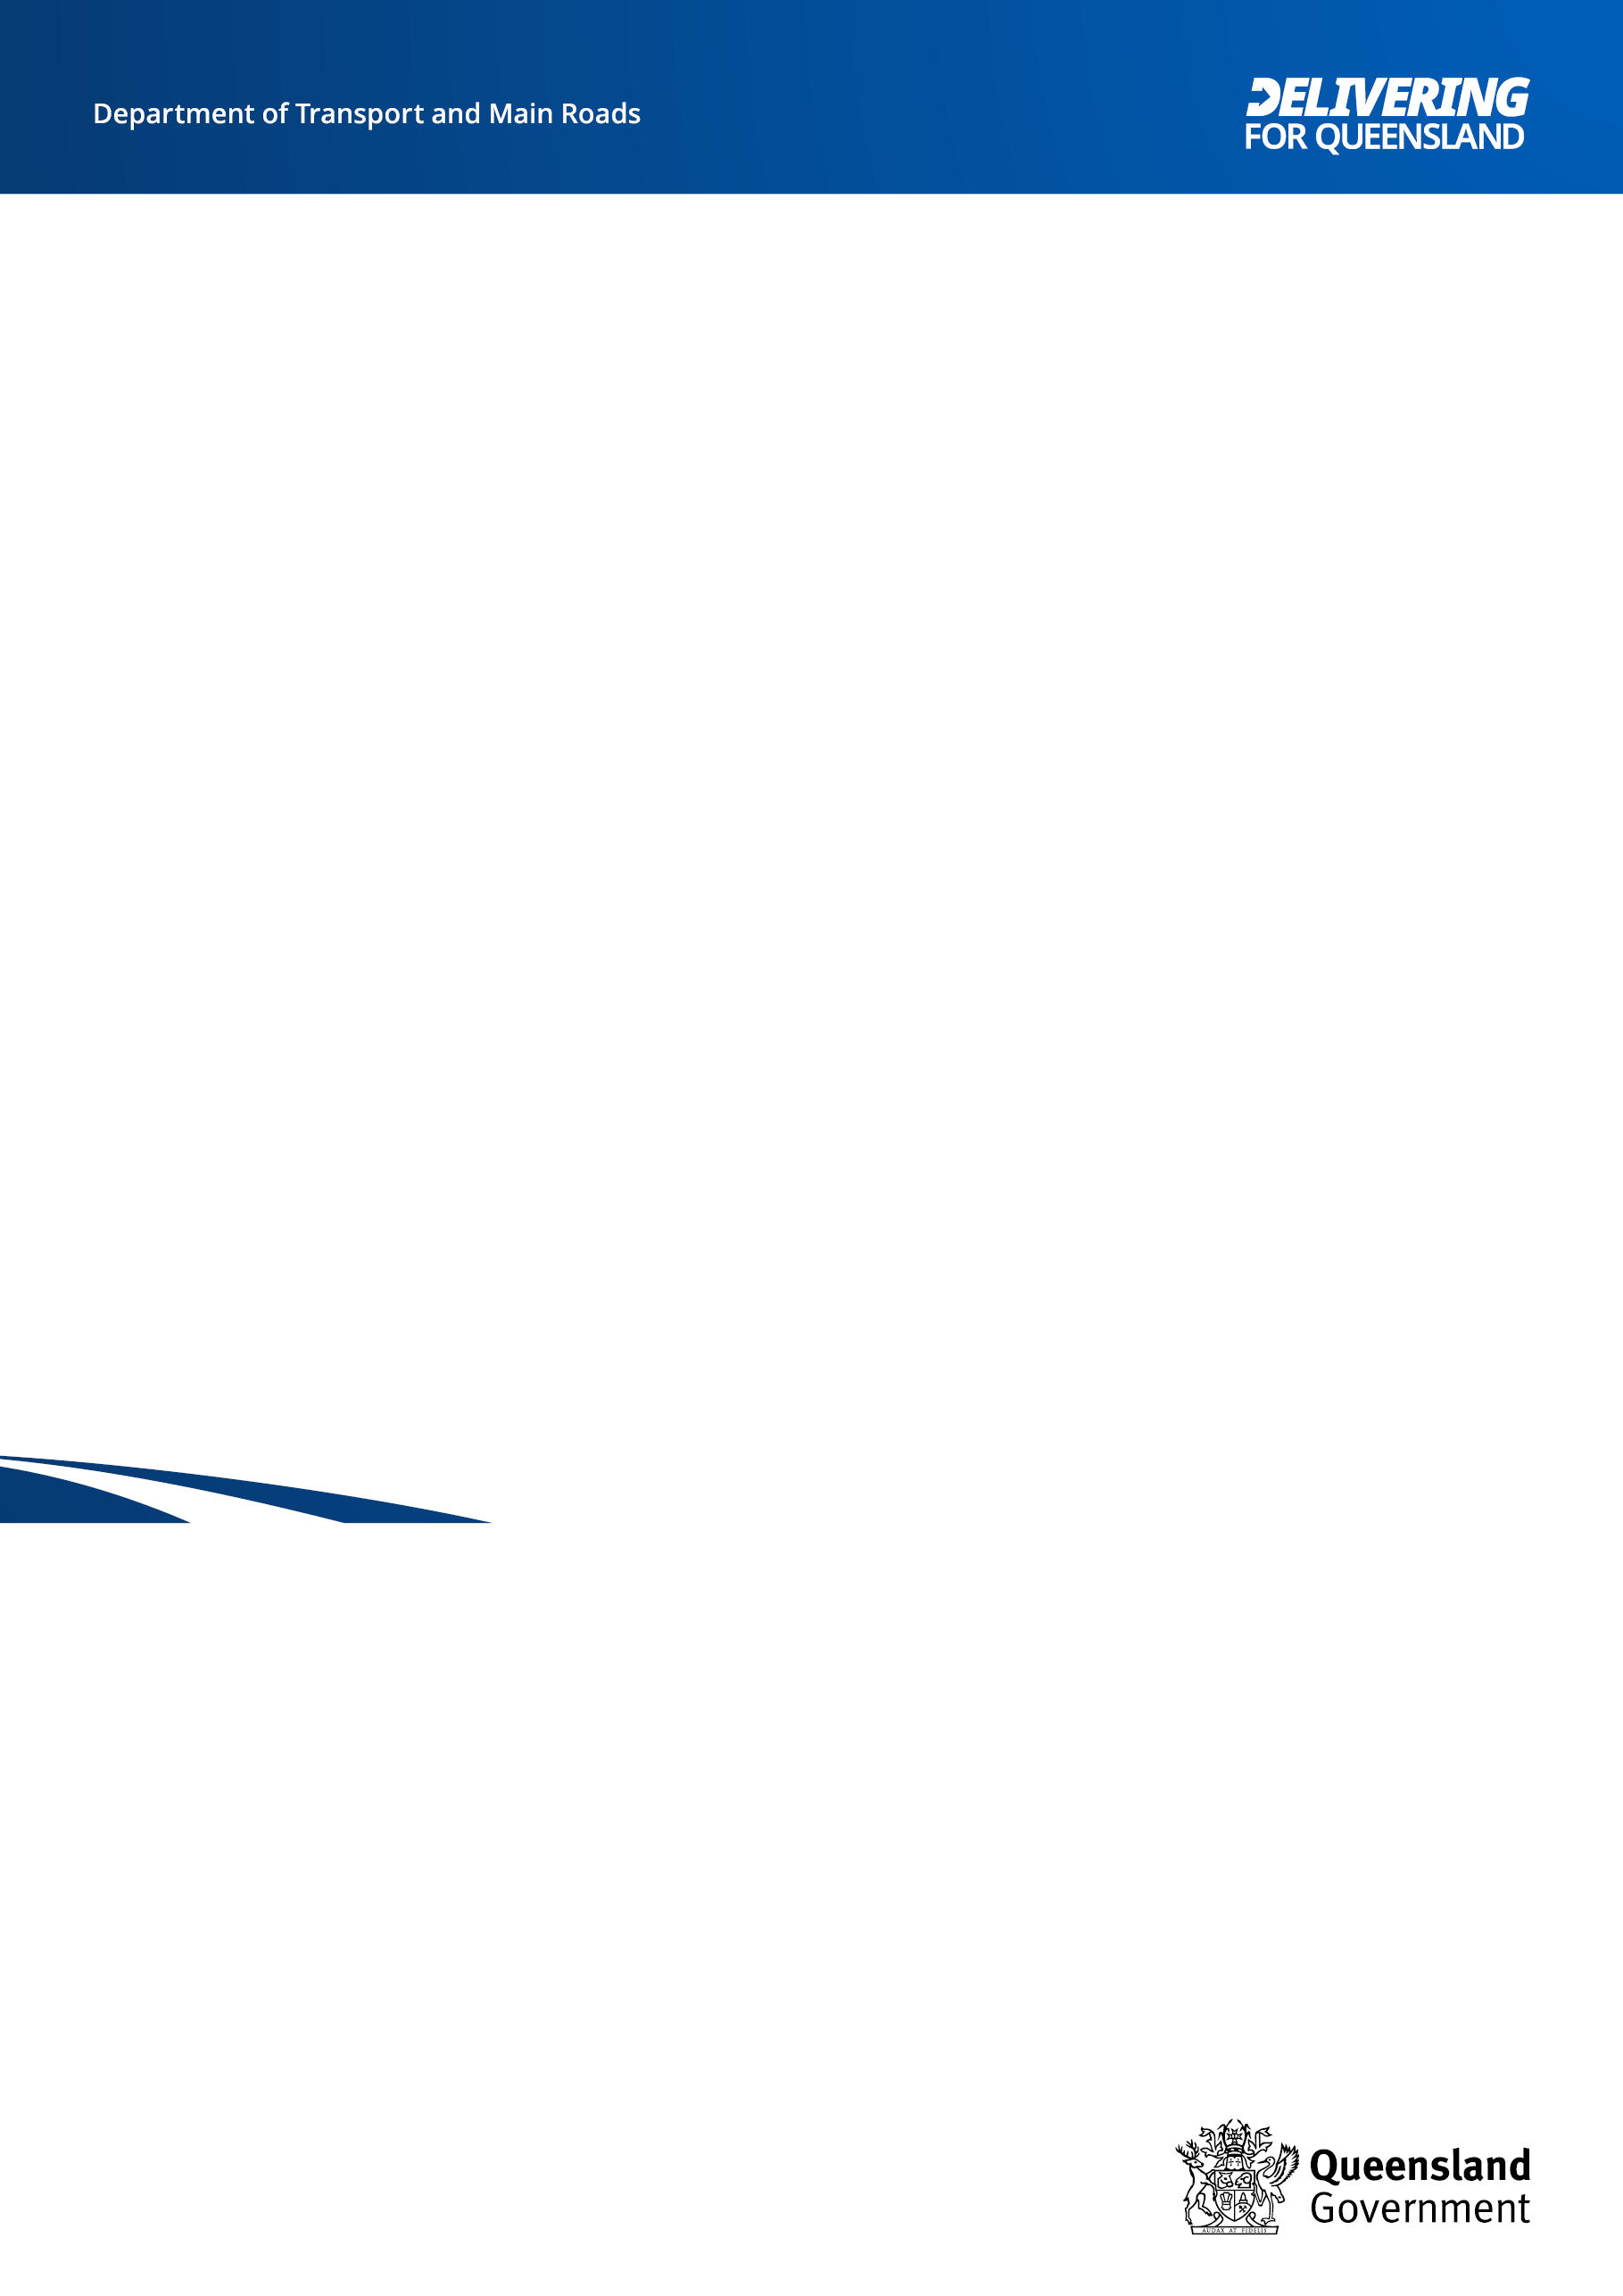

Accessibility and Inclusion Strategy and Action Plan

2025-2027

Acknowledgement of Country
The Department of Transport and Main Roads (TMR) respectfully acknowledges the Traditional Owners and Custodians of the land and waterways. We pay respect to their Elders past, present and emerging. TMR recognises those whose ongoing effort to protect and promote Aboriginal and Torres Strait Islander cultures will leave a lasting legacy for future First Nations people.

Accessibility
Other accessible formats are available on our website www.tmr.qld.gov.au.This includes an accessible word document and website HTML text.

Translating and interpreting assistance
If you need an interpreter, call the Translating and Interpreting Service (TIS National) on 131 450. If you are deaf or have a hearing or speech impairment, contact us through the National Relay Service: www.relayservice.gov.au.

Copyright
This publication is protected by the Copyright Act 1968. © The State of Queensland (Department of Transport and Main Roads) 2024. All rights reserved.

Disclaimer
This publication is provided as a source of information only and the State of Queensland makes no statements, representations or warranties about its accuracy or completeness. To the extent permitted
by law, the State of Queensland disclaims all responsibility for decisions or actions taken because of any data, information, statement or advice, expressed or implied, contained within and excludes all liability (including, without limitation, liability in negligence) for all expenses, losses, damages and costs that may be incurred.
Contents
Director-General’s message 1
Strategy on a page 2
Context 3
Our aspiration 3
Commitment to accessibility, diversity, equity, and inclusion across TMR 4
Access and inclusion change initiatives in progress 4
Our Journey 5
Progress since 2020 Strategy 7
Trends shaping transport 8
The Strategy 9
Co-designing with our stakeholders 9
Key concepts underpinning this Strategy 10
Commitments 12
Grow mindset, capability, and culture 12
Embed accountability 14
Commit to accessible and inclusive design 15
Delivering the Strategy 18
Roles and responsibilities 18
Monitoring progress 18
Action Plan Summary 19

Director-General’s message
In my capacity as Director-General and Champion for Accessibility for the Department of Transport and Main Roads (TMR), I am proud to present our new accessibility and inclusion strategy and action plan - Moving Together to Connect Queensland. This supports us to achieve TMR’s purpose of providing a reliable, resilient, and responsive transport network that is safe and accessible for everyone.

Teams across TMR have been working hard to raise awareness about accessibility and inclusion, and we are making great progress. We have integrated accessibility and inclusion principles and guidelines into project management, communication, leadership, and infrastructure design. We have improved recruitment practices, and involved our customers in research, planning and testing of products and services.

These are important, but early steps on our long-term journey towards embedding accessibility and inclusion in everything we do at TMR. We also know that the creation of truly inclusive attitudes, behaviour, structures, and systems requires a holistic transformation of organisational structures, policies, and practices, including dismantling the systemic barriers that inhibit lasting change.

Beyond our legal and moral obligations, providing equitable access to transport services gives people greater autonomy over their lives and better access to health, education, and employment—all of which have positive impacts for individuals, the broader community, and the economy.

We need to systematically co-ordinate our efforts, which is why we have co-designed this strategy and action plan with our customers, our employees, and our delivery partners. It sets out clear steps we must take together on the next stage of our journey to accessibility and inclusion.

We are fortunate at TMR to have innovative minds, modern technology, stakeholder partnerships and strong leadership commitment to deliver on this promise. The task is ever evolving, requiring constant attention and unwavering resolve. Importantly, our commitment extends beyond achieving mandatory compliance.

Our vision and true measure of success is for a transport network where everyone feels welcomed and can travel where and when they want, regardless of personal circumstances; and TMR workplaces where all current and future employees belong and feel safe.

Sally Stannard
Director-General
Department of Transport and Main Road

Strategy on a page
Key commitments
Grow mindset, capability, and culture  Develop a strong culture of accessibility awareness in all layers of the transport network; and drive mindset change to make inclusion part of core business.  Ensure all employees and delivery partners have the capability and commitment to contribute to accessibility and inclusion.  Increase the understanding that kindness and care shown by employees and community members can have a positive impact on the experience for all people during their journeys. | Embed accountability  Make sure everyone knows their accessibility and inclusion obligations, and who is responsible for what outcomes.  Ensure our compliance with accessibility requirements/obligations is clear and transparent, to encourage public confidence that we deliver on our commitments.  Measure and share successes and failures. Ensure we optimise the opportunities arising from complaints. | Commit to accessible and inclusive design  Accessible and inclusive design is both a mindset and a process and is considered in every transport project and process.  Go beyond compliance with minimum legislated requirements, consider the diverse lived experiences of customers, and create solutions to benefit everyone.  Leverage input from diverse perspectives to improve outcomes.
Key Actions
1. Move Together Social Media Campaign (Phase 3)  2. Inclusive Precincts Guide  3. Digital Accessibility Capability Uplift  4. Accessibility and Inclusion Change Champion Community of Practice | 5. Accessibility and Inclusion Organisational Change Plan  6. Accessible and Inclusive Social Impact Framework  7. Workplace Adjustment Process Mapping  8. Independent research to understand the experience of TMR employees with disabilities. | 9. TMR Universal Design Policy Framework  10. Co-design Capability Uplift  11. Accessible and Inclusive Forms  12. Accessible Communications Project
Outcomes
TMR employees and delivery partners have the skills, capability, and mindset to provide accessible, dignified, and inclusive experiences for customers. | TMR employees and delivery partners understand what their access and inclusion responsibilities are, enabling results to be measured and successes and failures shared. | Universal design is the standard by which TMR employees and delivery partners work and is applied from the start of every new initiative. Customer information and communication is consistent, accessible, and available to all in a range of ways.

Context

Our aspiration
This strategy fits within TMR’s vision and purpose:

TMR Vision: Connected communities in a sustainable, thriving, and inclusive Queensland.

TMR Purpose: To provide reliable, resilient, and responsive transport networks that are safe and accessible for everyone.

We strive towards:
Valuing, respecting, and celebrating diversity
- Being a leader in the provision of dignified, accessible, and inclusive transport products, services, information, and infrastructure that allow everyone to participate in our community and access employment, health, education, recreation and culture.
- Exceeding minimum requirements to deliver the most functional and inclusive outcomes for customers and employees. Compliance with state, national and international legislation and standards is the minimum expectation in everything we do.
- Creating an inclusive culture characterised by behaviours like cooperation, collaboration, openness and curiosity, which foster a sense of belonging, connection, equity and safety.
- Acknowledging and addressing systemic barriers that prevent equitable access to transport products, services, information, and infrastructure.
- Working collaboratively with our customers, employees, delivery partners, service providers and all levels of government to ensure alignment with government objectives, broader human rights and legislative obligations.
- Being an employer of choice, acknowledged for our inclusive and diverse workforce.
Our strategy and actions are framed around systemic change to transform mindsets and remove barriers preventing everyone from participating in society on an equal basis.

Commitment to accessibility, diversity, equity, and inclusion across TMR
TMR is committed to improving accessibility, diversity, equity and inclusion and there is an ongoing and proactive focus on the design and delivery of accessible products, services, communication, careers, and experiences across TMR and the transport network.

This strategy and action plan are focused on organisational transformation to embed and integrate accessibility across the organisation so that customers, employees, and the community all benefit. This complements the commitments in a range of strategies and action plans across TMR, which include:

Creating Better Connections 2022-2032
More accessible, seamless, and easy-to-use passenger transport.

Customer Strategy 2024-2029
Designing for the diverse needs of customers so they feel included and can access what they need.

Equity and Diversity Plan 2024-2028
Fostering a strengthened, diverse, and inclusive workplace and culture, reflecting the community we serve.

Indigenous Strategy Roadmap 2023-2025
Anti-discrimination and anti-racism initiatives, improving cultural safety, and increasing engagement with indigenous businesses.

Information and Communication Technology Strategic Plan 2024-2028
Making all digital channels inclusion and accessibility compliant businesses.

Interim Disability Action Plan 2023-2024
TMR’s commitment to improve accessbility for people with disability using the passenger transport system in Queensland.

Queensland’s Digital Economy Strategy and Digital Service Standard
Fully accessible, inclusive, and personalised services for customers.

Queensland Government Human Rights Strategy
Building a culture that respects and promotes human rights.

Queensland Walking Strategy 2019-2029
Inclusive mapping and quality active transport connections and precincts.

Access and inclusion change initiatives in progress:
A range of ideas that emerged during the co-design process are also already underway in TMR. For example:

People told us they want real-time and easier to understand information to make it easier to navigate and plan.

Current TMR initiatives:
- Simpler, more legible network signage.
- A new customer journey planner app is in development and will provide more accurate information for people to plan seamless door-to-door journeys.
- A new network map has been released to make it easier to understand, navigate and plan on the SEQ transport network.
- Proof of Concept trials of digital products are underway, including the See Me digital bus hailing system and Electronic Paper technology to display real-time timetable, route, temporary service changes, interruptions and other updates at bus stops.
People told us that cost presents barriers to many across all areas of transport.
Current TMR initiatives:
- 50 cent fares.
- Wheelchair accessible taxi driver incentive lift payments increased from $20 to $25.
- TMR has commissioned research to understand the behavioural impact of the introduction of a 50 cent public transport fare across Queensland, the impact it has on road congestion, and the implications of the low fares on cost of living pressures.
People told us that new, accessible infrastructure is making a difference. There are big differences between new and old stops, stations and vehicles, roads, and active transport options.
Current TMR initiatives:
- Station accessibility upgrades across the network feature new lift-accessible footbridges, fully raised full-length platforms, and extended platform shelters, upgraded customer facilities like accessible toilets, disability-compliant ticket windows and gates, improved seating, hearing augmentation loops, tactile floor indicators, new wayfinding signage, information screens and better security through CCTV and lighting upgrades.
- New Cross River Rail, Gold Coast Light Rail expansion and the new Direct Sunshine Coast Line.
- 65 new fully accessible trains under construction through the Queensland Train Manufacturing Program to increase fleet numbers.
- More than 400 new buses are being procured through the first stage of the Zero Emission Bus Program.

People told us that unreliable services affect every aspect of the customer experience. Frequency matters. Poor availability of taxis and rideshares, or drivers cancelling bookings for people with a disability is a significant problem. Connectivity through active transport routes is valued

Current TMR initiatives:
- Increased connectivity through new active transport links.
- On-demand transport trials.
- Removing level crossings to improve road congestion.
- Accessible Taxi Services Working Group to improve accessible taxi service levels.
- New trains and buses will increase the fleet and improve reliability.

Our Journey
Accessibility and inclusion (A&I) of the transport network has been continuously improving over decades, from the introduction of accessible taxis and the Taxi Subsidy Scheme in the 1980s, the first accessible bus in the 1990s, the establishment of the National Travel pass and DSAPT in the early 2000s, and the establishment of TMR’s Accessible Reference Group in 2014.

In 2018, TMR established a dedicated unit to accelerate change, to focus on accessibility and inclusion in a human rights framework, and to develop a systemic approach to improve accessibility and inclusion across TMR’s products, services, information, infrastructure, workplaces and work practises.

Tranche 1 – Initiate change

Commit to prioritising accessibility and inclusion.
2018: Accessible Transport Network (ATN) established to progress TMR’s increased focus on accessibility and inclusion.
2020: Human Rights Act 2019 comes into force.
2020: TMR’s first Accessibility and Inclusion Strategy is published.
2021: Co-designed and created the Easy Read Style Guide, icons and photography suite, now used across Queensland Government.

Tranche 2 – Embed our guiding principles

Embedding accessibility in all that we do.
Developing cultural attitudes and critical capabilities.
2022: Co-designed and released the Accessible Communication Guideline, Accessible and Inclusive Design Guide and Accessible Facilitation Guide.
2023: Public Sector Act 2022 comes into force with a new focus on equity and diversity in the public service.
2024: New Accessibility and Inclusion Strategy, accessible form template and social media campaign co-designed with customers, employees and delivery partners.
2024: TMR’s first accessible QTRIP released.
2024: TMR’s Equity and Diversity Plan launched.
2025: Move Together hidden disability social media campaign live.
2025: TMR Universal Design Policy Framework implemented.
2025: Accessible and inclusive forms rolled out.
2026: Accessible and Inclusive Transport Precincts Design guidance implemented.

Tranche 3 – Grow our reach
Being a leader in accessible and inclusive transport.
2026: A&I Capability Uplift.
2027: Accessibility and Inclusion Advocacy Champion Network embedded across TMR.
2027: Moving Together to Connect Queensland fully implemented and embedded across TMR.
2030: Continue to improve accessibility of transport infrastructure and services to support the Olympics and Paralympics.
2032: Brisbane Olympics and Paralympic Games – a fully accessible and car-free Games.

Progress since 2020 Strategy
Achievements since our first Accessibility and Inclusion Strategy was released in 2020 include:
- Chaired the National Accessible Transport Taskforce (NATT) in the review of the Disability Standards for Accessible Public Transport 2002 (DSAPT) in partnership with the Commonwealth Government.
- Grew the Accessibility and Inclusion Advocacy Network (AIAN) to over 250 members. It is a department-wide network that actively works towards accessibility and inclusion through ongoing action and advocacy. It is working towards the mission of growing a network of informed, empowered advocates committed to continuous learning about accessibility and inclusion and sharing their individual and collective knowledge across the business.
- Facilitated and funded the following accessibility and inclusion training courses, which have been made available to all TMR employees: Unconscious Bias, Disability Awareness, BlackCard Cultural Capability, Gender Identity and Discrimination, Deaf Awareness.
- Developed the Accessible Micro-Infrastructure Video Series to build the capability of TMR planners, designers and builders as well as increase the general awareness of TMR people about the accessible micro infrastructure features across Queensland’s Transport network.
- Facilitated and funded the Disability Engagement Panel. All business areas across TMR have access to this arrangement and are able to engage people with lived experience of disability from across Queensland to participate in a range of activities, including co-design sessions, focus groups, disability awareness training, guest speakers, surveys, user testing, photo shoots and videography.
- Co-designed and released the Accessible Communication Guidelines, Accessible and Inclusive Design Guide and Accessible Facilitation Guide as important resources to upskill employees and contractors working on TMR projects.
- Created the Move Together social change media campaign to build awareness with public transport users about practical things we can all do to improve the public transport experience for everyone. The long-term goal of this campaign is not only to build a more inclusive transport network, but also increase patronage from vulnerable user groups.
- Co-designed and created the Easy Read Style Guide, icons and photography suite which are now used across TMR and the Queensland Government.
- Developed and released the new mandatory Accessibility and Inclusion at TMR training. It was completed by more than 9600 TMR employees in the first year and was recognised at the LearnX Awards 2023 with two Diamond Awards—Best accessibility in e-learning design and Best diversity and inclusion project in the human resources talent management category. The training was also a finalist in the Australian Institute of Training and Development Awards 2023.

Trends shaping transport
In the five years since the last accessibility and inclusion strategy, the environment has changed considerably, including by the impact of a global pandemic on communities and transport stakeholders. Other examples of movement in the environment presenting opportunities and challenges include:

International megatrends
- New transport services are increasingly developed by the private sector, making government an enabler not a provider, and requiring more partnering with the private sector.
- Boundaries between buyers and sellers are changing e.g. Peer to peer markets and sharing economies are increasing.
- Automation and data driven capability is allowing better integration of systems.
- Better management of available resources is needed in the face of population changes (e.g. ageing communities), increasing consumer demands and environmental awareness.
- The impact of artificial intelligence (AI) on transport, mobility, and accessibility.
- Cybersecurity risks to transport networks.

National changes
- NDIS will require more from mainstream services as funded services become more targeted.
- Cost of living pressures are increasing demand for public/shared transport. People with accessibility needs are more adversely affected by less choice.
- Regional populations have grown post-pandemic and as economic pressures increase.
- Cost pressures on delivering infrastructure and services.

Queenland’s future planning needs, including:
- 2032 Olympic and Paralympic Games.
- Queensland’s commitment to emissions reduction, including the shift toward zero emission vehicles.
- Industry capacity and capability.
- Extreme weather events impacting on infrastructure and customer access.

The transport sector is grappling with both the opportunities and challenges of rapid changes in technology and the expectations of customers. Queensland also has some significant planning challenges ahead that TMR needs to prepare for.

The Strategy
This Strategy and Action Plan builds on the foundations and successes of TMR’s first accessibility and inclusion strategy launched in 2020 and subsequent Action Plan in 2022. This strategy and action plan goes further to dismantle the physical, communication and attitudinal barriers people experience with Queensland’s transport network. We know that accessibility is more than just meeting the needs of people with disability. It creates inclusive, intuitive, and dignified experiences for all customers and employees.

We want to embed systemic change and commit to improved processes, increased capability, and inclusive mindsets by systemising our approach to embed accessibility principles, processes and standards into how inclusive products, services, infrastructure, information, and workplaces are created.

This strategy and action plan brings TMR’s purpose to life in a practical and meaningful way. All actions are new or enhanced transformative actions. We have radically prioritised the actions to make sure they have maximum impact during 2025-2027.

Co-designing with our stakeholders
This strategy and action plan are relevant to all Queenslanders, including:
- All users of transport products, services, information, and infrastructure.
- Partners and contractors delivering services with or on behalf of TMR.
- Employees of TMR.

A comprehensive consultation and co-design process was used as the basis for developing this strategy and action plan and included:
- 3372 survey responses (2452 customers, 837 employees, 83 delivery partners)
- More than 200 participants in face-to-face co-design during 2024:
- 24 focus groups across Queensland
- Sensemaking workshop with ~50 people from the focus groups
- Targeted conversations with strategic leaders and delivery partners.

The social benefits/impact of transport was evident through the co-design. The overarching message from customers and employees was that equity, accessibility and inclusion in transport is crucial to:
- Meeting people’s basic needs like housing, jobs, education, and healthcare
- Enabling wellbeing by connecting family, friends, and communities.

Key concepts underpinning this Strategy
We are committed to removing barriers and making sure everyone feels like they belong on Queensland’s transport network, using our products and services, and in our workplaces.

When belonging happens, people feel welcome, safe, and included. We don’t categorise people, everyone is unique with varied, complex and intersectional needs and wants.

Apart from the social benefits evident in using these concepts, broader participation generates greater economic outcomes and productivity for individuals and communities.

Key values and concepts which underpin this strategy and action plan, are:

Accessibility
Accessibility means being able to use the full range of products and services. It is having services that are functional and designed to allow dignified access for all. It results in a connected and easy experience. When something is accessible, everyone can use it - footpaths, car parks, public transport, websites and services.

Inclusion
Inclusion is about everyone feeling confident and safe when accessing services and facilities. It means being included and having a sense of belonging and equitable opportunity. When something is inclusive, everyone can take part - everyone feels like they belong, are welcomed, and supported to participate and be involved.

Diversity
Diversity refers to the presence of a wide range of distinct characteristics, backgrounds and perspectives within a group or society. It encompasses differences in race, ethnicity, gender, age, religion, abilities, experiences and more. Embracing diversity promotes representation, understanding, inclusion, and innovation.

Universal Design
Universal design is the process of creating products, services, and environments that are as functional as possible for as many people as possible, without the need for adaptation or specialised design. Universal design considers the full range of human diversity during planning and design, including disability, language, culture, gender and age.

Equity
Equity means recognising that we do not all start from the same place and must acknowledge and adjust imbalances. Equity-based solutions consider the diverse lived experiences of individuals and communities, adapting services and policies according to these differences, so that everyone is given the tools to thrive.

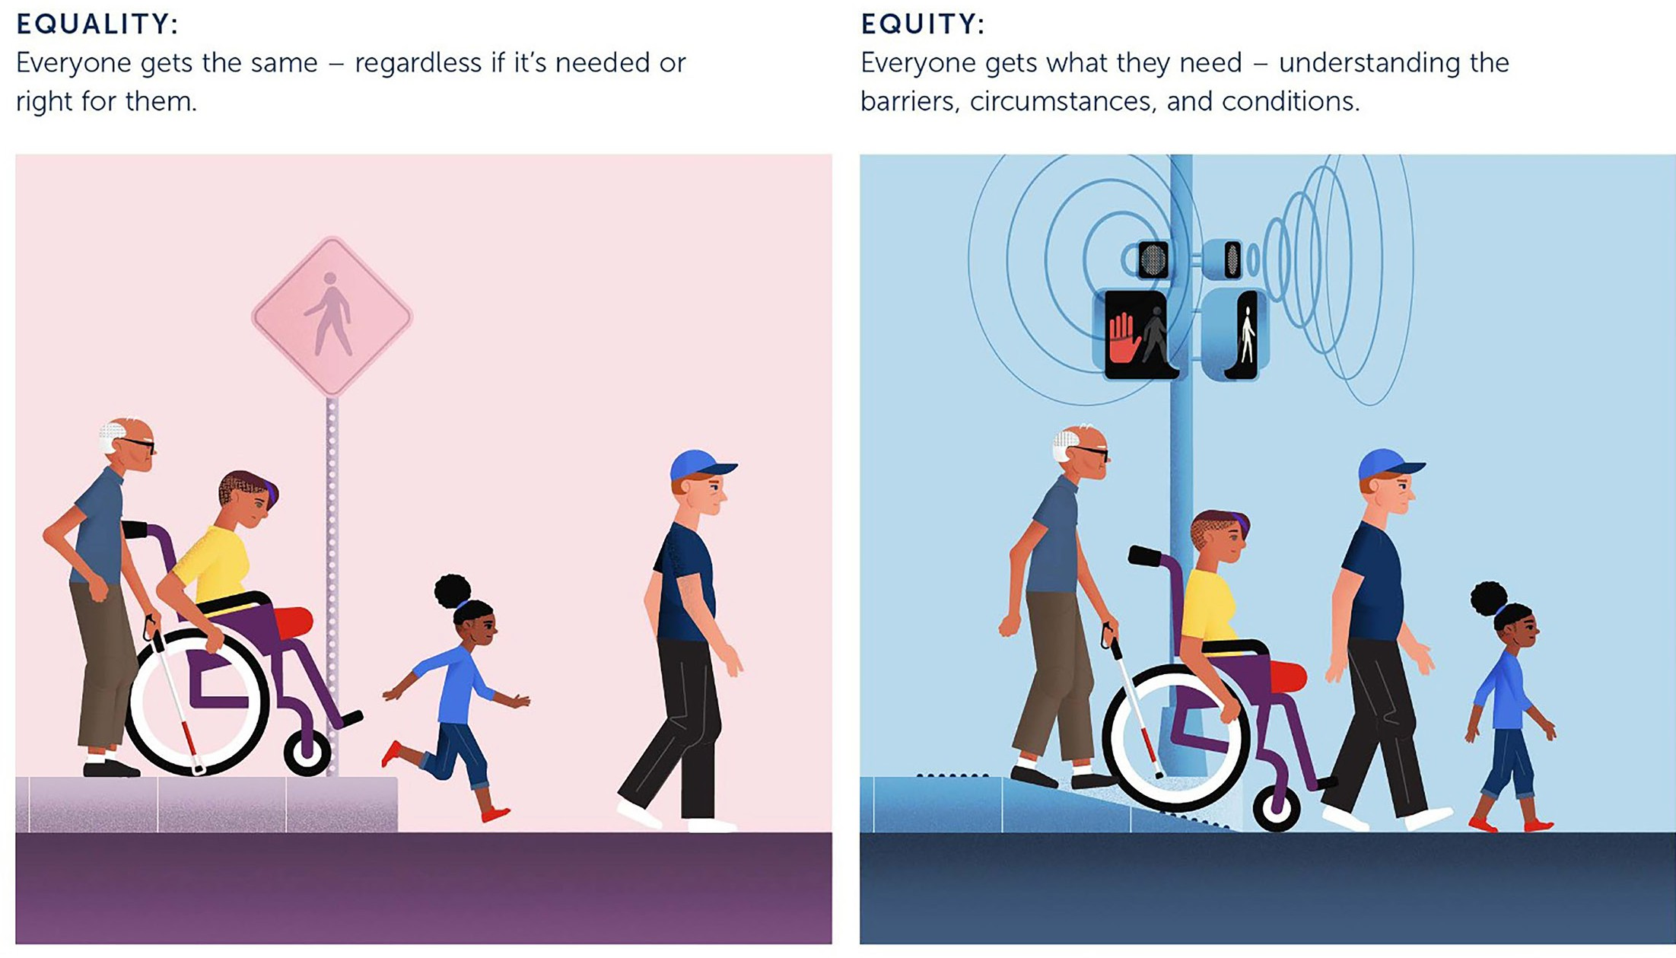
Copyright 2022 Robert Wood Johnson Foundation

Co-design
Co-design is a philosophy that places people at the centre of a design process and as key contributors alongside designers and policy makers. Critically, co-design is a process to achieve universal design.

Human rights
Human rights are the basic entitlements of everyone regardless of their background, ability, what they look like, what they believe or any other status or characteristic. Human rights principles uphold the dignity, equality, and respect of all individuals, including those for whom society currently presents barriers to their full participation.

Social model of disability
Social model of disability supports the view that people with disability have a right to be fully participating citizens on an equal basis with others. A social model perspective does not deny the reality of impairment nor its impact on the individual. However, it does challenge the physical, attitudinal, communication and social environment to accommodate impairment as an expected part of human diversity.

Under this model, society should change to accommodate people living with impairment; people with impairment do not need to be changed to participate in society.

Commitments

Grow mindset, capability, and culture

What we heard during the co-design process

Attitudes and behaviour matter
- Kindness and care make a difference when accessing transport. The attitudes and behaviours of transport staff and community members has a meaningful impact.
- All TMR employees and delivery partners need the skills and commitment to contribute to access and inclusion.
- More consistency in positive driver behaviour is needed in taxi, rideshare and bus services.

Employees want increased diversity, knowledge, and capability
- Employees value the support of executive leadership for access and inclusion.
- Increase capability to understand equivalent access and how to achieve functional outcomes.
- Efforts are needed to grow workforce diversity.

Customers and employees told us:
- ‘It makes such a difference when the public are helpful to each other’.
- ‘Ensure the public transport operators (i.e. bus drivers) make the person who has accessibility needs feel welcome and not a problem nor hindrance’.
- ‘You really need to change the attitude of people using the network, until you change that it is always going to be difficult. There is no use having accessibility options if you can’t use them because able bodied people are using them’.
- ‘I’m always assisted with a ramp to get on train and asked which station I will be getting off to contact that station to have ramp ready for me to use. It is such a joy to use the train network’.

Our commitment: to grow mindset, capability, and culture.
Develop a strong culture of accessibility awareness in all layers of the transport network; and drive mindset change to make inclusion part of core business.

Ensure all employees and delivery partners have the capability and commitment to contribute to accessibility and inclusion.

Increase the understanding that kindness and care shown by employees and community members can have a positive impact on the experience for all people during their journeys.

Our key actions
- Promote public attitudes of kindness and respect by commissioning a community campaign, to include TMR and service delivery partners, that actively promotes kindness and care for all users of transport.

- Develop and implement a TMR Inclusive Precincts Guide, including how to practically apply the equivalent access process to achieve the most functional outcomes for customers. This will also embed the updated DSAPT standards, processes, and procedures into practice.

- Provide tools, resources, and training to support our people with digital accessibility products, technology, and capability uplift.

- Explore opportunities to upskill employees in accessibility and inclusion through an accessibility and inclusion (A&I) Change Champion Community of Practice, sharing key information and learnings from A&I programs, and training in TMR A&I tools, resources, and guidelines.

Outcome
TMR employees and delivery partners have the skills, capability, and mindset to provide accessible, dignified, and inclusive experiences for customers.

Embed accountability

What we heard during the co-design process

Accessibility and inclusion accountabilities need to be clearer
- Customers want everyone to know their accessibility obligations, to make sure they are implemented, and to have confidence that we do what we say we will.
- Build capability of staff, and managers in particular, to better understand inclusion and to lead and behave in an inclusive manner.
- Ensure every service, team, and role knows and is accountable for their obligations and who is responsible for what outcomes.

Monitor customer feedback and measure successes and failures
- Treat complaints as opportunities to improve and inform the entire system and compliments as guidance on how to continue the process.
- Use data and evidence to make decisions.
- Measure and share successes and failures.

Customers and employees told us:
- ‘We know things breakdown – but we want to be informed about why or if they don’t know what’s going on – tell us that! Tell us what you know – even if you know nothing. Silence just makes it worse’.
- ‘We have different partners for different assets or infrastructure. The public don’t care who’s in charge of what. We have to find the best way to improve the whole journey for everyone, in an integrated way’.
- ‘TMR “says” they’re doing things to be inclusive, but this actually differs so much depending on your branch, area and manager. Regardless of policy managers make their own rules and if you don’t want to rock the boat you just have to go along with these rules that don’t align with inclusion & flexibility’.

Our commitment: to embed accountability.
Make sure everyone knows their accessibility and inclusion obligations, and who is responsible for what outcomes.
Ensure our compliance with accessibility requirements/obligations is clear and transparent, to encourage public confidence that we deliver on our commitments.
Measure and share successes and failures. Ensure we optimise the opportunities arising from complaints.

Our key actions
- Develop and implement an Accessibility and Inclusion Organisational Change Plan to embed accessibility and inclusion policies, processes and practices throughout TMR. Make sure everyone within the TMR workforce knows and is accountable for their access and inclusion obligations by clarifying who is responsible for which access and inclusion outcomes by assigning specific roles, outcomes and timeframes to appointed champions, sponsors, reference groups and committees.

- Develop a social impact framework to understand the individual, community and societal benefits that are being returned through investment in accessible and inclusive transport products and services.

- Create an end-to-end process map of TMR’s updated workplace adjustment process which will be made available to all employees.

- Undertake independent research to understand the experience of TMR employees with disabilities and use the recommendations to establish pilots or programs to improve access and inclusion in TMR workplaces.

Outcome
TMR employees and delivery partners understand what their access and inclusion responsibilities are, enabling results to be measured and successes and failures shared.

Commit to accessible and inclusive design

What we heard during the co-design process

People want better information in a range of formats
- Every message needs to be available in a range of ways (visual, auditory, tactile, plain English, multilingual) so people have options on how to access it.
- Information needs to be simplified for everyone, particularly those with lower literacy.
- It needs to be easier to navigate through a more consistent approach to the mode, style and content across every part of the transport network.
- Forms and application processes need to be simplified (for example, applying for the Taxi Subsidy Scheme or requirements to renew a Disability Parking Permit).

Co-design should be considered during every initiative
- Human centred design must be condered from the start.
- All stakeholders need to be involved – customers, employees, technical experts, delivery partners.

Design for the broadest range of people from the beginning
- A single design barrier can stop everything. For example, it can make it too hard to start or complete a journey, leave someone in an unsafe situation when they can’t get to their destination, make it impossible to get a licence, or mean information is out of reach.
- Accessibility standards are considered a minimum requirement as the focus on access moves towards inclusion for all.
- Some modes of transport are consistently better than others because of their design.
- Investment in active travel infrastructure is greatly valued. It increases alternate patterns of travel and contributes to better health, well-being, and community connection.

Customers and employees told us:
- ‘Have people with disability been given the chance to test and report on accessibility features before implementation, and analyse what current systems are not meeting enough needs?’
- ‘Don’t just leave it up to individuals to ask for adjustments that make each building accessible’.
- ‘The CityCat fleet is a game changer! It’s my go-to public transport. The pontoons are accessible. There’s space for mobility scooters and walkers as well as prams and wheelchairs. The toilets are accessible with sliding doors. The new boats have wider walkways. The employees are so friendly and helpful and announce not just what the stop is but also what is in the area’.
- ‘It’s wonderful to have upgrades happening at stops and stations but during construction accessibility is badly affected. It’s important that good alternatives are available’.
- ‘There needs to be ramps and lifts at all stations – both, not either. It sucks to get stuck because of a broken lift’.
- ‘Have all announcements displayed visually, as well as over speaker’.

Our commitment: Commit to accessible and inclusive design.
Accessible and inclusive design is both a mindset and a process and is considered in every transport project and process.
Go beyond compliance with minimum legislated requirements, consider the diverse lived experiences of customers, and create solutions to benefit everyone.
Leverage input from diverse perspectives to improve outcomes.

Our key actions
- Embed universal design in TMR by developing and implementing a universal design policy framework to embed the mindset and action in all policies, projects and processes.

- Improve confidence and capability to undertake co-design throughout TMR by:
  - Promoting the Accessible and Inclusive Design Guide and providing resources and training to staff and delivery partners on implementing these processes.
  - Funding an arrangement to ensure relevant lived expertise, technical capability and other key areas of knowledge and experience can be drawn on by TMR and delivery partners when designing and implementing transport and infrastructure.

- Develop an Accessible and Inclusive Forms Guideline and roll out the implementation of universally accessible forms across TMR.

- Commit to a program to remediate any parts of the website identified as non-compliant during the website audit and maintain required WCAG certification and compliance with the Queensland Government Digital Services Standard. Develop a compliance plan and assurance approach to ensure the accessibility of all TMR communication content and materials is maintained and updated.

Outcome
Universal design is the standard by which TMR employees and delivery partners work and is applied from the start of every new initiative. Customer information and communication is consistent, accessible, and available to all in a range of ways.

Delivering the Strategy
The three key commitments direct a program of work in the action plan. Change will happen through clear and specific activities and projects contained in the action plan to make critical changes and embed them in everything we do.

Roles and responsibilities
Delivery of the strategy requires cohesive and sustained efforts, with clear oversight. Senior leaders are responsible for championing the strategy and action plan, and all employees have a role to play in supporting the goals of the strategy. The individual efforts of champions, advocates, and curious minds across TMR have contributed significantly to our success to date and will continue to be valued. The Accessibility and Inclusion Board is accountable for overseeing the delivery of the strategy.
Executive Leadership Team
- Oversee and set the strategic direction and priorities for inclusion and diversity.
- Assess the enterprise risks and allocate appropriate resourcing to implement the strategy.
- Monitor and oversee the performance of the strategy and action plan.
Accessibility and Inclusion Board
- Advise the Executive Leadership Team on relevant resourcing required to implement the strategy.
- Monitor the implementation of the strategy.
- Advise on the progress of the strategy to the Executive Leadership Team.
Change Champions
- Actively lead and visibly champion relevant employee-led network initiatives, action plans, and events.
- Drive senior leadership conversation on inclusion and diversity.
Leaders at every level
- Champion the goals of the strategy.
- Implement strategies in their areas of responsibility.
- Engage in conversations about inclusion and diversity.

Monitoring progress
This strategy will be measured using a variety of metrics and feedback, including:
- Working for Queensland Survey Results
- Equal Employment Opportunity data
- Accessibility and Inclusion Survey Results
- Australian Network on Disability Access and Inclusion Index data and results
- Workforce diversity targets
- Data collection on compliance with physical and digital product and infrastructure accessibility
- Research and engagement with stakeholders including customers, employees, and delivery partners.

Action Plan Summary
Commitment: Grow mindset, capability, and culture
Actions
- Promote public attitudes of kindness and respect by commissioning a community campaign, to include TMR and service delivery partners, that actively promotes kindness and care for all users of transport and digital services.
- Develop and implement a TMR Inclusive Precincts Guide, including how to practically apply the equivalent access process to achieve the most functional outcomes for customers. This will also embed the updated DSAPT standards, processes, and procedures into practice.
- Provide tools, resources, and training to support our people with digital accessibility products, technology, and capability uplift.
- Explore opportunities to upskill employees in accessibility and inclusion (A&I) through an A&I Change Champion Community of Practice, sharing key information and learnings from A&I programs, and training in TMR A&I tools, resources, and guidelines.

Outcome
TMR employees and delivery partners have the skills, capability, and mindset to provide accessible, dignified, and inclusive experiences for customers.

Commitment: Embed accountability
Actions
- Develop and implement an Accessibility and Inclusion Organisational Change Plan to embed A&I policies, processes and practices throughout TMR. Make sure everyone within the TMR workforce knows and is accountable for their access and inclusion obligations by clarifying who is responsible for which access and inclusion outcomes by assigning specific roles, outcomes and timeframes to appointed champions, sponsors, reference groups and committees.
- Develop a social impact framework to understand the individual, community and societal benefits that are being returned through investment in accessible and inclusive transport products and services.
- Create an end-to-end process map of TMR’s updated workplace adjustment process which will be made available to all employees
- Undertake independent research to understand the experience of TMR employees with disabilities and use the recommendations to establish pilots or programs to improve access and inclusion in TMR workplaces.

Outcome
TMR employees and delivery partners understand what their access and inclusion responsibilities are, enabling results to be measured and successes and failures shared.

Commitment: Commit to accessible and inclusive design
Actions
- Embed universal design in TMR by developing and implementing a universal design policy framework to embed the mindset and action in all policies, projects and processes.
- Improve confidence and capability to undertake co- design throughout TMR by:
- Promoting the Accessible and Inclusive Design Guide and providing resources and training to staff and delivery partners on implementing these processes.
- Funding an arrangement to ensure relevant lived expertise, technical capability and other key areas of knowledge and experience can be drawn on by TMR and delivery partners when designing and implementing transport and infrastructure.
- Develop an Accessible and Inclusive Forms Guideline and roll out the implementation of universally accessible forms across TMR.
- Commit to a program to remediate any parts of the website identified as non-compliant during the website audit and maintain required WCAG certification and compliance with the Queensland Government Digital Services Standard. Develop a compliance plan and assurance approach to ensure the accessibility of all TMR communication content and materials is maintained and updated.

Outcome
Universal design is the standard by which TMR employees and delivery partners work and is applied from the start of every new initiative. Customer information and communication is consistent, accessible, and available to all in a range of ways.

