TMR Governance Framework
  - March 2026
Translating and interpreting assistance
The Queensland Government is committed to providing accessible services to Queenslanders from all cultural and linguistic backgrounds. If you have difficulty understanding this publication and need a translator, please call the Translating and Interpreting Service (TIS National) on 13 14 50 and ask them to telephone the Queensland Government (Department of Transport and Main Roads) on 13 74 68.
Copyright
© The State of Queensland (Department of Transport and Main Roads) 2026. All rights reserved.
Disclaimer
This publication is provided as a source of information only and the State of Queensland makes no statements, representations or warranties about its accuracy or completeness. To the extent permitted by law, the State of Queensland disclaims all responsibility for decisions or actions taken as a result of any data, information, statement or advice, expressed or implied, contained within and excludes all liability (including, without limitation, liability in negligence) for all expenses, losses, damages and costs that may be incurred.
.
Contents

1. Purpose 3
2. Guided by strong principles 3
3. Guided by values 4
4. Our culture 4
5. Structure 5
6. Governance practices 5
7. Internal accountability mechanisms 7
8. External accountability 9
9. TMR structure and leadership 9
10. Accountability model 12
11. Employees 14
12. Review 14

Purpose
The Department of Transport and Main Roads (TMR) delivers reliable, resilient, and responsive transport networks and services that are safe and accessible for everyone. Connecting Communities in a sustainable, thriving, and inclusive Queensland.
Good governance is at the heart of everything we do. The governance framework sets out how we manage performance and operations in line with the Financial and Performance Management Standard 2019. Aligned with ISO standards and the Institute of Internal Auditors’ An integrated governance model the framework drives accountability through clear structures, culture, priority setting, performance, and monitoring. Strong governance and informed decisions ensure we deliver for Queenslanders while meeting all accountability requirements.

Guided by strong principles
The Public Sector Act 2022 sets the foundation for how Queensland’s public sector is managed. The governance framework is built on these principles and the ‘Even Better Public Sector for Queensland Strategy 2024–2028’, ensuring TMR is high-performing, accountable, and trusted to meet the needs of Queenslanders.
We operate with agility, responding quickly to emerging needs and delivering sustainable, timely, and effective outcomes. Cultural capability is central to our approach, embedding respect for diversity and inclusion in every decision and interaction.
Our governance remains fair and transparent, upholding equity and impartiality to maintain stakeholder confidence. We strive for excellence through continuous improvement and efficient use of resources, while safeguarding independence and objectivity so decisions always serve the public interest.
Together, these principles guide our actions and shape a sector that is trusted, effective, and aligned with government and community expectations.

Guided by values
At TMR, we uphold Queensland Government values as the foundation of our culture and decision-making—ensuring integrity, accountability, and respect guide everything we do for the community. These values include:
Customers first
- Know your customers
- Deliver what matters
- Make decision with empathy
Ideas into action
- Challenge the norm and suggest solutions
- Encourage and embrace new ideas
- Work across boundaries
Unleash potential
- Expect greatness
- Lead and set clear expectations
- Seek, provide, and act on feedback
Be courageous
- Own your own actions, successes, and mistakes
- Take calculated risks
- Act with transparency
Empower people
- Lead, empower and trust
- Play to everyone’s strengths
- Develop yourself and those around you

Our culture
Our culture complements our governance values and shapes how we deliver for Queenslanders. It drives good decisions, accountability, and collaboration. Key elements include:

- Accessibility: we provide equal access, participation, and opportunity for all, including people with disability, by removing barriers in our physical, social, and attitudinal environments.
- Safety: is a shared responsibility. Our governance model prioritises protecting all Queenslanders, including children.
- Diversity: we embrace an inclusive workforce that reflects our community, values differences in experience and culture, and strengthens our business.
- OneTMR: as a diverse, geographically dispersed organisation, we respect and protect human rights, act lawfully, ethically, and responsibly and promote unity and collaboration to achieve shared objectives.

Structure
TMR’s Governance framework illustrates how strong governance connects vision to outcomes. Like a bridge spanning a wide gap, it relies on solid foundations and balanced supports to create a stable pathway for connecting people, places, goods, and services safely, efficiently, and effectively across Queensland. Built on integrity, ethics, and accountability, this structure withstands challenges and enables progress toward our objectives.
- Foundations: Integrity, ethics, and accountability anchor the structure, ensuring stability and trust.
- Pillars: Strong leadership and stewardship rise from these foundations, supporting the span.
- Supports: Risk management and stakeholder relationships provide balance and resilience, absorbing pressure and uncertainty.
- Deck: Transparent planning and operations form the pathway, enabling smooth progress toward objectives.
- Cables: Continuous performance monitoring, evaluation, and reporting keep the bridge tensioned and secure.
Together, these elements create a governance structure that is robust, connected, and built to last—delivering confidence and clarity for Queenslanders

Governance practices
TMR’s Performance Management Framework (PMF) is a cornerstone of transparent and accountable operations. It ensures we operate efficiently, effectively, and economically to meet the needs of Queenslanders.
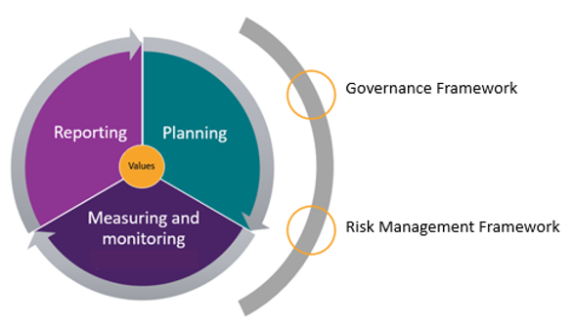
Figure 1 – Performance Management Framework
Key elements include:
- accountability – being liable for decisions and having appropriate mechanisms in place to ensure the department adheres to all applicable legislation, standards, and regulations.
- openness and transparency – open to public scrutiny, having clear roles, responsibilities, and procedures for making decisions and exercising delegations.
- public defensibility – activities and decisions are capable of being defended in argument as fair, equitable and provide value for money.
- integrity – soundness of moral principle and character, acting honestly, impartially, ethically and in the interests of TMR.
- due care – serious attention and diligence expected to be exercised to avoid harm.
The PMF describes how TMR applies the Queensland Government Performance Management Framework in the department’s performance environment. Figure 1 shows the approach taken to planning, measuring, monitoring, and reporting TMR’s performance. It acknowledges that for this to successfully occur accountable governance and effective risk management must be in place.

Internal accountability mechanisms
TMR's governance processes consist of six interrelated functions to ensure control and risk management processes are effectively managed.
These elements are:
- Leadership and strategy
- Ethical standards and values
- Service delivery
- Performance management and evaluation
- Risk management
- Systems and processes
In Table 1 below, governance practices are mapped alongside TMR’s accountability controls which empowers the organisation to meet its performance and compliance requirements.
Internal accountability mechanisms |  |  |  |  |  | 
Internal accountability mechanisms | Leadership and strategy | Ethical standards and values | Service delivery | Performance management | Risk management | Systems and processes
Ministerial Charter letter
State budget
Legal, legislative & regulatory compliance
Delegations
Internal control framework
Risk management framework
Organisational structure
Governance committees
Integrity framework
Whole of government strategies and plans
TMR strategies, plans, and frameworks
Specific purpose plans
Performance management framework
Business continuity and disruption management
Division and branch plans
Policy registers
Mandatory induction program
Financial sustainability plan and principles
Annual report
Stakeholder & community engagement
Table 1: Internal accountability mechanisms

External accountability
Statutory agencies provide assurance of TMR's demonstration of performance, legislative and compliance requirements. Examples of external oversight include:
- Crime and Corruption Commission
- Estimates hearings and other committees of the Queensland Parliament
- Judicial Review of administrative decisions
- Queensland Ombudsman
- Queensland Audit Office
- Queensland Family and Child Commission
- Queensland Human Rights Commission
- Queensland Integrity Commissioner
- Right to Information and the Office of the Information Commissioner.
TMR provides assurance to these entities through TMRs Governance Framework, compliance with legislated obligations, internal controls, provision of evidence, information responses to audits and reviews, and performance, financial and integrity reporting.

TMR structure and leadership
TMR serves as the central authority for delivering regulatory, transport, transport related services, and critical infrastructure across Queensland. This responsibility is supported by a broader governance ecosystem comprising three statutory authorities, four government-owned corporations, and one private company. Together, these entities form an integrated network that ensures the delivery of holistic transport services for the state.
This structure is underpinned by legislated obligations, with each entity operating within a robust governance framework aligned to principles of transparency, accountability, and integrity. The connectedness of these organisations is deliberate and strategic, enabling collaboration while maintaining compliance and independence.
Each entity plays a vital role in supporting the overall transport system:
- TMR provides the foundation, setting policy direction and regulatory oversight.
- Statutory authorities and corporations deliver specialised services and infrastructure.
- The proprietary limited company complements the network, ensuring innovation and flexibility in service delivery.
This interconnected model ensures that Queensland’s transport system is resilient, future-focused, and capable of meeting community needs while upholding the highest standards of governance.

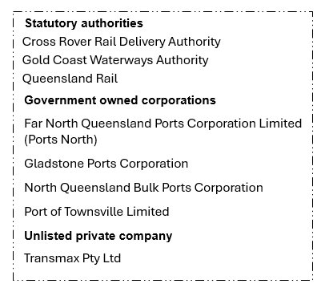
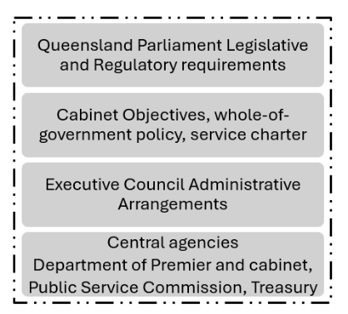
Figure 2 – Queensland’s Transport Network

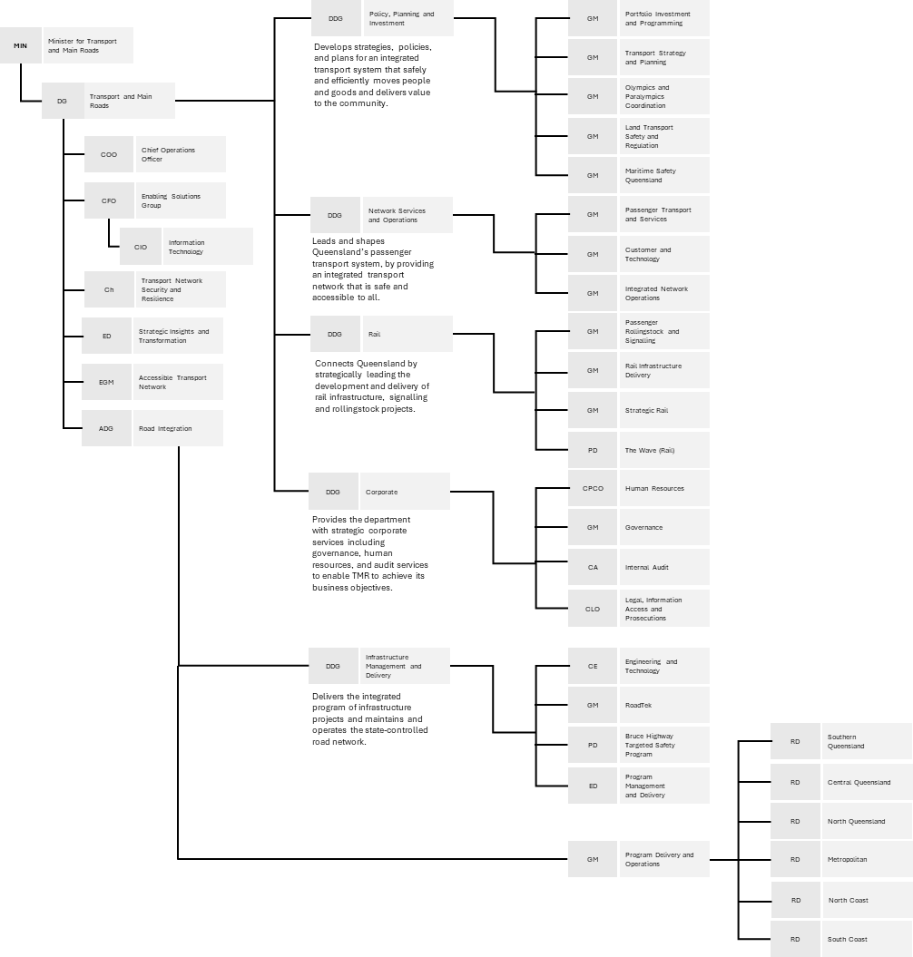
Transport and Main Roads

Title abbreviation
- ADG Associate Director General
- CA Chief Auditor
- CE Chief Engineer
- CFO Chief Finance Officer
- Ch Chief
- CIO Chief Information Officer
- CLO Chief Legal Officer
- COO Chief Operations Officer
- CPCO Chief People and Culture Officer
- DDG Deputy Director-General
- DG Director-General
- ED Executive Director
- EGM Executive General Manager
- GM General Manager
- MIN Minister
- PD Program/Project Director

Accountability model
Director General
The Director-General (DG) of TMR is the accountable officer for TMR under the Financial Accountability Act 2009. The accountable officer is responsible for the effective management and operation of TMR and may delegate functions and powers under Part 5 of the Financial Accountability Act 2009 to appropriately qualified public servants. Further, the DG must discharge their responsibilities in accordance with the Queensland Public Sector Act 2022 and ensure there are internal controls to ensure legislative and regulatory compliance.

Governing committees
Executive Leadership Team (ELT)
The Executive Leadership Team is TMR’s peak policy, priority setting, stewardship, and decision-making authority, with members supporting the DG in the discharge of their responsibilities for TMR.
ELT and its governing committees support the DG in the effective management of TMR's governance practices. The responsibilities of ELT include:
- strategic planning
- resource allocation
- delivering government priorities
- workforce wellbeing, and safety
- strategic policy setting
- performance and risk management
- workforce policy and planning
Five committees support the DG and ELT. The Audit and Risk Committee (ARC) reports directly to the DG to maintain its independence.
Audit and Risk committee (ARC)
The DG appoints the members of the Audit and Risk committee to provide independent oversight of TMR's financial statements and internal controls, compliance with legislative and regulatory requirements including TMR's ethical standards and policies, the process relating to internal risk management and control systems, and the performance of the internal audit function.
The committee is comprised of external members, including the Chair.

Finance and Procurement committee (FaPcom)
The Finance and Procurement committee monitors performance and seeks robust justification for all matters with budgetary implications, to achieve reasonable value for money in accord with the Financial Accountability Act 2009 and Financial and Performance Management Standard 2009.
FaPcom oversees TMR's procurement function and provides senior executives direction on matters of strategic planning, policy, and compliance.
Information Systems committee (ISC)
The Information and Systems committee is the peak governance committee for all business led-ICT and ICT- enabled investments and implementation of the information security strategy to enable the achievement of information security objectives.
The Committee uses an investment prioritisation framework to ensure value-for-money decision making and recommendations in the delivery of programs and projects.
Infrastructure and Investment committee (IIC)
The Infrastructure Investment Committee is TMR’s peak infrastructure investment decision-making body. It provides oversight of the department’s infrastructure investment strategies enabling the delivery of an integrated transport system.
The Committee is responsible for providing strategic alignment, effective resource, investment, and risk management and monitoring of performance to achieve benefits realisation.
Commercialised RoadTek Advisory Group (CRAG)
The Commercialised RoadTek Advisory Group ensures that RoadTek is strategically aligned with TMR and continues to deliver and respond in line with the department and government expectations. It reports to the Executive Leadership Team (ELT) and advises on strategy and commercialisation framework compliance for ELT approval.
Each committee has its own charter which outlines its purpose, members, authority, accountabilities, and reporting requirements. The committees undertake periodic reviews to ensure they remain effective, efficient, and aligned with their purpose, and function as intended.

Employees
All employees contribute to TMR's governance and are entrusted with sufficient authority to conduct their work, based on the respective functions and delegated responsibilities.
Maintaining strong governance practices, conducting themselves in compliance with the Public Service Code of Conduct, audit trails and record keeping ensures TMR complies with our internal control mechanisms to satisfy its legislative, regulatory and whole-of-government requirements.

Review
This framework will be reviewed as required to reflect changes in structure, systems, and practices in TMR's governance. The review will be coordinated by Governance Branch, Corporate Services division, prior to DG approval.

AS ISO 31000:2018 Risk Management, ISO 37000:2021 Governance of organisations, ISO 37301:2021 Compliance Management Systems, Committee of Sponsoring Organisations (COSO) Internal Control (2013), COSO Enterprise Risk Management (2017), International Internal Auditing Standards Board (2016).
An Integrated Governance Model, Institute of Internal Auditors, Australia
Performance Management Framework Better Practice Guide, Financial and Performance Management Standard 2019 (section 6) and Financial Accountability Handbook, Queensland Treasury, Public Sector Ethics Act 1994 (section 4), Public Sector Act 2022 (section 39).
Human Rights Act 2019 section 58.
Queensland Government Performance Management Framework Policy
Internal Audit, governance processes.

