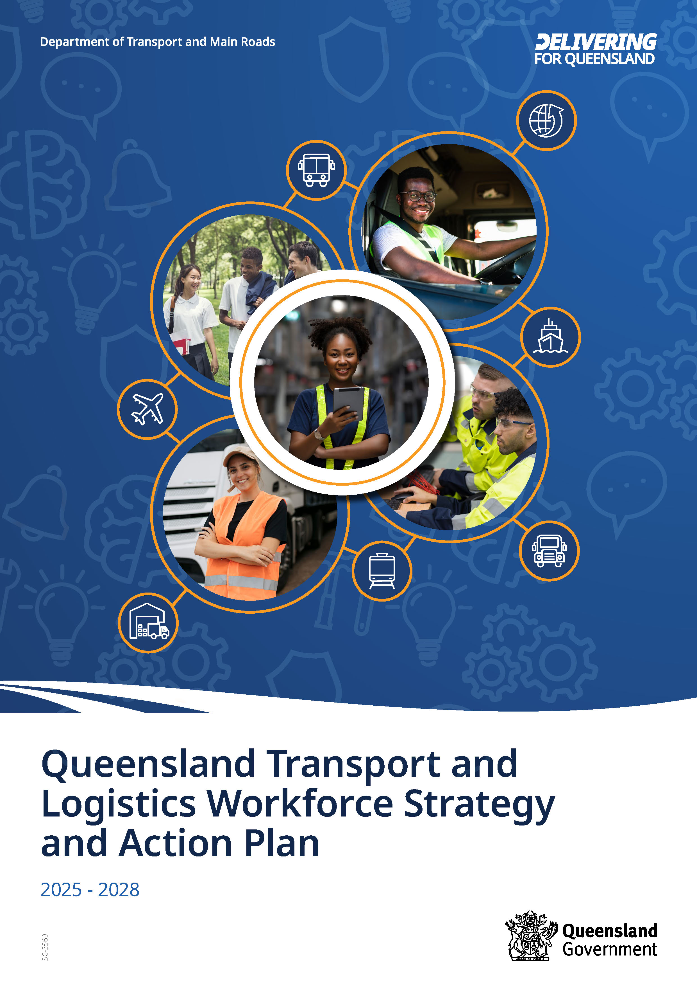

Queensland Transport and Logistics Workforce Strategy and Action Plan
2025 - 2028

Copyright
This publication is protected by the Copyright Act 1968.
© The State of Queensland (Department of Transport and Main Roads) 2025. All rights reserved.

Disclaimer
This publication is provided as a source of information only and the State of Queensland makes no statements, representations or warranties about its accuracy or completeness. To the extent permitted by law, the State of Queensland disclaims all responsibility for decisions or actions taken as a result of any data, information, statement or advice, expressed or implied, contained within and excludes all liability (including, without limitation, liability in negligence) for all expenses, losses, damages and costs that may be incurred.

Interpreter and accessibility services
Translating Interpreter Services (TIS) - 13 14 50

If you are deaf, hard of hearing, or have a speech difficulty please contact us by the National Relay Service (NRS), select NRS call numbers and links and ask for 13 23 80.

Introduction

The transport and logistics workforce delivers essential services for all communities and is critical to Queensland’s economic success.

Every day, thousands of Queenslanders are working together to:
- make sure every Australian has access to goods and services
- connect us to world trade
- improve access to work, health, education, and recreation
- connect people and improve access to services and communities
- give us the convenience of home delivery.

The Queensland Transport and Logistics Workforce Strategy and Action Plan (Strategy and Action Plan) sets out actions for industry and government to maintain a skilled and engaged workforce for the transport and logistics industry across Queensland.

‘The transport and logistics workforce delivers essential services for all communities.’

The Strategy and Action Plan has been developed by the industry, for the industry.

The Transport and Logistics Workforce Advisory Committee (TLWAC) is a group of representatives who are working on behalf of the transport and logistics industry to identify and prioritise workforce solutions for their industry. Representatives are from a cross-section of industry modes and sectors as well as industry associations.

Led by TLWAC, the Strategy and Action Plan was developed by the Department of Transport and Main Roads in consultation with industry stakeholders representing all sectors including, warehousing, road passenger transport, road freight transport, rail, maritime, logistics, and aviation.

Recognising the importance of youth for the future of the transport and logistics workforce, contributors included professionals working with young people in multiple education and training settings, along with specialists in a variety of skilling and employment related fields.

The Strategy and Action plan supports the vision and purpose of the Department of Transport and Main Roads:

- Vision: Connected communities in a sustainable, thriving and inclusive Queensland.
- Purpose: To provide reliable, resilient and responsive transport networks and services that are safe and accessible for everyone.

Our freight system is responsible for moving goods around the state and connecting Queensland with the world. Whether by road, rail, sea or air, freight helps to grow our economy and ensures we have access to fresh produce and the resources we need to maintain a good quality of life.

Workforce context and challenges
Industry representatives and other stakeholders reported their current workforce challenges. Research and labour force data also confirm the challenges that continue to impact the transport and logistics workforce:
- Limited awareness of transport and logistics careers in the community, including amongst young people and those assisting them with career planning.
- Limited understanding in the community about roles in the industry with high levels of responsibility and professionalism.
- An ageing workforce.
- Persistent skill shortages in several specific occupations.
- Many more men than women in the workforce.
- Ongoing pace of change across multiple domains, including technological and social.
- Barriers to licencing.
- Evolving expectations of the emerging workforce regarding communication preferences and work-life balance.
- Navigating the complexities of workforce management in a 24/7 industry, while addressing employee expectations regarding flexibility. Seasonal fluctuations are also a challenge.
- Competing with other industries offering attractive salaries and benefits.

By the numbers

This labour force information for workers in transport, postal and warehousing (TPW), is based on data from the Australian Bureau of Statistics, 2024.

TPW workers comprise approximately 5 per cent of the total Queensland workforce, or 8 per cent including workers performing transport and logistics roles inside other industries.

Occupation shortages
- Several professional and trade transport and logistics occupations feature in the Occupation Shortage List for Queensland.
- Truck, bus and coach drivers are all on the national shortage list.
- The high proportion of road transport related roles in the TPW workforce (45 per cent) highlights the impact of these shortages.

The ageing workforce
- The median age of the Australian TPW workforce is 42.9 years. The median age of the total workforce median is 38.9 years.
- 25.3 per cent of the Australian TPW workforce is aged 55 years and above. For the total workforce, 19.6 per cent is aged 55 years and above.
- Almost one quarter of storepersons are aged 15–24 years, and almost half are aged 34 years and younger.
- This highlights the importance of entry level warehousing as a pathway into the industry, and the value of visible progression pathways to encourage retention.

Full-time
- In Queensland, men hold 80 per cent of TPW roles in comparsion to 60 per cent of the total workforce.
- In Queensland, women hold 20 per cent of TPW roles in comparison to 40 per cent of of the total workforce.

Part-time
- In Queensland, men hold 60 per cent of TPW roles in comparison to 32 per cent of the total workforce.
- In Queensland, women hold 40 per cent of TPW roles in comparison to 68 per cent of of the total workforce.

Gender balance
- Men feature significantly more than women in the TPW workforce at a ratio of four to one for full-time roles, and three to two for part-time roles.
- For the total workforce (across all industries), the full-time ratio of men to women is three to two, while women occupy more than twice the number of part-time roles as do men.

Road transport and driving roles
- Road transport enterprises account for around 45 per cent of employment in the Queensland TPW sector.
- Truck drivers represent the largest portion of driving roles. Storepersons also represent a significant portion of this workforce, and serve as a key entry point to the broader industry (refer to Figure 1).
- These roles are a primary focus for entry pathways.

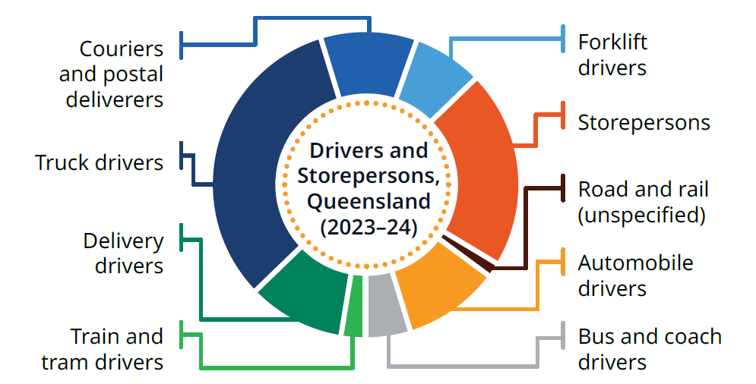

Figure 1: A doughnut graph representing nine types of driving roles in Queensland, and the approximate proportion of each type. Truck drivers represent a significant proportion, closely followed by storepersons. The proportion of the other seven roles in descending order are automobile drivers, delivery drivers, couriers and postal deliverers, forklift drivers, bus and coach drivers, train and tram drivers and road and rail (unspecified).

A key theme

Intergenerational teams and employee engagement

The industry has identified the challenge of working with and attracting/retaining talent from different generations—revealing a key employee engagement consideration.

The presence of multiple generations in the workplace is not new; nor are the challenges of working together.

However, according to (Renton and McCrindle, 2024), today’s increasing pace of change requires workers to navigate complex generational differences. But there are also valuable opportunities to be found:

- Thriving intergenerational teams can increase adaptability, innovation and resilience.
- Creating opportunities to learn from one another can improve attraction and retention of workers from emerging generations, while honouring and harnessing the wisdom and experience of established generations.
- Mutual understanding and appreciation between generations, can pave the way for individuals to contribute their unique strengths towards the organisation’s success.

While there are certainly differences, workers from all generations share the desire for trust, meaningful work, flexibility, and approachable leaders (Renton and McCrindle, 2024).

Intergenerational teams whose members can learn with and from each other, can be pivotal to their organisation’s success. In a learning organisation, ’people continually expand their capacity to create the results they truly desire‘ (Senge, 2006).

Timeless wisdom

’Every generation imagines itself to be more intelligent than the one that went before it, and wiser than the one that comes after it.’ George Orwell.

’Seek first to understand, then to be understood.’ Stephen Covey.

‘The only sustainable competitive advantage is an organisation’s ability to learn faster than the competition.’ Peter Senge.

The path ahead

The vision is that individuals at every career stage can discover roles in transport and logistics, and then pursue careers in the industry because the work has purpose, is engaging and aligns with their development and lifestyle goals.

To realise this vision, TLWAC and key stakeholders agreed to organise actions into three main focus areas:
- Promote transport and logistics as an excellent career choice, where individuals can build successful, purpose-driven and fulfilling careers.
- Optimise engagement with current and potential employees to maintain a skilled, motivated and available workforce.
- Link with specialists to increase the visibility, availability and accessibility of transport and logistics entry pathways for a wide range of job seekers.

The actions align with the aims of the Good People. Good Jobs: Queensland Workforce Strategy 2022–2032, the Queensland Skills Strategy, and the applicable Industry Skills Australia workforce plans.

‘Our vision is to see a thriving transport and logistics workforce, where young people and others can find a role in the industry, discover the endless opportunities available, and then stay to pursue long-term, rewarding careers. The actions laid out here, provide a game plan for us and our industry colleagues to work towards every day.’ TLWAC Members.

Vision

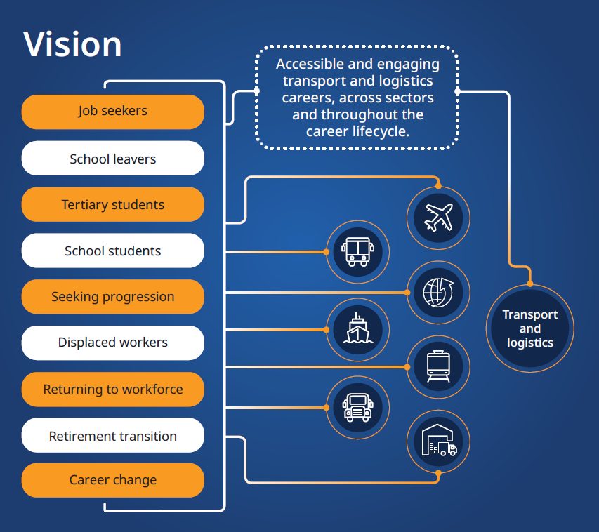
Figure 2: Diagram representing the vision of Accessible and engaging transport and logistics careers, across sectors and throughout the career lifecycle. Nine job seeker groups are listed, with lines representing their possible pathways into seven different sectors in the industry. The job seeker groups are: job seekers, school leavers, tertiary students, school students, seeking progression, displaced workers, career change, retirement transition, and returning to the workforce. The sectors are aviation, road passenger transport, logistics, maritime, rail, road freight transport, and warehousing.

Focus Areas and Actions

Promote
Promote transport and logistics as an excellent career choice, where individuals can build successful, purpose-driven and fulfilling careers.

Actions can include:
- Produce high quality, engaging content to promote industry careers and advertise vacancies on multiple platforms.
- Highlight the essential role of transport and logistics for the community and the economy. Explicitly link industry roles with purpose-driven work.
- Increase the visibility of industry roles across all target audiences by providing multiple career education opportunities to progressively build awareness.
- Highlight the variety of roles, including those requiring a level of complexity and accountability not well understood in the community.
- Showcase stories of people thriving in transport and logistics careers.
- Promote workforce development programs that are successfully addressing transport and logistics workforce challenges.

Engage
Optimise engagement with current and potential employees to maintain a skilled, motivated and available workforce.

Actions can include:
- Highlight the purpose-driven nature of work in the industry, including the essential contribution to community, environmental and social factors.
- Make opportunities for career advancement and growth visible and rewarding. Map career pathways, including career lattices and transferable skills.
- Respond to employee and job seeker preferences regarding job design, flexibility, and workplace culture. Highlight strengths in job advertisements.
- Advocate for training and skilling that is fit-for-purpose, accessible and linked to career pathways. Includes micro-credentials, and initiatives to support heavy vehicle licencing.
- Respond to individuals’ contextual factors that influence workforce participation and engagement. Consider people at all stages of the career lifecycle, members of underrepresented groups, those living in regional and remote communities, and seasonal/mobile workers.
- Adopt practices that facilitate employee wellbeing (physical and psychosocial).
- Create opportunities for existing and potential employees from multiple generations to learn from each other, and value their respective strengths and contributions.

Link
Link with specialists to increase the visibility, availability and accessibility of transport and logistics entry pathways for a wide range of job seekers.

Actions can include:
- Link with education professionals to provide career education experiences and entry pathway opportunities for secondary students and recent school leavers.
- Link with universities to provide career education experiences and entry pathways opportunities for university students.
- Increase visibility of existing entry pathways to expand participation. For example: internship programs, mentoring programs, Heavy Vehicle Driver Apprenticeship, traineeships and apprenticeships, scholarships, graduate recruitment.
- Facilitate new career education opportunities and entry pathways for a variety of job seekers and target audiences.
- Identify and support solutions to common employment or progression barriers. This includes programs to help young people obtain a driver licence.

Making it happen

The 2025–2028 actions will be implemented via a series of events and activities facilitated by:
- TLWAC members
- members of the related Pathways and Attraction Working Group
- TLI Connect
- industry colleagues
- collaboration with professionals working in education, training and employment.

Events and activities will be planned in a variety of locations around the state, including in regional communities. These will be supported by the development and distribution of quality career education resources and promotional content.

Coordinating resources and efforts for activities across the sectors remains a challenge. Success will rely on the active engagement and participation of industry representatives from across the industry and around the state, and on creating additional opportunities for industry to work with education and training representatives.

Dynamic, actively engaged industry groups with expanding membership, a comprehensive annual events calendar, and regular reporting of activities will facilitate tangible progress towards the vision: ‘Accessible and engaging transport and logistics careers, across sectors and throughout the career lifecycle.’

‘We look forward to working with our partners and stakeholders on these actions. We genuinely love working in this industry, and we are committed to building a skilled workforce to keep delivering the services so essential to our communities.’ TLWAC Members.

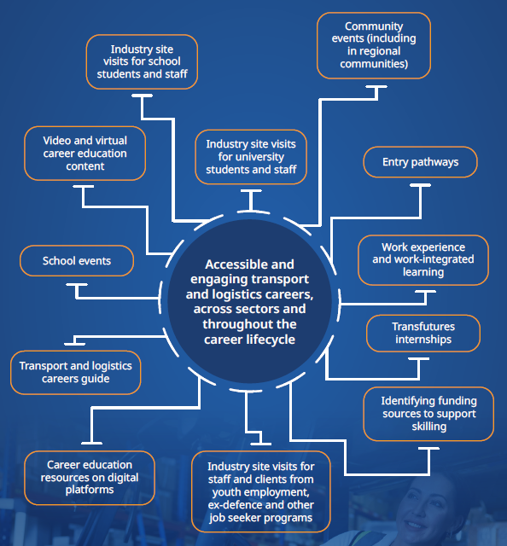
Figure 3: Mind map representing the vision of “Accessible and engaging transport and logistics careers, across sectors and throughout the career lifecycle”, with twelve examples of activities included. The activities are: industry site visits for school students and staff, industry site visits for university students and staff, community events (including regional communities), entry pathways, school events, work experience and work-integrated learning, transport and logistics careers guide, Transfutures internships, career education resources on digital platforms, identifying funding sources to support skills, industry site visits for staff and clients from youth employment, ex-defence and other job seeker programs.

References

Australian Bureau of Statistics. (2024, September). Labour Force, Australia. ABS. https://www.abs.gov.au/statistics/labour/employment-and-unemployment/labour-force-australia/latest-release.
Australian Government, Jobs and Skills Australia. (2024). Occupation Shortage Analysis. Jobs and Skills Australia. https://www.jobsandskills.gov.au/data/occupation-shortages-analysis
Covey, S. R. (1989). The seven habits of highly effective people: Restoring the Character Ethic. New York, Simon and Schuster.
Department of Employment, Small Business and Training. (2022). Good people, Good jobs: Queensland Workforce Strategy 2022-2032 [Report]. Queensland Government. https://www.publications.qld.gov.au
Department of Employment, Small Business and Training. (2024). Good Jobs, Great Training: Queensland Skills Strategy 2024 – 2028 [Report]. Queensland Government. https://www.publications.qld.gov.au
Department of Transport and Main Roads. (2019). Queensland Freight Strategy. Queensland Government.
Department of Transport and Main Roads. (2020). Queensland Freight Action Plan 2020–2022. Queensland Government.
Department of Transport and Main Roads. (2022). Queensland Transport and Logistics Workforce Marketing Strategy 2022-2024. Queensland Government.
Department of Transport and Main Roads. (2020). Queensland Transport and Logistics Workforce Strategy and Action Plan 2021–2024. Queensland Government.
Orwell, G. (1945). [pseud. of Eric Arthur Blair]. Review of a coat of many colours: Occasional essays by Herbert Read, Poetry Quarterly (Winter 1945).
Renton, S. and McCrindle, M. (2024). Cultivating Healthy Intergenerational Teams. Norwest, McCrindle Research.
Senge, Peter M. The Fifth Discipline: The Art and Practice of The Learning Organization. New York, Doubleday/Currency, 1990.
Seawright, S. (2009). Influencing Career Development Commitment with Employers and Individuals. Australian Journal of Career Development, 18(3), 65-67.

