Personalised Transport Security Camera
Status Lights (07.25)
Approved Security Camera Systems
The following security camera systems are approved by the Department of Transport and Main Roads (TMR):
- Mark 5 TaxiCam (VerifEye/Lytx)
- SnapShot Mark 4 with internal camera model PV3006-001 (MTData/MTI)
- SnapShot Mark 4 with internal camera model PV3006-002 (MTData/MTI)
- TaxicamHD Mobile CCTV System (Taxicomms)
- Streamax (G60DT) X5-Lite
- Streamax (G60DT) X5-Lite V2
- Streamax (G60DT) X5-Lite Mini
- 13CABSi (Taxitech)
- Crown Cabs Camera Mark 1
Notes:
- Only approved security cameras in a personalised transport vehicle may face inwards to record the driver or passengers while a personalised transport service is being provided.
- Externally focused forward or rear facing cameras are allowed in all personalised transport vehicles, however, these cameras must not record images or audio of persons inside the vehicle. Camera specifications and the download of images from these cameras are not regulated by TMR.
- If a security camera system is faulty, it is the operator’s responsibility to inform TMR that the system is not fully operational and to arrange for the system to be fixed or replaced. A Fault Notification Form (F4760 ) must be sent to TMR and kept in the vehicle while the system is not operational. The fault notification form is valid for four days following the latter of either the date TMR is informed or the start date provided on the notification.

The information overleaf aims to help identify the operational status of an approved personalised transport security camera system using the visual indicator lights. Further information regarding the personalised transport security camera scheme is available here.
Mark 5 TaxiCam (VerifEye/Lytx)
SnapShot Mark 4 (MTData/MTI)
The camera system is not fully operational if the visual indicator status light display is:
Verifeye MTData/MTI
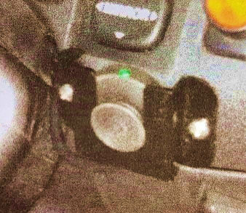
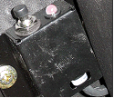
Blinking Red; or
Red and Green
Not illuminated (no light)

TaxicamHD Mobile CCTV System (Taxicomms)
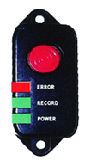
The camera is working properly and recording when both the power and
recording LED lights are lit green.

When the camera is asleep the recording light will not be lit. It will take up
to 30 seconds for this to become lit after the vehicle ignition is turned on.
If no LEDs are lit the power maybe disconnected.
If an Error LED is lit RED or the Record LED is amber a fault may have occurred.

Streamax systems
Streamax (G60DT) X5-Lite
Streamax (G60DT) X5-Lite V2
Streamax (G60DT) X5-Lite Mini

Indicator Light Meaning
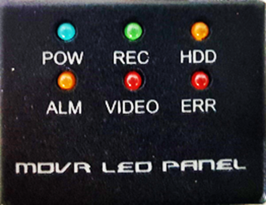
POW Power light
REC Indication that the unit is recording footage
HDD* Indication that the HDD is working correctly
ALM An alarm is triggered
VIDEO* Video loss (camera is no longer displaying video)
ERR Error with the system or camera
*Applicable for older indicator only.
*For newer indicator, PWR and Green lights only indicate system working, any other lights indicate a fault.
13CABSi (Taxitech) & Crown Cabs Camera Mark 1
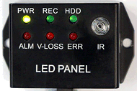
Indicator Light Meaning
POW The unit has power
REC The unit is recording footage
HDD The HDD is working correctly
ALM An alarm has been triggered
VIDEO Video loss (Camera has not been detected)
ERR Error with the system, GPS or camera

Crown Cabs Camera Mark 1

Indicator Light Meaning
If the MDVR system is working correctly, ‘PWR’, ‘REC’ and ‘HDD’ lights should always be lit.
PWR – Green Light
REC – Orange Light
HDD – Orange Light

Camera missing (video loss) – VLOSS and ALM to stay flashing.

GPS (no signal) – ERR to stay flashing.

System fault (the cameras have stopped recording to hard disk) – ERR to stay flashing, HDD off, REC off.

