How to set-up and access Accelerate as an external user

- You will first need to self-register using the below link https://learn.accelerate.tmr.qld.gov.au/login/signup.php?
- Complete all mandatory fields to create a new user account, then select Create my new account.
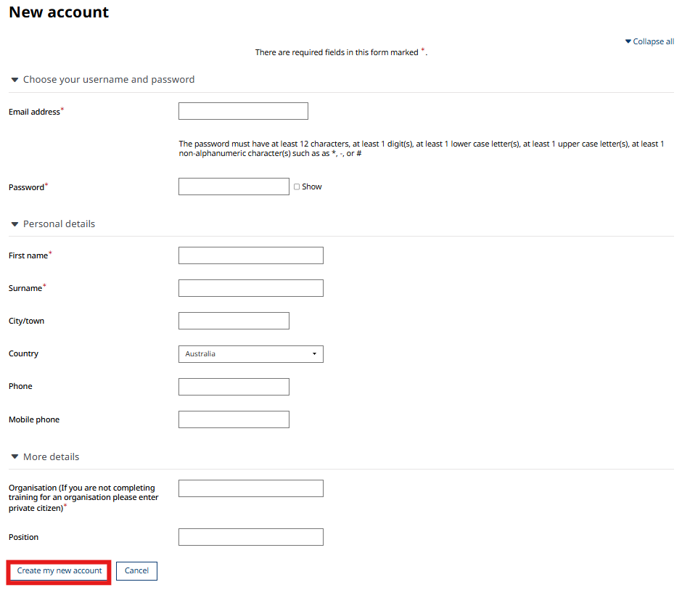

- A confirmation message will appear advising that further instructions have been sent to your nominated email address. Select Continue.


- Open the email received from the Accelerate team and select the registration link to complete your account setup.
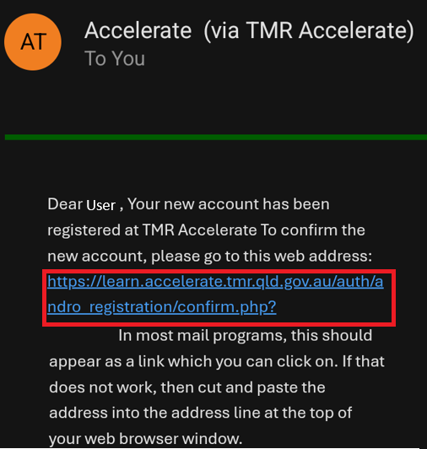

- Once registration is complete, select Continue.
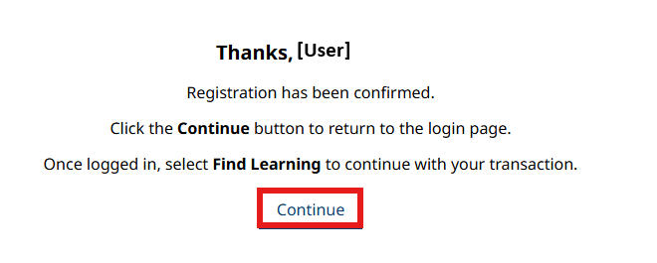

- If you are not automatically taken to the sign-in page, select Sign in located at the top-right corner of the Accelerate page.

- On the sign-in page, select External users.
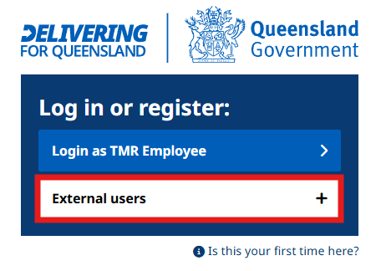

- Log in using your registered email address and password.
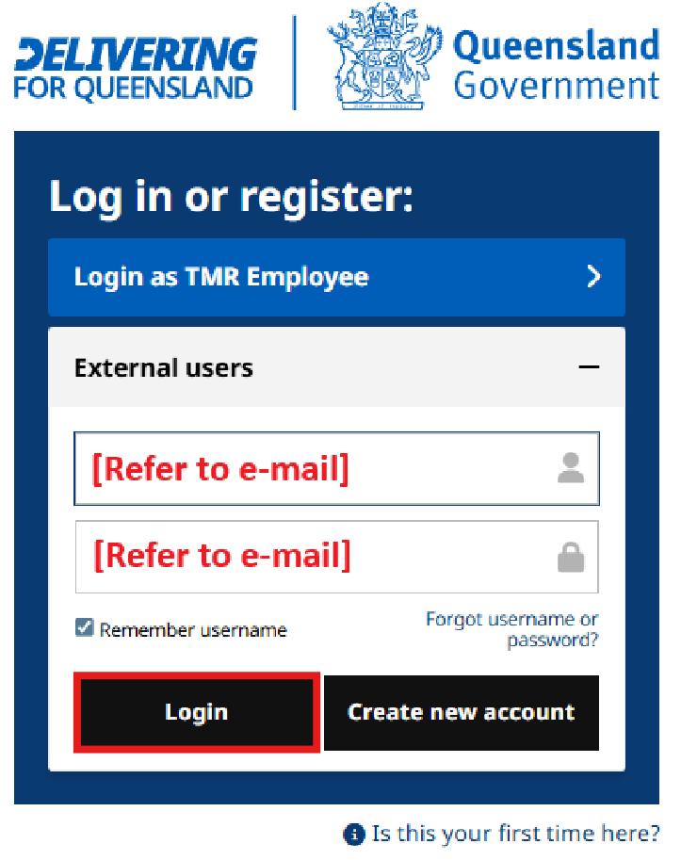
- Once signed in, locate your e-learning course by expanding the Explore dropdown menu and selecting Public Catalogue.
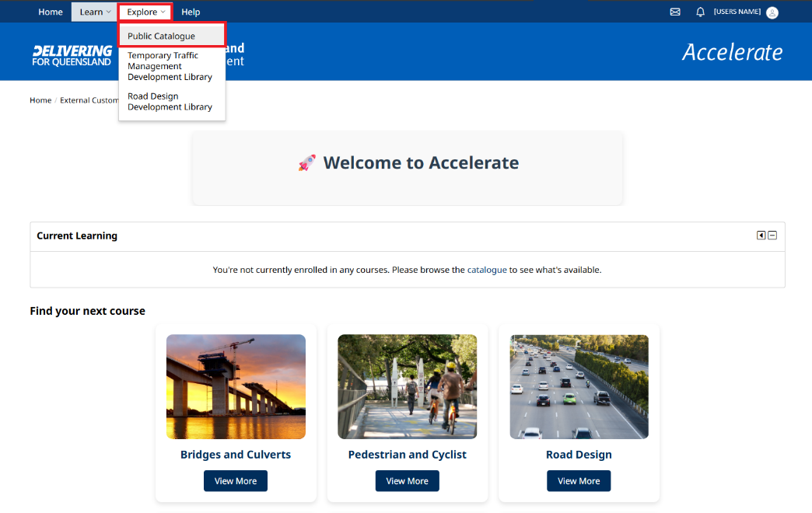
- In the search field, enter the name of the required course and select Search.
(example shown is online cultural heritage induction)
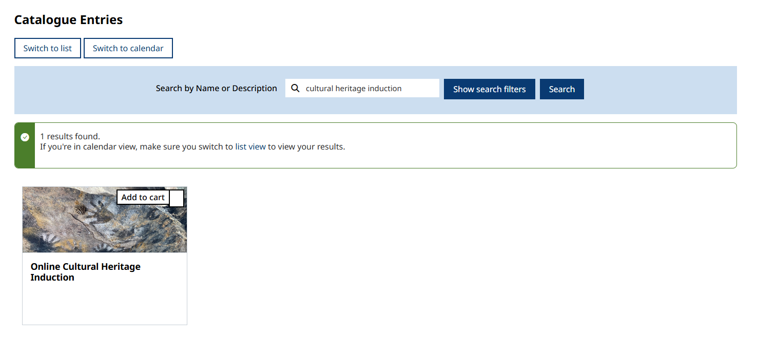
- Select Add to cart. A tick will appear to confirm the course has been added.

- Once the course has been added to your cart, a new window will appear, allowing you to enrol in the course.
  - Tick the Enrol myself checkbox.
  - Select the Enrol button once it becomes available.
Note: if your course requires payment your button will display as “Buy and enrol” which will then take you through to finalise payment before the course will be enabled.
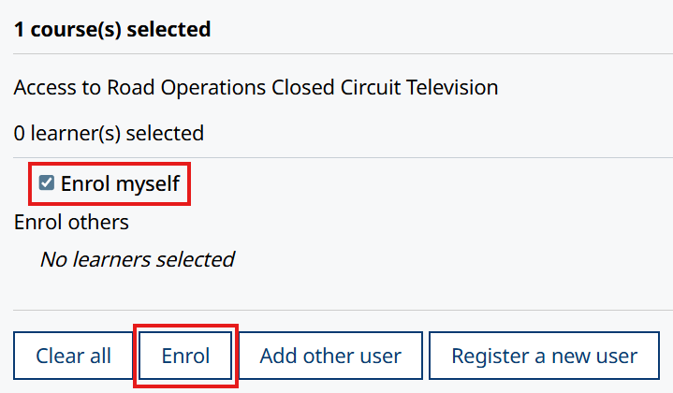
Online Cultural heritage induction
- The course will now be enabled for completion. Select the course to expand the details, then select Go to course.
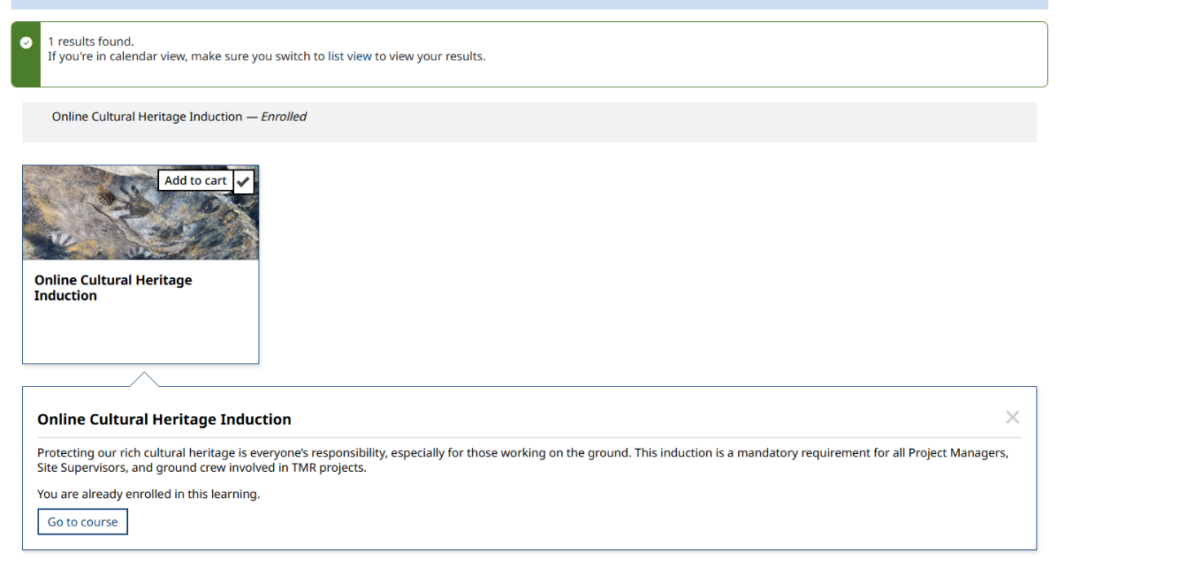

- Select Launch Course to commence the course.

