Waste 2 Resource – annual status report
  - September 2025
Translating and interpreting assistance
The Queensland Government is committed to providing accessible services to Queenslanders from all cultural and linguistic backgrounds. If you have difficulty understanding this publication and need a translator, please call the Translating and Interpreting Service (TIS National) on 13 14 50 and ask them to telephone the Queensland Government (Department of Transport and Main Roads) on 13 74 68.
Copyright
This publication is protected by the Copyright Act 1968. © The State of Queensland, 2025.
Disclaimer
While every care has been taken in preparing this publication, to the extent permitted by law, the State of Queensland accepts no responsibility and disclaims all liability (including without limitation, liability in negligence) for all expenses, losses (including direct and indirect loss), damages and costs incurred as a result of decisions or actions taken as a result of any data, information, statement or advice, expressed or implied, contained within. To the best of our knowledge, the content was correct at the time of publishing.
Contents
Waste 2 Resource – annual status report 0
Executive summary 3
Introduction 5
Targets 5
Waste reporting 7
Waste reuse and recycling 12
Using recycled materials 15
W2R Strategy implementation 18
Appendix A: Department of Environment and Science State Entity Reporting Template 19

Executive summary
The Department of Transport and Main Roads’ (TMR) current Waste Reduction and Recycling Plan, the Waste 2 Resource Strategy, was published in 2022. It sets out the strategy for TMR to reduce waste and to monitor waste generation and diversion from landfill.
Figure 1 and Table 1 below provides a summary of the waste data for the 2024–2025 reporting year and the following report outlines how these outcomes were achieved. The downward trend in the diversion rate in recent years is linked to the diversion rate of excess earthworks, including embankment and fill. Further investigation is necessary to understand this trend.

Figure 1: Annual trends.
Waste stream | Generated  (t) | Diverted  (t) | Landfilled  (t) | Diversion rate
Excess earthworks / embankment / fill | 956761 | 742972 | 213789 | 78%
Asphalt and profiles (RAP) | 159057 | 127207 | 31851 | 80%
Regulated waste cat 2 | 137737 | 119473 | 18263 | 87%
Other recovered pavement materials | 98632 | 95561 | 3071 | 97%
Concrete | 82977 | 71156 | 11821 | 86%
Acid sulphate soil | 39231 | 39231 | 0 | 100%
Vegetation | 23007 | 17414 | 5594 | 76%
Other construction waste (timber, glass, plastic, bricks) | 12220 | 6532 | 5687 | 53%
Other contaminated earthworks | 8671 | 3000 | 5671 | 35%
Metal | 4675 | 2968 | 1706 | 63%
Office - recyclables | 354 | 277 | 76 | 78%
Office - paper | 190 | 186 | 4 | 98%
Tyres and rubber | 140 | 85 | 54 | 61%
General refuse | 5057 | 31 | 5026 | 1%
Office - general and foodwaste | 1073 | 17 | 1055 | 2%
Regulated waste cat 1 | 162 | 1 | 161 | 1%
Illegally dumped refuse | 5387 | 0 | 5387 | 0%

Table 1: Annual TMR Waste Data Summary 2024–2025 in tonnes.

Introduction
TMR is a large, complex, diverse, and decentralised organisation, responsible for the management of different modes of transport including motor vehicle, rail, bus, bike, pedestrian, personal mobility devices and boating. TMR operations include the construction and maintenance of linear transport infrastructure, transport and office facilities, public rest areas, and customer service centres all of which generate a wide variety of waste streams due to the diversity and scale of operations.
The Queensland Government has a vision to become a zero-waste organisation, where waste is avoided, reused, and recycled to the greatest extent possible. The 2020 Waste Management and Resource Recovery Strategy (WMRRS) released by the Department of Environment and Science identifies strategic targets that support this vision.
Queensland’s Waste Reduction and Recycling Act 2011 also imposes a requirement on each Queensland Government department to develop a Waste Reduction and Recycling Plan and to report on waste management achievements.

Targets
The WMRRS identifies four main destinations for waste: landfill, recycling, reuse, and energy recovery. Waste diversion is a measure of waste that is not sent to landfill and includes waste that is sent for recycling, reused, or is used for energy recovery. As TMR does not direct any waste to energy recovery, waste diversion in this report only includes materials that are recycled or reused.
The WMRRS identifies waste diversion and recycling rate targets. Recycling rate targets are based on materials that are recycled or reused. For TMR, waste diversion and recycling rate targets measure the same thing as waste can only be diverted from landfill by either recycling or reusing it. As most waste in TMR is generated from construction and demolition activities, TMR has adopted the waste diversion targets for construction and demolition as described in the WMRRS.

Figure 2: TMR diversion target (WMRRS).

Waste reporting
The following are highlights of the waste data from TMR for 2024–25. There was a slight increase in the total waste generated compared to last year (approximately 100 thousand tonnes). However, there was also a decrease in the diversion rate to 80 per cent in 2024-2025, from 87 per cent in 2023-2024.
The illegally dumped refuse waste stream encapsulates the roadside litter and War on Wrecks (WOW) program. The WOW program is the collection of derelict and illegally dumped vessels from Queensland waterways. Roadside litter includes rubbish from rest stops and rubbish that is left on TMR land and construction sites. The amount of illegal waste and roadside litter collected in 2024-2025 is the same as last year and WOW has increased from previous years. This has resulted in a marked increase in the litter and illegal dumping recorded in 2024-2025.
As TMR's work is civil, most waste is generated by the removal and construction of transport infrastructure.

Figure 3: Performance against diversion target.

Figure 4: Annual trends

Figure 5: Litter and illegal dumping.

Figure 6: Top 5 waste streams generated in 2024–2025.

There was a decrease in the waste diversion rate in 2024–2025 (compared to 2023–2024). The 2024–2025 diversion rate is still largely due to the diversion rate for excess earthworks (see Figure 6) but all the top five waste streams have a diversion rate over 70 per cent. Further investigation is necessary to determine the cause of the dropping diversion rate.
Excess earthworks, including embankment and fill, is the dirt that is removed from site and not required for the construction of the transport infrastructure. The diversion rate for excess earthworks has fluctuated since waste reporting started in 2017–2018 (see Figure 7) and is 78% in the current reporting period. This is the first year that the diversion rate has fallen below 80 per cent however the long-term diversion rate is 86 per cent. If this trend were to continue TMR may not be able to meet the required diversion targets in the future.

Figure 7: Destination of top five waste streams for 2024–2025.

Figure 8: Trend in diversion rate for excess earthworks/embarkment/fill

Case Study 1: Repurposing electrical waste (e-waste)
RoadTek is actively contributing to a more inclusive and sustainable future. The collaboration with the Endeavour Foundation not only promotes environmental sustainability by reducing e-waste but also creates meaningful employment opportunities for people with disabilities, fostering inclusivity and community engagement.
Key highlights of this initiative include:
- Environmental Impact: Recycling 16,648 luminaires and diverting 179 tonnes of material from landfill demonstrates a strong commitment to sustainability. With up to 98% of components being recyclable, this initiative significantly reduces waste and promotes resource recovery.
- Social Impact: By partnering with the Endeavour Foundation, RoadTek provides meaningful work opportunities for people with disabilities, empowering them and enhancing their participation in the workforce. The ability to dismantle up to 80 traffic or streetlights per person per day showcases the efficiency and dedication of the workers involved.
- Community Engagement: This initiative exemplifies how partnerships between organisations can address multiple societal challenges, such as waste management and employment barriers, while fostering a sense of shared purpose.
This initiative truly exemplifies the power of collaboration in driving positive change. By working together, RoadTek and the Endeavour Foundation are not only breaking down barriers to employment but also showcasing the significant contributions that people with disabilities make to our workforce and society.
Diversity and inclusion are more than just ideals—they are actionable strategies that create tangible benefits. Through this partnership, we see how inclusive practices can empower individuals, strengthen organisations, and enrich our communities. It’s a reminder that when we embrace diversity, we unlock potential, foster innovation, and build a more equitable and sustainable future for everyone.
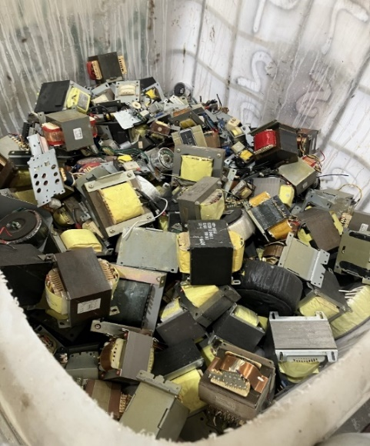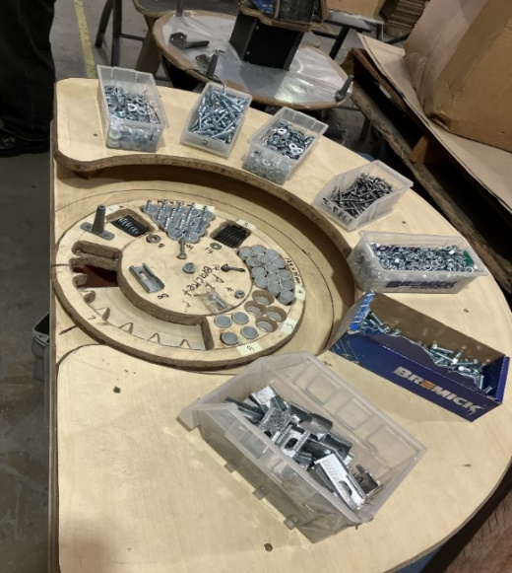
Image: Repurposing traffic and streetlights into recyclability components. Source: TMR.

Waste reuse and recycling
An objective of TMR's Waste 2 Resource Strategy is to support the circular economy, and this can be achieved by directing suitable wastes for reuse and recycling. A waste is reused when no additional processing (other than transporting) is required for it to be productively used again. An example of this is directing excess earthworks from one project to another that needs fill material. A waste is recycled when some processing is required to make it into a usable product, for example crushing concrete to supplement road base materials.
The following are highlights of the waste generated by TMR in 2024–2025 and either reused or recycled. Reuse and recycling are more common along the coastal regions of Queensland due to the current distribution of licenced recycling facilities.

Figure 9: Top 5 reused or recycled wastes.

Figure 10: Reused or recycled wastes.

Case Study 2: The Bruce Highway Upgrade Program – Caboolture-Bribie Island Road to Steve Irwin Way (Exit 163)
Through innovative thinking, local partnerships, and a commitment to sustainability, the project set a new benchmark for integrating circular economy principals into transport infrastructure in Queensland.
Led by the Department of Transport and Main Roads, the upgrade was delivered in two contracts. Contract 1 undertaken by Acciona Infrastructure Projects Australia, covered the section from Caboolture-Bribie Island Road to Pumicestone Road. Contact 2 delivered by Fulton Hogan, extended from Pumicestone Road to Steve Irwin Way (Exit 163). The project expanded 11 kilometres of highway from four to six lanes, upgraded creek crossings and key interchange ramps, enhanced safety, and increased capacity along one of Queensland’s busiest transport corridors.
As part of a commitment to sustainability, Fulton Hogan partnered with local supplier ABFI Steel Group to tackle a common construction challenge: the disposal of steel pile liner offcuts. Typically discarded as scrap, the team returned the offcuts to the supplier, who spliced them for reuse in the second stage of the project.
More than 100 metres of steel offcuts were returned, with nearly 64 metres successfully recycled! This simple shift avoided an estimated 87 tonnes of carbon emissions; equivalent to a passenger vehicle driving more than 345,000 kilometres, reduced virgin steel use by 13.6 per cent and cut transport emissions by backloading the offcuts during deliveries.
This ground-breaking initiative demonstrates how rethinking traditional construction practices can drive meaningful change across the industry. By embracing circularity and collaborating with local suppliers, the project marked a change in how sustainability is integrated into transport infrastructure in Queensland.
It also reflects the TMR project team’s commitment to innovation and collaboration. By fostering strong relationships with delivery partners and local industry, the team created an environment where sustainable solutions could thrive — transforming a simple idea into a measurable environmental outcome.
It also highlights a focus on delivering essential infrastructure that respects environmental values and supports long-term community outcomes. Program Delivery and Operations projects are not just about where roads go, but about how we build them and the legacy we leave behind for communities now and in the future.
That commitment hasn’t gone unnoticed. The initiative was recently featured in the Civil Contractors Federation QLD Winter Magazine (June 2025), page 29, shining a spotlight on what’s possible when innovation and sustainability are at the core of PDO project delivery.
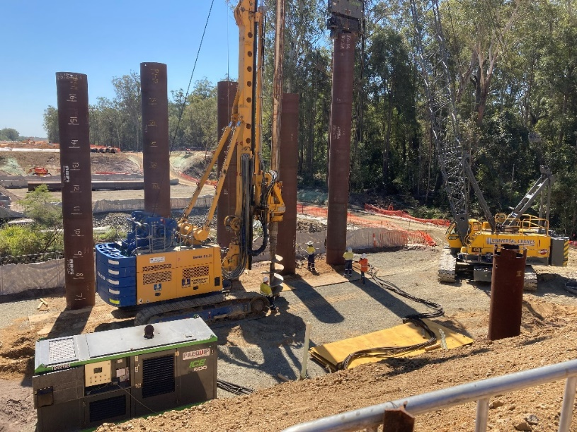
Image 1: Piling underway on a southbound bridge. Source: © Fulton Hogan.
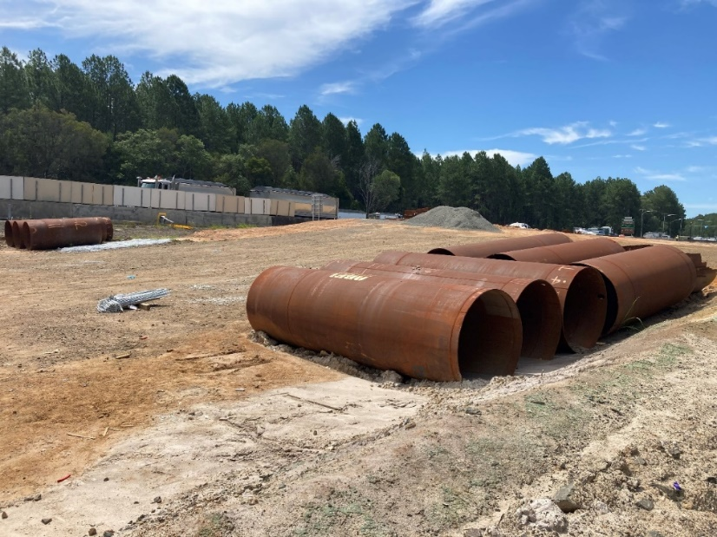
Image 2: Salvaged offcuts were spliced together into complete liners for use on the northbound bridges.
Source: © Fulton Hogan.

Using recycled materials
In addition to collecting information on the destination of wastes that are generated, TMR collects information on the recycled materials used to construct infrastructure. TMR prefers to use recycled materials on transport infrastructure projects, and this is discussed more in the ‘W2R Strategy Implementation’ section.
There was a significant increase in the amount of recycled material reported as used in 2024–2025 (approximately 403,000 tonnes) compared to 2023-2024 (approximately 164,000 tonnes) however this was soley due to the increased use of insitu material in 2024-2025. If insitu material is excluded from the analysis then there was less recycled material reported as used in 2024-2025 (approximately 85,000 tonnes) compared to 2023-2024 (approximately 135,000 tonnes).
The use of recycled materials is more common in South-east Queensland due to the concentration of recycled material suppliers. In-situ materials, or materials already available on site, recovered pavement material and reclaimed asphalt, are the most used recycled materials in 2024–2025. The North Coast Region continues to report the highest use of recycled materials in 2024-2025, as compared to 2023-2024, which was mostly insitu material (approximately 250,000 tonnes).

Figure 11: Annual recycled material use.

Figure 12: Recycled materials used.

Figure 13: Recycled materials for location.

W2R Strategy implementation
TMR's current Waste Reduction and Recycling Plan, the Waste 2 Resource (W2R) Strategy, was published in 2022 and sets out the strategy for TMR to reduce waste and monitor waste generation and diversion from landfill. Previous actions to support the strategy included the publication of the TMR W2R calculator, and a requirement for tenderers on transport infrastructure contracts to submit the Tender Schedule S12 - Waste to Resource Plan.
TMR had no specific actions during 2024–2025 in relation to diversion targets and currently has no specific actions or targets relating to the use of recycled materials.
Consistent with previous years, the main source of waste in 2024-2025 was from infrastructure projects. There has been ongoing work to improve the completeness of contract waste reporting, and this is reflected in the count of contracts contributing to the annual report (see Figure 15). An analysis of the contracts that have submitted contract waste data by the financial year that the contract reached practical completion shows there is still a large gap in the data to be addressed (see Figure 16). Only 41 per cent of contracts that reached practical completion in the current reporting period have submitted waste data.
There was an increase to the total waste generated from TMR facilities in 2024–2025 compared to previous years due to the addition of calculated values for locations without specific data.

Figure 14: Data sources for annual report.

Figure 15: Count of contracts contributing to annual report.

Figure 16: Submission of contract waste data.

Figure 17: Annual trend for facilities waste

Appendix A: Department of Environment and Science State Entity Reporting Template
- Name of the State Entity
Department of Transport and Main Roads
- Please list the types and amounts of waste generated, recycled or disposed of by your department/agency in carrying out its activities during 2024-25.
Table 2: Annual TMR waste data summary 2024–2025.
Waste stream | Generated  (t) | Diverted  (t) | Landfilled  (t) | Diversion rate
Excess earthworks / embankment / fill | 956,761 | 742,972 | 213,789 | 956,761
Acid sulphate soil | 39,231 | 39,231 | - | 39,231
Other contaminated earthworks | 8,671 | 3,000 | 5,671 | 8,671
Regulated waste cat 1 | 162 | 1 | 161 | 162
Regulated waste cat 2 | 137,737 | 119,473 | 18,263 | 137,737
Asphalt and profiles (RAP) | 159,057 | 127,207 | 31,851 | 159,057
Other recovered pavement materials | 98,632 | 95,561 | 3,071 | 98,632
Concrete | 82,977 | 71,156 | 11,821 | 82,977
Metal | 4,675 | 2,968 | 1,706 | 4,675
Vegetation | 23,007 | 17,414 | 5,594 | 23,007
Other construction waste (timber, glass, plastic, bricks) | 12,220 | 6,532 | 5,687 | 12,220
Tyres and rubber | 140 | 85 | 54 | 140
General refuse | 5,057 | 31 | 5,026 | 5,057
Illegally dumped refuse | 5,387 | - | 5,387 | 5,387
Office - general and food waste | 1,073 | 17 | 1,055 | 1,073
Office - recyclables | 354 | 277 | 76 | 354
Office - paper | 190 | 186 | 4 | 190

Table 3 describes how TMR’s waste streams align with the Department of Environment and Science waste classification.

Table 3: TMR waste stream descriptions.
General waste | TMR waste streams | Description
Office waste | Office – recyclables | Mixed recyclables including plastic plates, bottles, aluminium cans etc.
Office waste | Office – paper | Paper and cardboard recyclable waste.
Construction and demolition waste | Excess earthworks/ embankment/fill | Any excess earthworks, embankment or fill generated by a project which is then exported outside the project boundary for either reuse, recycle or landfill beyond the project boundary.
Construction and demolition waste | Other contaminated Earthworks | Any other contaminated earthworks, but not acid sulphate soils.
Construction and demolition waste | Asphalt and profiles (RAP) | Asphalt only (not chip seals and other pavements).
Construction and demolition waste | Other recovered pavement materials | Spray seal pavements, stabilised pavements (not asphalt).
Construction and demolition waste | Concrete | Structural concrete, shotcrete, hardened grout, concrete washout.
Construction and demolition waste | Metal | Signposts, guardrails etc.
Construction and demolition waste | Other construction waste (timber, glass, plastic, bricks) | Any construction waste not accounted for in other construction waste categories, such as uncontaminated timber, glass, plastic and bricks).
Construction and demolition waste | Acid Sulphate Soil | Acid Sulphate Soils.
Construction and demolition waste | General refuse | Cardboard, plastic packaging.
Green waste (land clearance, parks and gardens) | Vegetation | Timber vegetation, stripped grasses etc.
Food waste (kitchen waste) | Office – General and food waste | Putrescibles, kitchen waste, non-recyclable packaging.
Mechanical/workshop waste | Tyres and rubber | Waste tyres.
E-waste | Regulated waste cat 2 | N/A
Chemical wastes | Regulated waste cat 1 | Regulated waste is category 1 regulated waste if it meets the requirements of section 43 of the EP Regulation.
Chemical wastes | Regulated waste cat 2 | Regulated waste is category 2 regulated waste if it is not category 1 regulated waste.
Sewage | Septic general | Septic waste generated by projects.
Litter or illegally dumped waste | Illegally dumped refuse | Waste collected from road reserve.

- Please list actions taken by your department/agency to reduce the amount of waste generated during 2024-25.
TMR took no specific actions in 2024-2025 to reduce waste generated.

- Please discuss actions taken by your department/service to recover, and re-use or recycle waste during 2024-25.
TMR took no specific actions in 2024-2025 to recover, and reuse or recycle waste generated.

- Please discuss actions taken by your department/agency to increase the use of recycled materials during 2024-25.
TMR has continued to use the National Asset Centre of Excellence (NACOE) Program, a collaborative research agreement with the Australian Road Research Board, to conduct research and development on use of recycled materials in infrastructure.

- Please discuss progress made by your department/agency in relation to its waste and recycling performance indicators during 2024-25.
TMR has had a consistently high diversion rate however this has been trending down. This correlates with a fall in the diversion rate in excess earthworks / embankment / fill. There is insufficient data to determine the reason for this reduction in the diversion rate for earthworks / embankment / fill.
If this trend in the diversion rate for earthworks / embankment / fill continues then it is unlikely that TMR will be able to continue to meet the committed diversion targets.

- Please discuss the ways in which your department/agency has contributed towards achieving the goals and targets under Queensland's waste management strategy during 2024-25.
The performance against the targets in the Queensland waste management strategy, are shown in Table 4. There has been a decrease in the diversion rate compared to the last reporting year, however the diversion rate continues to be above the diversion target. TMR has adopted the waste diversion targets for construction and demolition waste as described in 2020 Waste Management and Resource Recovery Strategy.

Table 4: Annual trend – diversion rate and diversion target.
Reporting year | Diversion rate | Diversion target (WRRS)
2017-2018 | 83% | 50.90%
2018-2019 | 69% | 54.30%
2019-2020 | 77% | 57.80%
2020-2021 | 88% | 61.20%
2021-2022 | 91% | 64.70%
2022-2023 | 86% | 68.10%
2023-2024 | 87% | 71.60%
2024-2025 | 80% | 75.0%

A diversion rate of more than 80 per cent has been achieved for the following waste streams:
- Acid sulphate soil
- Regulated waste category 2
- Asphalt and profiles (RAP)
- Other recovered pavement materials
- Concrete
- Office - paper

The total waste generated by TMR in 2024–2025 is 1,535,330 tonnes, of which 80 per cent was diverted (reused or recycled) and remaining 20 per cent was disposed to landfill.

- Please list the amounts and types of litter or illegally dumped waste that were collected by your department/agency during 2024-25.
TMR regularly removes litter and illegally dumped items from the state-controlled road network. Included in this report are the following:

- The cost and amounts of rubbish collected from bins along the road, litter dumped along the road, and other waste that may be dumped adjacent to the road or on other land managed by TMR.
- Estimated weight of vessels removed from Queensland waterways by Maritime Safety Queensland or its compliance partners as part of the War on Wrecks (WoW) Program. Estimates are based on the length of the vessel. The costs have not been included as this information is not collected.

Table 7: Annual trend – litter and illegally dumped waste.
Financial Year | Cost ($) | Mass (tonnes)
2017-2018 | $5,670,602 | 1,743
2018-2019 | $5,770,248 | 1,697
2019-2020 | $4,636,566 | 1,538
2020-2021 | $4,116,861 | 2,387
2021-2022 | $4,479,020 | 2,702
2022-2023 | $4,456,698 | 2,235
2023-2024 | $5,337,544 | 3,705
2024-2025 | $5,130,466 | 5,387

