Waste 2 Resource – Annual Status Report 2023–2024

October 2024

Copyright
This publication is protected by the Copyright Act 1968.
© The State of Queensland (Department of Transport and Main Roads) 2024. All rights reserved.
Disclaimer
This publication is provided as a source of information only and the State of Queensland makes no statements, representations or warranties about its accuracy or completeness. To the extent permitted by law, the State of Queensland disclaims all responsibility for decisions or actions taken as a result of any data, information, statement or advice, expressed or implied, contained within and excludes all liability (including, without limitation, liability in negligence) for all expenses, losses, damages and costs that may be incurred.
Translating and Interpreting Services
 | The Queensland Government is committed to providing accessible services to Queenslanders of all cultural and linguistic backgrounds. If you have difficulty understanding this publication and need a translator, please call the Translating and Interpreting Service (TIS National) on 13 14 50 and ask them to telephone the Queensland Department of Transport and Main Roads on 13 74 68.

Front cover images (left to right and top to bottom): nestbox, rootball and excavator, compacted profilings on haul road, and log pile.
Image source: © The State of Queensland.
Contents
Executive summary 1
Introduction 2
Targets 2
Waste reporting 3
Case study 1: Mackay Ring Road to Bald Hill Connection Road Project 6
Waste reuse and recycling 7
Case study 2: Christmas 2023 storms 9
Using recycled materials 10
W2R Strategy implementation 13
Appendix A: Department of Environment and Science State Entity Reporting Template 16

Executive summary
The Department of Transport and Main Roads’ (TMR) current Waste Reduction and Recycling Plan, the Waste 2 Resource Strategy, was published in 2022. It sets out the strategy for TMR to reduce waste and to monitor waste generation and diversion from landfill.
Figure 1 and Table 1 below provides a summary of the waste data for the 2023–2024 reporting year and the following report outlines how these outcomes were achieved.
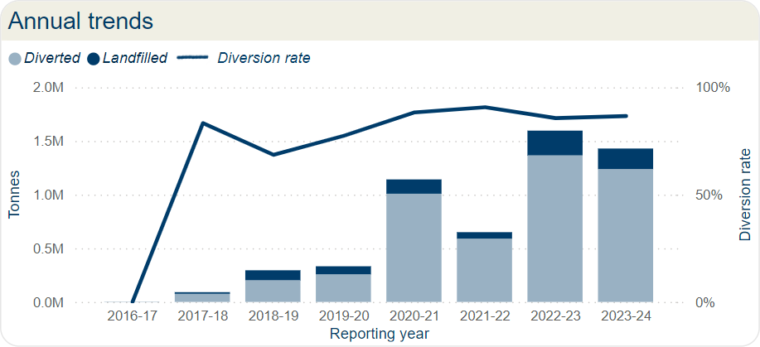

Figure 1: Annual trends.
Waste stream | Generated  (t) | Diverted  (t) | Landfilled  (t) | Diversion rate
Excess earthworks / embankment / fill | 1,102,651 | 981,745 | 119,943 | 89%
Acid sulphate soil | 1,854 | - | 1,854 | 0%
Other contaminated earthworks | 9,700 | - | 9,700 | 0%
Regulated waste cat 1 | 1,227 | 3 | 1,224 | 0%
Regulated waste cat 2 | 1,382 | 359 | 865 | 26%
Asphalt and profiles (RAP) | 160,514 | 133,124 | 31,912 | 83%
Other recovered pavement materials | 15,896 | 15,845 | - | 100%
Concrete | 75,839 | 70,006 | 5,069 | 92%
Metal | 15,818 | 13,838 | 1,968 | 87%
Vegetation | 24,611 | 13,617 | 10,844 | 55%
Other construction waste (timber, glass, plastic, bricks) | 6,811 | 6,772 | 39 | 99%
Tyres and rubber | 166 | 156 | 2 | 94%
General refuse | 6,564 | 2,514 | 2,034 | 38%
Illegally dumped refuse | 4,096 | 13 | 3,711 | 0%
Office - general and food waste | 1,928 | 1 | 1,925 | 0%
Office - recyclables | 298 | 226 | 67 | 76%
Office - paper | 275 | 212 | 60 | 77%

Table 1: Annual TMR Waste Data Summary 2023–2024 in tonnes (highlighted are quantities).

Introduction
TMR is a large, complex, diverse, and decentralised organisation, responsible for the management of different modes of transport including motor vehicle, rail, bus, bike, pedestrian, personal mobility devices and boating. TMR operations include the construction and maintenance of linear transport infrastructure, transport and office facilities, public rest areas, and customer service centres all of which generate a wide variety of waste streams due to the diversity and scale of operations.
The Queensland Government has a vision to become a zero-waste organisation, where waste is avoided, reused, and recycled to the greatest extent possible. The 2020 Waste Management and Resource Recovery Strategy (WMRRS) released by the Department of Environment and Science identifies strategic targets that support this vision.
Queensland’s Waste Reduction and Recycling Act 2011 also imposes a requirement on each Queensland Government department to develop a Waste Reduction and Recycling Plan and to report on waste management achievements.

Targets
The WMRRS identifies four main destinations for waste: landfill, recycling, reuse, and energy recovery. Waste diversion is a measure of waste that is not sent to landfill and includes waste that is sent for recycling, reused, or is used for energy recovery. As TMR does not direct any waste to energy recovery, waste diversion in this report only includes materials that are recycled or reused.
The WMRRS identifies waste diversion and recycling rate targets. Recycling rate targets are based on materials that are recycled or reused. For TMR, waste diversion and recycling rate targets measure the same thing as waste can only be diverted from landfill by either recycling or reusing it. As most waste in TMR is generated from construction and demolition activities, TMR has adopted the waste diversion targets for construction and demolition as described in the WMRRS.
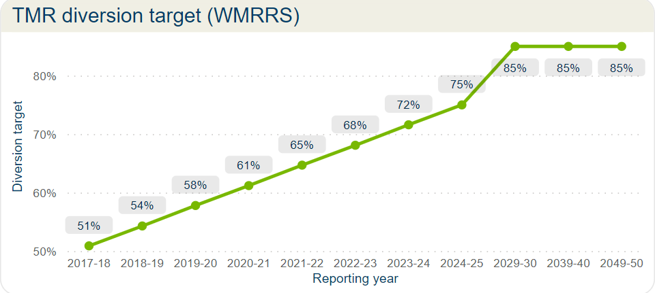
Figure 2: TMR diversion target (WMRRS).

Waste reporting
The following are highlights of the waste data from TMR for 2023–2024. There was a slight decrease in the total waste generated compared to last year (approximately 100 thousand tonnes). There was also a slight increase in the diversion rate to 87 per cent in 2023-2024, from 86 per cent in 2022-2023.
The illegally dumped refuse waste stream encapsulates the roadside litter and War on Wrecks (WOW) program. The WOW program is the collection of derelict and illegally dumped vessels from Queensland waterways. Roadside litter includes rubbish from rest stops and rubbish that is left on TMR land and construction sites. The amount of illegal waste and roadside litter has increased, and WOW has decreased from previous years.
As TMR's work is civil, most waste is generated by the removal and construction of transport infrastructure.

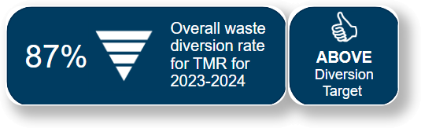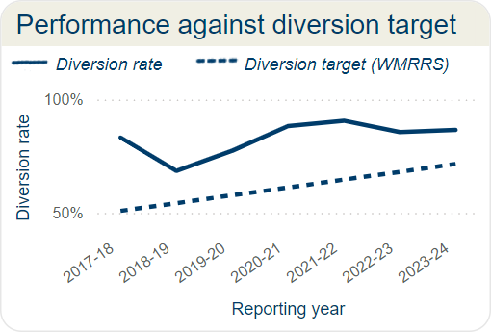
Figure 3: Performance against diversion target.
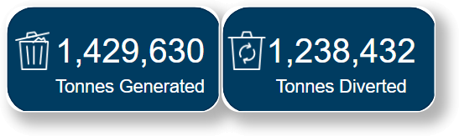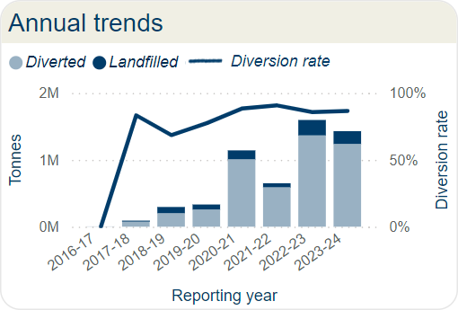
Figure 4: Annual trends.

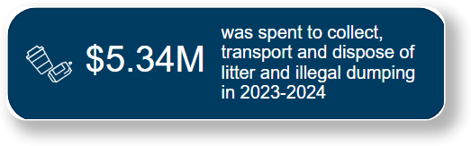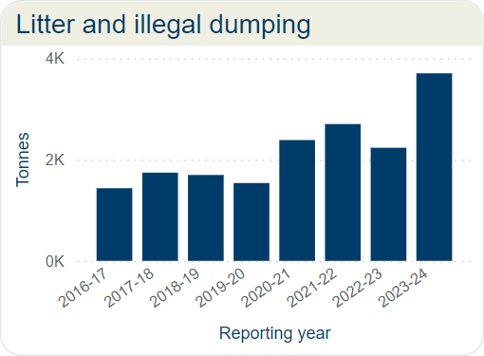
Figure 5: Litter and illegal dumping.
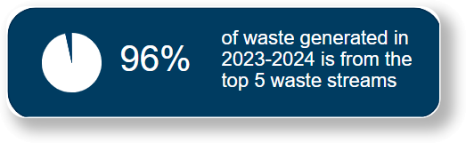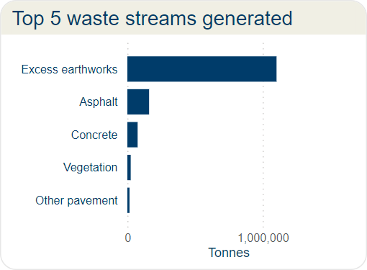
Figure 6: Top 5 waste streams generated in 2023–2024.

There was a slight increase in the waste diversion rate in 2023–2024 (compared to 2022–2023). The 2023–2024 diversion rate is still largely due to the high diversion rate for excess earthworks (see Figure 7) but all the top five waste streams have a diversion rate over 55 per cent.
Excess earthworks, including embankment and fill, is the dirt that is removed from site and not required for the construction of the transport infrastructure. The diversion rate for excess earthworks has fluctuated since waste reported started in 2017–2018 (see Figure 8) however it has not fallen below 80 per cent and the long-term diversion rate is 88 per cent. This shows that TMR’s current actions to manage waste are effective and will ensure that TMR can meet the 2029–2030 target of 85 per cent diversion for construction waste.
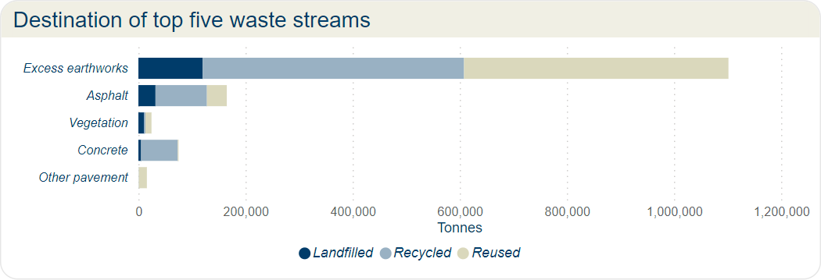
Figure 7: Destination of top five waste streams for 2023/2024.
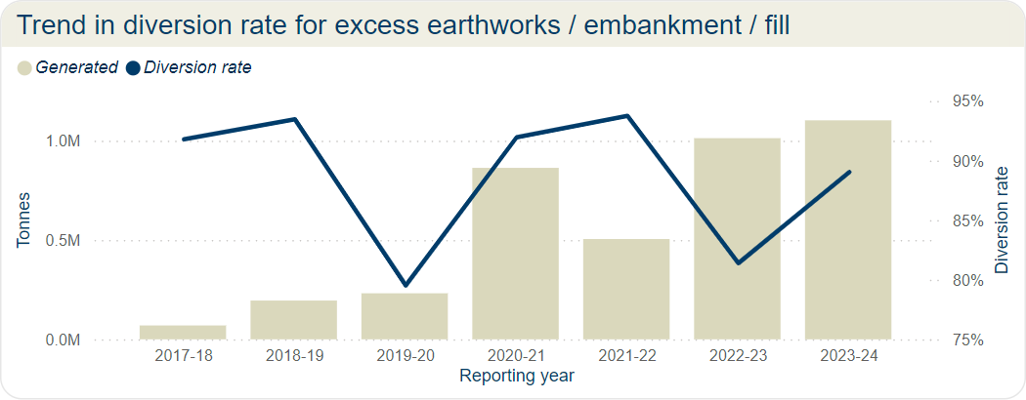
Figure 8: Trend in diversion rate for excess earthworks/embarkment/fill

Case study 1: Mackay Ring Road to Bald Hill Connection Road Project
The Mackay Ring Road to Bald Hill Road Connection Project is a continuation of the $497.3 million Mackay Ring Road project, which was completed in 2020.
Construction of the Mackay Ring Road to Bald Hill Road Connection project commenced in November 2022 and is expected to be completed in early 2025.
The project will duplicate the highway between the Ring Road and Bald Hill Road, build two new overpass bridges, a new port rail line overpass and an upgrade to the Bald Hill Road intersection.
The project includes the construction of an earthworks component for the future Mackay Port Access. Construction of the earthworks has allowed this portion of work to be utilised as a haul road for the current project. The haul road was originally intended to be left unsealed, however the 2023/2024 wet season prompted the project team to examine further opportunities to protect the surface against erosion and provide an “all weather” access.
Golding Contractors has since re-directed over 700 tonnes of waste asphalt profilings generated from the project for use as protective sheeting on this haul road. This new “all weather” surface is expected to protect the current subgrade embankment for wet weather use, reduce the need for rework, and reduce the expected annual soil loss from this area until final design is completed. Additional profilings have also been sought from other TMR projects within the Mackay/Whitsunday district where surplus quantity was needed. The re-use of these waste products was undertaken in consultation with the Department of Environment and Science and in accordance with their End of Waste Code ENEW07604819 Recycled Aggregates.
The onsite re-use of these waste materials has also reduced offsite transportation costs, disposal fees and carbon emissions associated with truck movements.
For more information visit:
https://www.tmr.qld.gov.au/projects/mackay-ring-road
Images (left to right): Unsealed haul road before and after placement and compaction of reused site profilings. © The State of Queensland.
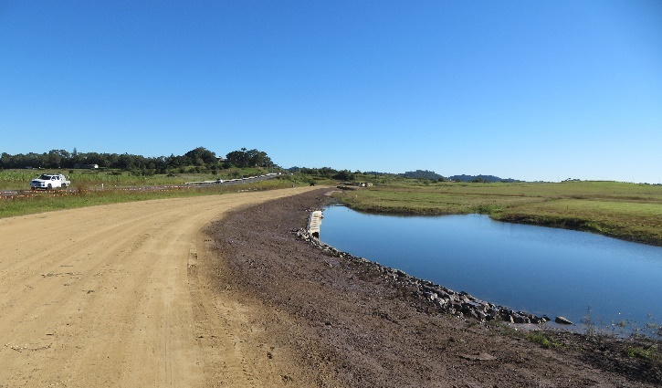 | 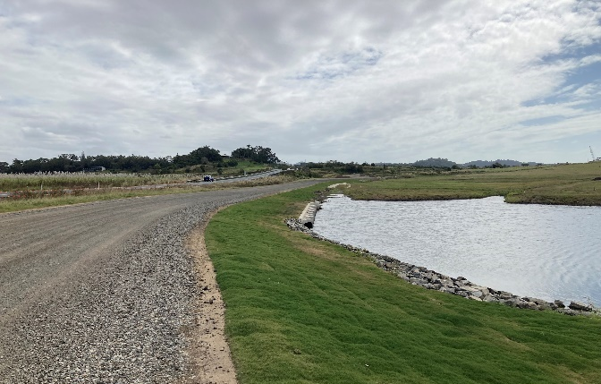

Waste reuse and recycling
An objective of TMR's Waste 2 Resource Strategy is to support the circular economy, and this can be achieved by directing suitable wastes for reuse and recycling. A waste is reused when no additional processing (other than transporting) is required for it to be productively used again. An example of this is directing excess earthworks from one project to another that needs fill material. A waste is recycled when some processing is required to make it into a usable product, for example crushing concrete to supplement road base materials.
The following are highlights of the waste generated by TMR in 2023–2024 and either reused or recycled. Reuse and recycling are more common along the coastal regions of Queensland due to the current distribution of licenced recycling facilities.

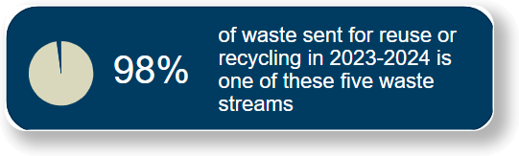
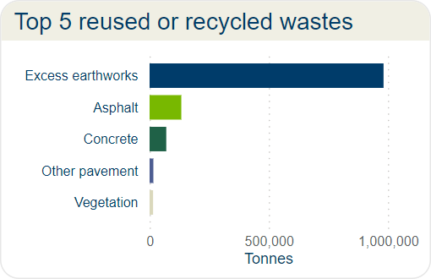
Figure 9: Top 5 reused or recycled wastes.
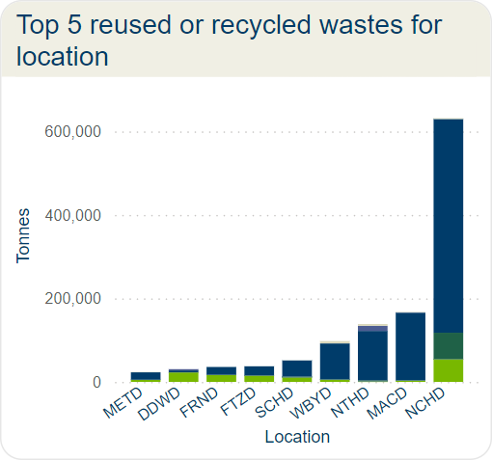
Figure 10: Reused or recycled wastes.
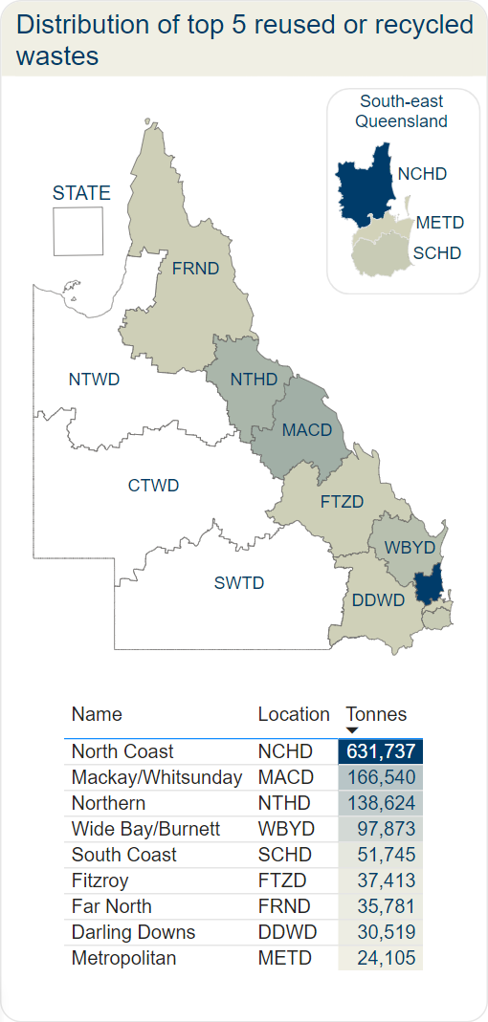
Figure 11: Top 5 reused or recycled wastes.

Table 2: Top 5 reused or recycled wastes for location.
Location | Asphalt  (tonnes) | Concrete  (tonnes) | Excess Earthworks  (tonnes) | Other pavement  (tonnes) | Vegetation  (tonnes)
DDWD | 22,596 | 185 | 4,674 | 3,050 | 14
FRND | 16,776 | 94 | 18,857 |  | 54
FTZD | 14,985 | 42 | 22,324 |  | 61
MACD | 3,049 | 340 | 162,397 | 700 | 54
METD | 4,900 | 224 | 17,984 |  | 997
NCHD | 54,035 | 63,736 | 512,035 |  | 1,931
NTHD | 894 | 2,946 | 118,248 | 12,095 | 4,441
SCHD | 10,418 | 2,349 | 38,649 |  | 329
WBYD | 5,471 | 90 | 86,578 |  | 5,734
Total | 133,124 | 70,006 | 981,746 | 15,845 | 13,615

Case study 2: Christmas 2023 storms
From 26 December 2023 to 3 January 2024, the Gold Coast and hinterland experienced destructive storms that severely impacted local communities and the transport infrastructure network. The impact of these storms caused thousands of trees to be damaged or destroyed, infrastructure damage and flash flooding within the catchment waterways.
The South Coast Region Natural Disaster Program team was quick to react to the situation, and immediately rolled out emergency repair and response works. These works required the removal of 15,000 tonnes of storm debris impacting the TMR road network in the days and weeks immediately following the event. The recovery works are jointly funded by the Australian and Queensland Governments through the Disaster Recovery Funding Arrangements (DRFA).
Inspections of severely impacted areas and stockpile sites storing timber debris determined materials were suitable for reuse in the region. Local government and businesses were able to provide some options for recycling of the materials including:
- Rootballs to be used for riparian protection projects to City of Gold Coast (Catchment Management Unit)
- 5,250 tonnes of mulch to City of Gold Coast
- 2,500 tonnes of mulch to a landscaping company at Jacobs Well
- 2,500 tonnes of mulch to Cape Byron Power for their biomass generators in Northern New South Wales.
It was also noted there was a large amount of high-quality hardwood timber, including trunks with hollows, which were suitable to be repurposed in an environmentally positive way. TMR partnered with Habitec, a local not-for-profit organisation that specialises in habitat creation for conservation projects.
To date, Habitec have used the materials supplied by TMR in several restoration and regeneration projects across Brisbane City Council and City of Gold Coast, including:
- 28 rootballs for riverbank and riparian zone stabilisation and habitat enhancement
- 12 habitat logs for ground habitat use by native fauna species, to increase biodiversity and increase natural vegetation growth
- 53 fauna poles, including koala escape poles added to new fauna fencing
- 25 nesting boxes on wildlife corridor projects to assist arboreal fauna travelling through narrow corridors linking high value habitat.
Images: (left to right) high quality timber stockpiled for use, artificial nest box, koala escape pole. © The State of Queensland.
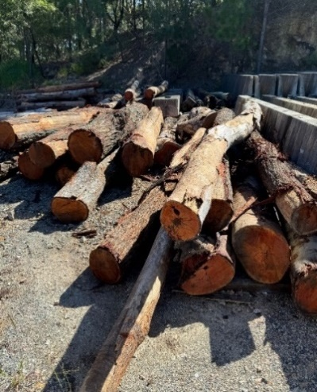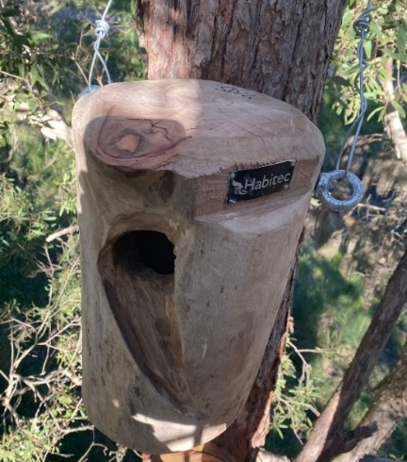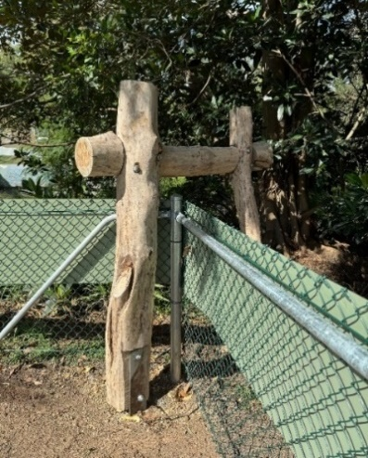

Using recycled materials
In addition to collecting information on the destination of wastes that are generated, TMR collects information on the recycled materials used to construct infrastructure. TMR prefers to use recycled materials on transport infrastructure projects, and this is discussed more in the ‘W2R Strategy Implementation’ section.
There was a significant increase in the amount of recycled material reported as used in 2023–2024. The quantity of reclaimed asphalt used in 2023–2024 was approximately 122,000 tonnes which is slightly less than the 133,000 tonnes of asphalt and profiles (RAP) diverted from landfill in 2023–2024 (see Table 1 and Table 3). This demonstrates how TMR is building a circular economy by both redirecting materials away from landfill and using recycled materials in infrastructure projects.
The use of recycled materials is more common in South-east Queensland due to the concentration of recycled material suppliers. In-situ materials, or materials already available on site, and reclaimed asphalt, are the most used recycled materials in 2023–2024. The North Coast Region reported the highest use of recycled materials which was mostly reclaimed asphalt (approximately 110,000 tonnes).

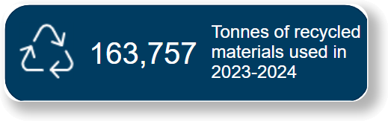
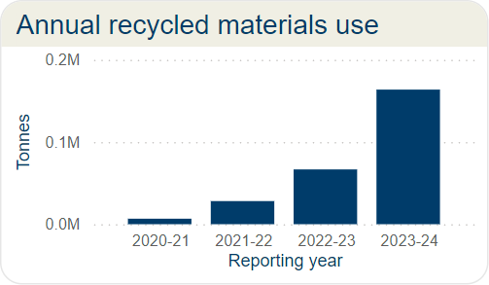
Figure 12: Annual recycled material use.

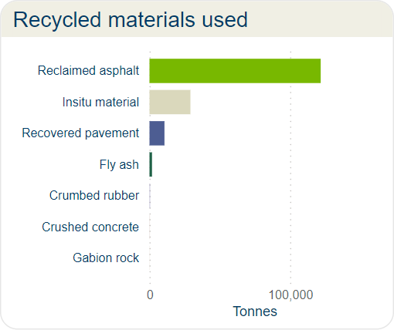
Figure 13: Recycled materials used.

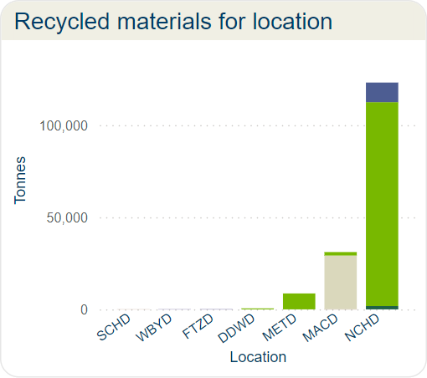
Figure 14: Recycled materials for location.
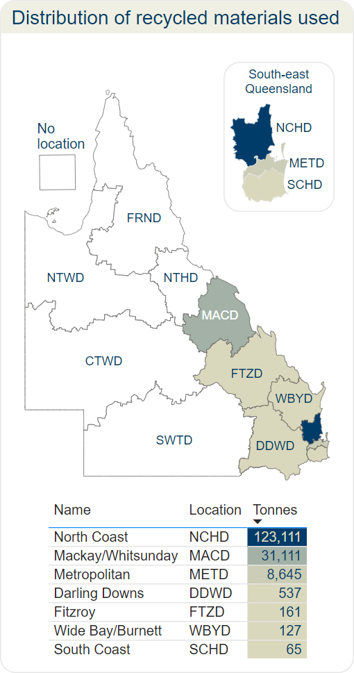
Figure 15: Distribution of recycled materials used.

Table 3: Recycled materials used for location.
Location | Crumbed rubber  (tonnes) | Crushed concrete  (tonnes) | Fly ash  (tonnes) | Gabion rock  (tonnes) | In situ material  (tonnes) | Reclaimed asphalt  (tonnes) | Recovered pavement  (tonnes)
DDWD |  |  |  |  |  | 537
FTZD | 161
MACD |  | 100 |  |  | 29,111 | 1,900
METD |  |  |  |  |  | 8,645
NCHD |  |  | 1,786 |  |  | 110,677 | 10,648
SCHD |  |  |  | 65
WBYD | 127
Total | 288 | 100 | 1,786 | 65 | 29,111 | 121,759 | 10,648

W2R Strategy implementation
TMR's current Waste Reduction and Recycling Plan, the Waste 2 Resource (W2R) Strategy, was published in 2022 and sets out the strategy for TMR to reduce waste and monitor waste generation and diversion from landfill. Previous actions to support the strategy included the publication of the TMR waste 2 resource calculator, and a requirement for tenderers on transport infrastructure contracts to submit the Tender Schedule S12 - Waste to Resource Plan.
Actions during 2023–2024 have been focused on supporting the implementation of these previous actions and monitoring the results. Consistent with previous years, the main source of waste from TMR operations was contract waste from infrastructure projects. There has been ongoing work to improve the completeness of contract waste reporting, and this is reflected in the count of contracts contributing to the annual report (see Figure 17). An analysis of the contracts that have submitted contract waste data by the financial year that the contract reached practical completion shows there is still a large gap in the data to be addressed (see Figure 18). Only 32 per cent of contracts that reached practical completion in the current reporting period have submitted waste data.
The total waste generated from TMR facilities in 2023–2024 has consistently reduced in each reporting period since 2020–2021 (see Figure 19). Action is necessary to improve the completeness of the facilities waste reporting as currently only 72 per cent of the TMR staff work at a facility that has submitted waste data in 2023–2024.

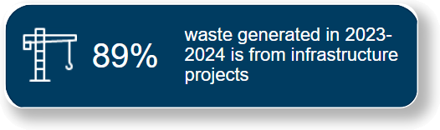
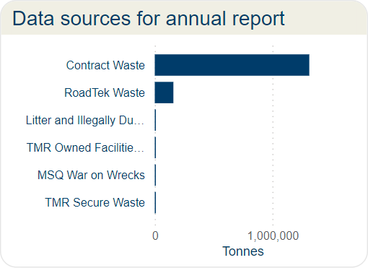
Figure 16: Data sources for annual report.
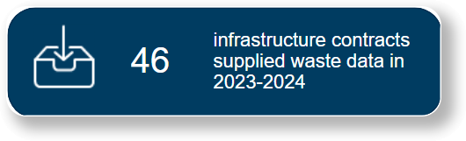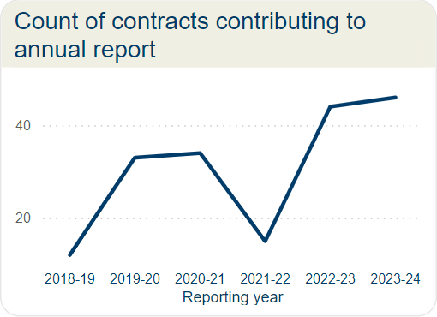
Figure 17: Count of contracts contributing to annual report.
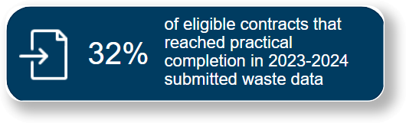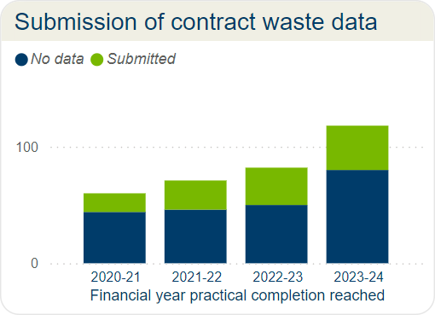Figure 18: Submission of contract waste data.

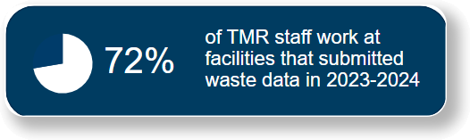
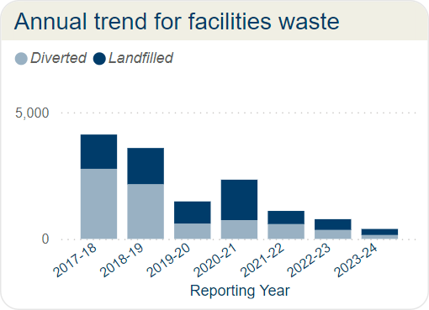
Figure 19: Annual trend for facilities waste.

TMR has continued to use the National Asset Centre of Excellence (NACOE) Program, a collaborative research agreement with the Australian Road Research Board, to conduct research and development on use of recycled materials in infrastructure. The NACOE projects often support multiple strategic objectives and the following projects have been identified as supporting the Waste 2 Resource Strategy:
- S67 Future availability of fly ash for concrete production in Queensland
- P111 Improved Crumb Rubber Modified Bituminous Binder Sprayed Sealing Practices for Road Pavements
- P135 Optimisation of quarried / recycled pavement material blends
- P152 Increased use of RAP in asphalt (towards 100 per cent)
- O25 Use of recycled Materials in Earthworks

Appendix A: Department of Environment and Science State Entity Reporting Template
State Entity Waste Reporting 2024
- Name of the State Entity
Department of Transport and Main Roads

- Please list the types and amounts of waste generated, recycled or disposed of by your department/agency in carrying out its activities during 2023–24.
A summary of the combined TMR waste amounts from all sources is provided in Table 4. The table identifies the amounts generated, diverted (reused and recycled combined) and disposed to landfill. The summarising diversion rate is the amount diverted from landfill as a percentage of the amount generated by waste stream.

Table 4: Annual TMR waste data summary 2023–2024.
Waste stream | Generated  (t) | Diverted  (t) | Landfilled  (t) | Diversion rate
Excess earthworks / embankment / fill | 1,102,651 | 981,745 | 119,943 | 89%
Acid sulphate soil | 1,854 | - | 1,854 | 0%
Other contaminated earthworks | 9,700 | - | 9,700 | 0%
Regulated waste cat 1 | 1,227 | 3 | 1,224 | 0%
Regulated waste cat 2 | 1,382 | 359 | 865 | 26%
Asphalt and profiles (RAP) | 160,514 | 133,124 | 31,912 | 83%
Other recovered pavement materials | 15,896 | 15,845 | - | 100%
Concrete | 75,839 | 70,006 | 5,069 | 92%
Metal | 15,818 | 13,838 | 1,968 | 87%
Vegetation | 24,611 | 13,617 | 10,844 | 55%
Other construction waste (timber, glass, plastic, bricks) | 6,811 | 6,772 | 39 | 99%
Tyres and rubber | 166 | 156 | 2 | 94%
General refuse | 6,564 | 2,514 | 2,034 | 38%
Illegally dumped refuse | 4,096 | 13 | 3,711 | 0%
Office - general and food waste | 1,928 | 1 | 1,925 | 0%
Office - recyclables | 298 | 226 | 67 | 76%
Office - paper | 275 | 212 | 60 | 77%

Table 5 describes how TMR’s waste streams align with the Department of Environment and Science waste classification.

Table 5: TMR waste stream descriptions.
General waste | TMR waste streams | Description
Office waste | Office – recyclables | Mixed recyclables including plastic plates, bottles, aluminium cans etc.
Office waste | Office – paper | Paper and cardboard recyclable waste.
Construction and demolition waste | Excess earthworks/ embankment/fill | Any excess earthworks, embankment or fill generated by a project which is then exported outside the project boundary for either reuse, recycle or landfill beyond the project boundary.
Construction and demolition waste | Other contaminated Earthworks | Any other contaminated earthworks, but not acid sulphate soils.
Construction and demolition waste | Asphalt and profiles (RAP) | Asphalt only (not chip seals and other pavements).
Construction and demolition waste | Other recovered pavement materials | Spray seal pavements, stabilised pavements (not asphalt).
Construction and demolition waste | Concrete | Structural concrete, shotcrete, hardened grout, concrete washout.
Construction and demolition waste | Metal | Signposts, guardrails etc.
Construction and demolition waste | Other construction waste (timber, glass, plastic, bricks) | Any construction waste not accounted for in other construction waste categories, such as uncontaminated timber, glass, plastic and bricks).
Construction and demolition waste | Acid Sulphate Soil | Acid Sulphate Soils.
Construction and demolition waste | General refuse | Cardboard, plastic packaging.
Green waste (land clearance, parks and gardens) | Vegetation | Timber vegetation, stripped grasses etc.
Food waste (kitchen waste) | Office – General and food waste | Putrescibles, kitchen waste, non-recyclable packaging.
Mechanical/workshop waste | Tyres and rubber | Waste tyres.
E-waste | Regulated waste cat 2 | N/A
Chemical wastes | Regulated waste cat 1 | Regulated waste is category 1 regulated waste if it meets the requirements of section 43 of the EP Regulation.
Chemical wastes | Regulated waste cat 2 | Regulated waste is category 2 regulated waste if it is not category 1 regulated waste.
Sewage | Septic general | Septic waste generated by projects.
Litter or illegally dumped waste | Illegally dumped refuse | Waste collected from road reserve.

- Please list actions taken by your department/agency to reduce the amount of waste generated during 2023–24.

In the 2023–2024 period, TMR monitored the success of previously identified strategies to reduce waste generation. Previous strategies have included the use of the Waste and Recycling Calculator during the development phase of projects to identify potential waste streams and determine management strategies to minimise or divert waste from landfill. Additional strategies have included the requirement for large projects to have a Sustainability Assessment.

- Please discuss actions taken by your department/service to recover, and re-use or recycle waste during 2023–24.

In the 2023–2024 period, TMR has monitored the success of previously identified strategies to increase diversion rates and increase the use of recycled materials on infrastructure projects.

- Please discuss actions taken by your department/agency to increase the use of recycled materials during 2023–24.

TMR has continued to use the National Asset Centre of Excellence (NACOE) Program, a collaborative research agreement with the Australian Road Research Board, to conduct research and development on use of recycled materials in infrastructure. The NACOE projects often support multiple strategic objectives and the following projects have been identified as supporting the Waste 2 Resource Strategy:

- S67 Future availability of fly ash for concrete production in Queensland
- P111 Improved Crumb Rubber Modified Bituminous Binder Sprayed Sealing Practices for Road Pavements
- P135 Optimisation of quarried / recycled pavement material blends
- P152 Increased use of RAP in asphalt (towards 100per cent)
- O25 Use of recycled Materials in Earthworks

- Please discuss progress made by your department/agency in relation to its waste and recycling performance indicators during 2023–24.

TMR has had a consistently high diversion rate that is on track to meet the 2029-2023 target of 85 per cent diversion of construction waste. This is largely due to the high diversion rate in excess earthworks / embankment / fill. Reusing and recycling excess earthworks has become standard practice on infrastructure projects so it is likely that the current overall diversion rate can be maintained.

- Please discuss the ways in which your department/agency has contributed towards achieving the goals and targets under Queensland's waste management strategy during 2023–24.

The performance against the targets in the Queensland waste management strategy, are shown in Table 6. There has been a slight increase in the diversion rate compared to the last reporting year, and the diversion rate continues to be above the diversion target. TMR has adopted the waste diversion targets for construction and demolition waste as described in 2020 Waste Management and Resource Recovery Strategy.
Table 6: Annual trend – diversion rate and diversion target.
Reporting year | Diversion rate | Diversion target (WRRS)
2017-2018 | 83% | 50.90%
2018-2019 | 69% | 54.30%
2019-2020 | 77% | 57.80%
2020-2021 | 88% | 61.20%
2021-2022 | 91% | 64.70%
2022-2023 | 86% | 68.10%
2023-2024 | 87% | 71.60%

A diversion rate of more than 80 per cent has been achieved for the following waste streams:
- excess earthworks/embankment/fill
- asphalt and profiles (RAP)
- concrete
- metal
- tyres and rubber
- other construction waste

The total waste generated by TMR in 2023–2024 is 1,429,630 tonnes, of which 87 per cent was diverted (reused or recycled) and remaining 13 per cent was disposed to landfill.

- Please list the amounts and types of litter or illegally dumped waste that were collected by your department/agency during 2023–24.

TMR regularly removes litter and illegally dumped items from the state-controlled road network. Included in this report are the following:

- The cost and amounts of rubbish collected from bins along the road, litter dumped along the road, and other waste that may be dumped adjacent to the road or on other land managed by TMR.
- Estimated weight of vessels removed from Queensland waterways by Maritime Safety Queensland or its compliance partners as part of the War on Wrecks (WoW) Program. Estimates are based on the length of the vessel. The costs have not been included as this information is not collected.
Table 7: Annual trend – litter and illegally dumped waste.
Financial Year | Cost ($) | Mass (tonnes)
2017-2018 | $5,670,602 | 1,743
2018-2019 | $5,770,248 | 1,697
2019-2020 | $4,636,566 | 1,538
2020-2021 | $4,116,861 | 2,387
2021-2022 | $4,479,020 | 2,702
2022-2023 | $4,456,698 | 2,235
2023-2024 | $5,337,544 | 3,705

