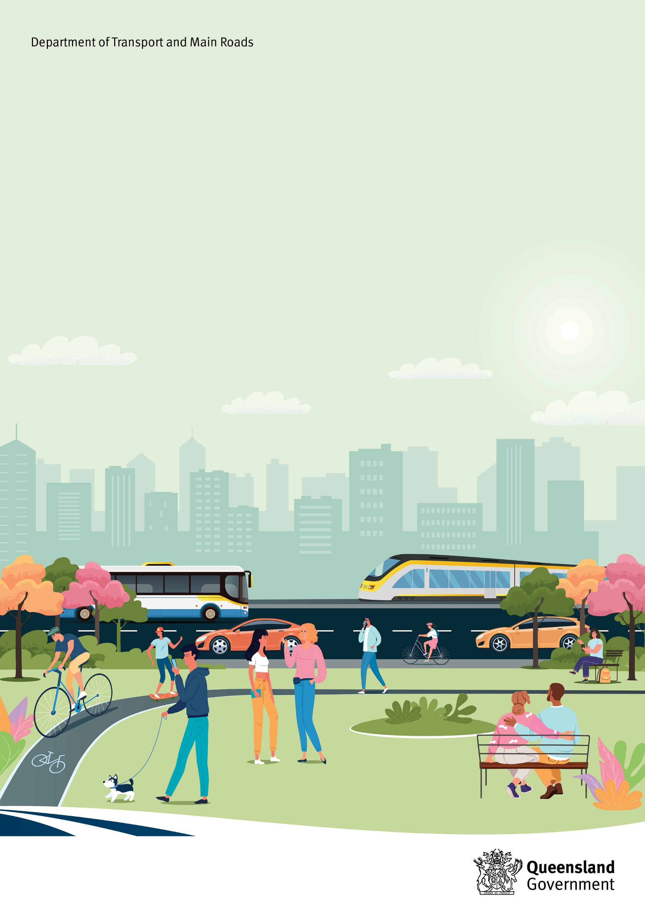
Movement and Place Policy
December 2024
Copyright information
© State of Queensland (Department of Transport and Main Roads) 2024


The Queensland Government is committed to providing accessible services to Queenslanders of all cultural and linguistic backgrounds. If you have difficulty understanding this publication and need a translator, please call the Translating and Interpreting Service (TIS National) on 13 14 50 and ask them to telephone the Queensland Department of Transport and Main Roads on 13 74 68.

Disclaimer
While every care has been taken in preparing this publication, the State of Queensland accepts no responsibility for decisions or actions taken as a result of any data, information, statement or advice, expressed or implied, contained within. To the best of our knowledge, the content was correct at the time of publishing.
Contents
TMR’s Movement and Place Vision 3
1. Purpose 3
2. Policy statement 4
3. Policy principles 5
4. Objectives 6
4.1 Performance Indicators 7
5. Scope 10
6. Defining Movement and Place 10
6.1 Defining movement 10
6.2 Understanding place 11
7. Benefits 12
8. Applicability 12
8.1 Stakeholders 12
8.2 Aboriginal and Torres Strait Islander considerations 13
8.3 Human Rights 13
9. Compliance 13
10. Authority 15
10.1 Accountability 15
11. Responsibility 15
11.1 Functional responsibility 15
12. Supporting documents 15
13. Implementation and review 16
14. Definitions 17
15. References 18

TMR’s Movement and Place Vision
With collaboration and inclusivity at the centre of what we do, we consider the complementary and essential contributory functions of movement and place together to deliver multiple-value outcomes from our transport network. In doing so, we positively contribute to the creation of more connected, liveable and sustainable neighbourhoods, cities and regions for all Queenslanders.
- Purpose
Movement and place is an internationally recognised best practice planning and design approach that seeks to balance the transport network’s function in moving people and goods with the role of transport corridors, nodes and precincts as places that are essential to social and economic activity. It helps decision makers balance the functional requirements of movement infrastructure with the needs of people and the lifestyle characteristics and distinctive qualities of places. It emphasises the role of movement infrastructure as a critical contributory element in the creation of great places.
Queensland’s population is forecast to continue to grow strongly in coming decades, increasing from 5.2 million to around 7.3 million by 2046 and to over 9.2 million by 2071. As this growth will create additional demand and pressure on our networks and systems, we must ensure that the decisions we make now help to create and maintain great places to live, work, shop, and socialise into the future.
The Department of Transport and Main Roads (TMR) has a responsibility to plan and provide for the associated increase in the movement of people and goods while considering the relationship, influence, and opportunities of this movement within the context of ‘place’.
Movement and place is about acknowledging and managing the conflicts and trade-offs that need to occur in order to improve outcomes. The Movement and Place Policy (the Policy) and associated framework provides guidance to assess these challenges and competing demands to consider the contributory role and value that both ‘movement’ and ‘place’ elements provide to the social, economic, and environmental success of Queensland into the future.
The purpose of the Policy is to define and establish a movement and place process responsive to the Queensland context. The Policy outlines the principles, objectives, scope and definitions of a movement and place approach, as well as identifying key performance indicators to guide TMR in achieving significant benefits and outcomes. The Policy reflects a commitment to sustainable development, economic prosperity, social well-being, and effective governance; addressing the multifaceted challenges and opportunities associated with the dynamic nature of urban and rural environments in Queensland.
Vision and validate describes the approach used in the movement and place process. It defines a preferred vision and objectives for the future, and identifies the option(s) that is most likely to achieve it. It does this through collaboratively creating a shared future vision for a location or project, identifying and developing strategies and initiatives to achieve the agreed vision, and testing and validating these strategies and initiatives to ensure they can deliver the agreed vision. Vision and validate replaces the historic ‘predict and provide’ method, which estimates future requirements based on historic patterns and aims to meet them.
Through the vision and validate approach intrinsic to movement and place, the Policy seeks to prioritise the delivery of safe, accessible public places that reflect the unique character and identity of our communities and First Nations people. Its goals are to promote social equity, economic vitality, health and well-being while supporting the delivery of well connected, efficient, sustainable and resilient multi-modal transport choices for our customers.
The Policy also establishes a common language to bring partners and stakeholders together to help guide investment decision making, planning, design and operations of the transport network and enhance TMR places such as roads and streets, train and bus stations, precincts and rest areas.
- Policy statement
The Policy confirms and guides our commitment to enhancing and creating a seamless and integrated network that prioritises the needs of Queensland communities and the environment. It supports integrated transport planning, ensuring the needs of movement and placemaking are considered simultaneously when planning for and developing our transport network.
It aligns with our strategic direction and, in collaboration with multi-disciplinary and cross-jurisdictional stakeholders, will enable better planning and management of our transport network to foster vibrant communities, enhance quality of life, and enable the safe, efficient and reliable movement of people and goods. It will contribute to delivering more liveable and sustainable neighbourhoods, cities and regions, and evolve Queensland’s transport system for the benefit of people of all backgrounds and abilities.
The Policy guides TMR to achieve multiple-value outcomes for our customers:
- Better, safer and healthier movement and place options: Adopt a customer-centric approach to the design and development of our network, across a range of scales, enhancing and contributing to safe, convenient and accessible movement and places.
- Sustainability: Promote the use of active transport modes, creating opportunities to reduce emissions, and delivering resilient and environmentally sustainable infrastructure.
- Efficiency: Optimise efficient and accessible transport networks to seamlessly integrate different modes of travel, to maximise the convenient movement of people and goods.
- Cultural identity and community need: Collaboratively engage with community (including First Nations people), local government and industry to design and shape movement and place outcomes that align with and benefit cultural identity, community needs and foster economic growth.
- Technology Integration: Integrate smart technology with movement and place considerations to support future emerging technologies and customer digital needs, provide real-time transportation information, enable smart traffic management, and support the development of innovative transportation solutions for all modes.
TMR will achieve this through implementing and embedding the TMR Movement and Place Operational Framework that will guide staff in achieving the outcomes of this policy and build capability.
- Policy principles
There are six common principles embedded within the Policy to guide action and decision making throughout policy, planning and investment:
- Vision and outcome led: Lead from a vision and validate approach by shaping an endorsed vision with clear desired outcomes to guide project activities and decision-making.
- A people and place focus: Prioritise the needs of people and the distinctive qualities and characteristics of places to balance environmental, social, cultural and economic aspirations as well as the movement needs of a place.
- Contextually holistic: Investigate a whole of system view of ‘movement’ and ‘place’ to foster solutions that meet desired strategic outcomes and needs of the individuals, the community, and the built and natural environment, including connection to Country. Ensure all users, time contexts (past, present and future), modes and mobility enhancing smart technologies are considered, alongside place.
- Collaborative approach: Facilitate stakeholder collaboration to shape the development and application of movement and place outcomes to meet their needs.
- Flexible and scalable: Empower practitioners, stakeholders and decision-makers to make decisions which best suit local, regional or state planning needs from the design and operation of a local place, street or regional connection, and for active travel modes through to freight journeys.
- Evidence based: Use qualitative and quantitative evidence to understand context, define success, identify impacts and benefits and inform decision making.
- Objectives
By adopting the above principles of movement and place, the Policy seeks to deliver the following outcomes:
Vibrant and successful places
- improve liveability of places including comfort and convenience, attractiveness, and cultural identity
- create places that invite and support sustainable economic growth for local communities.
Happy and healthy people
- prioritise safety in all decision-making to reduce fatalities and serious injuries on Queensland roads
- create places that are inclusive, safe and secure and foster health and wellbeing opportunities.
Natural, sustainable, and resilient communities
- promote sustainable travel, reduce reliance on single-occupancy vehicles and integrate environmental considerations into transport planning and design
- develop environmentally friendly and climate resilient communities that enhance the quality of life for Queenslanders.
Connected, accessible and convenient ‘Movement’ for people and goods
- improve accessibility and convenience of transport options by integrating Universal Design into the planning, design, delivery, safety and operation of transport infrastructure for road, rail, active travel, bus, maritime and modal interchanges
- foster a smooth and tailored transport experience for customers, emphasising the convenience of interchanging between various modes of transport
- leverage emerging technologies and the digital needs of customers to improve the efficiency and reliability of the transport system by reducing travel time and delivery time of goods, leading to an increase in overall productivity.
  - Performance Indicators
Well defined and targeted performance indicators are a fundamental part of the 'vision and validate' approach of movement and place. They provide quantifiable measures that help validate the effectiveness of a project or intervention against the vision and its objectives.
Identifying performance indicators as part of the collaborative vision-setting phase, and reviewing for adjustment as required across different project stages will help guide a responsive, outcomes-led approach. Performance indicators can assist in enabling:
- evaluation of the existing and or planned future state
- assessment of different options
- final assessment and reporting
- monitoring of success after delivery.
Importantly, there is no one size fits all approach to delivering movement and place outcomes, and therefore no single set of performance indicators that must be applied in every situation. Each application of the Policy will involve development of a unique combination of the performance indicators by each individual project team to match a project’s vision and objectives. The weight of each performance indicator is also determined by the project team’s assessment of how critical each are in achieving the vision.
The four broad movement and place outcomes and performance indicator themes, shown in Figure 1, are aligned directly to the Policy objectives and broader TMR strategic objectives. Table 1 expands further, linking these themes to possible performance metrics that practitioners may consider. For example, urban heat, air quality and noise metrics could be used to measure the ‘health and wellbeing’ indicator, while mode share surveys could be used to measure the ‘transport choice’ indicator.

Figure 1: Broad movement and place outcomes and performance indicators
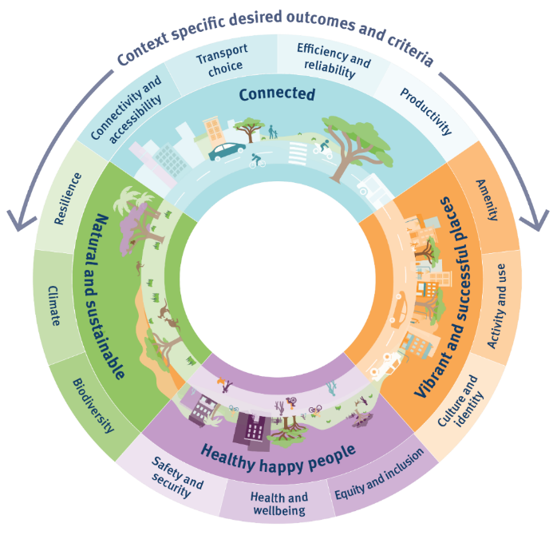

Table 1: Alignment of Performance Indicators and Strategic Objectives
Policy objective / Performance Indicator theme | TMR Strategic Objective | Desired outcomes | Potential Performance Indicator metrics
Vibrant and successful places  Integration of transport with the built environment to create great places | - Responsive  - Accessible and integrated  - Sustainable | - Amenity  - Activity and use  - Culture and identity. | - Dwell times  - Percentage of shade  - Noise pollution levels  - Density  - Community engagement data
Happy healthy people  The role of transport in supporting desired social outcomes | - Efficient and productive  - Safe and secure | - Safety and security  - Health and wellbeing  - Inclusion. | - Safety–perceived and actual (road accidents, crime)  - Road characteristics e.g. traffic volume, type and speed  - Universal Design levels  - Social exclusion index
Natural and sustainable  Interplay between transport, the natural environment and sustainability | - Sustainable  - Responsive | - Resilience  - Climate  - Biodiversity. | - Reliability of network under different conditions  - Urban green space  - Green Infrastructure Index  - Heat data  - Air and water pollution data
Connected  Network connectivity with a focus on sustainable and reliable mobility choices | - Accessible and integrated  - Responsive  - Efficient and productive | - Connectivity and accessibility  - Transport choice  - Efficiency and reliability  - Productivity. | - Accessibility within 15min/30min  - Walk score, transit score and bike score  - Evaluation of mode share  - Service reliability and punctuality
- Scope
The Policy applies to investment and life cycle decision making, planning, design, maintenance, and operational aspects of the Queensland transport system.
The transport system includes:
- physical infrastructure (ports, roads, bus and train stations, pedestrian paths and cycleways, transit-oriented developments)
- digital infrastructure (satellite-based navigation aids, travel apps, communication technologies, Intelligent Transportation Systems, smart ticketing, Mobility as a Service, public transport real-time data, smart crossings and sensor-equipped walkways, smart sensors and data analytics as well as smart lighting and infrastructure)
- mobility services (public transport, ride-shares)
- regulation systems that influence how the transport system functions and develops (network optimisation).
The transport system affects all Queenslanders, and TMR will work collaboratively with and across communities, First Nations peoples, multidisciplinary teams, portfolio, agency and jurisdictional boundaries to lead a holistic approach to movement and place design and delivery.
- Defining Movement and Place
The movement and place approach provides a strategic and structured approach to exploring the complex elements of ‘movement’ and ‘place’ allowing for a better understanding and integration of both.
  - Defining movement
The ‘movement’ of people and goods is driven by a range of social, economic and environmental activities that are critical to the success of our local areas, cities and regions. Movement can be understood using two lenses, described below. These lenses are important to understand how movement is undertaken, and to consider the current and potential future role and function of transport.
Character/function identifies the nature of the travel task in relation to the study area:
- To/from - movement generated from within the study area, with an origin or destination outside it
- Through - movement through the study area without stopping or dwelling
- Within - local or ‘contained’ movement within the study area.
Modal hierarchy examines the priority of how transport modes are to be considered. Alongside overarching themes of accessibility and safety, and depending on the context, the hierarchy of modes should be considered with pedestrians first, then cycling and micro-mobility, public transport, freight and private vehicles lastly. Using this lens to better understand the varying impacts of movement, we can identify and prioritise investment that aligns to the delivery of connected, liveable and sustainable communities.
When considered together, the dynamic interactions between movement of goods and people and places within a community, facilitates an understanding of:
- how and when people and goods move
- how and when public places are used, and
- benefits and disbenefits of those activities.
These considerations enable an enhanced understanding of potential opportunities, conflicts and synergies between movement and place well as any strategic trade-offs, informing collaborative discussions and decision-making about strategic outcomes and priorities.
  - Understanding place
Places play a vital role in shaping the experience of communities and their composition, qualities and characteristics influence the ways people live, move and engage with their surroundings. The quality, safety and amenity of places and how people experience and use them plays a vital role in influencing their overall attractiveness and liveability, vitality and prosperity.
The essential qualities that make places distinctive and valued by the community can generally be understood through an analysis of the following attributes:
- Environment: the important physical features, distinctive flora and fauna, topography and hydrology–the elements of the natural environment
- Community: demographic characteristics of a community, patterns of place use, social and community assets and places of community cohesion and gathering such as schools and places of worship
- Commerce and activity: the fundamental drivers of economic productivity, land use mixes, the location of places of commerce, exchange and employment that support lifestyle needs including high streets
- Movement: the patterns of use (volume and time) and different hierarchies of movement infrastructure–starting with active and public transport infrastructure through to private vehicles
- Heritage and culture: places that have important cultural and historic significance and contribute to the sense of place and identity
- Urban form: the typologies of buildings, variety and locations of residential properties and spatial organisation of neighbourhoods. It can be considered at various scales from regional, city, to a local area and considers the overall structure of a city with the pattern of development and streets to the relationship of public realm (and parks) and street widths to developable land and granularity of street block sizes.
- Benefits
Implementation of this policy will enhance TMR’s delivery of the Strategic Plan
2023–2027, Queensland Transport Strategy, and Transport Coordination Plan
2017–2027 (TCP) objectives by establishing a common language for practitioners, decision makers, and stakeholders to identify and evaluate placemaking opportunities on the network alongside movement capabilities.
As part of the operational framework (refer 12. Supporting documents) an action will focus on the development of consistent and repeatable end-to-end benefits realisation process and refine a series of standard measures to monitor the delivery of ‘movement’ and ‘place’ outcomes.
- Applicability
This policy applies to all TMR employees and contractors engaged in life cycle decision making, planning, design and operational aspects of the transport system where TMR has a state interest. The ‘best practice’ nature of this policy means that while other government agencies (including local government) and partners are not required to adopt this policy, it may be used to support, leverage and support movement and place discussions with a common language.
  - Stakeholders
Stakeholders may include but are not limited to:
- TMR professionals: (transport planners, engineers, architects, urban planners and designers, heritage specialists, economists, Indigenous engagement and accessibility specialists)
- Other state government departments and agencies
- Local governments
- Affected community members and businesses
- Community representative organisations (for example, groups representing people with disability, older people, Aboriginal and Torres Strait Islander groups, chambers of commerce)
- First Nations
- Service providers that support socially disadvantaged communities
- Representatives from major local facilities such as schools, higher and further education, hospitals and retail precincts
- Active transport advocates such as Bicycle Queensland, local bicycle user groups and Queensland Walks
- Active transport advisory or reference committees hosted by local governments
- Freight groups such as the Queensland Trucking Association (QTA).
  - Aboriginal and Torres Strait Islander considerations
TMR will follow the advice set out in the Aboriginal and Torres Strait Islander Engagement in Transport and Roads Infrastructure Delivery and Maintenance Strategy as part of its stakeholder engagement.
  - Human Rights
The implementation of this policy will generally respect and promote the freedom of movement in section 19 of the Human Rights Act 2019. Consideration will need to be given to whether other human rights may be relevant in a particular case.
- Compliance
The following legislation, policies, and other jurisdictional policies are relevant to the TMR Movement and Place Policy.
Legislation
Disability Standards for Accessible Public Transport 2002
Disability Discrimination Act 1992
Human Rights Act 2019
Information Privacy Act 2009
Planning Act 2016
State Planning Policy
Transport Operations (Road Use Management—Road Rules) Regulation 2009
Transport Infrastructure (State-controlled Roads) Regulation 2006
Transport Operations (Road Use Management) Act 1995
Transport Infrastructure Act 1994
Transport Planning and Coordination Act 1994
Transport Operations (Passenger Transport) Act 1994
TMR organisational policies
Road Safety Policy
Cycling Infrastructure Policy
Cultural Heritage Policy
Environmental Sustainability Policy
Information Management Policy
Infrastructure Proposal Development Policy
Records Management Policy
Statewide Strategies
Queensland Transport Strategy: Our 30-year plan for transport in Queensland
Transport Coordination Plan 2017–2027
State Infrastructure Strategy 2022–2042
Queensland Road Safety Strategy 2022–2031
Queensland Walking Strategy 2019–2029
Queensland Cycling Strategy 2017–2027
Queensland Freight Strategy—Advancing Freight
Queensland Zero Emission Strategy 2022–2032
Creating Better Connections for Queenslanders: A ten-year plan for Queensland Passenger Transport
TMR Network Optimisation Framework
Accessibility and Inclusion Strategy
Regional Transport Plans
ShapingSEQ
Guidelines
TMR/LGAQ Cost Sharing Arrangement (section 6.1)
TMR Pedestrian and Walking Guidance and Resources
TMR Walking Network Planning Guidance
TMR Technical pages for cycling and walking
TMR Principal Cycle Network Plans
TMR Active Transport Investment Program Community and Stakeholder Engagement Guide
TMR Public Transport Infrastructure Manual
TMR Traffic and Road Use Management
TMR Road Planning and Design Manual
IPWEA (Queensland) Street Planning and Design Manual
TMR Cultural Heritage Process Manual
TMR Environmental Processes Manual
QDesign
National Strategies and Policy
Austroads Guide to Road Design
Austroads Movement and Place Frameworks guidance (in preparation)
National Urban Freight Planning Principles
National Road Safety Strategy 2021–2030
- Authority
  - Accountability
The accountable officer is the Director-General of TMR.
- Responsibility
  - Functional responsibility
The General Manager, Transport Policy Branch, will monitor and revise the policy every two years.
The implementation of the Operational Framework will be governed by a TMR collaborative governance group (refer 12. Supporting documents).
- Supporting documents
Introducing Movement and Place provides more background information to the process and why it is important and relevant to Queensland. It explains what the movement and place concept is, why it is important and how it will be applied across TMR.
An accompanying Practitioner Guidance explains how practitioners can apply the Policy to decision making, planning, design and management of our transport network to maximise benefits for our customers, while supporting a context-sensitive application of MPP elements to projects across Queensland.
The Policy and accompanying Introducing Movement and Place and Practitioner Guidance are the first elements of a Movement and Place Operational Framework (Figure 2) which will embed movement and place over the long term, to drive organisational change and grow capability to deliver movement and place outcomes.
The collaborative, cross-disciplinary governance group and structure oversees the implementation of the Movement and Place Operational Framework.

Figure 2: TMR Movement and Place operational framework
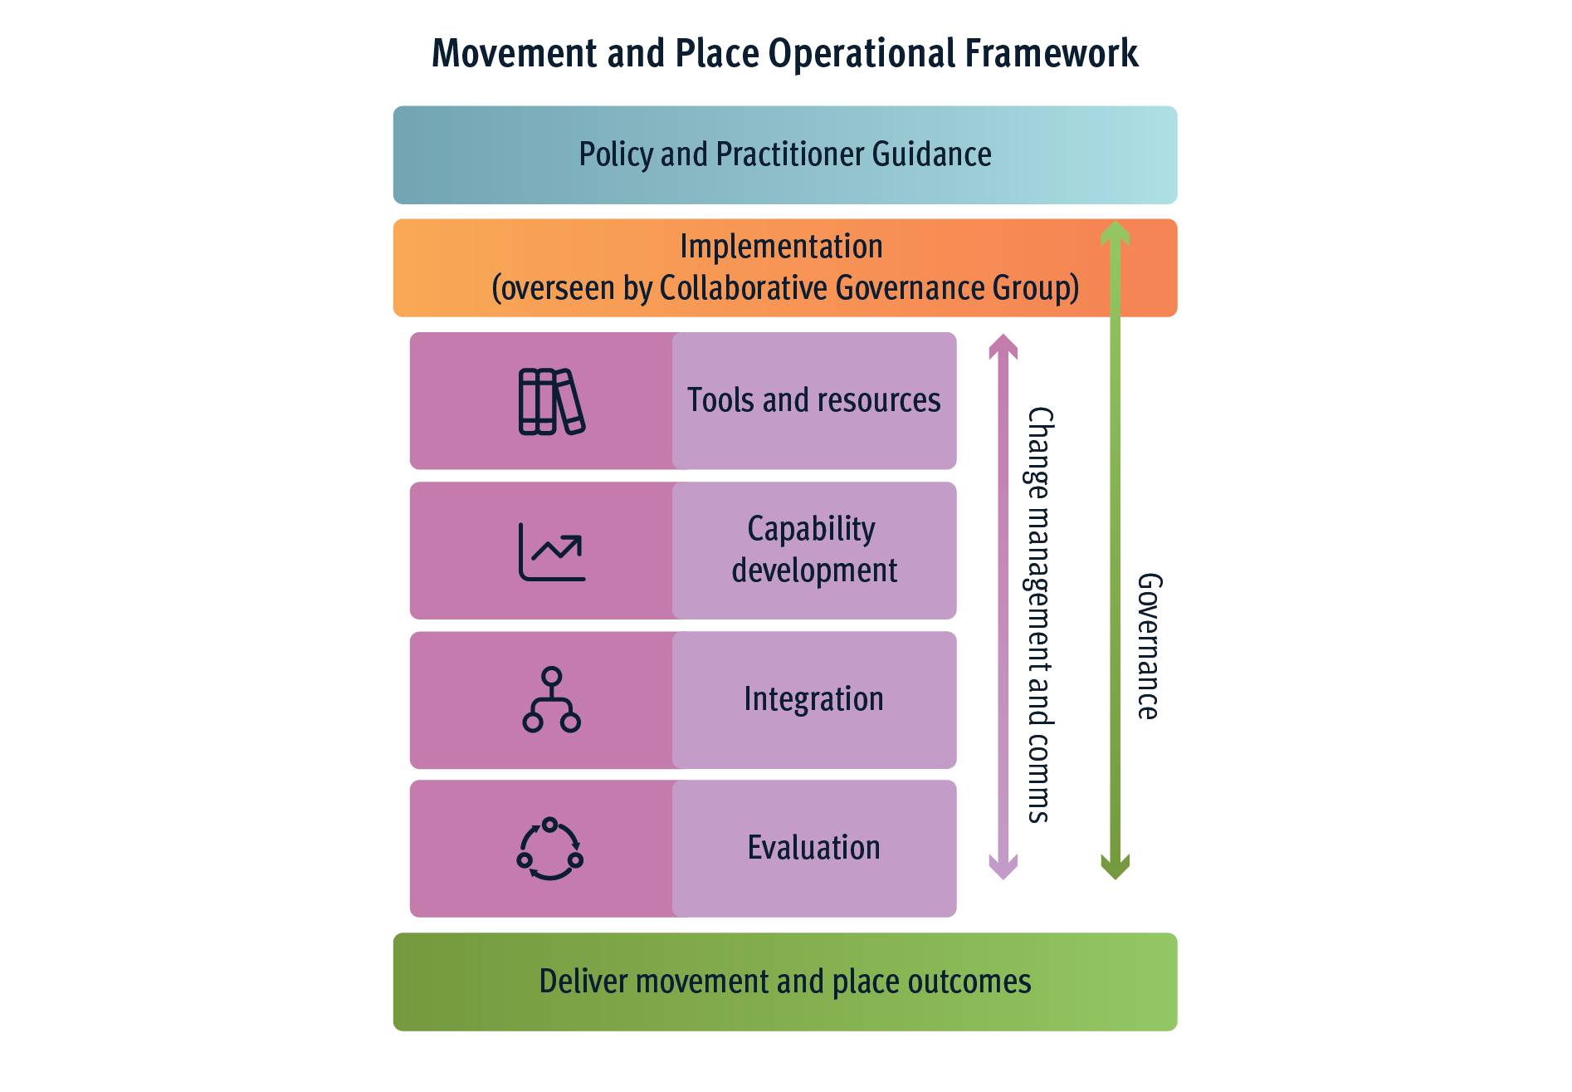
- Implementation and review
The Policy takes effect from 30 July 2024. In recognition that there will be a need to align and integrate the Policy into existing procedures, implementation will be guided by the Movement and Place Operational Framework, and progressively developed and refined through pilot projects. The Movement and Place Practitioner Guidance provides further detail on broad process steps that are designed to be able to be adapted to and tested on current projects.
The Policy will be monitored and revised every two years by the General Manager, Transport Policy Branch, Policy, Planning and Investment Division.
- Definitions
Term | Explanation
Active Travel/Active Transport | Incorporates cycling, walking and other physically active ways of travelling that can be undertaken alone or combined with public transport.
Micro-mobility | Includes personal mobility devices such as e-scooters.
Modal hierarchy | The ordered priority of transport modes within a transport corridor or a study area.
Movement | The movement of people and goods by a transport mode (for example, active or public transport, private vehicle), typically covering movement to and from, through or within a transport system, or a combination.
Movement and place | Internationally recognised best practice planning approach that helps decision makers balance the movement of people and goods to, from and within a transport system, with places that are essential to social and economic activity.
Operational Framework | The operational framework is TMR’s Movement and Place methodology, procedures, policy and tools to guide and support implementation of Movement and Place across the department.
Pedestrian | This definition includes a person walking, a person operating motorised mobility device, a person in a wheelchair, or a person pushing a wheelchair.
Place | A place is a space or location which has meaning shaped by the activity of people within it, its social and economic value to the community, and its physical and natural setting.
Predict and provide | A problem-solving method where future requirements are predicted based on past and present behaviours, and a response is designed to meet them.
Transport system | The transport system includes:  - The physical infrastructure (e.g. ports, roads, rail, stations, transport hubs)  - Digital infrastructure (e.g. satellite-based navigation aids, travel apps, communication technologies)  - Mobility services (e.g. public transport, ride–shares)  - Regulation systems that influence how the transport system functions and develops.
Universal design | Universal Design is a framework for the design of living and working spaces and products benefiting the widest possible range of people in the widest range of situations without special or separate design.
Vision and validate | A method of creating a shared future vision for a location or project, identifying and developing strategies and initiatives to achieve the agreed vision, and testing and validating these strategies and initiatives to ensure they can deliver the agreed vision.
- References
NSW Government. Accessed 2024. Movement and Place. https://www.movementandplace.nsw.gov.au/about/about-movement-and-place
Victorian Government. Accessed 2024. Movement and Place. https://www.vic.gov.au/movement-and-place-victoria
Ministry of Transport New Zealand. Accessed 2024. One Network Framework. https://www.nzta.govt.nz/planning-and-investment/planning/one-network-framework/

Queensland Government Statistician’s Office, 2023 edition (medium series)

