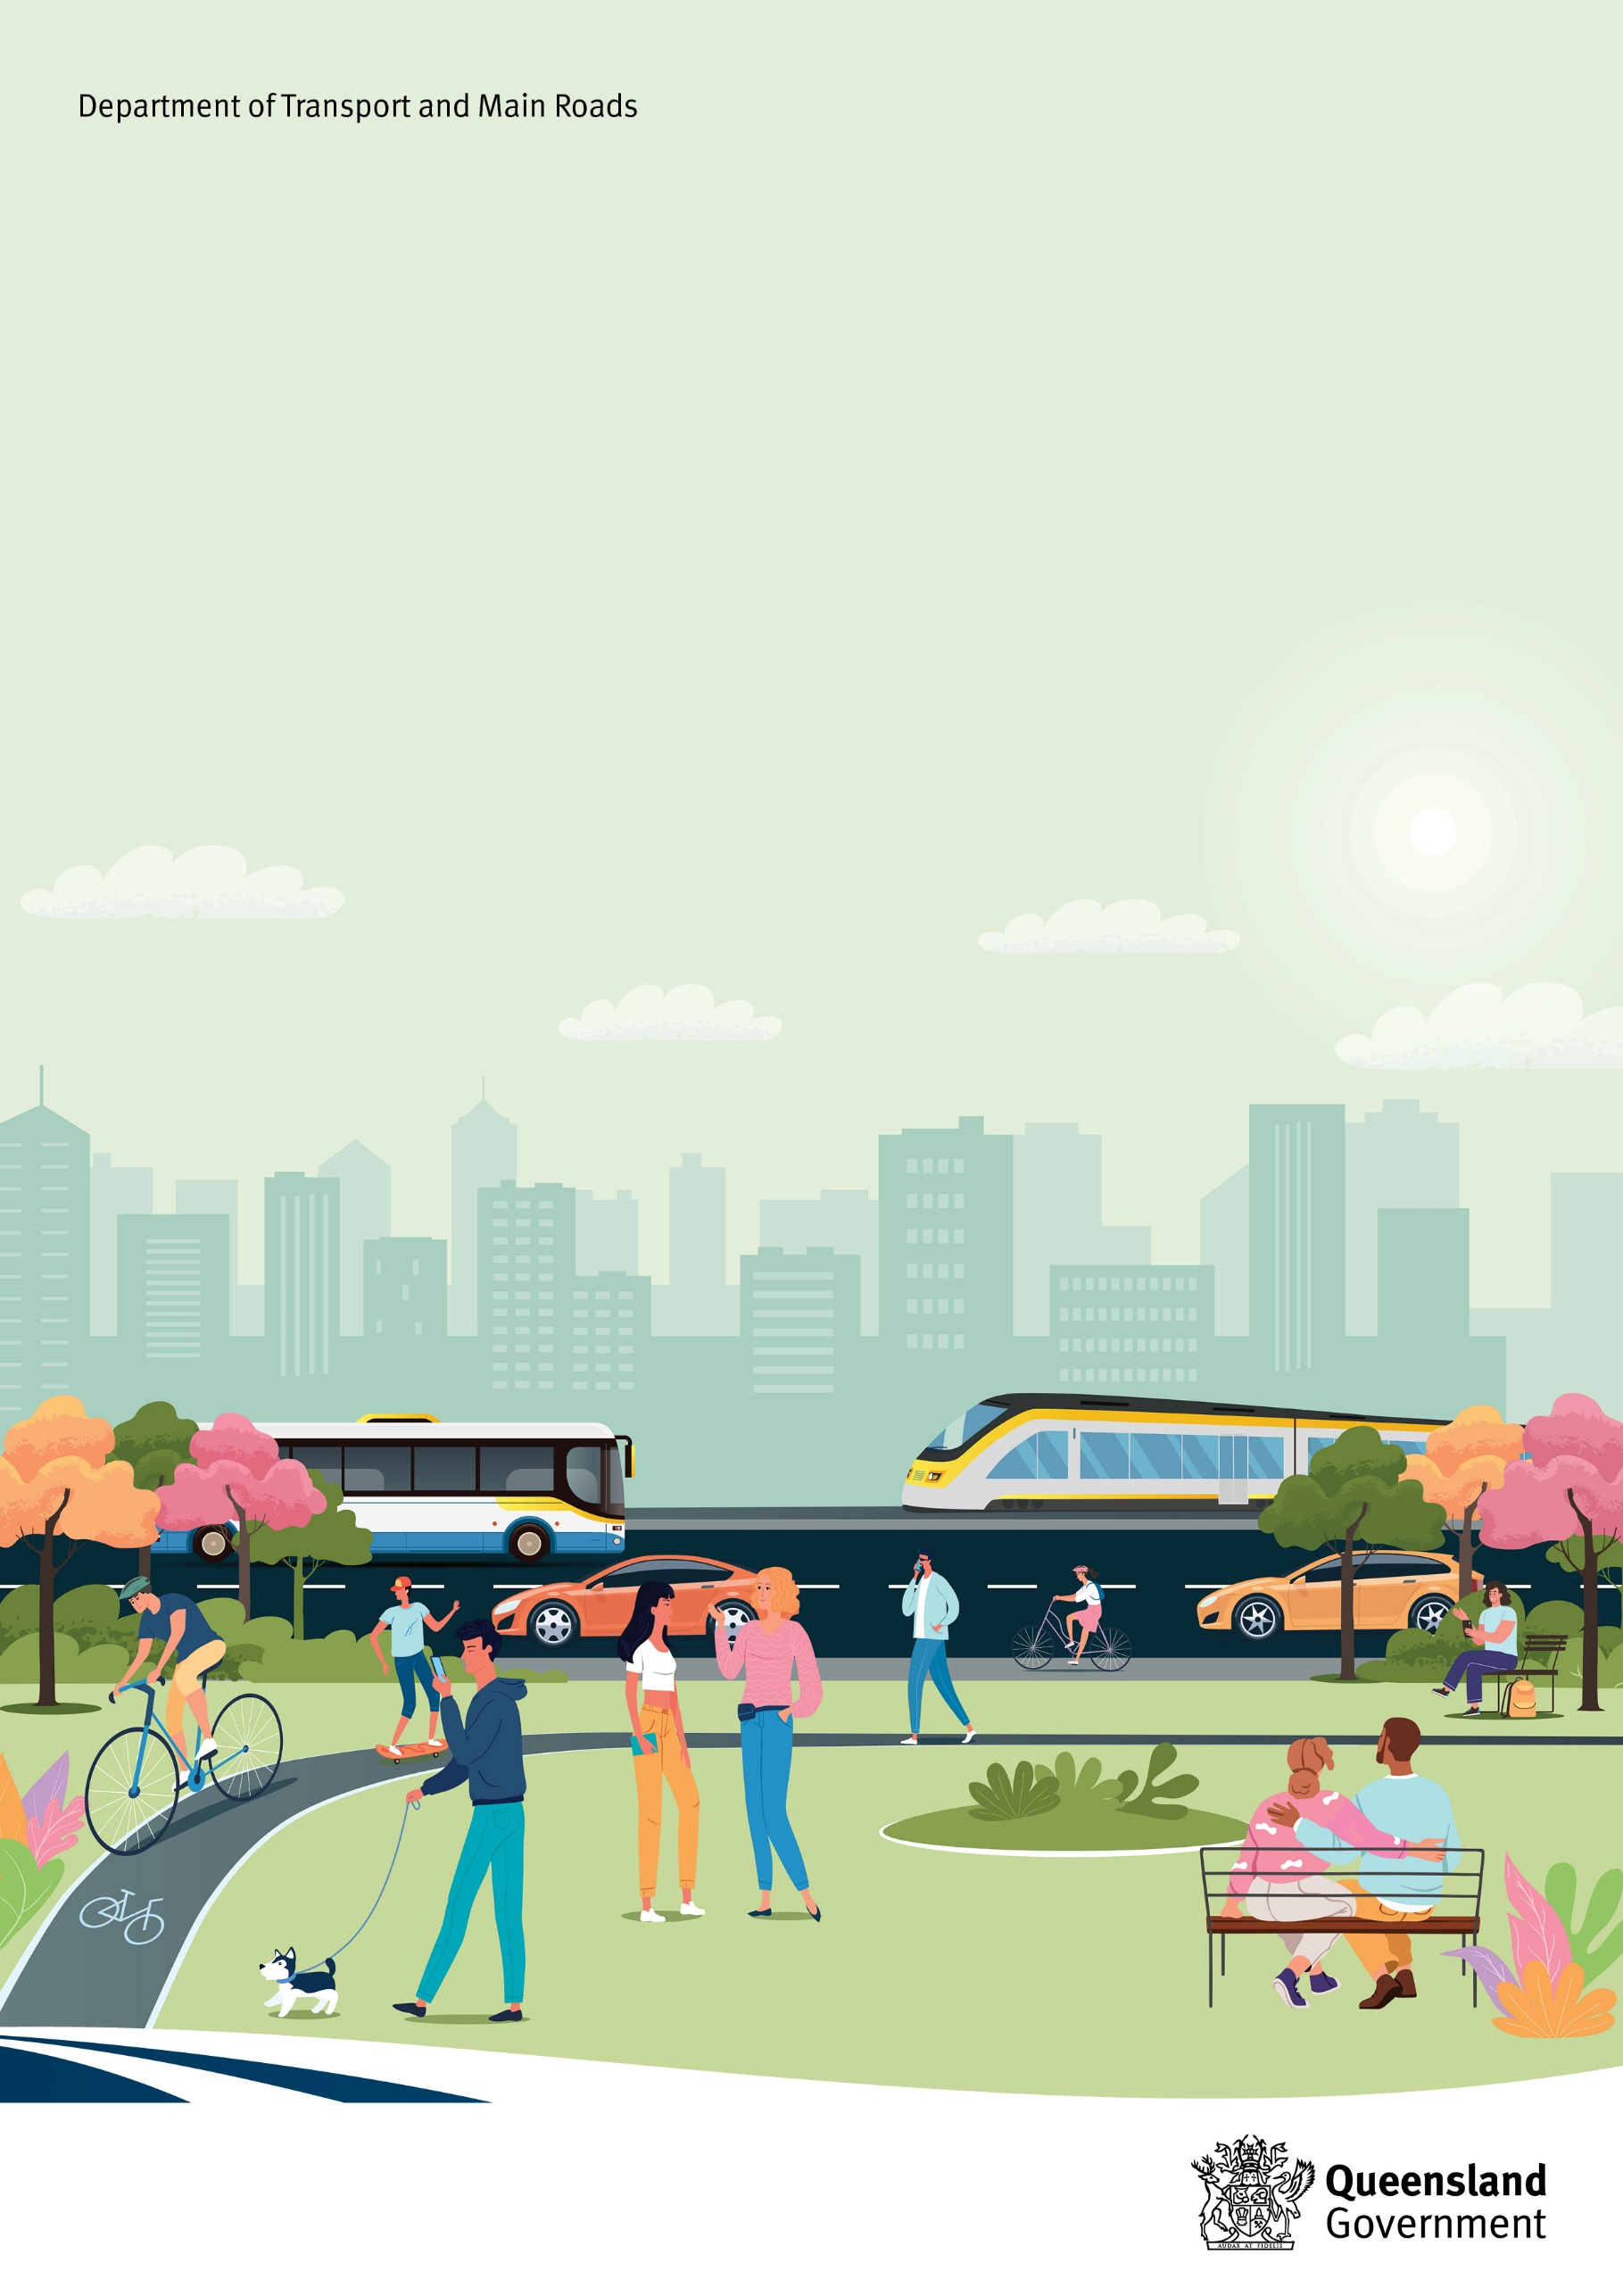
Movement and Place Practitioner Guidance
December 2024

Copyright information
© State of Queensland (Department of Transport and Main Roads) 2024.


The Queensland Government is committed to providing accessible services to Queenslanders of all cultural and linguistic backgrounds. If you have difficulty understanding this publication and need a translator, please call the Translating and Interpreting Service (TIS National) on 13 14 50 and ask them to telephone the Queensland Department of Transport and Main Roads on 13 74 68.

Disclaimer
While every care has been taken in preparing this publication, the State of Queensland accepts no responsibility for decisions or actions taken as a result of any data, information, statement or advice, expressed or implied, contained within. To the best of our knowledge, the content was correct at the time of publishing.

Acknowledgement of Country
The Department of Transport and Main Roads (TMR) acknowledges the Traditional Owners of the lands and waterways. We also acknowledge their ancestors and Elders both past and present. The Department of Transport and Main Roads is committed to reconciliation among all Australians.


Artwork: ‘Travelling’ by Gilimbaa

Purpose of this document
The Department of Transport and Main Roads’ (TMR) Movement and Place Practitioner Guidance (the Practitioner Guidance) explains how practitioners can apply TMR’s Movement and Place Policy (MPP) to decision making, planning, design and management of our transport network to maximise benefits for our customers.
The Practitioner Guidance introduces the movement and place process and describes how to apply movement and place elements to undertake future planning, develop strategies, and deliver projects.
It is designed to complement and enhance current approaches to project management methodology with a ‘vision and validate’ approach, including stakeholder engagement, development of project briefs, business cases and strategic planning. The steps of the movement and place process are scalable and flexible, to enable a context-sensitive application of MPP elements to projects across Queensland.

About this document
This Practitioner Guidance outlines:
- the movement and place approach and process at a strategic level, including identifying the key steps and milestones
- a collaborative methodology for practitioners, stakeholders, and the community to use a common language in supporting the shared responsibility of place-making
- a process for implementing this approach across a range of decisions and throughout the life cycle of a plan, project, or asset, and
- an approach to measuring and evaluating the alignment of movement and place elements in existing contexts, comparing options, and monitoring, reviewing and improving outcomes.
As movement and place is implemented and evolves across TMR, this document will be reviewed and supplemented to further assist practitioners and evaluators.

Table of Contents
Acknowledgement of Country 2
Purpose of this document 3
About this document 3
Movement and Place overview 6
Our Vision 6
Principles of movement and place 7
Movement and Place Operational Framework 8
Where does Movement and Place apply? 9
Movement and Place Methodology 10
1. Scoping 14
Step 1 purpose 14
Step 1 inputs 14
Scoping, the team and governance 14
Step 1 outcomes 15
2. Forming 16
Step 2 purpose 16
Step 2 inputs 16
Strategic context 16
Stakeholder analysis 16
Defining ‘movement’ 17
Understanding ‘place’ 18
Developing a shared vision 19
Key milestone – success definition 20
Step 2 outcomes 23
3. Exploring 24
Step 3 purpose 24
Step 3 inputs 24
Classification of ‘movement’ and ‘place’ 24
Classifying movement 25
Classifying place 27
Identifying the movement and place classification 29
Validation against the vision 31
Step 3 outcomes 31
4. Shaping 32
Step 4 purpose 32
Step 4 inputs 32
Develop options 32
Options analysis 33
Deliver, monitor and improve 34
Step 4 outcomes 34
Appendix A 35
Performance Indicators 35
Theme 1: Vibrant and successful places 35
Theme 2: Healthy and happy people 37
Theme 3: Natural and sustainable 38
Theme 4: Connected 39
Appendix B 40
Urban and Rural Classification Matrices 40

Movement and Place overview
At its core, movement and place is an approach to positively integrate transport as contributory to the life of communities, and the quality and experience of the built and natural environment. Widely recognised as best practice, its approach seeks to achieve balance of the transport network’s function in moving people and goods with the role of transport corridors, nodes and precincts also acting as places that are essential to social and economic activity.
The movement and place approach was developed to help reduce friction between these two functions, particularly in recognition of increasing levels of demand for finite spaces. Through a vision and validate approach, it seeks to improve outcomes for placemaking on roads and streets in urban and regional environments, by envisaging the places we want to create and planning ways of getting there. It encourages a more holistic consideration of different activities within spaces rather than solely considering the movement of vehicles, often to the detriment of quality and amenity of place.
Vision and validate describes the approach used in the movement and place process which replaces the historic ‘predict and provide’ method. Where predict and provide estimates future requirements based on historic patterns and aims to meet them, vision and validate defines a preferred vision and objectives for the future, and identifies the option(s) that is most likely to achieve it. It does this through collaboratively creating a shared future vision and performance indicators for a location or project, identifying and developing strategies and initiatives to achieve the agreed vision, and testing and validating these strategies and initiatives to ensure they can deliver the agreed vision.
Adopting a movement and place approach in Queensland will improve the quality of the transport system and environment, and foster more activated, sustainable, attractive and productive cities, towns and regions. TMR’s MPP adopts the vision and validate principles associated with the movement and place approach to inform planning, design, operational and investment decisions for Queensland’s transport network and precincts. In doing so, it aims to provide better outcomes and more opportunities for Queensland’s people and places.

Our Vision
With collaboration and inclusivity at the centre of what we do, we consider the complementary and essential contributory functions of movement and place together to deliver multiple-value outcomes from our transport network. In doing so, we positively contribute to the creation of more connected, liveable and sustainable neighbourhoods, cities and regions for all Queenslanders.

Principles of movement and place
The movement and place principles guide decision making throughout policy, planning and investment stages. Most of the principles will be familiar to TMR practitioners, but when considered together, they set the tone of our organisation’s aspirational and practical approach to embed movement and place in line with our vision.


Vision and outcome led
Transition from a ‘predict and provide’ approach to ‘vision and validate’ by shaping an endorsed vision, with clear proactive outcomes that address both movement and place to guide project activities and decision making.

A people and place focus
Put people and place front of mind to ensure we consider the environmental, social and economic aspirations of a place as well as moving people and goods.

Contextually holistic
Guide solutions to achieve the endorsed vision through development of a complete picture of movement and place factors, including connection to Country.


Collaborative approach
Include and empower stakeholders and partners to play an instrumental role in shaping the development and application of movement and place to meet their needs, roles and responsibilities.

Flexible and scalable
Empower practitioners, stakeholders, partners and decision-makers to make decisions which best suit their movement and place aspirations, from state or regional planning to the design or operation of a local place, precinct, street, road or intersection.
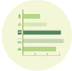
Evidence based
Broaden the types of qualitative and quantitative evidence about place and use it to support understanding of context, define success, identify impacts and benefits, consider trade-offs, and ultimately inform decision making.

Movement and Place Operational Framework
Releasing TMR’s MPP and Practitioner Guidance is the first step in our Operational Framework (Figure 1) to embed organisational change and build capability to improve the balance of movement and place outcomes across the transport system. Figure 1 shows the MPP and Practitioner Guidance (this document) which form the foundation of the framework, followed by a more detailed implementation plan with overarching themes of governance, change management and communication with stakeholders and partners.
Embedding movement and place will enable TMR to:
- Work collaboratively with industry, partners and practitioners: assist TMR to work with industry and a range of cross-government practitioners from engineers and operators to urban planners and designers
- Frame and deploy: educate and communicate the concept and rationale for the implementation of the framework
- Establish the common language required to support implementation of the Framework by providing definitions, classification matrix and performance indicator themes.
Figure 1: Movement and Place Operational Framework
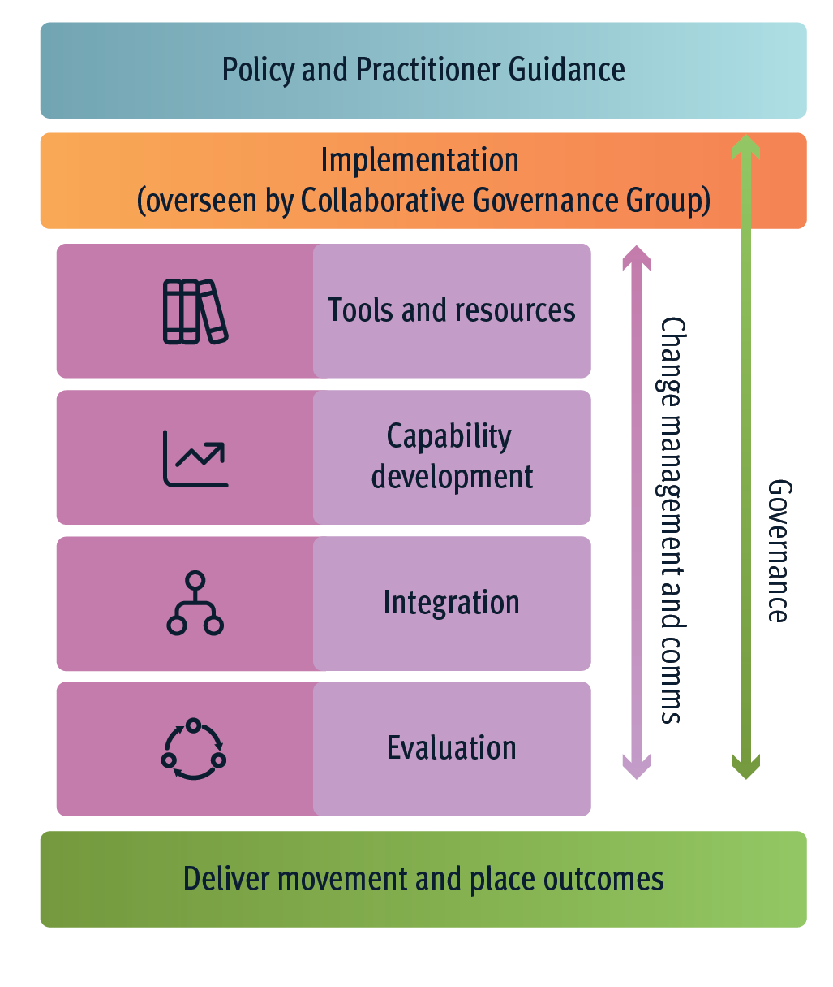

Table 1 sets out the key focus areas to support implementation which are intended to be developed and refined by a TMR Movement and Place Collaborative Governance Group (MaP CGG).
Table 1: Snapshot of potential implementation focus areas
Focus area | Description
Tools and resources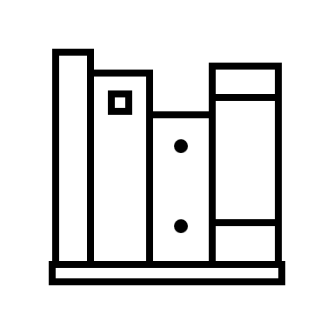 | Develop new and update existing resources and tools to ensure effective integration and application of movement and place across a wide range of project scales, including pilot projects that contribute to continuous learning and improvement.
Capability development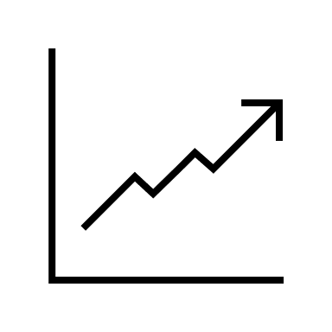 | Grow movement and place skills, knowledge, and capabilities across relevant TMR teams.
Integration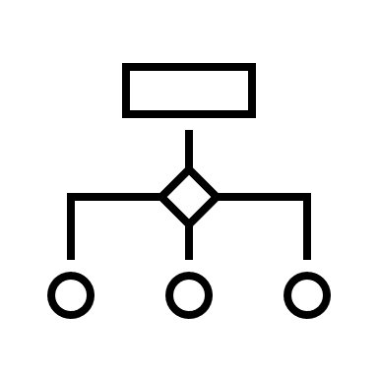 | Fully integrate the Movement and Place Framework into TMR's standard practices, ensuring that it becomes a fundamental consideration in all aspects of transport planning, design, operational management, and investment decision-making.
Evaluation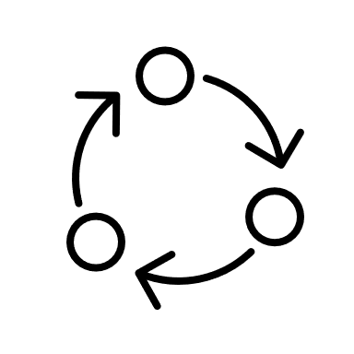 | Support continuous improvement in embedding and monitoring of movement and place practices across TMR, and ensure improvements and learnings are applied and communicated.

Where does Movement and Place apply?
As every journey on the network has interactions with places, and all places are impacted positively and negatively by their connection to the network, a movement and place approach can be applied in any scenario or scale of project in either urban or regional contexts.
The movement and place approach and process has been designed to be flexible and scalable. It can be applied broadly from strategic network planning (regional, district-wide) to targeted projects (assessing speed zones, improving access) or master plans, operations and maintenance.
Movement and place is intended to augment, not replace, current planning and project processes. In each case, the principle of ‘vision and validate’ remains central to the process and its outcomes.

Movement and Place Methodology
The movement and place process adopted by TMR (Figure 2) aims to deliver a collaborative and vision-led approach that better considers and integrates place in our investment, planning and projects. The process is designed to complement, rather than replace, current project management methodology by using a collaborative and iterative process to design the best possible outcomes for both movement and place. The process is also about identifying and acknowledging the conflicts and trade-offs that need to occur to deliver these outcomes.
The key elements that comprise the movement and place process are:
- a comprehensive understanding of context and the development of a shared vision with performance indicators
- define and classify contextually specific movement and place objectives
- application of the roads and streets classification matrices
- option analysis and selection, and
- deliver, monitor and refine.
The methodology involves four key steps summarised in Table 2, with further details provided in the following sections of this document.

Figure 2: TMR Movement and Place process
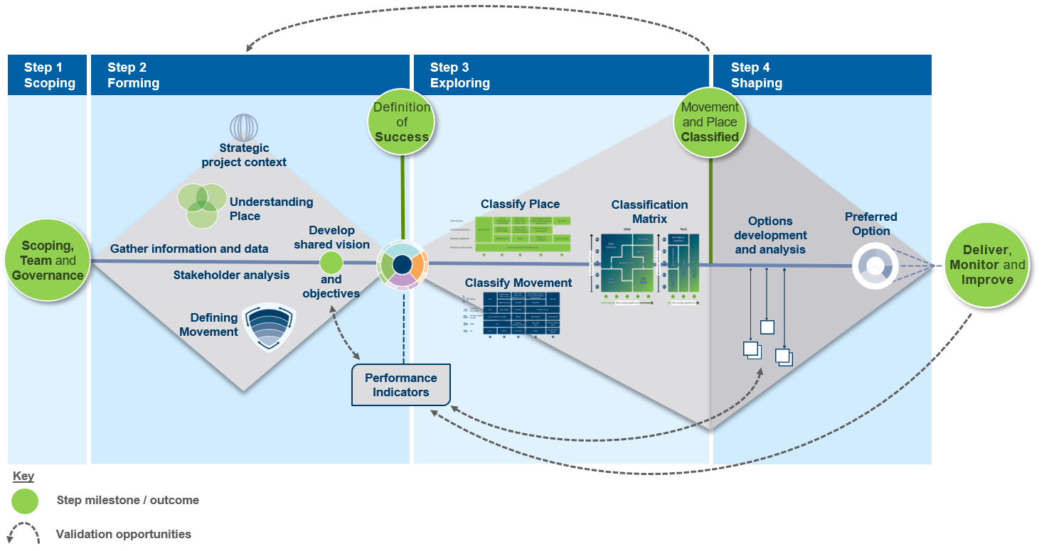

Table 2: TMR Movement and Place process summary
Step | Purpose | Inputs | Key Tasks and Activities | Outcome
Step 1: Scoping | To scope and understand the project at a high level, set out and understand the movement and place approach and parameters, and establish a project team that has the appropriate expertise to best understand and work together to deliver quality outcomes. | - Plan / problem identification | - Analyse and understand the strategic social, environmental, and economic context for the plan or project, including understanding the local and state government planning intentions for the study area  - Establish a project team and a governance structure to apply MPP principles to achieve both movement and place outcomes. | An established project team to implement the movement and place process, with key milestones and responsibilities agreed.
Step 2: Forming | To develop a more in-depth understanding of the strategic context of the project, analyse the stakeholders involved contextually and develop an approach to engagement, and define and understand the 'movement' and 'place' elements. This Step also includes, critically, the development of a shared vision and strategic objectives, as well as identifying Performance Indicators for future validation. | - Project team and plan  - High level project context | - Collaborate and engage with stakeholders across multiple disciplines, including engagement with local community including First Nations people using appropriate cultural practices and protocols, to establish:  - a deeper understanding of the study/project area (building on the context established under Step 1) including stated community aspirations and local planning intent, to inform the strategic, environmental, social and economic context  - a definition of ‘place’ and ‘movement’ functions, needs and priorities within the project context  - a movement and place vision and objectives  - Agree on a definition of success and set of prioritised performance indicators to enable a qualitative and/or quantitative appraisal of the project delivery against the movement and place vision. | A thorough understanding of the project context, an understanding of the movement and place elements of importance to the community located in the study area, an engaged group of stakeholders, and agreement on a shared vision with identified performance indicators.

Step | Purpose | Inputs | Key Tasks and Activities | Outcome
Step 3: Exploring | To classify the 'movement' and 'place' elements of a given project and identify the opportunities, challenges and potential trade-offs which may occur in moving from the present state to a future state that achieves the agreed vision. | - Step 2 inputs  - Vision and objectives  - Performance indicators  - Stakeholders | - Identify issues and opportunities in detail, by classifying the role and significance of both movement and place in present and future scenarios  - Conduct a gap analysis to begin to form options as to how to reach the established movement and place vision and definition of success. | Current and desired future state movement and place classifications.  A gap analysis between the current and desired future state, validated against the vision.
Step 4: Shaping | To identify and explore options that respond to the opportunities and challenges identified in Step 3 and select the option that overall has the strongest alignment with the vision and Performance Indicators - this validation of the preferred option is to then follow through to delivery and ongoing monitoring and improvements if necessary. | - Step 3 inputs  - Stakeholders  - Gap analysis | - Assess options against the vision, success definition, and current and desired future scenarios  - Identify the preferred option through evaluation of evidence and performance indicators, consideration of trade-offs, and further stakeholder engagement  - Deliver, validate, monitor and improve against the vision, success definition and selected performance indicators. | A preferred option that can be delivered and tested against the previously defined shared vision and performance indicators to inform further opportunities to improve.

1. Scoping

Step 1 purpose
To scope and understand the project at a high level, set out and understand the movement and place approach and parameters, and establish a project team that has the appropriate expertise to best understand and work together to deliver quality outcomes.

Step 1 inputs
- Plan / problem identification

Scoping, the team and governance
Establishing a shared, movement and place-based vision for a study area or project context is underpinned by the aspirations of the project team, relevant local / state government, people, communities and businesses connected with the study area.
In this Step, initial scoping of the project context and area should:
- Consider strategic plans, policies or strategies that are relevant to the study area (for example: Regional Transport Plans, Cycling Network Plans, freight routes, etc).
- Consider the existing and strategic planning intentions and aspirations of relevant local / state government stakeholders, including ‘live’ development applications, as well as the people, communities and business connected with the study area to help understand the strategic social, and economic context of the plan or project.
- Analyse and interrogate information to understand the physical and social context and characteristics of the study area and the transport task at hand using spatial data, demographics, overlays, previous studies and site visits where appropriate, including identifying where specialist studies may be necessary. Consider the following six layers – the environment, the community, heritage and culture, urban form, commerce, and activity and movement.
- Consider the stakeholders applicable to the project including their interest and influence on the project area and how and when they may need to be engaged.
This high-level scoping of the project context will allow the formation of the right people to lead the movement and place process and start to establish project management principles around key responsibilities and risk management.
Depending on the project, applying a movement and place process requires a multidisciplinary team bringing together suitable expertise to work collaboratively to holistically consider the project and the transport systems’ role in the place. By incorporating a diverse group of professionals with experience relevant to the project context, whether it be within the project team, working group and/or advisory body, it ensures a diverse approach to deliver interconnected, cohesive, and balanced movement and place outcomes. Developing an understanding of the project context in Step 1 will help inform the need to bring in certain expertise into the project team, for example urban designers, heritage consultants, architects, landscape architects, etc.
Through understanding the project context, the team can identify the inputs that may be required in Step 2, which may include inputs on both ‘movement’ and ‘place’ aspects of the study area, and should consider the necessary requirements and methodologies to support the project relating to data collection, modelling and stakeholder engagement.
The project team will be responsible for initiating and implementing the steps of the movement and place process, including leading the ‘vision and validate’ approach.

Step 1 outcomes
- A strategic-level understanding of the project, the study area and its context.
- An established project team to implement the movement and place process, with agreement on key milestones, risks, resources and responsibilities.
- A list of required inputs necessary to inform Step 2, such as the likely stakeholders, any further research, specialist studies, data, modelling, or support necessary from additional subject matter experts.

2. Forming

Step 2 purpose
To develop a more in-depth understanding of the strategic context of the project, analyse the stakeholders involved contextually and develop an approach to engagement, and define and understand the ‘movement’ and ‘place’ elements. This Step also includes, critically, the development of a shared vision and strategic objectives, as well as identifying Performance Indicators for future validation.

Step 2 inputs
- Project team and plan
- High level project context
- Potential stakeholders

Strategic context
The project context established in Step 1 should now be explored in further detail. This includes problem definition and any issues related to the problem, the location, stakeholders, strategic alignment (including the strategic intent of state and local government, relevant planning obligations, etc). Other key matters such as risk identification, potential options, sustainability, environmental and cultural heritage and safety can be explored collectively and detailed by the project team.
Holistically considering all critical elements in this phase and arriving at an agreed vision with the project team is important when there are conflicts and/or trade-offs to be considered in Step 4. Not all stakeholders will ultimately benefit as they would have liked, however the role of the project team will be to consider all the trade-offs and make decisions best aligned to the vision of the project.
There are multiple stages where decisions will be validated against the vision, and depending on the project, where stakeholders will be involved in key decisions.

Stakeholder analysis
The project team should undertake an analysis of stakeholders applicable to the project and how they will be engaged. If applicable and appropriate, engagement with stakeholders should occur at this step, which may include an introduction to the project and project team, visioning exercise etc, to gather valuable input about the movement and place elements of the study area and to inform (or even define) the future vision.

Defining ‘movement’
For the purposes of the MPP and Practitioner Guidance, the definition of ‘movement’ is the movement of people and goods by a transport mode (e.g. active or public transport, private vehicle), typically covering movement to and from, through or within a transport system, or a combination.
Movement can be understood by practitioners through several lenses to enable an enhanced definition of the current and future role and function of transport modes in order of their impact. The movement elements are shown in Figure 3 and described in further detail below.
Figure 3: The defining elements of 'movement'
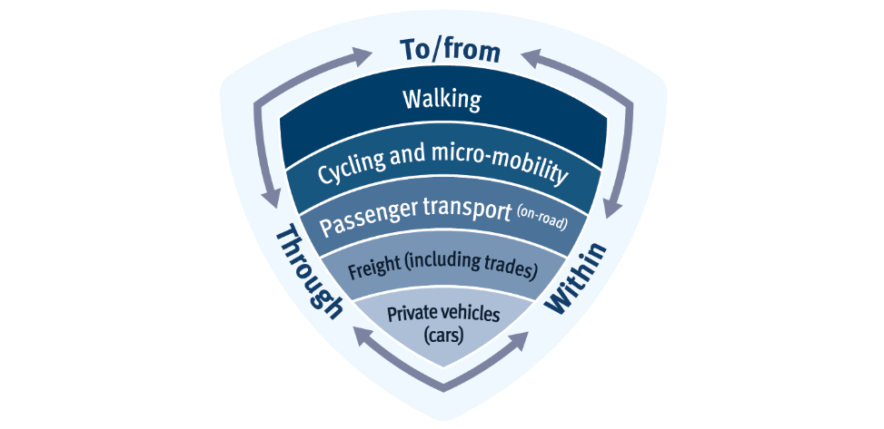
Character/function
This lens focuses on characterising the nature of the transport task in relation to the project context or study area, and considers how people travel to and from, through and within it:
- To / from examines how, why and when movement (people and goods) are generated from within the study area, with an external origin or destination
- Through examines how, why and when people and goods move through the study area without stopping or dwelling
- Within examines how, why and when local or ‘contained’ movement of people or goods occurs wholly within an area, centre or precinct within the study area.
Modal hierarchy
This lens focuses on understanding the transport elements of a study area in relation to its existing hierarchy of transport modes, such as walking and cycling, public transport and private vehicles, and their relative levels of impact and influence within the project context or study area.
The future priorities around movement and the role of each mode within the project context or study area should be established. By thinking about the needs (and character/function) of movement in this way, and depending on the context of the project, practitioners should consider opportunities to address more sustainable transport modes first and plan or design for other modes once these opportunities are maximised.
Within any given study area there are likely to be a combination of movement types and travel modes, depending on the local context and the types of activities that occur within or adjacent to it. Developing an understanding the type of movement occurring within a study area and the interactions between each movement type is critically important to help define the future vision.

Understanding ‘place’
For the purposes of the MPP and Practitioner Guidance, the definition of ‘place’ is a space or location which has meaning shaped by the activity of people within it, its social and economic value to the community, and its physical and natural setting.
To define place in a project context is to seek to understand the complexity and collective meanings people attach to a place (including the activities that occur within it) and define a vision for this meaning, for now and in the future. ‘Place’ can be a generic term in transport related projects, as it might refer to a very specific location or an entire corridor. Defining the location and scale of the ‘place’ element(s) within the study area forms part of this step. There may be multiple ‘places’ each comprising different scales, activities and distinct attributes which all need to be considered individually. Depending on the project context and vision, it may also relate to providing or designing a new place within a ‘movement’ project.
To assist the process of understanding place, six layers have been identified which, when explored and mapped, are intended to provide a holistic representation of a places’ characteristics. Through these layers, a place can be characterised, defined, and understood on a time continuum including its historical and current context, future aspirations, vision or intent. An understanding of relevant statutory obligations and planning approvals applicable to place should also be developed at this stage of the process.
In addition to understanding and mapping the physical characteristics of place (using the six layers), project teams should seek to gather insights and perspectives from diverse stakeholders including local communities and First Nations groups when considering movement and place principles to find an approach that is commensurate to the scale of the project context or study area, that reflects connection to Country.
The considerations that can help practitioners holistically understand a place are summarised in Table 3.
Table 3: Understanding 'place'
Place 'layer' | Definition
Environment | the important physical features, distinctive flora and fauna, topography and hydrology – the elements of the natural environment
Community | demographic characteristics of a community, patterns of place use, social and community assets and places of community cohesion and gathering such as schools and places of worship
Commerce and activity | the fundamental drivers of economic productivity, land use mixes, the location of places of commerce and exchange that support lifestyle needs
Movement | the patterns of use (volume and time) and different hierarchies of movement infrastructure – starting with active and public transport infrastructure through to private vehicles
Heritage and culture | the important cultural and historic significance that contribute to a sense of place and identity
Urban form | the typologies of buildings, variety and locations of properties and spatial organisation of neighbourhoods. Consider various scales from regional, city, to a local area and the overall structure of a city with the pattern of development and streets to the relationship of public realm (and parks) and street widths to developable land and granularity of street block sizes.
This process of defining the various elements that make up place in a project context, particularly through stakeholder engagement, will provide a deep understanding of the potential value that place holds, or should hold, in setting a future vision.
These initial investigations can help to consider place through the six layers described in Table 3 above. Present information through diverse methods of documentation including through video, photographs, sketches and mapping, to assist project teams to observe and note the interactions and interfaces between movement and place within their study area.

Developing a shared vision

Defining a vision
Step 1 requires an understanding of ‘movement’ and ‘place’ to be developed through data collection, analysis and mapping. Step 2 (this step) involves collaboratively identifying a vision, strategic objectives and measures for success for the project/study area.
Establishing a shared, co-designed vision for both movement and place involves a collaborative process based on a shared understanding of the desired future state between the project team, key stakeholders and / or community representatives who bring knowledge and experience to the process. The vision is required to determine how the study area will best benefit the community in the future.
When developing a vision for the project, practitioners should consider how this vision paints a compelling and tangible narrative of a future state for the place and the role and experience of movement related to that place. The vision should define the outcome sought and should be able to be used to direct the thinking, activity and actions of the team. Advocacy of the vision will serve as a conceptual map to direct and challenge people to design and achieve the desired future state.
The key MPP elements to assist with establishing the vision involve the following:
- principles
- the context specific understanding of the issues and opportunities for both movement and place, and
- the categories for prioritised performance indicators.

Strategic objectives
To develop strategic objectives that relate to the shared vision, project teams should refer to the four movement and place performance indicator outcome themes of connected, vibrant and successful places, healthy and happy people, and natural and sustainable (see diagram and description in the following section). The following key questions should be considered when setting objectives:
- Which of the four themes are relevant to the project context and vision?
- What role does movement play in each of the four themes?
- What role does place play in each of the four themes?
- Which themes should be given a higher or lower priority?
- Are there other layers that need to be considered – for example, safety, accessibility, movement and place activity over time?
- Is there a specific issue or theme within the local context that is driving the project need?
The linking of strategic objects to performance indicators will greatly assist in creating a definition of success and benchmark measurements and validation for the remainder of the movement and place process.

Key milestone – success definition
With an agreed vision and strategic objectives in mind, the project team should collectively define how this vision can be reviewed, validated and adjusted to ensure the vision is achieved and successful and sustainable outcomes realised. A key component of this milestone will be through the determination and allocation of a series of agreed performance indicators.
The movement and place process should not continue to Step 3 until this milestone and success has been defined and agreed on by the project team.

Performance indicators
Overview
Performance indicators (PI) play a crucial role in evaluating the effectiveness of policy by providing quantifiable measures that help define and assess success, guide decision-making, and continuously identify areas for improvement.
PI provide structure that is adaptable and scalable for use across a range of practices, from strategy and planning to design, operation and investment decision making. Identifying PI as part of the collaborative vision setting phase and reviewing for adjustment as required across different project stages, will help deliver benefits and enable TMR to set a responsive, outcome-led approach.
PI are the mechanism to achieve the shared vision and enable:
- evaluation of the existing and or planned future state
- assessment of different options
- final assessment and reporting
- monitoring of success after delivery.
A series of movement and place performance indicators, grouped into four themes have been developed specifically for TMR’s Movement and Place approach and map directly to the four policy objectives set out in the MPP. They provide a structure that is adaptable and scalable for use across a range of practices, from strategy and planning, to design, operation and investment decision making.
The four Performance Indicator Themes (PI Themes) of the performance indicator wheel (Figure 4) are:
- Vibrant and successful places: focus on integration of transport with the built environment to create great places
- Healthy and happy people: focus on role of transport supporting desired social outcomes
- Natural and sustainable: focus on the interplay between transport, the natural environment and sustainability
- Connected: network connectivity with a focus on sustainable and reliable mobility choices.

Figure 4: Broad movement and place performance indicators
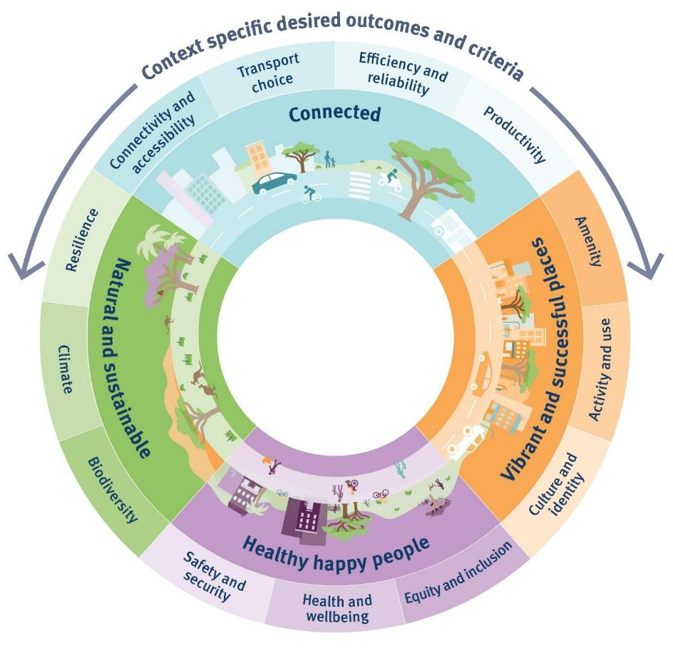
Selection
The project team will collectively determine how the agreed vision and definition of success will be measured. The team will do this by identifying which PI Themes directly align to, and represent the desired outcomes of, the vision, then select one or more indicators from those themes. Including measures from across the performance indicator wheel will ensure balanced movement and place outcomes. Project teams may also consider applying different priority or weightings to indicators to ensure an appropriate balance or to strengthen alignment with the vision.
Measurement
Performance Indicators can be measured through both qualitative and quantitative means. For example, if there is an objective about improving safety and security, customer perception surveys about safety of a place may be considered. Or undertaking active transport data collection, if one of the objectives is to achieve an increase the number of people cycling. Both types of data can be used to measure the before and after scenarios.
Setting the performance indicators and measurement methods is important here, as they will form important validation touch points in Step 3 and Step 4, as demonstrated in the Movement and Place Process (Figure 2).
Appendix A provides further definition of each PI Theme, the desired outcomes and objectives, and potential inputs which can assist project teams in the measuring of selected indicators and ultimately the success of their project against the vision.

Step 2 outcomes
- An analysis of stakeholders, and engagement approaches where appropriate
- An understanding of ‘movement’ and ‘place’ in the context of the study area / project
- A clear shared vision and definition of success
- An agreed set of performance indictors and measurement approach.

3. Exploring

Step 3 purpose
To classify the ‘movement’ and ‘place’ elements of a given project and identify the opportunities, challenges and potential trade-offs which may occur in moving from the present state to a future state that achieves the agreed vision.

Step 3 inputs
- Build from Step 2 inputs
- Vision and objectives
- Performance Indicators
- Input from stakeholders

Classification of ‘movement’ and ‘place’
Taking the vision established in Step 2, this next step is about studying the desired future movement and place elements of a study area in detail and comparing them to the existing condition. It is important to consider both ‘movement’ and ‘place’ elements separately and then together. This process step is critical in order begin to identify where the opportunities, challenges, and potential trade-offs may occur in moving from the current state to the desired future state.
With a shared future vision and strategic objectives in place from Step 2, the project team should now consider and classify the ‘movement’ and ‘place’ functions of the study area in its current form and the desired future outcome. By thinking about these two scenarios, a deep exploration of issues and opportunities can be considered and a pathway to reach the future state defined. This will consider what changes, if any, may need to be made to the ‘movement’ and ‘place’ functions within the study area and where balances between the two need to be made.
To assist project teams in considering the current and / or potential future functions of a road or street from a movement and place perspective, classification matrices can be used to collaboratively identify a typology that best reflects both the current and the desired future state.
Classification requires three key inputs:
- a vision (from Step 2)
- classifying movement, and
- classifying place.
The latter of these tasks are described in the following sections.

Classifying movement
Practitioners should next use the classifying movement diagram (Figure 5) to determine the current and desired future movement significance based on the agreed vision. Using research and evidence initially developed in Step 2, rank where on each of the five rows the movement attributes best fit.
Movement significance captures the types and scales of transport functions across the network. It considers the broader network context of the study area and nature of movement tasks including the movement of people and goods to and from, through and within an area.
Classifying the movement significance of a particular road or street also considers the functional hierarchy of modes across the network. Modes are considered and prioritised by both their suitability for a transport function, and in order of their sustainability.
The role certain roads and streets have to support sustainable mobility should be considered first. For example, identify and prioritise the functional and spatial requirements to support walking network plans, the principal cycle network, strategic bus or light rail network.
This classification activity enables discussion and deliberation about gaps between the existing state and desired future state, and the role of the movement of people and goods within a given context.

Figure 5: Classifying movement matrix
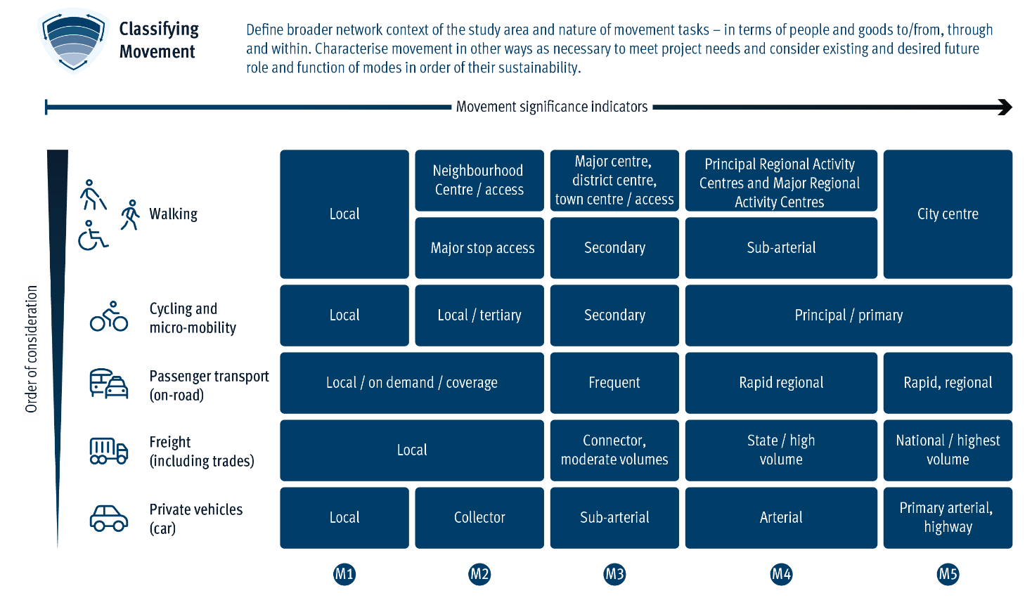

Classifying place
Practitioners should use the classifying place diagram (Figure 6) to determine the current and envisioned future place significance. Using evidence, including further stakeholder input where appropriate, project teams should rank where on each of the four rows the place attributes best fit in each scenario.
To help initiate this process, classifying place activity significance can be informed by assessing:
- Centre hierarchy – designated in accordance with Queensland Government’s regional planning terminology, this enables consideration of our formally designated key social and economic activity centres around the state.
- Community destinations – places that provide services for the community including educational facilities, healthcare facilities, recreational facilities and other retail and commercial centres.
- Destination significance – defined by the size of the catchment a place attracts visitors from.
- Place activity intensity – use activity intensity and dwell time data, in addition to classifying place activity significance, characterise other layers of place such as the environment and meaning of the place to the community.
As per movement, this classification activity enables discussion and deliberation about gaps between the existing state and desired future state, and the role of place within a project context and its contribution to achieving the future vision.

Figure 6: Classifying place matrix
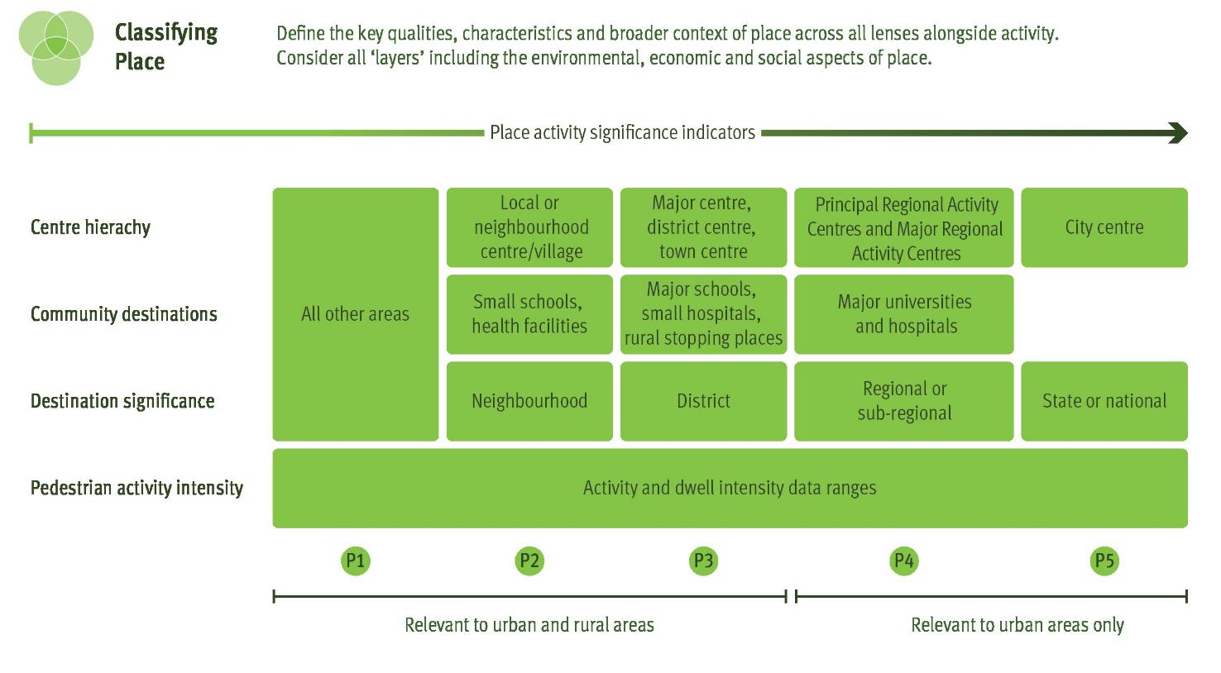

Identifying the movement and place classification
Once the individual ‘movement’ and ‘place’ classifications have been made for both current and future (vision) scenarios, they can then be plotted on the combined movement and place matrix.
Firstly, practitioners should determine the classification matrix (urban or rural), consider the road or street context. Determine the street / road typology by putting the place classification along the horizontal axis (from P1 to P5) and movement classification along the vertical axis (M1 to M5).
As shown in Figure 7 and 8 respectively, classification is based around a 5x5 matrix for urban areas and a 5x3 matrix for rural areas. Eleven categories of road and street environments have been identified which broadly encapsulate the range of typologies across Queensland (refer to Appendix B). Each typology is characterised by a different balance of ‘movement’ and ‘place’ functions, noting that the categories are not intended to cover every single scenario. More specific road and street typologies (e.g., transit boulevard, laneway) may be introduced in future.

Urban Movement and Place Classification Matrix
Relates to all developed areas of Queensland likely to attract a level of activity on our roads and streets. This includes detached housing areas in outer metropolitan suburbs to regional townships.
Figure 7: Urban classification matrix
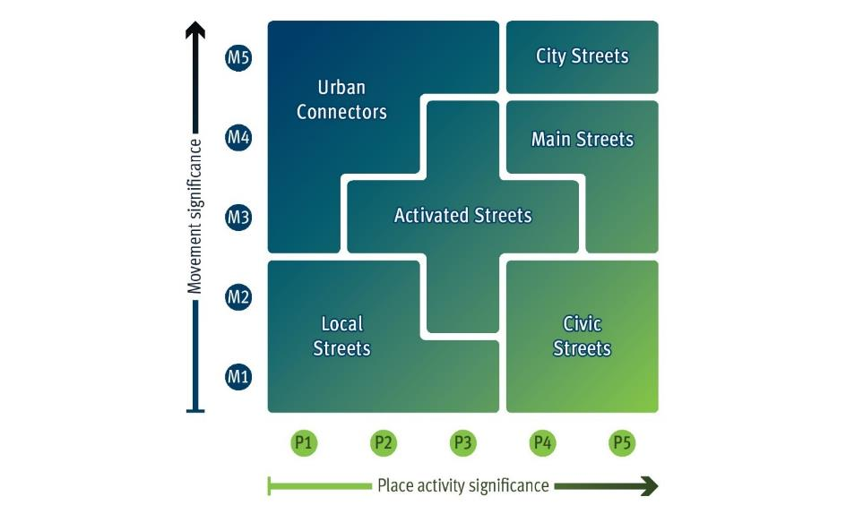

Rural Movement and Place Classification Matrix
Relates to less developed areas unlikely to generate significant levels of on-street activity, generally zoned for rural, agricultural, or similar uses.
Figure 8: Rural classification matrix
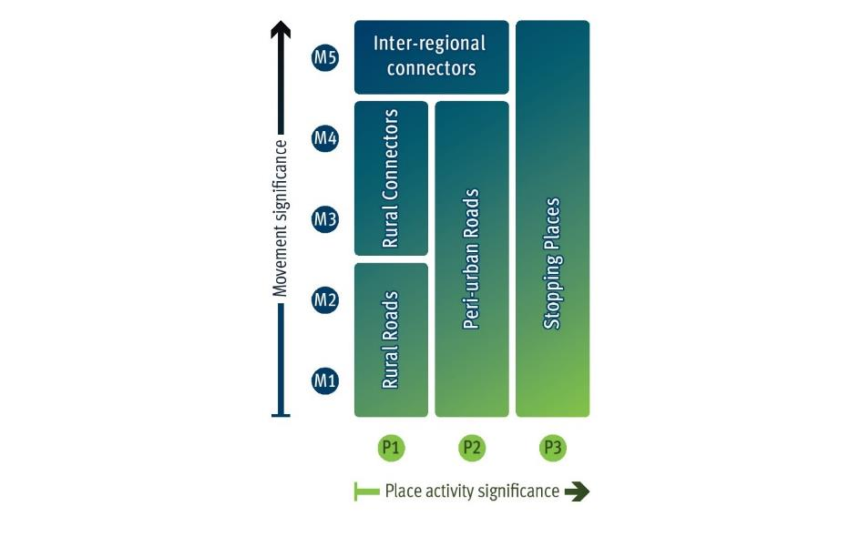Secondly, confirm the current and desired future state typology as part of multi-disciplinary, cross jurisdictional workshops and community engagement if appropriate. Rationalise adjustments to better align to stakeholder needs with clarity on broad typology achieved, agree on the functional priorities. This process is to consider the role and function of a street from a place perspective and for each mode to support project activities and provide for better design.
Lastly, the project team should seek to understand the issues and opportunities to determine a gap analysis between the current and desired future state to balance potential trade-offs and achieve collective outcomes. Developing and selecting options that respond to the identified gaps are explored in Step 4.
As shown in the urban example given in Figure 9, the ‘future state’ scenario based on an agreed vision will see an increase in a road's movement function from M1 to M2, resulting in a change in classification from ‘local street’ to ‘activated street’.
Figure 9: Current state vs future state matrix example (urban)
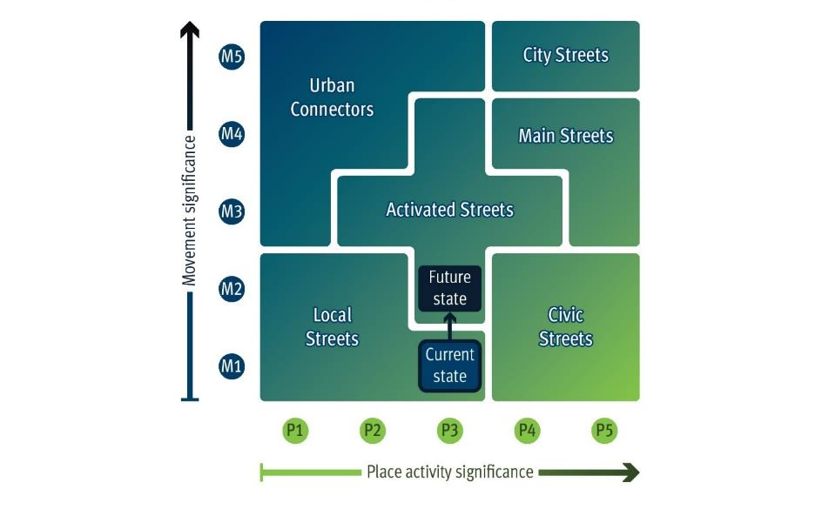

Validation against the vision
Once the urban or rural movement and place matrices for both the existing and future states have been established and agreed by the project team, there should be a reflection upon the work undertaken in Step 2. In particular, the team should consider the future state against the agreed vision to ensure alignment to the desired outcomes for the project.

Step 3 outcomes
- A deep understanding of current and desired future-state movement and place classifications which aligns with stakeholder input and the agreed vision.
- A gap analysis between the current and desired future state which considers issues and opportunities between place and movement functions to inform the next step in the process.

4. Shaping

Step 4 purpose
To identify and explore options that respond to the opportunities and challenges identified in Step 3 and select the option that overall has the strongest alignment with the vision and Performance Indicators. This validation of the preferred option is to then follow through to delivery and ongoing monitoring and improvements if necessary.

Step 4 inputs
- Build from Step 3 inputs
- Input from stakeholders
- Gap analysis and validation

Develop options
This step complements current best practice in options development and analysis, whether it be a policy, business or infrastructure investment project, the overall intent and process for developing and assessing options is similar. Option development (and analysis) guidance such as that provided by the Australian Transport Assessment and Planning Guidelines (ATAP) may be a useful reference for project teams at this stage of the process.
The work undertaken in Step 3 in classifying the ‘movement’ and ‘place’ characteristics of the study area and, particularly the gap analysis, should be used to inform the development of options and responses aimed at delivering on the agreed vision.
Examining all available data and information from various stakeholder groups, including inviting co-design where appropriate, relevant analysis and preliminary investigation results should all be considered in developing options that are aimed at achieving the agreed vision.
Options will be context-specific and may comprise physical interventions, optimisation of existing practices or operations, introducing behavioural change programs, safety improvements, or a combination of various measures. Validating the type of options against the project vision and objectives should be undertaken to ensure alignment and to avoid the potential for scope creep.
Depending on scale and context, each project may require different options for distinct locations – for example, an option for one section of a movement corridor may not be appropriate for a different section on the same corridor.

Options analysis
Each project type will have its own individual methodology of assessing and analysing the performance of identified options and interventions based on context. However, the movement and place process fundamentally requires the outcomes of options analysis to be validated against the agreed vision. The classification matrix analysis in Step 3 and the selection of performance indicators in Step 2 should be used to guide the assessment process, to understand and rate how well each option meets the project’s vision and objectives.
For example, transport modelling may be used to assess various impacts of a place-based enhancement on movement (or vice versa) with the outputs viewed against the vision and through the lens of the preferred movement and place outcomes for the study area.
Such an assessment against performance indicators could be undertaken using a simple matrix shown in the Table 4, with ‘Option 2’ being the preferred option in this example.
Table 4: Example options analysis matrix - alignment with performance indicator categories and result.
Option Analysed | Vibrant and successful places | Healthy happy people | Natural and sustainable | Connected | Weighted Result
Option 1 | Medium | Medium | Low | Very high | Medium
Option 2 | High | High | Medium | High | High
Option 3 | Medium | Low | Low | High | Medium
Option 4 | Medium | Medium | Medium | Very high | Medium
As various intervention approaches may form part of each option being analysed, tying the outcomes of each to the performance indicators selected (and potentially weighted) in Step 2 provides a useful way to compare outcomes. This can also be a helpful tool when considering trade-offs between options, and ‘movement’ and ‘place’ outcomes within options.
Ultimately, the preferred option should align with and achieve a project’s vision for the future, stated objectives, inform mitigation strategies to address the issues and significantly improve the current state to meet the desired classification of the future state in Step 3.

Deliver, monitor and improve
The last step complements current best practice in delivering, monitoring and continuous improvement, whether it be a policy, business or infrastructure investment project, the intent and process is similar. Reflection should be made here to the ‘success defined’ milestone achieved earlier in the process.
In any project, TMR project management best practice relies on continuous monitoring of the project performance to assess the overall health of the project and identify areas that require special attention. Through the movement and place process, there is a vision and set of performance indicators agreed in Step 2 which the project outcomes can be validated against and adjusted if needed. More detailed approaches to evaluation such as those set out by ATAP could be referred to here.
The MPP elements support existing TMR project management best practices by establishing a common language and understanding between disciplines, across jurisdictions and in the community. The use of the policy elements to report, brief and communicate with stakeholders, decision-makers and the community should promote a balance of ‘movement’ and ‘place’ for safer, healthier and more sustainable outcomes.

Step 4 outcomes
- An options assessment output that details the options that were considered, how they performed against the vision, and any trade-offs or changes that resulted from the analysis stage
- An agreed option that delivers on the project vision agreed upon in Step 2
- A review of the agreed performance indicators to test the validity of the preferred option against the vision, and monitoring to allow adjustments to be made if necessary.

Appendix A

Performance Indicators
The below tables include further detail about the four PI Themes: Vibrant and successful places, Happy, healthy people, Natural and sustainable and Connected. These PI Themes match the four objectives of TMR’s Movement and Place Policy. Each PI Theme is supported by performance indicators, objectives and inputs for practitioners to consider when evaluating them. The suggested inputs are notional only, and practitioners may refer to or seek additional inputs to consider. TMR practitioners may also review the TMR Metric Catalogue for inputs to consider, noting that some projects may necessitate the documenting of bespoke datasets relevant to a particular context.

Theme 1: Vibrant and successful places
Objective
The objective of the ‘Vibrant and successful places’ PI Theme is to collaboratively engage with community, local government and industry to design and shape movement and place outcomes that align with and benefit cultural identity, community needs and foster economic vitality.
Performance Indicator | Objective | Inputs to consider
Amenity considers the comfort, convenience and attractiveness of a place. This indicator can be used widely, from roads and streets to active transport corridors to public transport precincts.  Roads with wide paved corridors, high vehicle traffic volumes at high speeds, and limited landscaping, canopy, physical space or facilities for people ‘beyond the kerb’ can have negative impacts on the amenity and overall user experience of the built environment, impact the meaning of a place to local people, or constrain local social and economic opportunities | To measure the overall user experience of the built environment. | • Dwell times / duration of stay  • Quality of dwell spaces and facilities  • Characteristics of services available  • Noise pollution  • Percentage of shade  • Road characteristics (e.g., road width, speed, and traffic volumes)
Activity and use considers transport’s role in the economic and social activity of a place, the desired density and diversity of land use in the transport context. Transport can shape planning visions to consolidate urban growth by enabling a more compact built form, and supporting higher order centres with higher order sustainable transport connections. | To measure desired growth, land use and local social and economic opportunities within context. | • Activities along transport corridor (social and economic)  • Density (planned and existing) of land use, e.g. shops, restaurants  • Proximity of access to public transport services  • Volumes of people walking and cycling.
Culture and identity considers how transport can use social insights to preserve and celebrate both Aboriginal and non-Aboriginal values and heritage.  This indicator can take many forms in projects, reflecting the nuances of communities and users of an area and their values.  Engagement with Indigenous stakeholders can often lead to the identification of values that directly influence project development that support increased cultural respect, expression, or appreciation (e.g. through art, storytelling, naming etc). | To measure the area’s ability to reflect and respond to the local culture and nuanced values of communities and customers. | • The specific cultures and values of local communities and users  • Spatial information for built and environmental heritage listings  • Community engagement data

Theme 2: Healthy and happy people
Objective
The objective of the ‘Healthy and happy people’ PI Theme is to support desired social outcomes, ensuring the health, safety and security of people of all backgrounds and abilities.
Performance Indicator | Objective | Inputs to consider
Safety and security draws on the vision and targets set out in the Queensland Road Safety Strategy 2022–2031 from a road safety perspective, as well as the Queensland Counter-Terrorism Strategy. ‘Security’ encourages us to consider the users of a space and how the transport environment may need to ‘perform’ in providing personal security within a road, street, path or station as part of the built environment. | To measure and identify risks to people's safety and threats to the security of users or the network itself. | • Road safety audits  • Crime Prevention Through Environmental Design (CPTED)  • Road characteristics (traffic volumes and speeds) in high activity areas.  • Intercept surveys (understand perception of safety)
Equity and inclusivity considers a project’s approach to social considerations of fairness and equity. This calls on the TMR Accessible Network Team’s vision for ‘universal access’ from a design perspective and encourages us to consider how a road, street, station, or transport service network is fair, equitable and accessible. As with other indicators, important aspects of inclusivity need to be understood. Metrics of inclusivity can again vary significantly by project type, scale and location. | To measure the access to, use of the transport system and public infrastructure in terms of equity and inclusivity. | • Design audit on ‘universal access’  • Social exclusion index  • Affordable and effective public transport services to low socio-economic areas or outer metropolitan areas  • Level of diverse involvement in community engagement
Health and wellbeing considers the welfare and prosperity of people and communities. A ‘good’ transport environment is one that attracts people outside to be active in day-to-day life. This brings health benefits to individuals and reduces economic and operational impacts on health systems. | To measure the impact of design outcomes on the health and wellbeing of the people who use them. | • Active transport traffic and flows  • Health data by population cohort  • Crime data  • Health, wellbeing and activity spaces

Theme 3: Natural and sustainable
Objective
The objective of the ‘Natural and Sustainable’ PI Theme is to promote the use of active transport modes, create opportunities to reduce emissions, and deliver resilient and environmentally sustainable infrastructure.
Performance Indicator | Objective | Inputs to consider
Resilience considers the longevity and reliability of transport for customers and its ability to withstand and adapt to day-to-day operational planned and unplanned incidents, changing social and environmental pressures, and unexpected shocks and stresses in whatever form they take. | To measure the transport system and public spaces’ capability to operate under a range of conditions both planned and unplanned. | • Testing networks under different scenarios (COVID recovery, transport habits, natural disasters, emergency events)  • Reliability of the network (planned, unplanned, shocks and stresses)
Biodiversity considers transport’s impact on and integration with the immediate natural environment. Biodiversity is not usually an isolated indicator, but communities have growing concern for local natural habitat. In greenfield or urban expansion areas, it is critical to consider biodiversity and nature when planning and designing new links. It is also important to consider how biodiversity can be maximised in brownfield or infill areas or along existing corridors. | To measure impacts on local biodiversity and natural habitat. | • Green Infrastructure Index / spatial biodiversity data (for example, koala habitats, threatened ecological communities).  • Tree canopy coverage  • Urban green space
Climate considers the distinctive environmental characteristics of Queensland, high rainfall and hot temperatures. The business-as-usual criteria usually include user emissions; however this has broadened to include embodied carbon and urban heat (from exposed road pavement surfaces). This indicator, combined with biodiversity above, is a key aspect of meeting TMR’s Environmental Sustainability Policy. Climate impacts day-to-day human comfort and experience in the physical environment by having impacts on travel choices and participation levels. | To measure responsiveness to the local climate context, and measure the impacts of design outcomes in supporting and contributing to reduction of carbon emissions. | • Heat data  • Embodied, operational and user carbon emissions  • Road pavement coverage  • Air and water pollution

Theme 4: Connected
Objective
This PI Theme seeks to create a customer-centric approach to the design and development of our transport network by enabling safe, convenient, connected, and accessible places with a focus on sustainable and reliable mobility choices.
Performance Indicator | Objective | Inputs to consider
Connectivity and accessibility are traditional indicators of movement. Transport access facilities (e.g., parking, bus stops, stations, interchanges, bicycle parking etc) can also be evaluated as part of the ‘accessibility’ theme. Practitioners are required to identify what ‘good’ looks like for access by each mode, for those to be considered alongside other indicators. | To measure how conveniently and safely customers can access and travel between diverse transport options. | • Accessibility within 15 minutes or 30 minutes  • Walk score, transit score and bike score  • Elements affecting the study area such as signs, lighting and landscaping
Transport choice Transport choice is essential to meeting the diverse needs and preferences of customers and supports maximisation of sustainable transport uptake. | To measure variety of transport options available. | • Evaluation of mode share  • Access to various transport modes
Efficiency and reliability Considers efficiency in terms of movement of people and goods, rather than of vehicles. ‘Make the most with what we have got.’ In constrained urban environments where it is prohibitive to widen corridors due to cost, environmental or social reasons, we need to consider more space-efficient means of movement (including thinking beyond the immediate study area) and or consider trade-offs with vehicle movement performance. | To measure how efficiently space is used, how the system supports non-vehicular movement options, and reliability of the options. | • Efficient travel across networks and modes  • Pedestrian delay  • Performance by various modes to access key places
Productivity Measuring the economic impact of interventions for both movement and place from a benefits perspective. When considering the interface of freight corridors and activated places, potential trade-offs between the economy of movement and the economics of place are important. Transport should support both highly productive activity centres and corridors, while enabling economic productivity to and between industrial precincts, ports and other highly productive places. This indicator can be considered alongside ‘activity and use’ and ‘amenity’ as it enables the exploration of place-based or urban economics as part of transport investment and decision making. | To understand and measure economic impacts of transport interventions from a benefits perspective. | • Urban economic analysis  • Benefits or impacts of initiatives on the economic value of the public domain and its amenity

Appendix B

Urban and Rural Classification Matrices
This appendix provides a number of examples of different road and street environments from across Queensland that are considered to be generally indicative of the movement and place classifications identified within the urban and rural street matrices.
They include a mixture of state controlled and non-state controlled roads and locations, and where a detailed movement and place assessment has not been undertaken (the ‘movement’ and ‘place’ significance levels have been assumed). Therefore, any locations that have been specified are provided for demonstration purposes only.
For reference, the urban and rural movement and place matrices are reproduced below:

Urban
Relates to all developed areas of Queensland likely to attract a level of activity on our roads and streets. This includes detached housing areas in outer metropolitan suburbs to regional townships.

Rural
Relates to less developed areas unlikely to generate significant levels of on-street activity, generally zoned for rural, agricultural, or similar uses.

Urban Classification Matrix
Urban connectors (e.g. ‘sub-arterial, arterial roads’, ‘collector and distributor roads’)
Urban connectors provide safe, reliable, and efficient movement of people and goods between regions and strategic centres and mitigate the impact on adjacent communities. The purpose of urban connectors is to provide for efficient movement of people and goods from A to B. There are low levels of interaction between the adjacent land use, road users, and the street itself. Their key role is to facilitate movement along them rather than accessing adjacent properties.

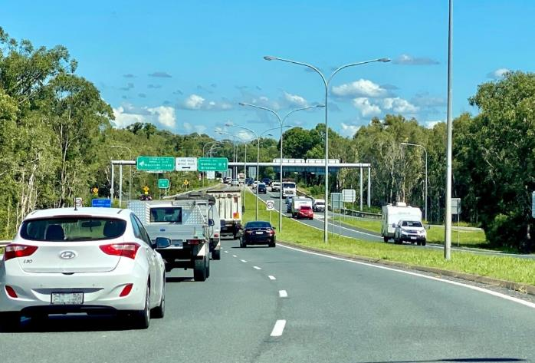
Sunshine Motorway, Mountain Creek
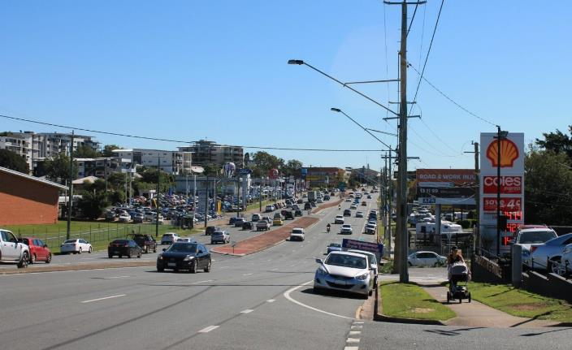
Gympie Road, Kedron
Other examples may include:
- Bruce Highway, Caboolture
- Mulgrave Road, Cairns
- Hooker Boulevard, Broadbeach

Urban Classification Matrix
City streets (e.g. ‘collector and distributor roads’)
Are dense and vibrant places that also have a high demand for people movement. They are also places providing focal points for businesses and culture. These streets should aim to reduce the impact of high traffic volumes while accommodating high pedestrian numbers, multi-modal journeys and access to public transport and essential emergency services. Managing the large number of competing demands along city streets requires careful consideration and involves significant trade-offs. These streets require efficient modes of transport, with lateral movement access prioritised to mitigate the impacts of congestion and ensure a safe environment.

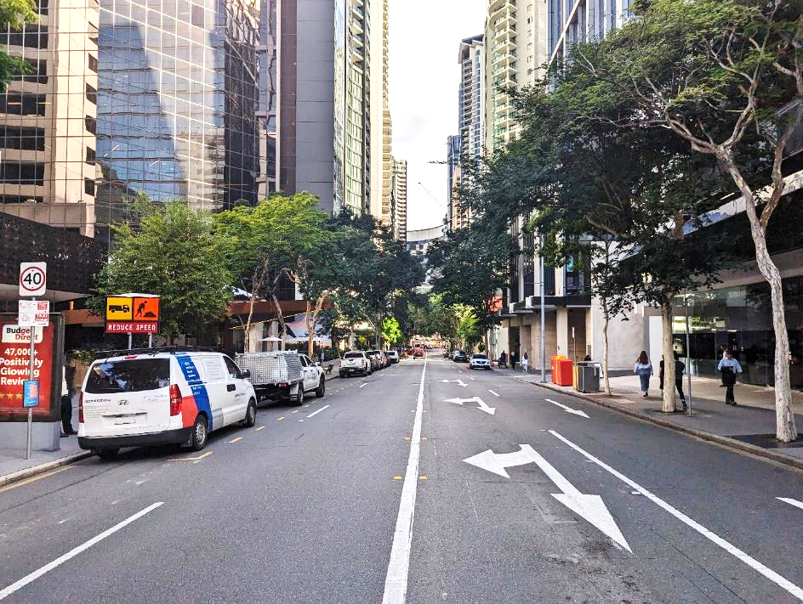
Mary Street, Brisbane
Other examples may include:
- Spence Street, Cairns
- Wickham Street, Fortitude Valley
- Surfers Paradise Boulevard, Surfers Paradise

Urban Classification Matrix
Activated streets (e.g. ‘collector and distributor roads’, ‘local roads’)
Provides access to shops and services by all modes, often supporting a mix of movement to and from, through and within. There is strong demand for both movement as well as place, with a need to manage competing demands within the available road space. Activated streets aim to ensure a high-quality public realm with a strong focus on supporting businesses, traders, and neighbourhood life. People spend a significant amount of time working, shopping, eating, residing, or undertaking recreation within these streets that often are located in an activity or town centre environment.

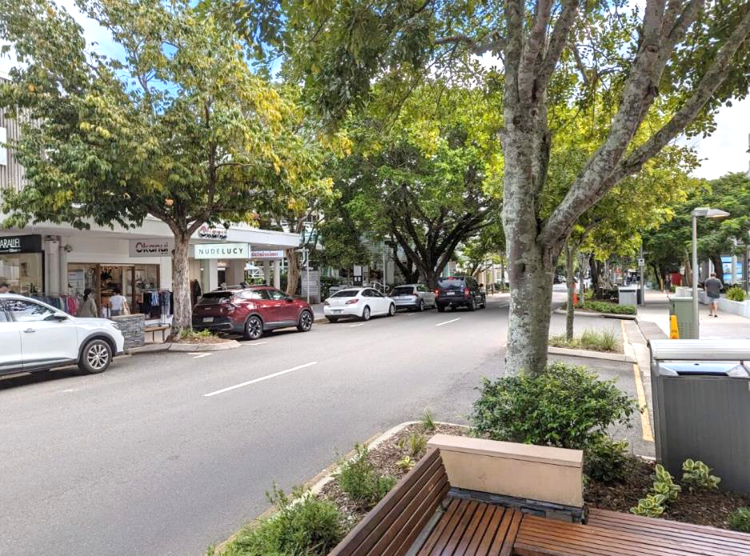
Hastings Street, Noosa
Other examples may include:
- Wood Street, Mackay
- Bulcock Street, Caloundra
- Macrossan Street, Port Douglas

Urban Classification Matrix
Main streets (e.g. ‘collector and distributor roads’, ‘local roads’)
Main streets have an important place function but a relatively important movement function as well, often including high through movement. They aim to support businesses, on-street activity and public life while ensuring connections with the wider transport network. Similarly to city streets, they need to balance the interaction between people and goods movement and on-street activity.

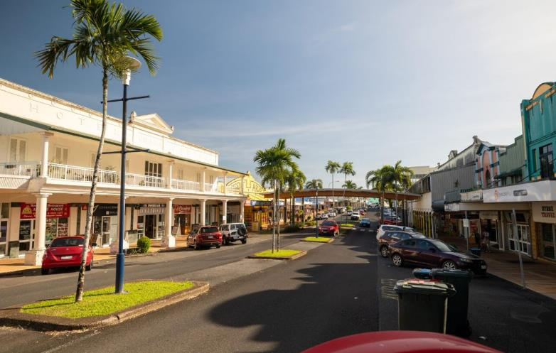
Edith Street, Innisfail
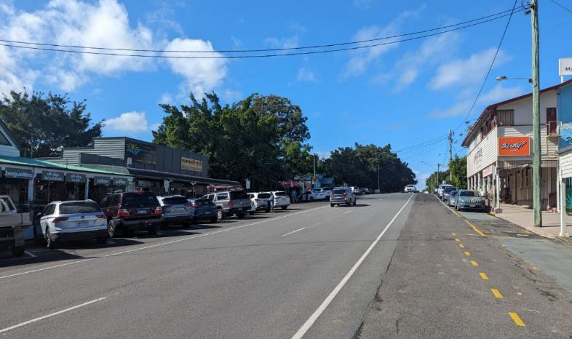
Memorial Drive, Eumundi
Other examples may include:
- Boundary Street, West End
- King Street, Caboolture
- Ruthven Street, Toowoomba
- McLeod Street, Cairns

Urban Classification Matrix
Local streets (e.g. ‘local roads’)
Local streets provide quiet and safe residential access for all ages and abilities and foster community spirit and local pride. They are part of the fabric of our neighbourhoods, where we live our lives, and they facilitate local community access.

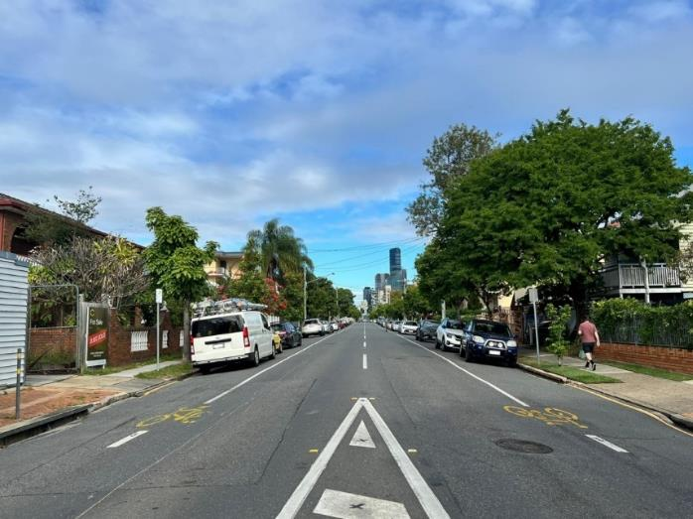
Kent Street, New Farm
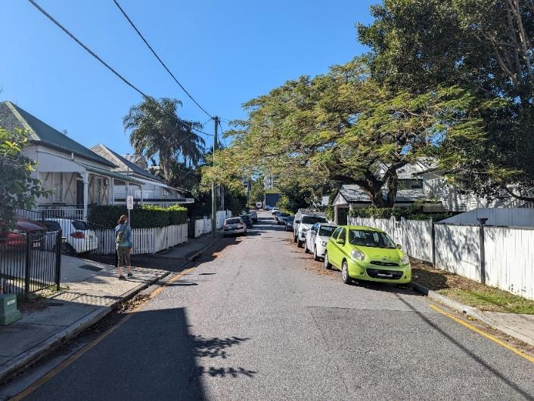
Lucy Street, Albion
Other examples may include:
- Roderick Street, Ipswich
- Fryer Street, Townsville
- Hill Street, Toowoomba

Urban Classification Matrix
Civic streets
These streets have a higher place classification representing the increased level of on-street activity and higher-density-adjacent land uses generating that activity. The lower movement classification indicates that these streets are mainly intended for localised on-street activity. The lateral movement of pedestrians is usually given priority in these spaces and are encouraged to spend time in, and where people on foot of all abilities can relax and move freely and safely. Other terms used include laneways, pedestrianised streets, plazas, and low speed shared streets.

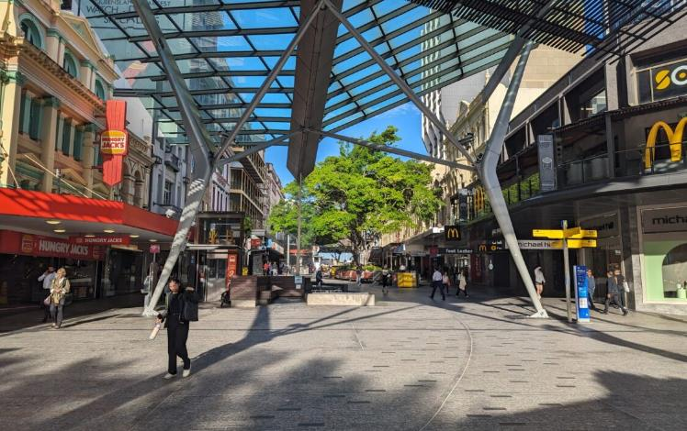
Queen Street Mall, Brisbane
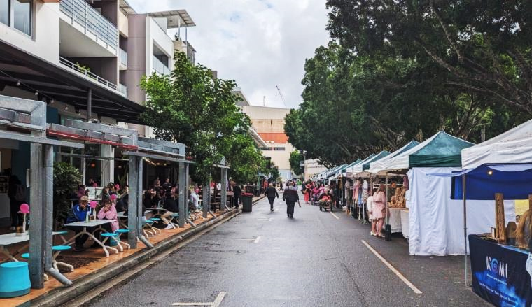
Little Stanley Street, South Bank
Other examples may include:
- Brunswick Street, Fortitude Valley
- Shields Street / Lake Street, Cairns

Rural Classification Matrix
Interregional connectors (e.g. ‘sub-arterial, arterial roads’)
Interregional connectors provide safe, reliable and efficient movement of people and goods between regions and strategic centres in a rural context. The focus of interregional connectors is to provide for efficient movement of people and goods over significant distances, and therefore these roads will usually have reduced land use access along them, many being designated as limited access roads.

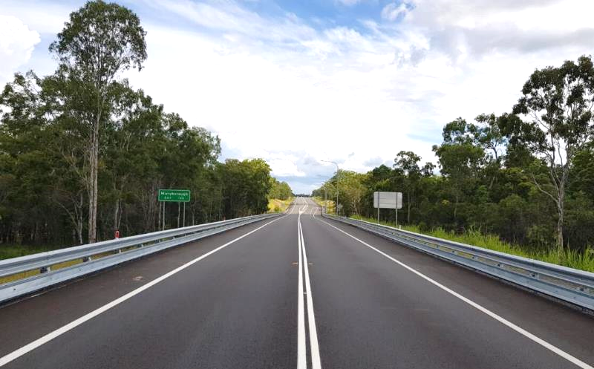
Bruce Highway, Tinana
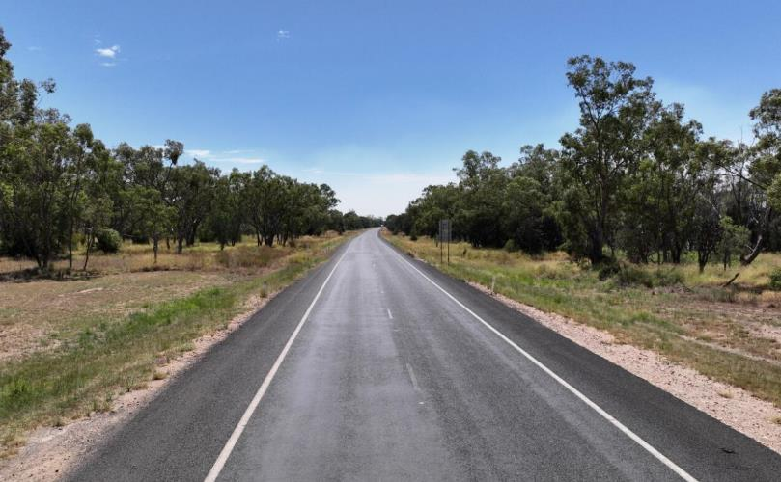
Gore Highway, Goondiwindi
Other examples may include:
- Burnett Hwy, Wyalla
- Landsborough Hwy, Barcaldine
- Mulligan Hwy, Cooktown

Rural Classification Matrix
Rural connectors (e.g. ‘collector and distributor roads’)
Rural connectors provide the link between rural roads and interregional connectors. They support an increased level of through traffic, while also providing access from the adjacent land they pass through. Examples include feeder roads into townships and roads to regionally significant tourist attractions.

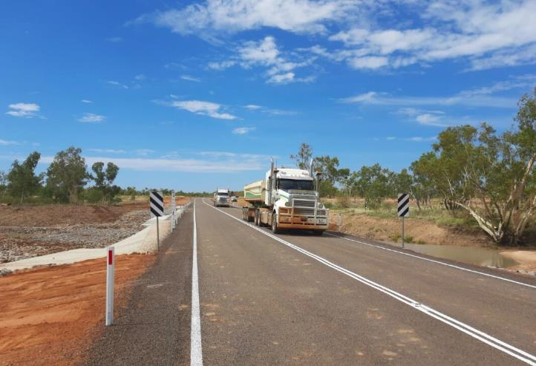
Aramac Torrens Creek Road, Amarac
Other examples may include:
- Kumbia Road, Brooklands
- Tableland Road, Mount Maria
- Kogan Condamine Road, Condamine

Rural Classification Matrix
Rural roads (e.g. ‘local roads’)
Rural roads primarily provide access to rural land, for those that live there, and in support of the land use activity being undertaken. Rural roads are the most common and most diverse roads in rural areas. They have no appreciable on-street activity occurring and in many parts of the country are unsealed. Some rural roads are important for freight, collecting dairy and forestry and other primary produce from their source, while others, where volumes of vehicular traffic are very low, can provide safe and pleasant recreational and tourism routes.

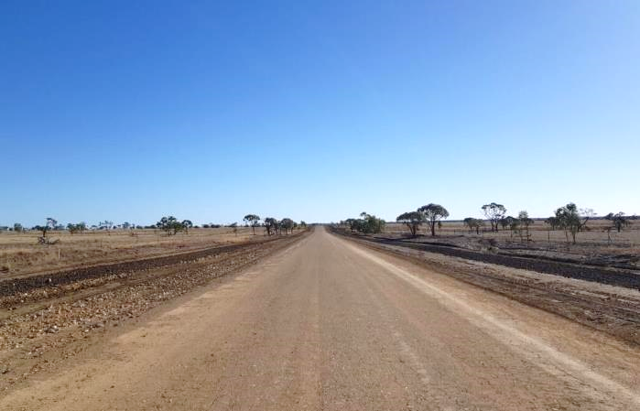
Cramsie Muttabura Road, Longreach
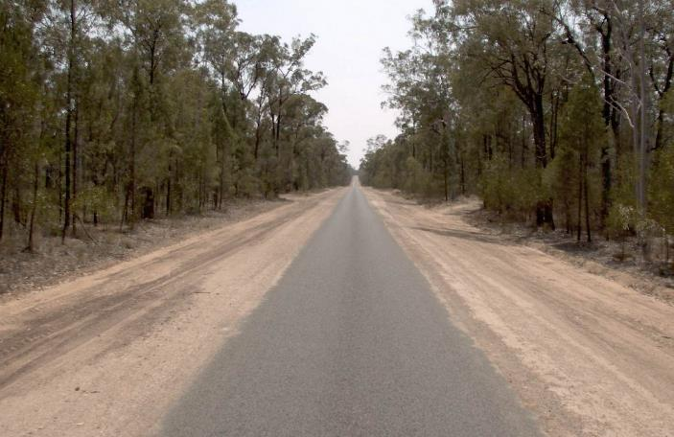
Auburn Road, Barakula
Other examples may include:
- Bollon Dirranbandi Road, Dirranbandi
- Leadingham Creek Road, Dimbulah
- Birdsville Developmental Road, Tanbar

Rural Classification Matrix
Peri-urban roads (e.g. ‘local roads’)
Peri-urban roads primarily provide access from residential property on the urban fringe, where the predominant adjacent land-use is residential, but usually at a lower density than that found in urban residential locations. On street activity is discernible and local in nature but also at lower levels than in urban areas. The level of people and goods movement on peri-urban roads can range from low volume through to regional.

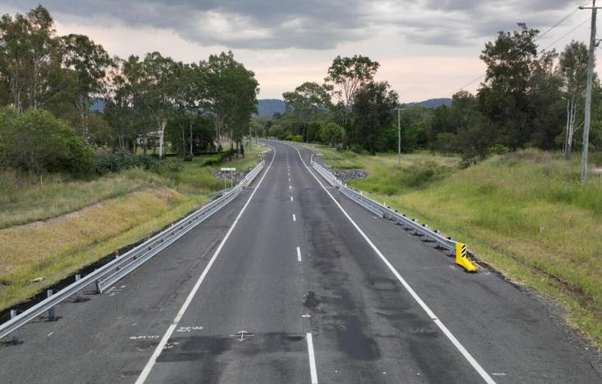
Postmans Ridge Road, Heildon Spa
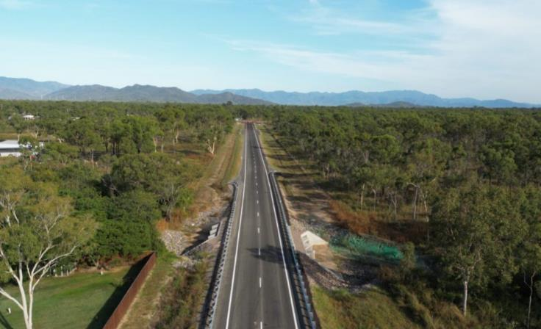
Nora Road Extension, Black River
Other examples may include:
- Ryan Road, Mt Isa
- Maleny-Kenilworth Road, Kenilworth
- McLaren Street, Hughenden

Rural Classification Matrix
Stopping places
Stopping places are where people gather in a rural setting. There is adjacent land-use generating on-street activity, and lateral movement across the roadway can be expected. They have levels of on-street activity or adjacent land-use generating activity that is above the level normally generated by residents. Examples include rest areas, rural schools, community halls, and sites of scenic interest. The movement classification around stopping places covers the entire range of road types and can occur on quiet rural roads through to interregional connectors.

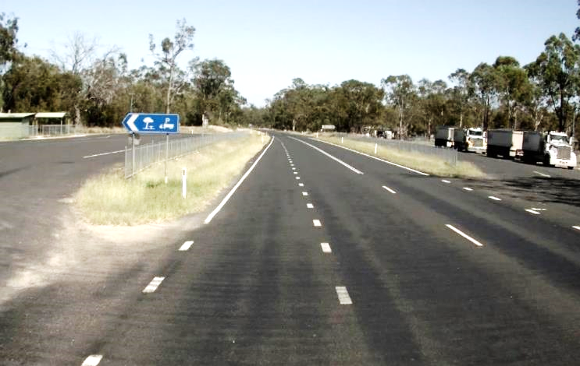
Cunningham Rest Area, Thane
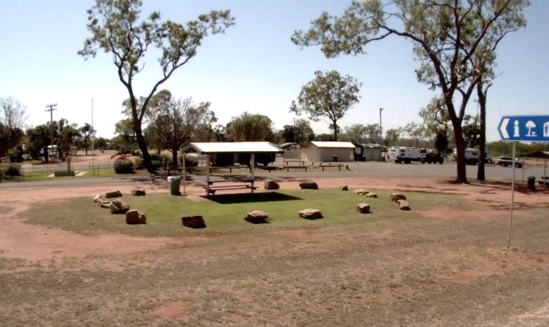
Duaringa Rest Stop, Duaringa
Other examples include:
- Rex Lookout, Captain Cook Hwy, Wangetti
- Cunningham's Gap, Tregony
- Stewart Street, Daintree

ATAP Step 3: Options generation and assessment - https://www.atap.gov.au/framework/options-generation-assessment/index
https://www.atap.gov.au/framework/review-evaluation/index

