Transport Academic Partnership
  - Annual Report 2024-2025
Translating and interpreting assistance
The Queensland Government is committed to providing accessible services to Queenslanders from all cultural and linguistic backgrounds. If you have difficulty understanding this publication and need a translator, please call the Translating and Interpreting Service (TIS National) on 13 14 50 and ask them to telephone the Queensland Government (Department of Transport and Main Roads) on 13 74 68.
Copyright
This publication is protected by the Copyright Act 1968. © The State of Queensland, 2025.
Disclaimer
While every care has been taken in preparing this publication, to the extent permitted by law, the State of Queensland accepts no responsibility and disclaims all liability (including without limitation, liability in negligence) for all expenses, losses (including direct and indirect loss), damages and costs incurred as a result of decisions or actions taken as a result of any data, information, statement or advice, expressed or implied, contained within. To the best of our knowledge, the content was correct at the time of publishing.

Contents
Transport Academic Partnership
A message from the TAP Chair 3
Messages from the TAP Partners 4
Motor Accident Insurance Commission 4
Queensland University of Technology 6
Griffith University 7
Queensland University 8
About us 9
University rankings 10
Project highlights 11
Improving the safety of personalised transport drivers – QUT 11
Providing passenger transport for Queensland’s ageing population - QUT 12
Train carriage loading models - UQ 13
Designing better bus shelters for tropical conditions - UQ 14
Specialised training for driving examiners - UQ 15
Performance snapshot 16
Performance analysis 18
TAP Sourcing Strategy highlighted projects 31
AusRAP – Manual Data Collection - QUT 31
Investigating interactions between heavy vehicles and young novice drivers - Griffith 31
Evaluation of the regulation of Personal Mobility Devices (PMD) in Queensland - QUT 31
Building cyber security capacity - UQ 31
TAP 2024–2025 Work Program: Project Status Report 32
Transport Academic Partnership 2024–2025 Work Program: Project Status Report 34
Leveraged projects 40
TAP Sourcing Strategy projects 40
Conclusion 44
2024-2025 highlights 44
Future directions 45

A message from the TAP Chair
This year’s annual report marks the final report under the Transport Academic Partnership (TAP) Agreement 2020–2025 and the tenth year of research delivered by the TAP university partners under the TAP Program.
During the 2024–2025 financial year, TAP continued to focus on the Department of Transport and Main Roads’ priority outcomes of improving transport safety, reducing the environmental impact of the network and providing accessible and efficient transport services.
The purpose of this report is to highlight TAP’s key successes and challenges against the TAP Agreement 2020–2025 and the priorities agreed by the TAP Steering Group built around the central themes of reliability, resilience and responsiveness.
The work and projects throughout 2024–2025 were focused on improving safety and access, enhancing the customer experience, and creating a transport network that supports our vision of having safe and connected communities that are sustainable, thriving and inclusive.
Importantly, motorcyclist safety (and their overrepresentation in the crash statistics), continued to be a significant research focus as we work with our university partners to address the causes of these crashes and the negative impact they have on the community.
There are many other exciting projects under way, and I encourage you to find out about them through viewing our TAP Website

Andrew Mahon
Deputy Director-General
Policy, Planning and Investment Division
Department of Transport and Main Roads

Messages from the TAP Partners

Motor Accident Insurance Commission
The Motor Accident Insurance Commission (MAIC) has continued our involvement in the TAP Program due to the recognised value derived from the transport-related research work conducted by our academic partners throughout the years.
MAIC’s grant funding prioritises injury prevention and rehabilitation, supporting initiatives aimed at reducing motor vehicle crashes and improving treatment for Queenslanders injured on our roads. Through programs such as TAP, MAIC continues to drive advancements in prevention, treatment, and rehabilitation to benefit individuals affected by road accidents.
During 2024–2025 a new initiative between the Department of Transport and Main Roads, MAIC and the MAIC-Queensland University of Technology Road Safety Research Collaboration has been the Behaviour Awareness Monitoring (BAM) trial, utilising variable messaging signs and camera technology to target tailgating on Queensland’s roads. Whilst still in the testing phase, it is hoped that this new technology will encourage drivers to adopt safer driving behaviours to reduce rear-end collisions, which account for approximately 50% of claims made to the Queensland Compulsory Third Party scheme.
Initiatives such as BAM highlight how leveraging research, technology, and collaboration can create impactful solutions that align with MAIC’s commitment to improving road safety and supporting injured Queenslanders.
MAIC looks forward to our continued association with the TAP Program, through the recent new five-year funding extension in the TAP Agreement 2025-2030.
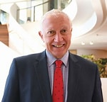
Neil Singleton
Insurance Commissioner
Motor Accident Insurance Commission
Queensland

Queensland University of Technology
The Transport Group at the Queensland University of Technology (QUT) continues very successful research activities with multiple stakeholders, including the Department of Transport and Main Roads, the Motor Accident Insurance Commission, iMOVE, the Department of Infrastructure, Transport, Regional Development, Communications, Sports and the Arts (DITRDCSA), the University of Sunshine Coast, the University of Queensland, and the Australian Research Council.
Our TAP Program is delivering research outcomes in the areas of traffic operations, road safety, travel behaviour, accessibility, active transport, transport modelling, and Mobility-as-a-Service. As a keen advocate of sustainability and safe travel, QUT remains committed to delivering projects that benefit the community and to seeking a future with an integrated, multi-modal, efficient, safe, and inclusive transport system.
We continued delivering research outcomes and recommendations to improve the overall transport system performance. Our deliverables included statistical analyses, revised models, universal design principles for accessible people movers, software tools, and recommendations.
Our group continues to leverage opportunities provided by the TAP Agreement to deliver the best possible outcomes. TAP has facilitated the attraction of additional resources for QUT, securing iMOVE grants totalling more than $500k, and new safety grants ($750k) from DITRDCSA.
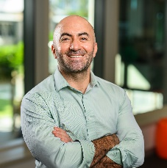
Professor Alex Paz
Transport and Main Roads Chair
School of Civil and Environmental Engineering
Queensland University of Technology

Griffith University
As we put the closing stages of Griffith University’s current involvement in the TAP Agreement, we are pleased to have finished with a number of high-quality projects contributing to the overall research impact and collaboration. Several high-quality projects this year have contributed greatly to the performance outcomes outlined in this report.
A major highlight was the completion of the three-year Advance Queensland project Transforming Queensland Tourism with Micro-Transport, led by Dr Abraham Leung. We also saw the completion of two significant TAP projects: Interchange and Network Planning: Developing Better Approaches for Queensland and Cycle Track Case Studies, with contributions from Dr Kelly Bertolaccini.
These projects applied systems thinking to tackle technical, engineering and planning issues, and support strategic alignment with State Government priorities. We also celebrate the recent success of Associate Professor Lyndel Bates, one of our TAP researchers, who was awarded $1,286,884, for her project 'Using an impaired driving context to enhance deterrence'. Finally, a big congratulations to Daniel Clarke who received First Class Honours for his TMR supported project “Transforming Community Transport.”
At Griffith University, the research landscape has undergone some significant changes, included the reduction of several research entities, including the Cities Research Institute. This has heralded a stronger focus on research capacity across Schools where many of our transport-related researchers continue to have the opportunity to work in a transdisciplinary environment. This is good news for the Department of Transport and Main Roads (TMR) as we look forward to offering a greater breadth and depth of researchers to help tackle critical TMR needs via the TAP Transport Research Projects procurement process in the future.

Professor Cara Beal
Acting Transport and Main Roads Chair
Director of City Research Institute
Griffith University

Queensland University
The University of Queensland (UQ) is a proud participant in the TAP Program, under the collaborative framework established with the Department of Transport and Main Roads (TMR), the Queensland University of Technology (QUT) and Griffith University. We believe our research and expertise at UQ, not just in transport engineering but across our schools and faculties, can support better solutions and outcomes to the long-term transport challenges facing Queensland.
This collaborative program has made it possible for researchers at UQ to make significant strides in generating options for access and mobility for under-served communities and regional cities in Queensland; observing and documenting patterns of e-bike and e-scooter use; creating frameworks to evaluate new cycling infrastructure; observing changes in travel by public transport passengers through Mobility-as-a-Service options; and discerning ways to make the public transport services and infrastructure more resilient in the future.
Through this research and other direct engagements with TMR, UQ seeks to enhance the practice of transport planning, engineering, and management across Queensland. We are proud to work with TMR to find solutions to these long-term research needs.

Professor Mark Hickman
Transport and Main Roads Chair
School of Civil Engineering
University of Queensland

About us
The $3.7 million TAP Agreement 2020–2025 has enabled strategic transport Research and Development (R&D) projects to strengthen transport capability within the university sector, the Queensland Government, and industry, to address future transport challenges in Queensland.
The Agreement establishes collaborative and cooperative arrangements to fund the delivery of research and learning and development outcomes to contribute to an integrated, safe, efficient, and reliable transport system in Queensland.
The 2024–2025 Annual Report is the final of the Transport Academic Partnership (TAP) Agreement 2020–2025, outlining years of collaborative research between the Department of Transport and Main Roads (TMR), the Motor Accident Insurance Commission (MAIC) and the TAP University Partners. This report outlines the program’s alignment with TMR’s strategic priorities, including transport safety, environmental sustainability, accessibility, and customer experience.
Key achievements during the reporting period and before publication include:
- Completion of 17 research projects.
- Leveraging of over $2.5 million in additional funding.
- Publication of more than 180 transport-related outputs.
- Increased engagement of higher-degree research students.
Performance against Key Performance Indicators (KPIs) demonstrated growth in collaborative R&D initiatives, research outputs, and student involvement, despite minor declines in academic staffing and workshop delivery.
The TAP Agreement 2025–2030 has been renewed with a revised partnership structure, welcoming the University of the Sunshine Coast (USC) and expanding the program’s focus to include sustainability, artificial intelligence, and cybersecurity. This transition reflects TMR’s ongoing commitment to innovation and evidence-based policy development through academic collaboration.
Total expenditure for TAP for the 2024–2025 period was $784,000, which was allocated to the three TAP University Partners.
Ten new projects were approved by the TAP Steering Group which commenced on 1 July 2024, and 15 projects were continued from previous programs which included 10 multi-year projects. Eleven projects were delivered in the 2024-25 period with a further six projects completed before the publication of this report.
In addition to providing research funding, the TAP Agreement outlines the objectives of the partnership and sets out the required KPIs and reporting arrangements. The R&D outcomes are intended to deliver on the agencies’ strategic priorities and provide support for the broader Queensland Government innovation agenda.
Program oversight is provided by the TAP Steering Group, consisting of representatives from TMR, MAIC and the TAP University Partners. The Steering Group is chaired by Andrew Mahon, Deputy Director-General (Policy, Planning, and Investment), TMR.
The Steering Group meets at least twice each calendar year and is responsible for:
- developing and endorsing the TAP Annual Work Program
- assessing project nominations against agreed criteria and identifying a list of priority projects
- developing and maintaining the current and future Agreements.

University rankings
In 2025 UQ ranked among the 45 top universities in the world. QUT ranked 52 for transportation engineering and UQ was ranked 68 for systems engineering. Griffith maintained its ranking in the top 275 universities in the world.

Project highlights

Improving the safety of personalised transport drivers – QUT
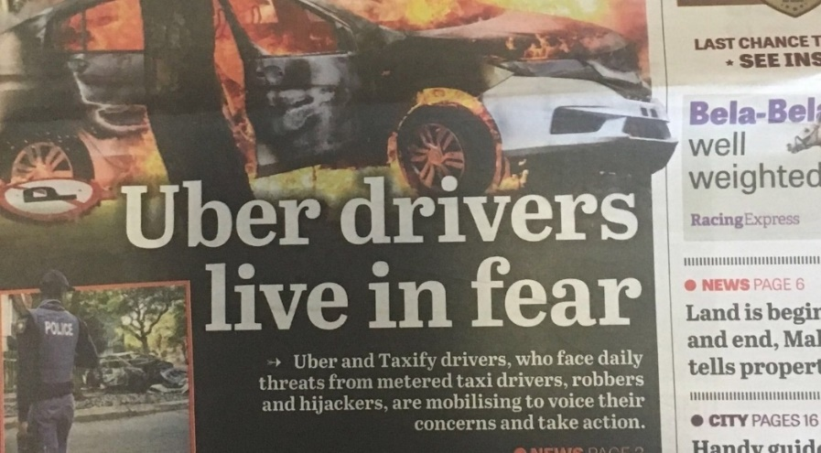
Caption 1: Newspaper clipping about Uber drivers
A TAP project has examined safety in Queensland's personalised transport industry. This work has been prompted by booking companies reporting concerns about an increase in the number and severity of incidents involving violence, aggression, and criminal or anti-social behaviour directed at drivers by passengers.
Similarly, there continues to be cases of serious offences and misconduct by drivers towards customers, leading to customer complaints and driver disaffiliation.
This trend is observed globally, with both drivers and passengers reporting a range of distressing encounters. Drivers frequently experience aggressive behaviour and physical attacks from passengers, while passengers, especially women, are at risk of harassment and unwanted advances from drivers.
The project has identified the following risk factors that may contribute to the vulnerability of drivers and customers to incidents of violence, assault, aggression, criminal, and anti-social behaviours:
· Night-time operation
· Lack of surveillance systems
· Racial and gender bias
· Inadequate training
· High stress environments
Personalised transport companies have undertaken a range of actions to address both driver and customer safety and security concerns. This research will provide further understanding of the issues to enable TMR to design and implement targeted, practical measures in partnership between the industry and government to maximise the safety of all individuals in personalised transport.

Providing passenger transport for Queensland’s ageing population - QUT
As mobility declines as people get older, first and last mile transport becomes increasingly important. Travel patterns and destinations change, as customers no longer commute to work but instead need to access local services. As customers lose their driving confidence or licences, passenger transport (including public transport, personalised transport taxis and rideshare), community transport and other forms of public passenger transport is critical to keeping this cohort connected to services, shops, and social connections, and has major impacts for their health and wellbeing. This is especially relevant as governments increasingly adopt strategies encouraging Queenslanders to age in their homes.
Caption 2: Passengers using accessible transport in South-East Queensland
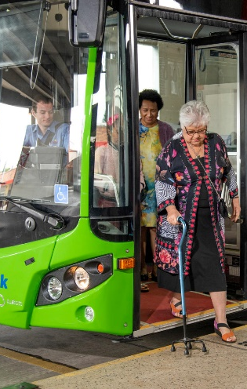

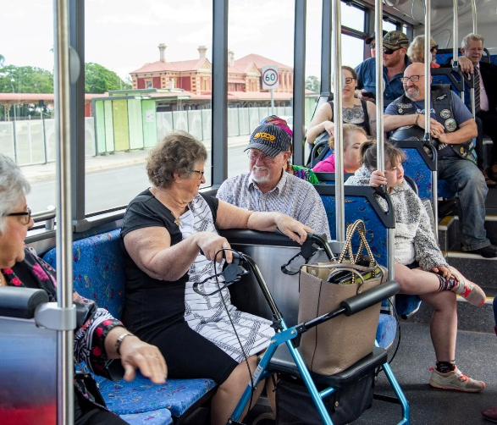

Understanding this changing dynamic is specifically relevant to the department’s strategic objectives to provide a transport network that is accessible and relevant. This project provided resources to improve the department’s understanding of the impact of an ageing population on the transport network and how to build the capacity of the department to shape future passenger transport to meet the needs of this cohort.

Train carriage loading models - UQ
This two-year project is an extension of a train carriage loading model project previously undertaken in 2023, which delivered a proof-of-concept train carriage loading model. The model predicts train passenger counts given by New Generation Rollingstock (NGR) data based on the data that TMR receives from the passenger-to-train assignment model and ticketing data. Data from the door counters on the NGR trains can provide a more complete estimation of train loads compared to the current reliance on ticketing data, which has gaps due to the use of special rail passes, free rail travel and fare evasion.
NGR trains are equipped with door sensors which can count the number of passenger entries and exits and therefore has the potential to better estimate train and carriage loads. UQ delivered a proof-of-concept train carriage loading model in FY2024–2025 which uses the outputs from passenger-to-train assignment model, (which is a model based on ticketing data), and predicts the NGR train-to-passenger counts.
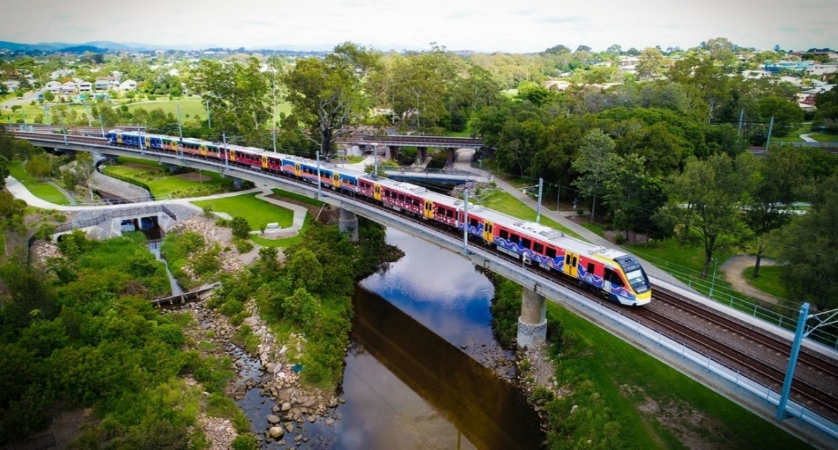
Caption 3: An NGR train travelling in South-East Queensland

Designing better bus shelters for tropical conditions - UQ
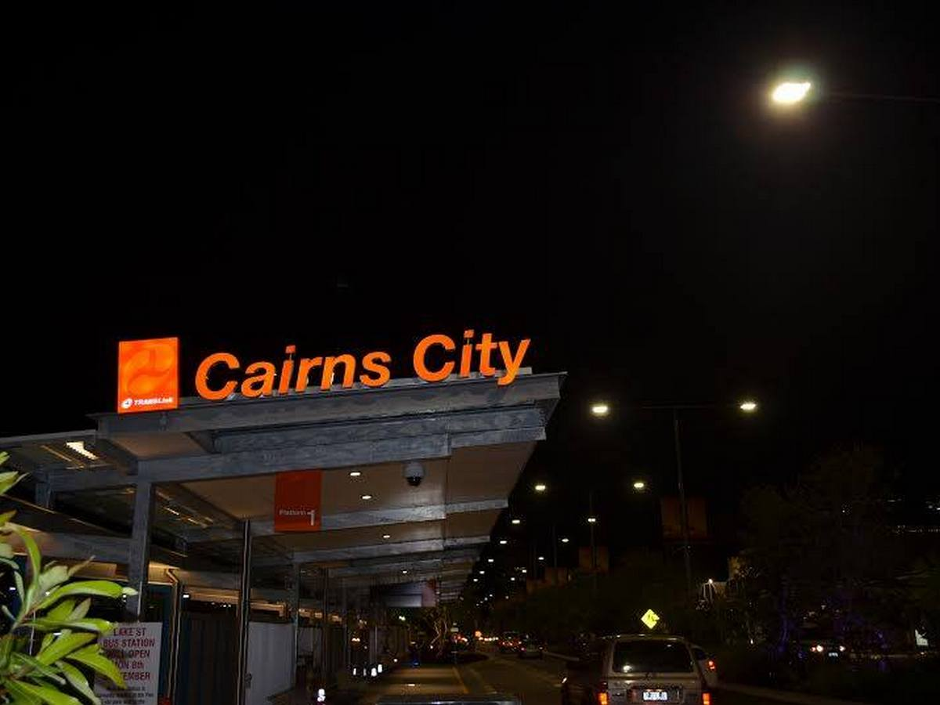
Caption 4: Cairns Central Bus Terminal
Given North Queensland's hot and often wet climate, TMR and local governments regularly receive requests from customers for new and improved bus stop shelters. Specific complaints about shelter design include orientation, roof overhang and waiting space.
Bus shelters in Queensland are designed in accordance with the Public Transport Infrastructure Manual 2015 (PTIM). The PTIM includes several shelter options for use at bus stops and interchanges, primarily developed in South-East Queensland. These shelters have been designed to provide some shelter from the rain and sun, while also ensuring accessibility and personal safety is maintained, but are not specifically designed for tropical climates with more intense heat and higher rainfall.
A trial of new bus stop designs was completed in 2011 along the Captain Cook Highway in Cairns. These prototype bus shelters were of varying designs and remain in-situ but have never been evaluated.
To address this issue, this TAP project aimed to investigate ways to make passenger journeys more comfortable with public transport infrastructure by designing better shelters for the tropical North Queensland climate. In North Queensland, this includes designing shelters more appropriate for higher temperatures, hotter and more frequent hot days and more intense rainfall. The project also ensured that the objectives aligned with TMR’s strategic priorities.
The project built on information obtained from a mobility study in Townsville (2022) which outlined the strategic priorities needed to provide efficient, equitable and convenient travel options for the people of Townsville and included recommendations to increase usage by improving passenger comfort at transport hubs and stops.
Additionally, the project recognised the importance of incorporating passenger feedback from surveys, around infrastructure improvements to make bus shelters more accessible and attractive to the wider community, and easier to use and navigate.

Specialised training for driving examiners - UQ
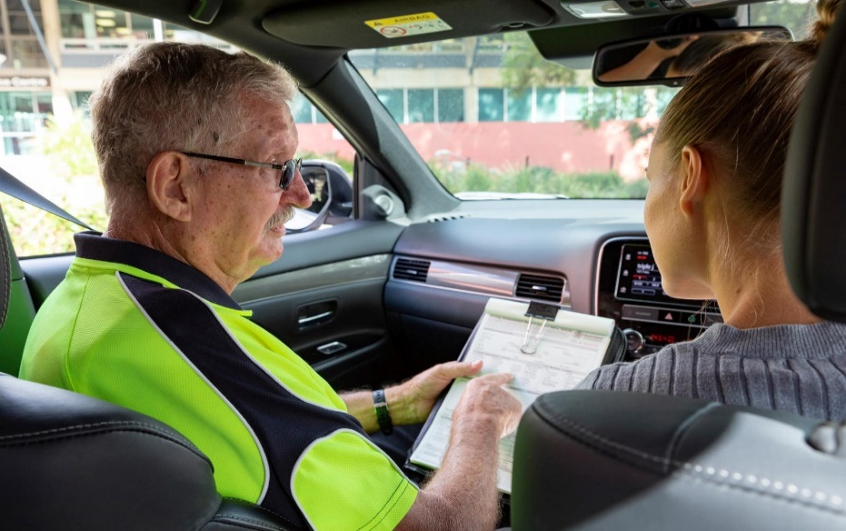
Caption 5: Young learner driver and TMR driving examiner.
This project developed a training package for TMR driving examiners (DEs) to enhance their ability to support learner drivers with diverse needs during practical driving tests. The training equips DEs with strategies to assist customers who may experience:
- Mental health conditions such as anxiety, depression, ADHD, or PTSD
- Neurodiverse conditions including Autism Spectrum Disorder, Tourette’s Syndrome, and tics
- Physical disabilities
- Experiences of domestic violence or road trauma
- Cultural and linguistic diversity
Safety during driving tests for DEs, customers, and other road users, is paramount. However, time constraints during test preparation and examination often limit DEs’ ability to fully engage with customers and adapt their approach.
This study identified key requirements and developed practical strategies to help DEs tailor their support. By improving examiner responsiveness to individual needs, the training aims to enhance customer experience and contribute to better road safety outcomes across Queensland.

Performance snapshot
The success of TAP in meeting its three objectives is measured against nine Key Performance Indicators (KPI) that are reported on at the end of each financial year.
Each of the objectives is supported by KPIs which are measured by the percentage they have increased or decreased compared to reports from last year and averages taken from previous reports.
The 2024–2025 performance snapshot below is a comparison from the 2023–2024 TAP Annual Report.
Table 1: Performance snapshot
Number | Key Performance Indicator description
KPI 1 | Number of transport-related academic staff employed and number of non-transport-related academic staff providing support (paid or in-kind)  to TMR.  Rating: <5% decrease on 2023–2024
KPI 2 | Number of higher degree research students (PhD, Masters, by Research and Honours Research) undertaking transport-related research at the universities, including synopsis of study area; agencies engaged and their involvement; and relevancy to the  Agreement objectives.  Rating: >5% – 10% increase on 2023–2024
KPI 3 | Number of university students enrolled in transport-related subjects.  Rating: <5% decrease on 2023–2024
KPI 4 | Name and number of transport-related workshops or seminars delivered by universities that contribute to the objectives of the Agreement.  Rating: <5% decrease on 2023–2024

KPI 5 | List of activities where university staff have worked on joint/collaborative R&D initiatives with government, industry and/or the academic sector, undertaking the Annual Work Program, including in–kind support.  Rating: >5% – 10% increase on 2023–2024
KPI 6 | List of organisations that participate in projects supported by  the Agreement.  Rating: <5% decrease on 2023–2024
KPI 7 | Universities demonstrate that they have matched program funding provided by agencies through in-kind contributions and funds leveraging.  Rating: <5% decrease on 2023–2024
KPI 8 | Number of transport-related outputs (published papers, conference papers, formal reports (not published), formal advice, or peer reviewed papers/articles) provided by the universities through this Agreement. These must be an output of activities undertaken through the association with this Agreement.  Rating: >5% – 10% increase on 2023–2024
KPI 9 | The R&D activities delivered by the Transport Chairs and dedicated staff funded by the Agreement are completed within the agreed timeframe and budget.  Rating: >5% – 10% increase on 2023–2024

Performance analysis

Objective 1: Build transport research excellence, innovation, and capability in Queensland.
This objective focuses on strengthening Queensland’s transport research ecosystem by tracking the number of academic staff and students involved in transport-related research, and the development opportunities created through TAP.
In 2024–2025, TAP continued to support the evolution of university research, which plays a vital role in driving innovation, informing public policy, and educating future professionals. TAP University Partners also collaborated across disciplines, engaging faculties such as UQ’s Architecture, QUT’s Computer Science and Information Systems, and Griffith’s IT, Analytics, and Cyber Security.
Performance Snapshot – KPI 1
Australia’s university system has evolved to realise a range of functions, which individually and collectively help drive outcomes for Queensland’s prosperity. University research not only leads to new products and innovation, but also informs public debate, improves our health and wellbeing and helps solve complex problems. Cutting-edge research in Australian universities also informs how we educate the next generation of university-trained professionals, researchers and leaders.
Despite a national average increase of 5.6% in academic staffing, both QUT and Griffith experienced a slight decline in transport-related staff numbers. This was largely due to internal restructuring and lower enrolments in planning and transport courses at Griffith, which have not yet rebounded to pre-pandemic levels.
Table 2: KPI 1 – Number of transport-related academic staff employed
University | 2020/21 | 2021/22 | 2022/23 | 2023/24 | 2024/25
QUT | 15 | 16 | 14 | 18 | 16
Griffith | 19 | 19 | 25 | 25 | 21
UQ | 24 | 23 | 22 | 21 | 24
Total | 58 | 58 | 61 | 64 | 61

Figure 1: KPI 1 – Number of transport-related academic staff employed

While staffing numbers dipped slightly, TAP University Partners maintained strong engagement across faculties, ensuring continued relevance and capability in transport research.
Performance snapshot – KPI 2
The number of higher-degree research students (PhD, Masters by Research and Honours Research) undertaking transport-related research at the Universities has increased by 12 per cent.
This growth has directly benefited TMR with three PhD students embedded in the department through the TAP Program. As demand for research in specific transport related areas grows, this number is expected to rise further.
QUT has led this growth, likely due to its strategic focus on sustainability, liveability, understanding infrastructure and a cross-disciplinary approach to research that appeals to international higher-degree research students.

Table 3: KPI 2 – Number of higher degree research students undertaking transport–related research
University | 2020/21 | 2021/22 | 2022/23 | 2023/24 | 2024/25
QUT | 109 | 104 | 80 | 111 | 126
Griffith | 15 | 16 | 20 | 18 | 17
UQ | 24 | 34 | 31 | 18 | 15
Total | 148 | 154 | 131 | 147 | 158

Figure 2: KPI 2 – Number of higher degree research students undertaking transport–related research

Performance snapshot - KPI 3
Despite the increase in research students, enrolment in transport-related courses have declined by 10 per cent, with significant reductions has decreased by 10 per cent with significant reductions at QUT and Griffith University, partially offset by increased numbers at UQ.

A Future Campus publication (U. Saikia et al.; 2025) identifies two key challenges threatening the stability and growth, reports that the stability and growth of Australian universities have realised:
- A significant but under-recognised decline in the population aged 18 to 25.
- Ongoing government caps on international student visas.
These factors have contributed to a 3.2 per cent decline in commencing domestic students in 2023, with undergraduate enrolments falling by 8.2 per cent, which is a concerning trend for the future of higher education.
Table 4: KPI 3 – Number of students enrolled in transport related subjects
University | 2020/21 | 2021/22 | 2022/23 | 2023/24 | 2024/25
QUT | 1892 | 1147 | 1045 | 1239 | 1002
Griffith | 1155 | 559 | 469 | 476 | 376
UQ | 499 | 494 | 366 | 400 | 506
Total | 3546 | 2200 | 1880 | 2115 | 1884

Figure 3: KPI 3 – Number of students enrolled in transport related subjects

Performance snapshot - KPI 4
The TAP University Partners delivered eighteen transport-related workshops, seminars and showcases in 2024–2025, a 33 per cent decrease from the previous year. Despite the drop, these events remain vital for building research capability and fostering collaboration between academia and TMR.
Events such as these provided an online opportunity for staff to engage transportation experts from around the world.
Highlights from 2024-2025
- The TAP Poster Showcase, which featured projects on motorcycle safety, universally designed autonomous people movers, train carriage loading models, community safety and traffic management.
- A seminar by Professor Darcy Bullock from Purdue University, USA, on traffic signal analytics using connected vehicle data.
- Participation in the 6th Bridging Transportation Researchers Conference, 7th August 2024, coordinated by Professor Lynette Cheah, TAP’s newest partner at the University of the Sunshine Coast.
- TMR’s promotion of the iMOVE National Research and Development Conference, 23rd October 2024, held at QUT’s Kelvin Grove campus and co-hosted with UQ.
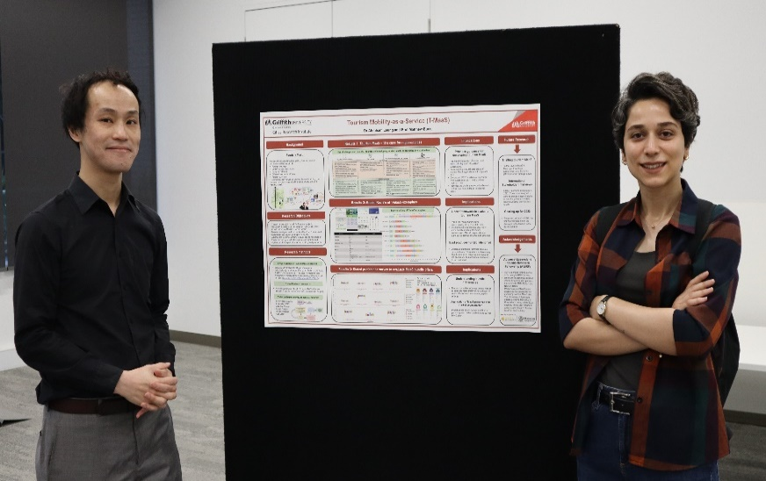
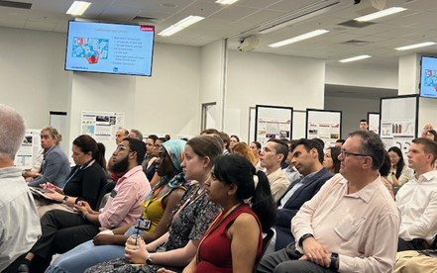
Caption 5: TAP Poster Showcases are an excellent way to see the variety of transport research undertaken.

Table 5: KPI 4 – Transport–related workshops and seminars delivered by the universities
University | 2020/21 | 2021/22 | 2022/23 | 2023/24 | 2024/25
QUT | 2 | 2 | 6 | 6 | 3
Griffith | 6 | 10 | 15 | 15 | 14
UQ | 2 | 3 | 1 | 6 | 1
Total | 10 | 15 | 22 | 27 | 18

Figure 4: KPI 4 – Transport–related workshops and seminars delivered by the universities.

Objective 2: Foster a collaborative partnership and strong alliance between government, industry, and the academic sector.
This objective seeks to strengthen strategic partnerships and foster dynamic collaboration between government, industry and the academic sector to drive innovation, shared research outcomes and impactive policy development.
Performance snapshot – KPI 5
The number of collaborative R&D activities undertaken by University Partners has increased by over 13 per cent throughout the period with fifty-one activities undertaken in the 2024–2025 financial year. This is a positive outcome and shows that businesses and organisations both value and understand the importance of continued collaboration.
Table 6: KPI 5 – Collaborative R&D initiatives with industry, government and academia
University | 2020/21 | 2021/22 | 2022/23 | 2023/24 | 2024/25
QUT | 19 | 22 | 21 | 22 | 29
Griffith | 20 | 11 | 12 | 14 | 10
UQ | 11 | 14 | 14 | 11 | 12
Total | 50 | 47 | 47 | 47 | 51
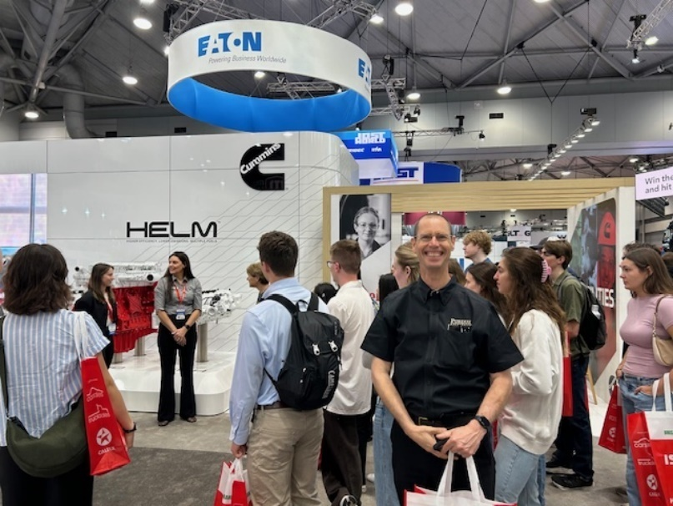
Caption: Professor Darcy Bullock at the Queensland Truck Show 2025
Figure 5: KPI 5 – Collaborative R&D initiatives with industry, government and academia

Performance snapshot – KPI 6
The TAP University Partners continued to work with industry and the academic sector throughout the 2024–2025 period. Although there was a five per cent decrease from 2023–24, this indicator has confirmed there are thriving global network of transportation experts, who regularly share their research and regularly undertake collaborations with Queensland researchers. Both Griffith University and UQ retained the number of organisations participating in their TAP projects under the Agreement.
QUT has built on its relationships with both national and international agencies through activities including research with the University of Nevada and Perdue University and their TAP Chair sits on the Standing Committee for the Transportation Research Board in the USA. Both QUT and UQ extended their collaborations with iMOVE and the Royal Automobile Club of Queensland.
The TAP University Partners have also participated in multiple committee meetings, such as with Bicycle Queensland, and the Standing Committee on the Effects of Communication (Travel choices) Brisbane City Council and Gold Coast City, Active Transport Committees. Participation on these committees means the TAP University Partners have relevance to emerging issues and ensures quality of academic research is maintained.
Collaborations have also been undertaken with local governments, state government agencies, cooperative research centres, other Australian and international
universities, industry, advocacy groups and advisory bodies. These include between Griffith University and the University of Cauca which specialises in systems and environmental engineering and a visit to TMR from transport experts from Nagoya University in Japan.
Table 7: KPI 6 – Number of organisations the participate in projects
University | 2020/21 | 2021/22 | 2022/23 | 2023/24 | 2024/25
QUT | 16 | 15 | 17 | 15 | 13
Griffith | 25 | 19 | 20 | 20 | 20
UQ | 10 | 11 | 10 | 10 | 10
Total | 51 | 45 | 47 | 45 | 43

Figure 6: KPI 6 – Number of organisations the participate in projects

While there was a slight decrease in the number of organisations participating in TAP projects with QUT, this can be accounted for by the completion of projects from the previous financial year and project timing.

Objective 3: Fund and enable transport-related research and development activities that deliver positive outcomes for the transport system and the Queensland community.
The performance measures for this objective are intended to demonstrate the value of the research and development activities delivered through the Agreement, including capacity of universities to leverage other funding sources and the number of outputs delivered.
Performance snapshot – KPI 7
Over the past four years, the amount of leveraged funding secured by the TAP University Partners has increased, enabling universities to recruit and retain highly qualified academics with ongoing specialisations to undertake transport research in Queensland. However, 2024-25 saw a decrease which reflects the changing financial situation at Griffith University.
The TAP University Partners have collectively contributed $2,507,793 of in-kind contributions over and above their TAP commitments. They have used this leveraged funding to support the delivery of the Agreement objectives and work program projects. Although there was a decrease, QUT continues to generate a significant amount of leveraged funding having bid successfully for funding grants from:
- Brisbane City Council,
- iMOVE, and
- The federal Department of Infrastructure, Transport and Regional Development, Communications, Sports and the Arts.
Table 8: KPI 7 – Leveraged funding
 | QUT | Griffith | UQ | Total
2020/21 | $570,116.00 | $526,689.00 | $309,000.00 | $1,405,805.00
2021/22 | $1,059,000.00 | $434,515.00 | $381,600.00 | $1,875,115.00
2022/23 | $1,229,750.00 | $832,508.00 | $417,000.00 | $2,479,258.00
2023/24 | $1,519,751.00 | $1,117,030.00 | $460,600.00 | $3,097,381.00
2024/25 | $1,451,000.00 | $596,193.00 | $460,600.00 | $2,507,793.00

Figure 7: KPI 7 – Leveraged funding

Performance snapshot – KPI 8
TAP University Partners continue to make significant contributions to several national and international journals, with a notable 40 per cent increase in transport-related publications in 2024–2025 compared to the 2020–2021 baseline.
Publication output declined by an average of 68 per cent during years 2021–2022 and 2022–2023, due to disruptions caused by the COVID-19 pandemic. However, the rebound in 2023–2024 and 2024–2025 reflects a strong global recovery in research activity, particularly in transport innovation and traffic management and technology (Australian National University 2024). This upward trend underscores the growing relevance and impact of TAP supported research in shaping Queensland’s transport future.
Table 9: KPI 8 – Number of transport–related publications
University | 2020/21 | 2021/22 | 2022/23 | 2023/24 | 2024/25
QUT | 70 | 70 | 79 | 94 | 99
Griffith | 18 | 18 | 17 | 17 | 56
UQ | 42 | 30 | 4 | 38 | 27
Total | 130 | 118 | 100 | 149 | 182
UQ contributed to a decarbonisation journal that looked at developing a strategic roadmap into low emission technologies. Griffith University contributed to journals around sustainable and healthy transport investment, and QUT contributed to over ninety-nine publications including traffic management, data analysis, autonomous vehicle technologies and infrastructure sustainability.
Figure 8: KPI 8 – Number of transport–related publications

Performance snapshot – KPI 9
Of the twenty-six projects on the 2024–2025 work program, twenty were due for completion. Of the remaining six projects, two were rescoped and four received variation notices to extend past their original completion dates. Eleven projects were completed in the reporting period, and six additional projects were completed prior to the publishing of this report.
The remaining three projects were not delivered in the allotted period, due to the unavailability of key staff, delays and changes in scope and changing priorities. These projects have been incorporated into the 2025–2026 TAP work program.
Overall, fifty-five per cent of projects were delivered as planned in the period 1 July 2024 to 30 June 2025.

Table 10: KPI 9 – Project completion rates
University | 2020/21 | 2021/22 | 2022/23 | 2023/24 | 2024/2025
QUT | 5 | 5 | 5 | 5 | 5
Griffith | 2 | 1 | 1 | 5 | 4
UQ | 3 | 3 | 3 | 3 | 2
Total | 10 | 9 | 9 | 13 | 11

Figure 9: KPI 9 – Project completion rates.

TAP Sourcing Strategy highlighted projects

AusRAP – Manual Data Collection - QUT
TMR has committed to publishing AusRAP star ratings for the national land transport network (NLTN) and high-speed roads that carry 80 per cent of travel. For QUT to undertake this project, TMR has performed an analysis and determined that a hybrid data collection approach using automated data, collected by TMR’s third party vendors, and manual data may yield the best results to allow for a more accurate publication.

Investigating interactions between heavy vehicles and young novice drivers - Griffith
This project will use an ecological model to investigate young novice drivers' interactions with heavy vehicles. The ecological model will help TMR understand the various environmental factors, road user characteristics, and contextual factors, such as organisational and legislative factors, which influence young driver behaviour.

Evaluation of the regulation of Personal Mobility Devices (PMD) in Queensland - QUT
Queensland was the first jurisdiction to introduce a comprehensive regulatory framework for PMDs. This project evaluates Queensland’s approach to regulating PMDs and whether the reforms and framework that were implemented in 2022 are meeting their intended road safety outcomes.

Building cyber security capacity - UQ
The aim of this project was to foster a trusted, collaborative ecosystem for senior cyber professionals. This industry led collaboration will research and identify emerging issues and solutions, with UQ supporting outcomes with evidence, research, and artefacts on these topics.
The aim of the initiative is to create a unique, safe space for cyber leaders to share best practices and research in cyber security, contribute to capability building across sectors and shape the cyber-leaders of tomorrow.

TAP 2024–2025 Work Program: Project Status Report
Table 11: List of TAP projects for 2024–2025
No. | Project | Status
1 | Improving the safety of personalised transport drivers | Complete
2 | Providing passenger transport for Queensland’s ageing | Complete
3 | Connected regional communities’ study – Phase 1 | Complete
4 | Specialised training for driving examiners | Complete
5 | Study of customer behaviour in S-E Queensland | Complete
6 | Investigating motorcycle safety (Part 2) | Complete
7 | Universally designed autonomous people mover – Phase 4 | Complete
8 | Understanding the mobility needs of senior road users | Complete
9 | Cycle track case studies | Complete
10 | Transforming Queensland Tourism with Micro-Transport | Complete
11 | Establishing MaaS trials for QLD’s sporting events | Complete
12 | Train carriage loading models | Complete*
13 | Interchange and network planning: approach for Queensland | Complete*
14 | Towards improved community transport | Complete*
15 | Determining spatially latent demand for active transport – Variation applied | Complete*
16 | Universal design for transport equity | Complete*
17 | Accessible public transport infrastructure study | Complete*
18 | Strengthening PT for climate change & wet weather – Variation applied | Ongoing
19 | Review of safety operations at Signalised slip lanes | Ongoing
20 | Heavy vehicle fleet safety standards – CLOCS-A | Ongoing
21 | Designing better bus shelters for tropical conditions – Variation applied | Ongoing
22 | Understanding the impact of bus stops – Variation applied | Ongoing
23 | Designing and modelling for major events | Ongoing
24 | Evaluation of separated bicycle tracks | Ongoing
25 | Movement and place project evaluation**  Developing an evidence base of long-term emissions abatement initiatives for the Queensland transport sector | Rescoped
26 | Cybersecurity – Education and training**  Review of AI enabled cybercrime risks in the transport industry | Rescoped
*Projects completed between July 2025 – September 2025 (prior to publication) **Project rescoped

Transport Academic Partnership 2024–2025 Work Program: Project Status Report
University Partners work with TMR to undertake and deliver an annual work program of research and development projects. In 2024–2025, there were 26 projects undertaken by the TAP University Partners. Of these, 11 were completed between July 2024 and June 2025 and six were completed between July 2025 and 30 September 2025*. Nine projects are ongoing, with two having been rescoped (with the associated funding reallocated to the revised projects**). The TAP work program projects include:
- projects that meet agencies’ strategic priorities
- trial projects such as proof of concept or pilot projects
- joint projects with other universities and/or industry partners and other ad-hoc/emerging issues
- Australian Research Council Linkage Projects and other leveraged funding opportunities.
The work program can also include in-kind and knowledge transfer activities, capability building, training, professional development, and work experience opportunities. Table 12 outlines the
2024–25 projects, defining their scope, alignment to TMR strategic priorities and status at the end of the period.
Table 12: Transport Academic Partnership 2024–2025 Work Program Status Report
No. | Project | Scope/description | TMR Strategic Objectives | Status at end of 2024–2025 FY | Partners
1 | Improving the safety of personalised transport drivers | The objective of this research is to obtain research and analysis of incidents of violence, aggression, criminal and anti-social passenger behaviour directed against (a) personalised transport drivers and (b) customers, to better understand the nature and causes of incidents of assaults in the personalised transport industry and to inform efforts to effectively address these issues. | This project is:  - Creating liveable regions and active cities  - Customer focused  - Innovative | Complete – June 2025  Output: Report with recommendations  Outcome: Increased understanding of customer patterns and behaviours to influence driver training, risk identification and safety management planning. | University: QUT  TMR: Passenger Transport Strategy,  Translink
2 | Providing passenger transport for Queensland’s ageing population – Phase 1 | This project enhanced departmental understanding of the passenger transport needs of an ageing population in Queensland. | This project is:  - Customer focused  - Creating liveable regions and active cities  - Innovative  - Investing in the future | Complete – June 2025  Output: Final report (targeted areas for attention)  Outcome: Understanding the key considerations to developing passenger transport policy to address the specific provision of services. | University: QUT  TMR: Passenger Transport Strategy,  Translink
3 | Connected Regional Communities Study (Phase 1) | This study provided an understanding of the factors driving transport disadvantage, and explored the barriers experienced by communities with unmet transport need across regional Queensland. It also identified system-wide service gaps and recommend solutions suited to local communities to improve mobility for regional customers now and into the future. | This project is:  - Creating liveable regions and active cities  - Customer focused  - Innovative  - Investing in the future | Complete – June 2025  Output: Technical report identifying methodology for Phase 2  Outcome: Provided an understanding of the extent of transport disadvantage in rural and regional communities and to formulate solutions. | University: UQ  TMR: Transport Planning and Prioritisation,  Transport Strategy and Planning
4 | Specialised training for driving examiners | This initiative is part of a larger project exploring opportunities to make the Queensland (Qld) Practical Driving Test (PDT) experience more inclusive and accessible for everyone. | This project is:  - Customer focused  - Creating liveable regions and active cities  - Innovative  - Investing in the future | Complete – June 2025  Output: Final report and training manual  Outcomes: Less PDT cancellations/reschedules for examiners. Improved customer satisfaction. | University: UQ  TMR: (Accessibility and Inclusion Program), Customer Services Branch, CSSR
5 | Study of customer behaviour in South-East Queensland regarding advanced mobility | This research project seeks to gain a better understanding of customer’s preferences and attitudes towards emerging and advanced mobility technologies in Southeast Queensland. The project will evaluate critical attributes of the technologies that are likely to be important for customers, and how they affect travel choice behaviour. | This project is:  - Customer focused  - Creating liveable regions and active cities  - Innovative  Investing in the future | Complete – (Phase III) multi-year  Output: Final report & presentation.  Outcome: The behavioural modelling capability delivered as part of this project will enable the Department to better forecast the impact of emerging modes. Accounting for behavioural responses in a comprehensive manner will enable the development of more appropriate policy interventions. | University: QUT  TMR: Office of the Director-General, Accessible Transport Networks Unit.
6 | Investigating motorcycle safety (Phase 2) | The aim of this project was to review motorcycle safety outcomes locally and in other jurisdictions, to identify underlying best practice safety factors, regarding policy, budget allocations, education and infrastructure improvements. | This project is:  - Customer focused  - Innovative  - Investing in the future | Complete – June 2025  Output: Final report (inform Phase II).  Outcome: This project has provided a better understanding of contributing factors to motorcycle crashes and the effectiveness of various types of investment and other interventions. The intention is to feed into TMR Safer Roads policy so that crashes involving motorcycles can be minimised. | University: QUT  TMR: Infrastructure Management and Delivery Division. Engineering and Technology Branch.
7 | Universally designed autonomous people mover (Phase 4) | Autonomous vehicles have the potential to revolutionise transportation and increase independence for people with disability, but current designs do not adequately address the unique needs of this population. This proposal seeks to complete a three-phase project to research, design and prototype an autonomous vehicle that, utilising the principles and goals of Universal Design, is accessible to everyone. | This project is:  - Creating liveable regions and active cities  - Building prosperity  - Customer focused  - Innovative  - Investing in the future | Complete – June 2025  Output: High level cost benefit analysis and report.  Outcome: This project is building understanding about the mobility opportunities that support a physical and psychologically safe and dignified transport experience for people with disability. | University: QUT  TMR: Accessible Transport Network – Office of the Director-General
8 | Understanding the safe mobility needs of Senior Road Users in a changing environment | The aim of this project was to understand the complexity of the various transport needs of different cohorts of road users across Queensland with a specific emphasis on seniors. | This project is:  - Customer focused  - Creating liveable regions and active cities  - Innovative  Investing in the future | Complete – May 2025  Output: Literature review; data sets and final report  Outcome: Usable tailored information about senior road users to develop journey options specifically suited to senior road users. | University: Griffith  TMR: Customer Services, Safety and Regulation, Road Safety Research
9 | Cycle track case studies | The project aims to achieve a nation-wide identification and review of the successful retrofit (brownfield) implementations of cycle tracks (physically separated cycleways) in urban areas within Australia and New Zealand. | This project is:  - Customer focused  - Creating liveable regions and active cities  Investing in the future | Complete – June 2025  Output: Research report  Outcome: Addresses the issues of interactions with public transport, curbside parking, and traffic.  This project has seen significant delays due to the unavailability of key research staff. | University: Griffith  TMR: Infrastructure Management and Delivery Division. Engineering and Technology Branch.
10 | Transforming Queensland Tourism with Micro-Transport | Advance Queensland Fellowship awarded to Dr Abraham Leung worth $689,000 cash including partner contributions. The project develops and tests the next generation of tourism focused, MaaS trials in regional and metropolitan Queensland for major events happening over the next decade. | This project is:  - Customer focused  - Creating liveable regions and active cities  - Innovative  - Investing in the future | Complete – May 2025  Output: Literature review; workshop reports; survey report; final report  Outcome: Provision of a transport plan that will provide a social and environmental MaaS solution to regional Queensland. | University: Griffith  TMR: Passenger Transport Strategy,  Translink
11 | Establishing MaaS trials for QLD sports & Entertainment Events | This project extends the existing collaboration between TMR and Griffith University on trials of Mobility-as-a-Service (MaaS) solutions for major events and tourism and will deliver research activities to 2025. | This project is:  - Creating liveable regions and active cities  - Customer focused  - Innovative  - Investing in the future | Complete – June 2025  Output: Final report  Outcome: Improved conceptual and applied understandings of sport/entertainment MaaS and the use of micromobility. | University: Griffith TMR: Passenger Transport Strategy and Technology, Translink
12 | Train carriage loading models* | The project aimed to gain a better understanding of the usability of the data TMR receives from the operations of the New Generation Rollingstock (NGR) which are equipped with additional sensors such as infrared door beams. | This project is:  - Creating liveable regions and active cities  - Customer focused  - Innovative  Investing in the future | Complete*  Output: 3D computer-based model and report.  Outcomes: Improved understanding of intended requirements of transport standards. | University: UQ  TMR: Passenger Transport Integration, Translink
13 | Interchange and Network Planning: developing better approaches for Queensland* | This project seeks to assist TMR with concept development and real-world analysis of alternative interchange and network planning options for Queensland cities and towns. | This project is:  - Customer focused  - Creating liveable regions and active cities  - Innovative  Investing in the future | Complete*  Output: Report & presentation  Outcome: This project will provide insight on how to improve the efficiency of the network at interchanges. | University: Griffith  TMR: Policy, Planning and Investment Division. Transport Strategy and Planning Branch.
14 | Towards improved community transport* | This project is designed as the first of a series of inquiries into community transport in Queensland, with future work to be mainly funded via Commonwealth grants and other non-TMR sources. It is designed to potentially be folded into an Australian Research Council project. | This project is:  - Creating liveable regions and active cities  - Building prosperity  - Customer focused  - Innovative  - Investing in the future | Complete*  Output: Final report.  Outcomes: Provide an understanding of the challenges facing community transport in Qld and assisting with the development of a disability plan with options to coordinate activities for community transport providers. | University: Griffith  TMR: Office of the Director-General, Accessible Transport Networks Unit.
15 | Determining spatially latent demand for active transport and related emerging modes in Brisbane (Year 3) * | There are many benefits associated with active transport including but not limited to reduction in congestion, crashes, and emissions as well as improvement in public health both physical and mental, and an overall better quality of life. There is a segment of the population who could potentially shift from non-active to active modes including those whose travel/life circumstances enable the shift because of distance and the availability of the required facilities. | This project is:  - Creating liveable regions and active cities  - Building prosperity  - Customer focused  - Innovative  - Investing in the future | Complete – multi-year project*  Output: Project stakeholder engagement plan & recommendations  Outcome: The outcome of the review could help determine a better way to investigate appropriate modelling approaches for active transport choices. | University: QUT  TMR: Policy, Planning and Investment Division. Transport Strategy and Planning Branch.
16 | Universal design for transport equity* | This project considers what is needed to create a truly integrated and accessible transport network and found a broader network-wide focus on accessibility is required. This research project also seeks to explore the various factors that contribute to transport inequity and identify interventions TMR can take to promote transport equity across the transport network. | This project is:  - Creating liveable regions and active cities  - Building prosperity  - Customer focused  - Innovative  Investing in the future | Complete – multi-year project*  Output: Literature review & final report.  Outcomes: Provide an understanding how Universal Design and other interventions would support TMR in the delivery of an integrated transport accessible to everyone. | University: Griffith  TMR: Office of the Director-General, Accessible Transport Networks Unit.
17 | Accessible public transport Infrastructure* | This project seeks to develop guidelines to provide acceptable tolerances for passengers when using passenger transport (buses). | This project is:  - Customer focused  - Creating liveable regions and active cities  - Innovative  - Investing in the future  - Building prosperity | Complete*  Output: 3D computer-based model and report.  Outcomes: Improved understanding of intended requirements of transport standards. | University: UQ  TMR: Service Planning and Infrastructure,  Translink.
18 | Strengthening Queensland Public Transport in Response to Climate Change and Severe Weather Events | This project will review current climate change science, Government policies, and international practices; as it pertains to public transport infrastructure and services. | This project is:  - Customer focused  - Creating liveable regions and active cities  - Innovative  - Investing in the future | Ongoing  Output: Research plan; Literature review and report  Outcome: Increased departmental capacity and knowledge about the impact of climate change in the transport context, specifically on large infrastructure (roads, bridges and railway tracks). | University: UQ  TMR: Translink
19 | Review of operations and safety at two-aspect signalised slip lanes | The aim of the project is to review and evaluate where heavy vehicle fleet safety interventions have been adopted and implemented domestically that assist with providing better vision of people walking and riding bikes or scooters. | This project is:  - Customer focused  - Creating liveable regions and active cities  - Innovative  - Investing in the future | Ongoing  Output: Final report  Outcome: Increased departmental capacity and knowledge about understanding of driver comprehension of two aspect slip lane signals that could inform future education campaigns and policy improvements | University: UQ  TMR: Infrastructure Management and Delivery Division. Engineering and Technology Branch.
20 | Review and evaluation of international and domestic applications of heavy vehicle fleet safety standards | The aim of the project is to review and evaluate where heavy vehicle fleet safety interventions have been adopted and implemented domestically that assist with providing better vision of people walking and riding bikes or scooters. | This project is:  - Creating liveable regions and active cities  - Innovative  Investing in the future | Ongoing  Output: Final report  Outcome: Improved and safer vehicles (particular the existing fleet) on Queensland roads. | University: UQ  TMR: Infrastructure Management and Delivery Division. Engineering and Technology Branch.
21 | Designing better bus shelters for tropical conditions | This project sought to review passenger comfort at existing bus stops in North Queensland and recommend improvements. | This project is:  - Customer focused  - Creating liveable regions and active cities  - Investing in the future | Ongoing  Output: Final report and recommendations  Outcome: Identification of evidence-based improvements to bus shelter design. | University: UQ  TMR: Infrastructure Planning,  Translink
22 | Understanding the impact of bus stops | This study seeks to better understand the economic benefits of bus stops to key destinations. | This project is:  - Customer focused  - Creating liveable regions and active cities  - Innovative  - Investing in the future | Ongoing  Output: Final Report  Outcomes: Provide an understanding of how value is placed on the positioning and value of bus stops | University: UQ  TMR: Infrastructure Planning,  Translink
23 | Modelling for major events | The intent of this TAP project is to increase the scale of this activity, and to further draw in supervisor expertise and PhD researchers to help TMR with pressing model development needs, and to help develop the pool of Queensland-based transport modellers for the future. | This project is:  - Creating liveable regions and active cities  - Investing in the future | Ongoing  Output: Draft work program, final report  Outcome: These outcomes are needed to support TMR in the preparation and execution of transport activities related to major events occurring in Queensland over the next decade. | University: Griffith  TMR: Policy, Planning and Investment Division. Transport Strategy and Planning Branch.
24 | Evaluation of separated cycle tracks in new developments | This project undertook an evaluation of the impacts of Economic Development Queensland's (EDQ) separated cycle track implementation in Caloundra South, Hamilton North Shore and Carseldine. | This project is:  - Customer focused  - Innovative  - Investing in the future  Creating liveable regions and active cities | Ongoing  Output: Final report  Outcome: Outcomes of the research will support further development of TMR's and EDQ's technical guidance and development assessment processes and provide evidence-based insights and recommendations to shape and support future guidance for inclusion in future Queensland Cycling Action Plans. | University: UQ  TMR: Policy, Planning and Investment Division. Transport Strategy and Planning Branch.
25 | Movement and Place Project Evaluation** | This project has been revised and will be titled: Developing an evidence base of long-term emissions abatement initiatives for the Queensland transport sector. | This project is:  - Creating liveable regions and active cities  - Innovative  - Investing in the future | Rescoped**: To be delivered on the 25-26 Annual Work Program  Output: Report & Database  Outcome: The analysis will inform broader TMR strategies, including TMR’s entity carbon management plan and Queensland Treasury’s whole-of-government emissions modelling. | University: UQ  TMR: Policy, Planning and Investment Division.
26 | Enhancing TMR's capabilities in cybersecurity education and training** | This project has been revised and will be titled: Review of AI enabled cybercrime risks in the transport industry. | This project is:  - Innovative  - Investing in the future  - Building prosperity | Rescoped**: To be delivered on the 25-26 Annual Work Program  Output: Detailed industry-facing report  Outcome: This will allow us to categorise emerging threats with direct relevance to transport operations and infrastructure (e.g. AI enabled fraud, adversarial attacks) and more broadly for government services. | University: Griffith  TMR: ODDG, Government Partnerships
*Projects completed between July 2025 – September 2025 (prior to publication) **Project rescoped

Leveraged projects
These are projects initiated and led by a TAP University Partner, which will benefit TMR but are not reliant on direct management or input from a TMR business area.
Table 13: Leveraged project
No. | Project | Scope/description | Outcomes | Status at end of 2024–2025 FY | Partners
1 | Transforming Queensland Tourism with Micro Transport  Advance Queensland  Project cost: $679,000 | The project seeks to develop the next tourism focused, MaaS trials in regional and metropolitan Queensland, for major events. | This study will contribute to new services and products for tourists in Queensland’s cities and regions, collaborating with innovative transport operators and tourism promoters to help develop Australia’s first tourism focused MaaS prototype. | Complete  Output: Literature review; workshop reports; survey report; final report  Outcome: Refinement of scope, development of surveys, early procurement of MaaS solution. | University: Griffith

TAP Sourcing Strategy projects
The TAP Sourcing Strategy was developed to provide a simplified and streamlined procurement process for R&D projects that align with the objectives of the Agreement but cannot be prioritised as part of the annual work program.
To be considered eligible, projects must meet one or more of the following criteria:
- research and/or experimental development must be a key project component
- build on previous research undertaken by the university
- has the potential to lead to future research projects
- investigate solution to known research gaps for the department
- outputs benefit the department and the university (shared/mutual interest).
Nine projects were either procured, completed or ongoing through the strategy in 2024–2025. The total value was approximately $835,000 (incl. GST).
Table 14: TAP Sourcing Strategy projects active/commencing/complete in 2024–2025
No. | Project | Scope/description | TMR Strategic Objectives | Status at end of 2024–2025 FY | Partners
1 | Transport policy impact on First Nations: A Century of Truth and Treaty Analysis  Project cost: $50,000 | This project will establish the best search terms, most relevant databases, data retrieval methods, and data extraction methods to ensure the relevant legislation, policies and practices employed by TMR are captured to provide a comprehensive and accurate evaluation of TMRs impacts on First Nations peoples over the last century. | This project is:  - Customer focused  - Creating liveable regions and active cities  - Innovative  - Investing in the future  - Building prosperity | Complete – December 2024  Output: Final report and comprehensive framework  Outcome: The framework will visually show how relevant legislative; policy and practice settings have impacted on Aboriginal and Torres Strait Islander peoples. The National Agreement on Closing the Gap indicators will be used to inform impacts. | University: Griffith  TMR: Office of the Director-General, Accessible Transport Networks Unit.
2 | Nudging for change: Design and  evaluation of roadside messaging to encourage safer driving behaviours (Tailgating)  Project cost: $62,572 | The focus of this TAP proposal is the development of appropriate messages for drivers detected engaging in unsafe behaviours and determining the effectiveness of the solution to positively change unsafe behaviours. | This project is:  - Customer focused  - Creating liveable regions and active cities  - Innovative | Complete – October 2024  Output: Literature review, Final evaluation report.  Outcomes: It is envisioned that this investigation using new technology will support behavioural change programs that lie outside traditional enforcement strategies to help keep people safe. | University: Griffith TMR: Customer Services, Safety and Regulation, Road Safety Research
3 | Building cyber security capacity  Project cost: $13,500 | The Queensland Government Cyber Security Unit (QGCSU) is seeking to embed a Cyber Security Masters student to assist with a new project (Capstone) commencing July 2024. The TAP Agreement 2020-25 provides a mechanism to support students undertake a broad range of activities that include consultation and collaborative R&D activities and projects on technical matters and complex issues requiring a high level of analytical capability to benefit both TMR and their respective university. | This project is:  - Customer focused  - Creating liveable regions and active cities  - Innovative | Complete – August 2025  Output: Final report  Outcome: An evidence-informed and organisation specific understanding of current cyber security threats that are created and perpetuated by TMR staff existing knowledge and behaviours related to cyber security. | University: UQ  TMR: Corporate, Information Technology Branch
4 | Investigating interactions between heavy vehicles and young novice drivers on Queensland roads  Project cost: $124,700 (Year 1) | This project will use an ecological model to investigate young novice drivers' interactions with heavy vehicles. The ecological model will help us understand the various environmental factors, road user characteristics, and contextual factors, such as organisational and legislative factors, which influence young driver behaviour. | This project is:  - Customer focused  - Creating liveable regions and active cities  - Innovative | Ongoing  Output: Final report with recommendations  Outcome: Mechanism to reduce the overrepresentation of young drivers involved in crashes on Queensland roads. | University: Griffith TMR: Customer Services, Safety and Regulation, Road Safety Research
5 | Evaluation of the regulation of personal mobility devices in Queensland  Project cost: $175,000 | Queensland’s approach to regulating e-scooters and other PMDs has been nation leading. As the first jurisdiction to introduce a comprehensive regulatory framework to support the safe use of PMDs on our transport network, it is critical that the reforms which were implemented in 2022, are reviewed to ensure they are meeting their intended road safety outcomes. | This project is:  - Customer focused  - Creating liveable regions and active cities  - Innovative  - Investing in the future  - Building prosperity | Ongoing  Output: Final report with recommendations  Outcome: Mechanism to reduce the overrepresentation of young drivers involved in crashes on Queensland roads. | University: QUT  TMR: Customer Services, Safety and Regulation, Road Safety Research
6 | Best Practice – Visual contrast: Measurement and Calculation research  Project cost: $50,000 | This project’s objective is to determine the best practice verification for the best method to measure and calculate the range of elements within public transport environments. | This project is:  - Customer focused  - Creating liveable regions and active cities  - Innovative | Ongoing  Output: Final summary report.  Outcomes: A new methodology will enable people using public transport to avoid hazards and access transport services. | University: UQ  TMR: Accessible Transport Network – Office of the Director-General:
7 | Investigating interactions between Heavy Vehicles and Young Novice Drivers on QLD roads  Project cost: $112,700 (Year 2) | The project will use an ecological model to investigate young novice drivers' interactions with heavy vehicles. The ecological model will help us understand the various environmental factors, road user characteristics, and contextual factors, such as organisational and legislative factors, which influence young driver behaviour. | This project is:  - Customer focused  - Innovative  - Creating liveable regions and active cities | Ongoing  Output: Literature review, data analysis report and final report  Outcomes: Provide an understanding of the size and impact of the perceived issue, with recommendations on interventions, approaches, and programs that can contribute to GLS and can be adapted by TMR. This will include motivators and barriers for safe driving behaviours by young novice drivers. | University: QUT  TMR: Customer Services, Safety and Regulation, Road Safety Research
8 | Approaches to BAU and academic modelling and planning for future travel demand  Project cost: $14,000pa | Mega events are coming to South-East Queensland in the lead up to 2032, and the planning is already having an impact on daily operations. This project looks to create a balance to ensure that Business as Usual (BAU) daily routines and processes are maintained to a high standard and not compromised. | This project is:  - Customer focused  - Creating liveable regions and active cities  Investing in the future | Ongoing  Output: Final project report  Outcome: The development and application of transport models are fundamental to the appraisal of many transport initiatives because they: Provide an analytical framework to assess existing demands on the transport system and project future demands to systematically test the impact of transport and land use options. | University: Griffith TMR: Policy, Planning and Investment Division. Transport Strategy and Planning Branch.
9 | Safety evaluation of slip lane configurations at signalised intersections using artificial intelligence (AI) based video analytics  Project cost: $232,700 (Year 1) | This research project aims to undertake a comprehensive safety evaluation of different slip lane configurations at signalised intersections for vehicle-pedestrian and vehicle-vehicle interactions by utilising advanced video-based traffic conflict analysis. | This project is:  - Customer focused  - Innovative  - Creating liveable regions and active cities  - Investing in the future | Ongoing  Output: 2023-24 Interim report  Outcome: It is envisioned that this project will make intersections safer by analysing the data and implementing the best types of interventions. | University: QUT  TMR: Infrastructure Management and Delivery Division. Engineering and Technology Branch.

Conclusion
The TAP Agreement 2025-2030 has been renewed to reflect the commitment TMR, and the TAP Partners share towards a transport system that is inclusive and accessible to all. Throughout the 2024-25 year the TAP Partners provided research support to deliver TMR’s strategic direction for accessible travel focused on keeping people safe, active and independent.
The Partners (in collaboration with TMR) have aimed to research ways to improve transport for the end user, by helping to enable a transport system that meets the user’s needs and addresses what users care about most, and by supporting the objectives of the Agreement.
The ongoing success of the TAP Program is due to the continued efforts of our University Partners, both staff and students, and the supportive, thoughtful, and positive contributions of TMR staff.
Performance highlights include:
- University Partners leveraged and matched more funding than previous financial years, with over $5.5M contributed to the program in total. They did this by encouraging more coordination between agencies and funders dealing with transportation in contemporary ways, across all modes.
- TAP Partners published over 180 papers and journals.
- TAP Partners increased the number of higher-degree students undertaking transport-related research at their respective universities.
In addition, TMR staffs’ positive approach has assisted the TAP Partners to deliver quality research outcomes, including research in the areas of:
- road safety
- travel and driver behaviours
- active transport
- accessibility and inclusion
- travel demand

2024-2025 highlights
This year the TAP Partners were successful in rolling out:
- Improving safety for personalised transport drivers.
- Providing passenger transport for Queensland’s ageing population
- Interchange and network planning
- Specialised training for driving examiners
- Creating connected regional communities.

Future directions
There is an increasing need for interdisciplinary research to address existing and emerging complex transport challenges. Both TMR, MAIC and our University Partners have a role in developing the capacity of future researchers to work together to address complexity through useful system design and strategic design to strengthen research outcomes.
Areas of future research will include a stronger focus on:
- road safety research
- productivity and network efficiency
- freight and logistics
- efficient infrastructure planning and delivery
TMR’s commitment to continuous improvement and innovation would not be possible in isolation. The Agreement will continue to support and invest in the long-term vision of TMR which in turn will help deliver a meaningful and well researched response to the complex transport challenges we are facing in partnership with our academic colleagues.
Moving forward, the 2025-2030 TAP Agreement does not include Griffith University, however, does include the University of the Sunshine Coast (USC) with USC’s Transport Chair Professor Lynette Cheah joining the partnership.
As the new academic partner of TMR, USC will concentrate on elevating transport research, training in sustainability, road safety, human factors, AI and cybersecurity. USC will also launch a new engineering master’s degree programme in civil engineering and renewable energy in 2026.
USC are committed to deliver collaborative research projects with TMR, in alignment with the research themes of Healthy People and Healthy Planet, while maintaining a global outlook, to support the delivery of sustainable, resilient, inclusive transport in Queensland, especially in the thriving Sunshine Coast and Moreton Bay regions.

