
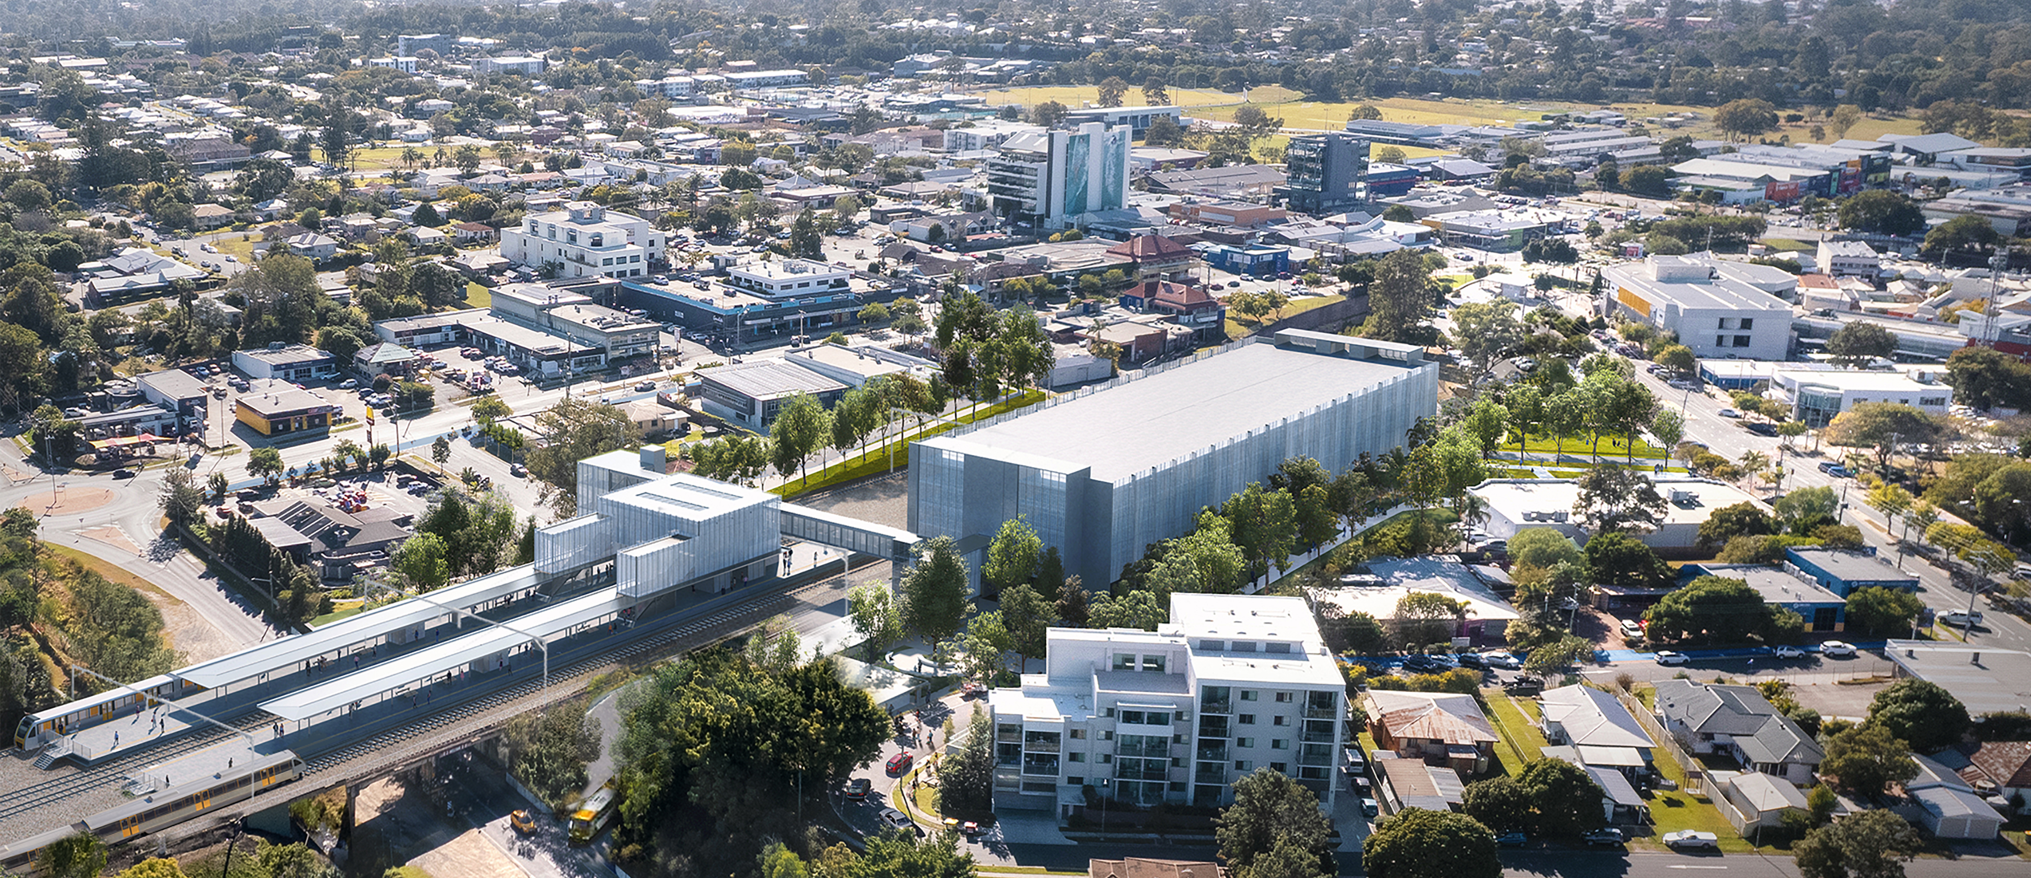

Key benefits for the community
- Safer, more accessible walking connections
- Improved public transport connections
- Increased park ‘n’ ride
- Road and intersection improvements

Funding
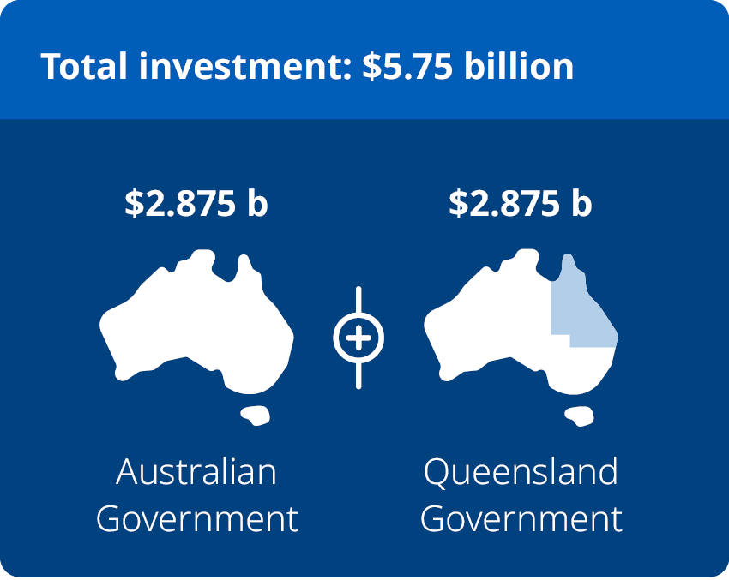
The Logan and Gold Coast Faster Rail (LGC) project, funded by the Australian and Queensland governments, is delivering a new Beenleigh station precinct to improve safety, accessibility, and connections to the town centre and key community facilities.

Design update
The new Beenleigh station will be relocated approximately 650m north of its current
location, to between Zander and Victoria
streets, near Beenleigh Town Square and
the Magistrates Court.
The updated design:
 | improves access to the town centre  and nearby destinations
allows the new station to be built while
the existing station continues operating.
 | provides a new bus interchange at the station.

Beenleigh station precinct

Logan and Gold Coast Faster Rail

April 2026
 | Design update

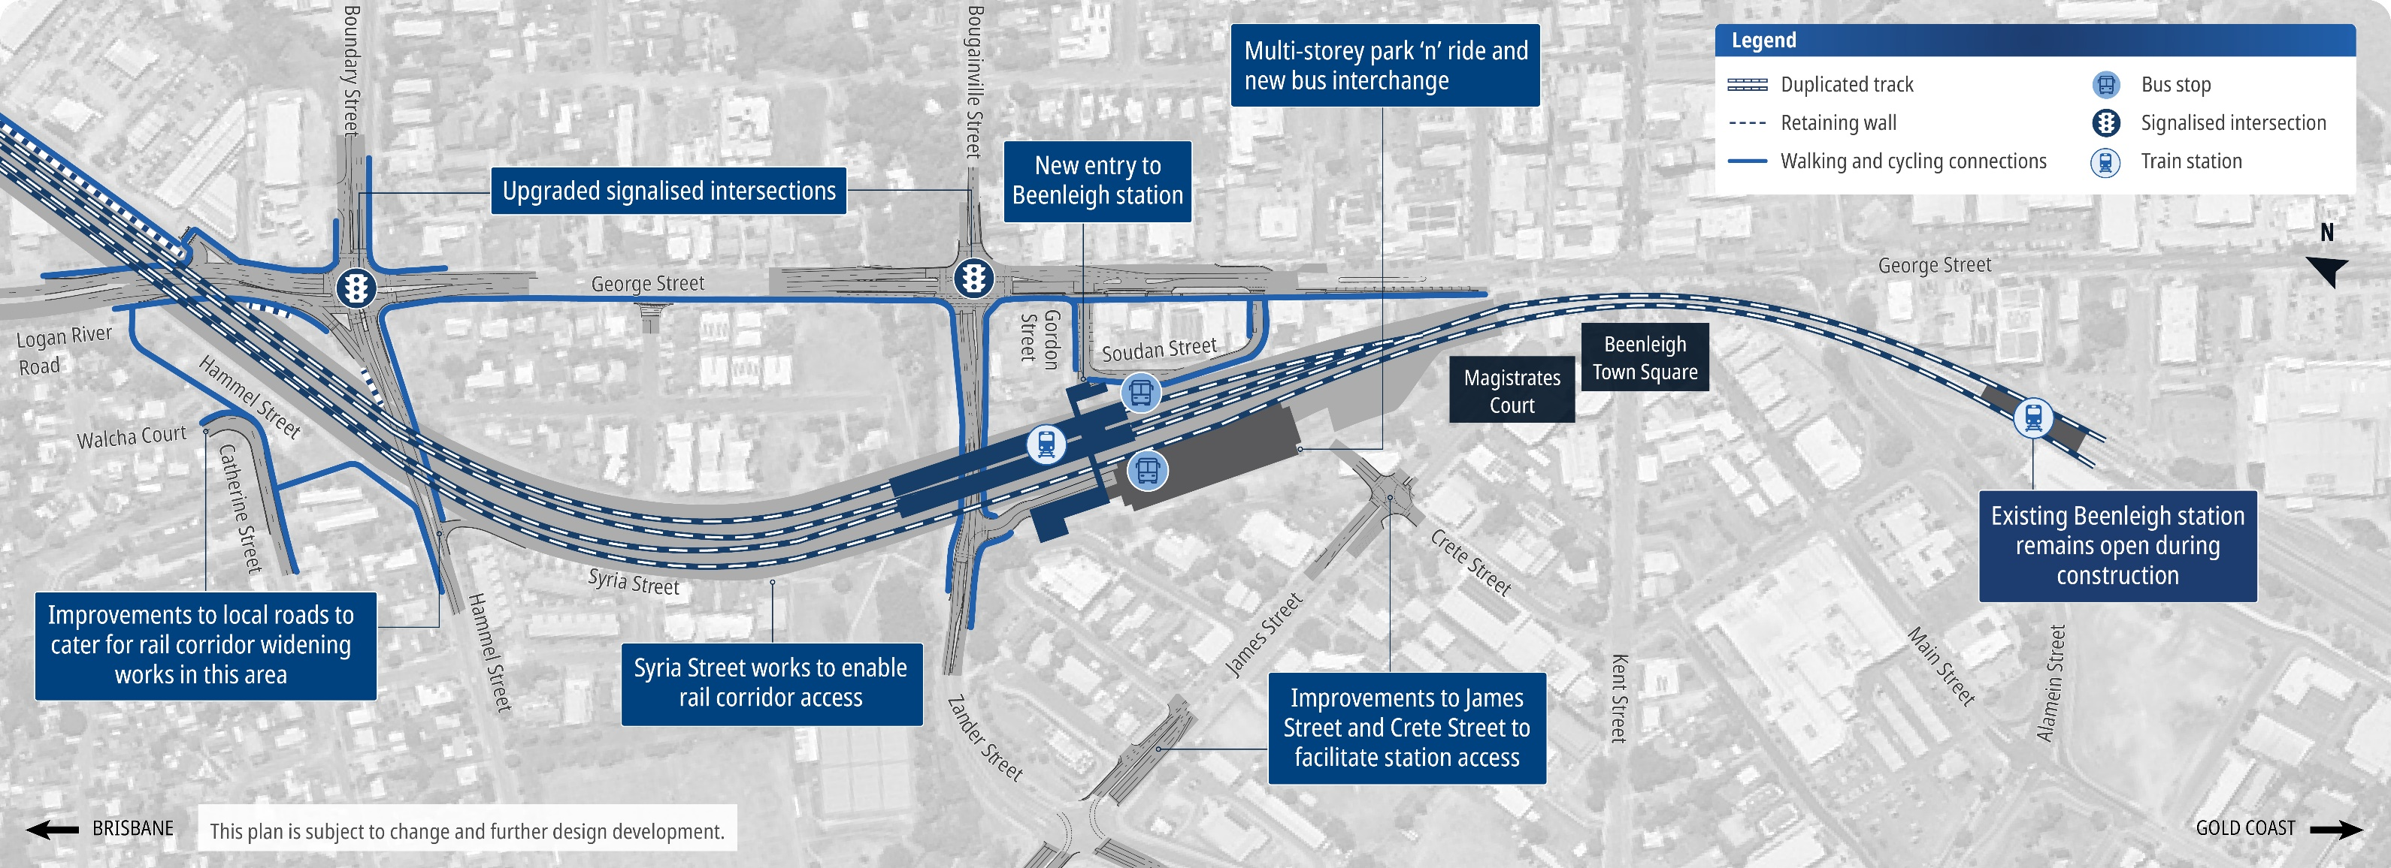

How community feedback shaped the design
Community feedback from 2023 has been incorporated into the updated design for the Beenleigh station precinct to further improve accessibility, safety and customer experience.

What you told us
You raised concerns about:
- the station location and limited connection with the town centre,
local businesses and community facilities
- the capacity of park ‘n’ ride facilities
- potential traffic impacts on the
local road network
- flooding impacts around the station area.

What’s new in the updated design
- Improved connections
Improved walking and cycling connections between the station, Beenleigh Town Square and nearby businesses. Pedestrian overpass at the station connecting both sides of the rail line.
- Increased car parks
A new multi-level park ‘n’ ride with approximately 600 car parks.
- Improved accessibility
New lifts, straightened and raised platforms, hearing loops and accessible car parks.
- Traffic improvements
Upgrades and new traffic signals at George and Zander streets, as well as George Street, Boundary Street and Logan River Road, to improve local traffic flow, safety and flood resilience.
- Improved safety and customer experience
Lighting and CCTV throughout the precinct.



Community drop-in sessions
You can speak directly with the project team at one of the following sessions:
Beenleigh Marketplace
114-118 George St, Beenleigh
Thursday 7 May 2026
9am–12pm and 3–7pm

Logan Lightning Football Club
Boundary Street, Beenleigh
Saturday 9 May 2026
9am–1pm

Beenleigh Library
Crete Street, Beenleigh
Wednesday 13 and
Saturday 16 May 2026
9am–12pm both days
Online: www.yoursay-projects.tmr.qld.gov.au/logan-and-
gold-coast-faster-rail
Deadline: Submit your feedback by Sunday 31 May 2026.

Next steps for the project
The LGC Rail package is being delivered by the ActivUs Alliance, made up of the Department of Transport and Main Roads, Queensland Rail and ActivUs.
The project includes:
- doubling tracks between Kuraby
and Beenleigh from two to four
- removing level crossings to improve
safety
- modern station upgrades
improved access and connectivity
along the 20km project corridor.
Design finalisation and site establishment works are underway, with major construction expected to begin across the corridor later in 2026.

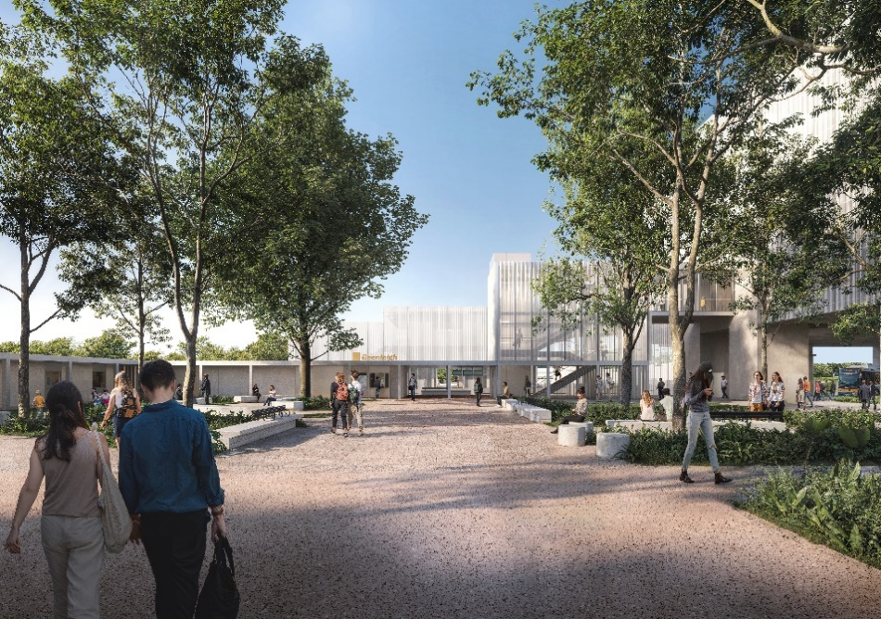
13 QGOV (137468)
www.tmr.qld.gov.au | www.qld.gov.au

Stay up to date
 | Search on tmr.qld.gov.au:  ‘Logan Gold Coast Faster Rail’
 | Email: lgcrail@activusalliance.com.au
 | Call: 1800 957 066 (all hours)
 | Post: Logan and Gold Coast Faster Rail Department of Transport and Main Roads  GPO Box 50, Brisbane, QLD 4001
For further information, or if you require translation or support services to access the documentation, please contact the project team on 1800 957 066
(9am – 5pm Monday to Friday).

 | For more information,  scan the QR code
www.yoursay-projects.tmr.qld.gov.au/logan-and-gold-coast-faster-rail

