Logan and Gold Coast Faster Rail

Bethania station precinct, September 2025

Bethania station precinct updated design
The Bethania station precinct is being upgraded to improve accessibility, safety and customer experience.
As part of the tender process for the Rail package of the Logan and Gold Coast Faster Rail (LGC) project, the Department of Transport and Main Roads (TMR) asked proponents to innovate and consider options to address prior community feedback. As a result, TMR has adopted a design that elevates Bethania station above Station Road and removes the need for a road-over-rail bridge.
The updated design significantly reduces impacts on important community facilities, nearby properties on Station Road, and provides easier access for everyone across the rail corridor.
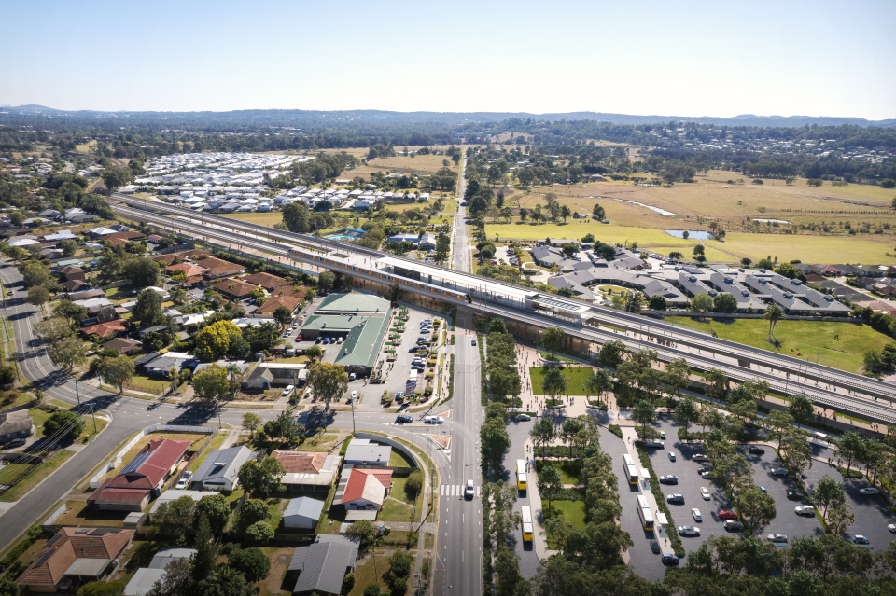

Figure 1 Artist impression of aerial view of new Bethania station, subject to change.

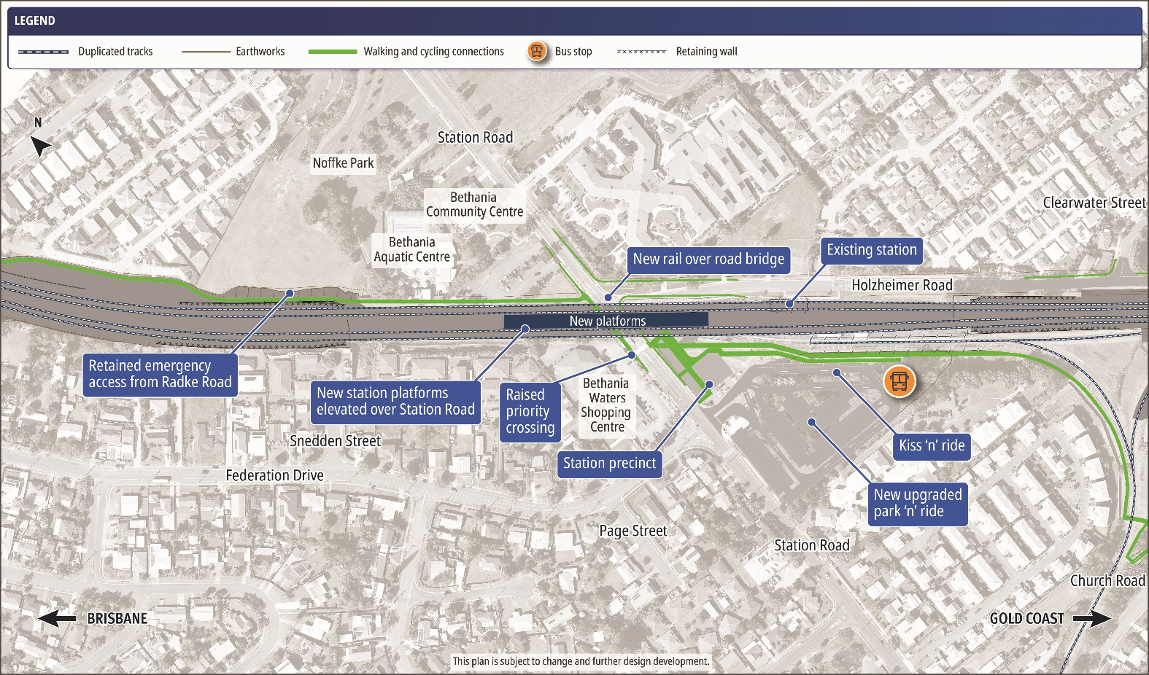

How community feedback has shaped the updated design
In late 2023, TMR sought public feedback on the Refined Reference Design for the whole LGC project, including the removal of five level crossings between Kuraby and Beenleigh.
ActivUs developed an alternative Bethania design solution for the LGC Rail package, which has been accepted by the state.

Community amenity
Community feedback received
Strong support for minimising impacts to community facilities.
Updated design features
Significantly reduced impacts to Noffke Park facilities, including the Bethania community and aquatic centres. Elevated station over Station Road:
- retains easy access to Bethania Waters Shopping Centre
- provides new civic space opportunities.

Local roads and traffic conditions
Community feedback received
Strong interest in local road changes. Feedback on existing flooding including impacts to local roads.

Updated design features
Elevated station eliminates Station Road level crossing at Bethania. Local road network remains largely unchanged. Retained cross-corridor emergency access from Radke Road during flood events.

Connectivity and accessibility
Community feedback received
Interest in cross-corridor pedestrian access and active transport connections.
Updated design features
Elevated station provides easier access for everyone across the rail corridor and improved connectivity to community facilities. Improved connections to the station including lifts and stairs to platforms and a signalised pedestrian crossing on Station Road.
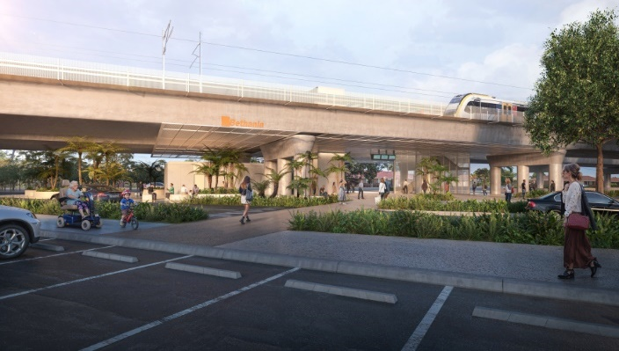

Figure 2 - Artist impression of new Bethania station entrance from park ‘n’ ride on Station Road, subject to change.

LGC Rail Alliance
In March 2025, the ActivUs consortium was awarded the design and pre-construction contract for the LGC Rail package to double the tracks between Kuraby and Beenleigh, deliver modern station upgrades, remove level crossings and improve access and connectivity along the 20km project corridor.
ActivUs with TMR and Queensland Rail has formed the LGC Rail Alliance to deliver these works. Further design and project planning activities have now commenced.

Project overview
The Australian and Queensland governments are delivering the LGC project to unlock additional services to address the high travel demand between Brisbane and the Gold Coast.
The number of tracks will double from two to four between Kuraby and Beenleigh which increases the capacity of the rail line and reduces waiting times at stations.
The project will also make it easier for everyone to access train services through modern station upgrades and improved walking and cycling connections, as well as improved safety and reduced traffic congestion for local communities through level crossing removals.

Property requirements
The Bethania station precinct updated design has reduced property requirements. TMR has contacted all property owners in Bethania where requirements have changed and will continue to engage with them and provide support through the acquisition process.

Next steps
To further progress the Bethania station precinct design, the LGC Rail Alliance has commenced site investigations and surveys within Bethania.
Site investigations will include geotechnical investigations and baseline noise assessments, to determine where noise mitigation treatments may be required.

Contact the project team
Telephone: 1800 957 066
Email: logangoldocastrail@tmr.qld.gov.au
The

