Logan and Gold Coast Faster Rail

Bethania station precinct, December 2025

Engagement summary

The Bethania station precinct is being upgraded to improve accessibility, safety and customer experience.

Between 9 September and 12 October 2025, the LGC Rail Alliance undertook engagement activities for the Bethania station precinct to seek feedback on the updated design.

Activities included in-person information sessions and an online engagement hub featuring:
- artist impressions of the updated station precinct design
- a detailed map
- have your say tool
- a question and answer (Q&A) tool.
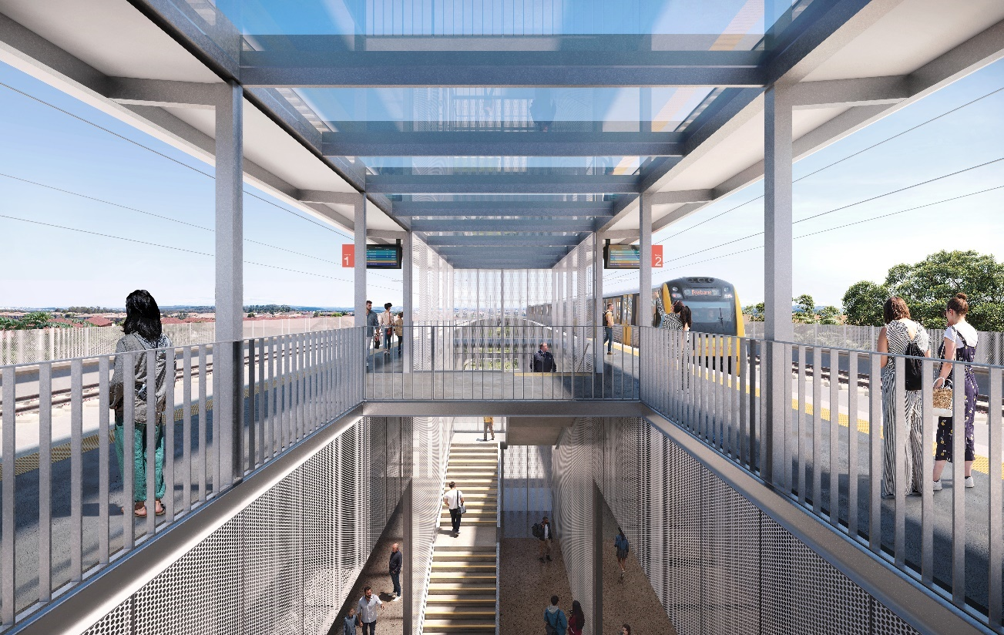

Figure 1 Artist impression of new Bethania station, subject to change

Engagement snapshot

How we engaged
- 5-week engagement period: 9 September to 12 October 2025
- Online engagement hub
- 7 in-person engagement sessions

How we promoted engagement
- 2500+ subscriber emails
- 2900+ flyers delivered to households in Bethania
- 2 customer awareness-raising sessions at Bethania station
- Social media targeting the Bethania area via the Department of Transport and Main Roads’ Facebook and LinkedIn pages

Who we engaged with
- Residents and community
- Elected representatives
- Local council
- Businesses
- Key interest groups

How you participated
- 1300+ in-person interactions
- 1900+ online hub views
- 18 Q&As
- 18 emails to project team

Key themes
The following key themes emerged from feedback collected during the engagement activities:
- noise and vibration during construction and operations
- station accessibility
- parking and traffic management
- flooding
- station design
- construction program
- bus connections
- active transport connectivity and access
- retaining the Bethania Waters Shopping Centre.

What you told us
- Supportive of the updated elevated station design.
- Strong interest in car parking and traffic management, in and around the station precinct.
- Feedback about past flood events and issues with local road access.
- Strong support for station accessibility upgrades.
- Interest in frequent communication and ongoing engagement on project timelines, construction impacts and final designs.

Next steps
Engagement on updated designs for the other station precinct upgrades being delivered as part of the Logan and Gold Coast Faster Rail project is continuing in late 2025 and early 2026. A detailed summary of feedback for all station precinct upgrades will be shared following the completion of this engagement.
Planning is underway to determine the construction staging and timings for all works along the 20km project corridor between Kuraby and Beenleigh.
Site investigation activities are continuing, in and around the rail corridor, which will help inform the design development and planning for future construction activities.
In early 2026, site establishment activities will start across the project corridor, ahead of major construction works later in the year.
The LGC Rail Alliance will keep the community informed about the detailed station precinct design development and construction staging and timings as the project progresses.

Did you know?
The Logan and Gold Coast Faster Rail project has no permanent works within the Bethania Waters Shopping Centre.
The project will continue to work with tenants throughout project delivery to minimise disruptions.

Stay up to date
To stay up to date on the LGC project, you can subscribe via our website at - www.tmr.qld.gov.au/logan-and-gold-coast-faster-rail.

