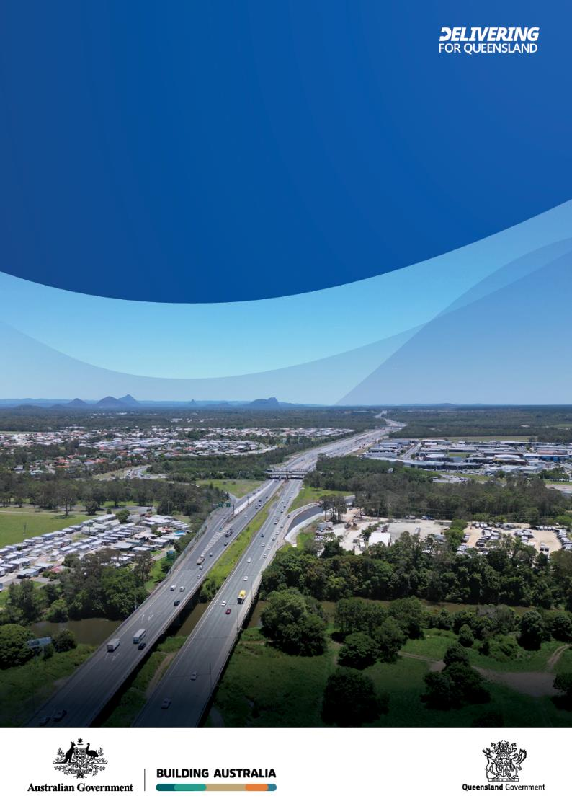
Community consultation summary
Bruce Highway Upgrade
Anzac Avenue to Caboolture-
Bribie Island Road
July to September 2025

Bruce Highway, looking north from Caboolture River towards Caboolture-Bribie Island Road interchange. Source: TMR

Copyright notice

This publication is protected by the Copyright Act 1968.
© The State of Queensland (Department of Transport and Main Roads) 2025. All rights reserved.

Attribution

The CC BY-NC-ND licence is a standard form licence agreement that allows you to copy and redistribute the material in any medium or format, and you attribute the material as follows:
© State of Queensland (Department of Transport and Main Roads), Bruce Highway upgrade : Anzac Avenue to Caboolture-Bribie Island Road, October-November 2023 is licensed under CC BY-NC-ND 4.0

You may not use the material for commercial purposes, and if you remix, transform, or build upon the material you may not distribute the modified material.

Enquiries about the use of any material in this publication can be sent to the department at: copyright@tmr.qov.au

Disclaimer

This publication is provided as a source of information only and the State of Queensland makes no statements, representations or warranties about its accuracy or completeness. To the extent permitted by law, the State of Queensland disclaims all responsibility for decisions or actions taken as a result of any data, information, statement or advice, expressed or implied, contained within and excludes all liability (including, without limitation, liability in negligence) for all expenses, losses, damages and costs that may be incurred.

Overview
The Department of Transport and Main Roads (TMR) is planning for upgrades to the Bruce Highway from North Lakes to Caboolture. Planning for proposed upgrades for this 18.8 kilometre section of the Bruce Highway will identify and assess a long-term solution to meet future traffic growth, reduce congestion, and improve efficiency, safety, and flood immunity.
The proposed upgrades include adding an additional northbound and southbound lane from Anzac Avenue to Uhlmann Road. The proposed upgrade for Uhlmann Road to Caboolture-Bribie Island Road is to add multi-lane, one-way collector-distributor roads on both sides of the existing Bruce Highway. Collector-distributor roads enhance highway efficiency, operation, and safety by providing extra traffic lanes and connectivity for short-trip traffic; and by reducing the number of highway access points. More information about the preferred option can be found in the project planning maps.
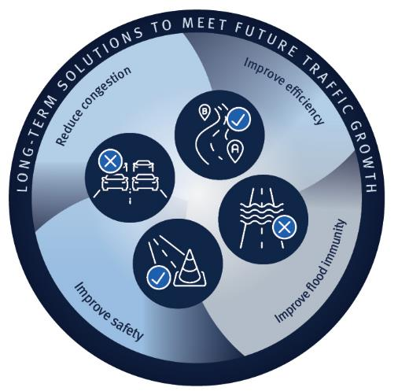
Active transport options are planned for pedestrian and bike rider facilities on the western side of the highway between Anzac Avenue and Caboolture-Bribie Island Road, along with improved east-west connections to local pathways and communities.

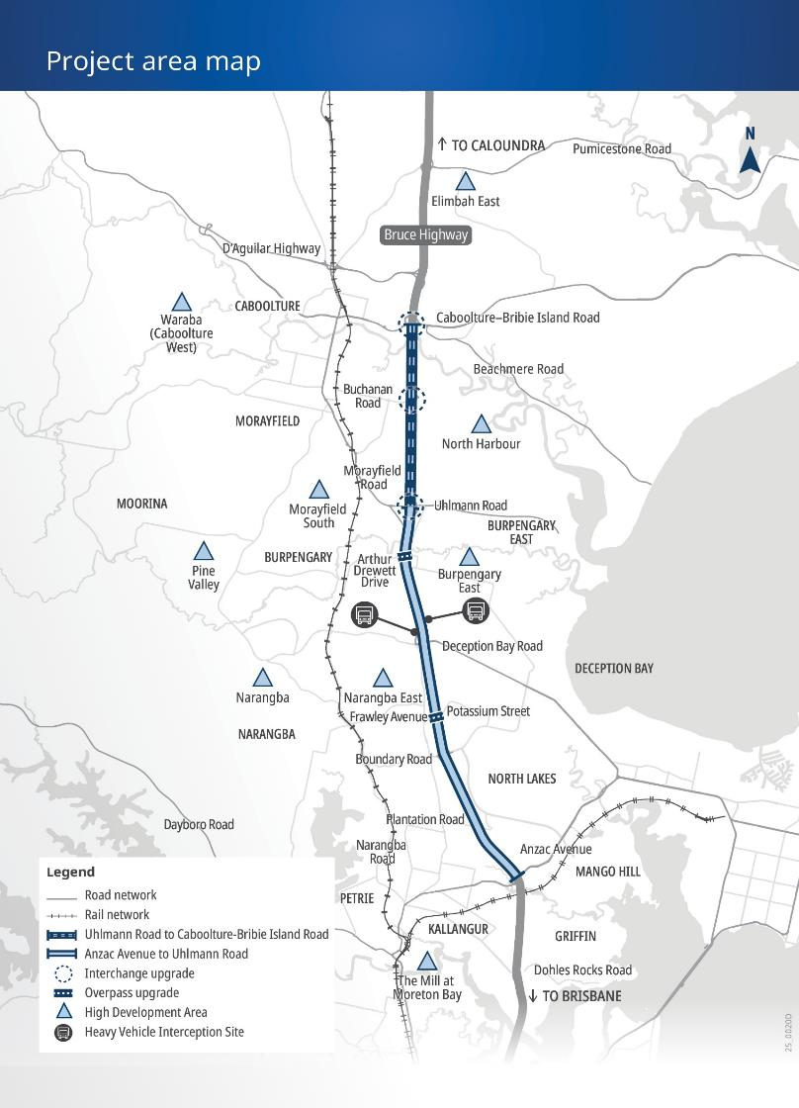
Community consultation
Above: The Bruce Highway Anzac Avenue to Caboolture-Bribie Island Road upgrade features interchange and overpass upgrades, as well as highway widening and collector-distributor roads.
TMR undertook two phases of community consultation. A separate report is available for consultation between 5 October to 20 November 2023. This report summarises activities from 16 July to 14 September 2025. The community was invited to provide feedback to help shape the planning of the Anzac Avenue to Caboolture-Bribie Island Road upgrades. Feedback was sought from potentially impacted landowners as well as residents, community groups, and business owners. The project team engaged directly with impacted property owners. Broader consultation was promoted using online and traditional methods including distribution of a project flyer, a social media campaign, the project webpages, and email.

Feedback summary


170+ feedback submissions


95,000+ flyers delivered to households and businesses


Online engagement: 5,600 views, 4,930 visits, 30 feedback submissions, 60 registrations for updates


More than 200 email notifications sent to project subscribers


More than 100 letters sent to property owners within the project area


Almost 6,000 visits to the project web pages

14,000 impressions, 885 link clicks, 60+ engagements on Facebook


More than 120 phone calls

Feedback themes and responses


Design – The feedback regarding project design included support for additional lanes, collector-distributor roads, and improved intersections to enhance safety and traffic flow. Concerns were raised about if the upgrades would address congestion at key interchanges such as Uhlmann Road, Buchanan Road and Caboolture-Bribie Island Road. Some questioned whether traffic movements between Morayfield and the Uhlmann Road interchange would rely too heavily on the collector-distributor roads, potentially creating bottlenecks. Others suggested improved noise barriers, clearer signage, and additional lighting.


Property impacts – Comments on property impacts highlighted concerns about potential resumptions, housing availability, and impacts on rentals and small businesses. Uncertainty about timeframes was concerning for some landowners.


Existing traffic congestion – The community highlighted delays during peak times, particularly near Uhlmann Road and Morayfield Road. Suggestions included extending merging lanes, enforcing "keep left" rules, and promoting carpooling and alternative transport options. Broader concerns were raised about whether current road improvements are keeping pace with increasing traffic volumes in the region. TMR also heard calls for greater investment in public transport to reduce highway congestion.


Active transport – Some welcomed protected pedestrian and bike pathways and corridors as a positive step, highlighting benefits for bike riders, people walking, and mobility aid users. Suggestions included adding greenery, shade, and soundproofing to improve comfort and accessibility for all ages. Concerns were raised about noise, fumes, limited connectivity, and the practicality of long-distance travel.


Project need – There was broad support for addressing growing congestion, safety concerns, and population growth. Some questioned why previous upgrades didn’t include more capacity. Others commented that the upgrade was long overdue, and anything to address congestion near Caboolture was welcomed.


Timing and funding - Feedback highlighted concerns about unclear timelines and funding uncertainty. TMR heard that many residents were frustrated with delays to address congestion and safety issues within the region.


Speed limits and safety - Feedback on speed limits and safety focused on maintaining consistent speeds to improve traffic flow and reduce driver frustration. Support was voiced for separating local and through traffic to reduce congestion and enhance safety.

Next steps
TMR would like to thank everyone who provided input during the consultation period. All feedback will be reviewed and considered further in future project phases. Planning for these staged upgrades began in 2023 and is nearing completion.
Funding is committed towards the detailed design and construction of upgrades north of Anzac Avenue. Total funding requirements will be confirmed when a construction contract is awarded. Construction staging, timeframes, and duration will be confirmed as the design progresses.
Timeframes for further upgrades will depend on future funding commitments.
This project is jointly funded by the Australian and Queensland governments. The community will be updated as the project progresses.

