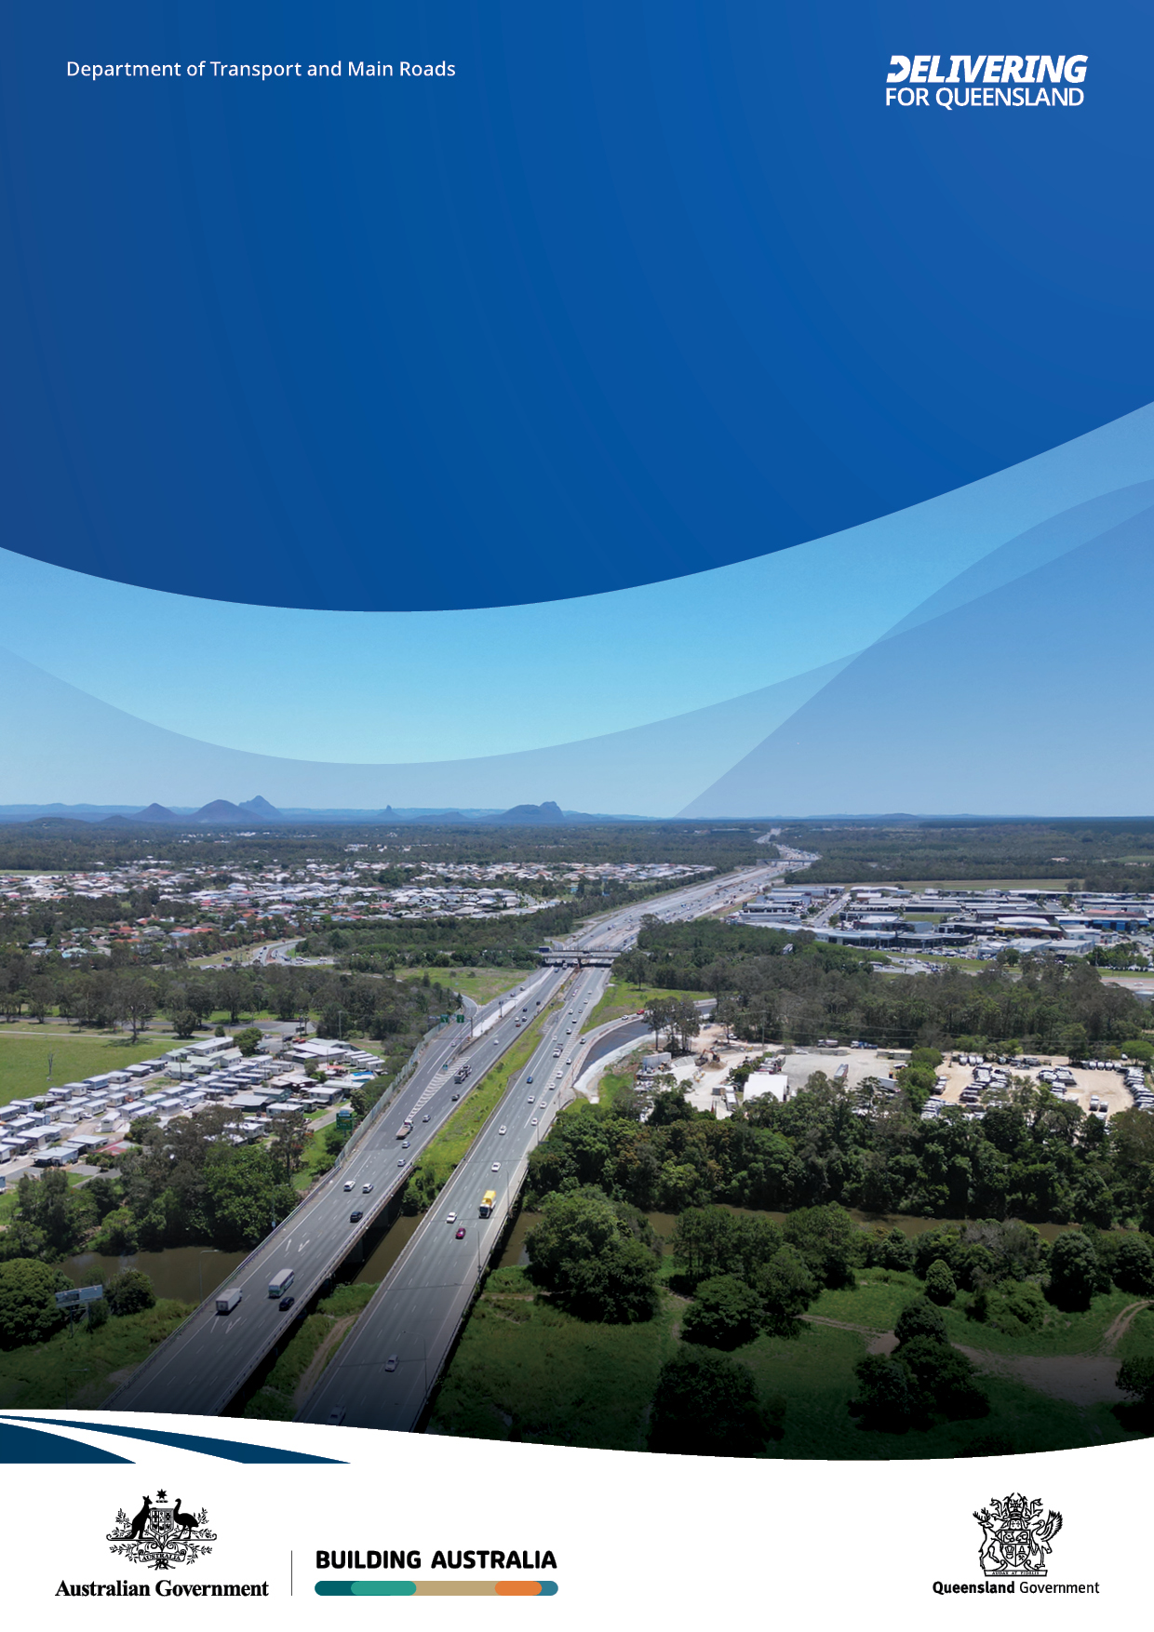

Bruce Highway, looking north from Caboolture River towards Caboolture-Bribie Island Road interchange. Source: TMR
Community consultation summary
Bruce Highway Upgrade
Anzac Avenue to Caboolture-
Bribie Island Road
October-November 2023

Copyright notice

This publication is protected by the Copyright Act 1968.
© State of Queensland 2025
Compiled and published by the Queensland Department of Transport and Main Roads.

Licence

The material in this work is licensed by the Department of Transport and Main Roads under a Creative Commons Attribution 4.0 International licence (CC BY-NC-ND 4.0), except for:

- the Queensland Coat of Arms
- this department’s logo
- any third-party material
- any material protected by a trademark, and
- any images and/or photographs.

To view this licence visit creativecommons.org/licenses/by-nc-nd/4.0/

Attribution

The CC BY-NC-ND licence is a standard form licence agreement that allows you to copy and redistribute the material in any medium or format, and you attribute the material as follows:

© State of Queensland (Department of Transport and Main Roads), Bruce Highway upgrade : Anzac Avenue to Caboolture-Bribie Island Road, October-November 2023 is licensed under CC BY-NC-ND 4.0

You may not use the material for commercial purposes, and if you remix, transform, or build upon the material you may not distribute the modified material.

Enquiries about the use of any material in this publication can be sent to the department at: copyright@tmr.qov.au

Disclaimer

This publication is provided as a source of information only. While every care has been taken in preparing this publication, to the extent permitted by law, the State of Queensland accepts no responsibility and disclaims all liability (including without limitation, liability in negligence) for all expenses, losses (including direct and indirect loss), damages and costs incurred as a result of decisions or actions taken as a result of any data, information, statement or advice, expressed or implied, contained within. To the best of our knowledge, the content was correct at the time of publishing.

Overview
The Department of Transport and Main Roads (TMR) is planning for upgrades to the Bruce Highway from North Lakes to Caboolture. Planning for proposed upgrades for this 18.8 kilometre section of the Bruce Highway will identify and assess a long-term solution to meet future traffic growth, reduce congestion and improve efficiency, safety and flood immunity.
The proposed upgrades include adding an additional northbound and southbound lane from Anzac Avenue to Uhlmann Road. Options investigated for upgrades from Uhlmann Road to Caboolture-Bribie Island Road were to either add an additional northbound and southbound lane or one-way, collector distributor (CD) roads on both sides of the existing Bruce Highway.
Active transport options are planned for pedestrian and bike rider facilities on the western side of the highway between Anzac Avenue and Caboolture-Bribie Island Road along with improved east-west facilities to better connect communities.



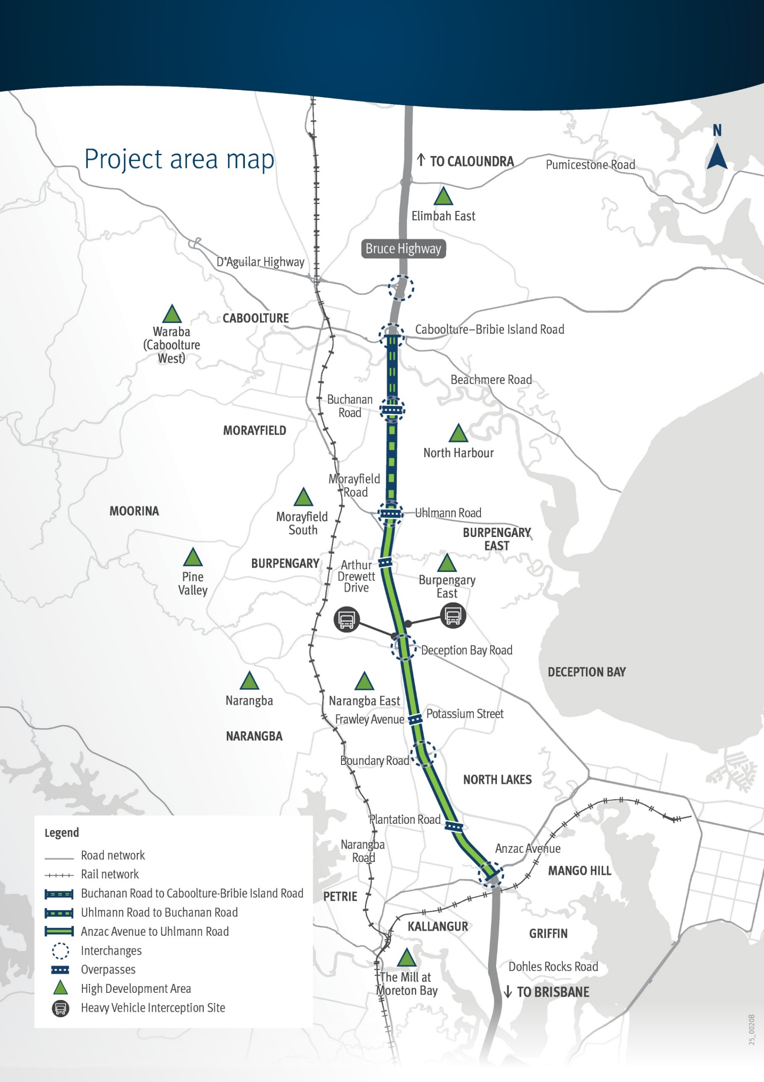

Community consultation
TMR undertook community consultation between 5 October to 20 November 2023. The community was invited to provide feedback to help shape the planning.
Feedback was received from residents, community groups, business owners and City of Moreton Bay during this consultation. Consultation was promoted widely using a range of online and traditional methods including distribution of a project newsletter, social media, project webpage and email.

Feedback summary
 | 90 comments received via online and traditional methods
 | 95,300 newsletters delivered to households and businesses from Caboolture to Petrie
 | Online engagement: 9406 views, 5178 visits, 57 survey responses,  37 registered for updates
 | 160 stakeholder email notifications sent
 | 180 letters sent to properties in the project area
 | 495 visits to the project web page
 | Facebook post: 78,391 impressions, 3103 link clicks, 169 comments
 | 24 phone calls

Feedback themes and responses

 | Design – There was support for extra lanes and some requests for five lanes in each direction instead of four. Some comments related to the cost and impact of widening the road. Comments included support for CD roads to remove local traffic from the highway and facilitate improvements for active transport. This was balanced by comments about the potential impact of CD roads on existing intersections, traffic flow and traffic noise. Some feedback questioned whether moving from four to three lanes at Uhlmann Road interchange would cause congestion. There were requests for road shoulders (breakdown lanes), directional signage, minimised merging and dedicated bus lanes.
 | Property impacts – There were general concerns from the community  about property resumptions to accommodate the upgrades, impacts on  established communities, homes, businesses and facilities.
 | Existing traffic congestion – Bruce Highway traffic congestion was a  general theme raised in comments. There were specific references to  peak hour congestion at locations such as Uhlmann Road overpass and  North Lakes, with requests for upgrades further south of the project  area. The impact of current roadworks was raised. The comments  emphasised the urgency of addressing existing traffic congestion.
 | Active transport – The feedback regarding active transport advocates  for a shift away from car-centric planning towards more sustainable  and active transport-focused approaches. There was some support for  separated active transport facilities, particularly to separate bike  riders and drivers. Safe crossings, shade, wide paths and separation  of bike riders and pedestrians on shared paths were also requested in  some comments.
 | Construction impact – The community questioned what construction  impacts would be involved in the upgrades including traffic delays,  detours and staging. They also questioned the compounding impact of  roadworks underway in adjacent areas on motorists and the community.

Feedback themes and responses

 | Public transport – Some comments highlighted a preference for  investments in public transport over road expansion, with a focus on  creating infrastructure that supports active transport, transit-oriented  communities and improved public transport services.
 | Environment – TMR heard that the environment is important to the  community, with residents concerned about the upgrade impacting  vegetation and wildlife. Some people were also concerned about  increased traffic noise and requested noise barriers and information on  proposed noise barrier locations. There were also requests for funding  to be made available for noise barriers.

Next steps
The community will be updated as planning progresses.

Contact us
- Email: NCR_Planning_Comms@tmr.qld.gov.au
- Phone: 1800 161 135 (Monday to Friday, 8.30am to 4.30pm)
- Web: www.tmr.qld.gov.au/projects/programs/
Bruce-Highway-Upgrade-Anzac-Avenue-to-Caboolture-Bribie-Island-Road
- Post: Bruce Highway Upgrade - Anzac Avenue to Caboolture Bribie-Island Road
Department of Transport and Main Roads, North Coast Region
PO Box 1600, Maroochydore QLD 4558

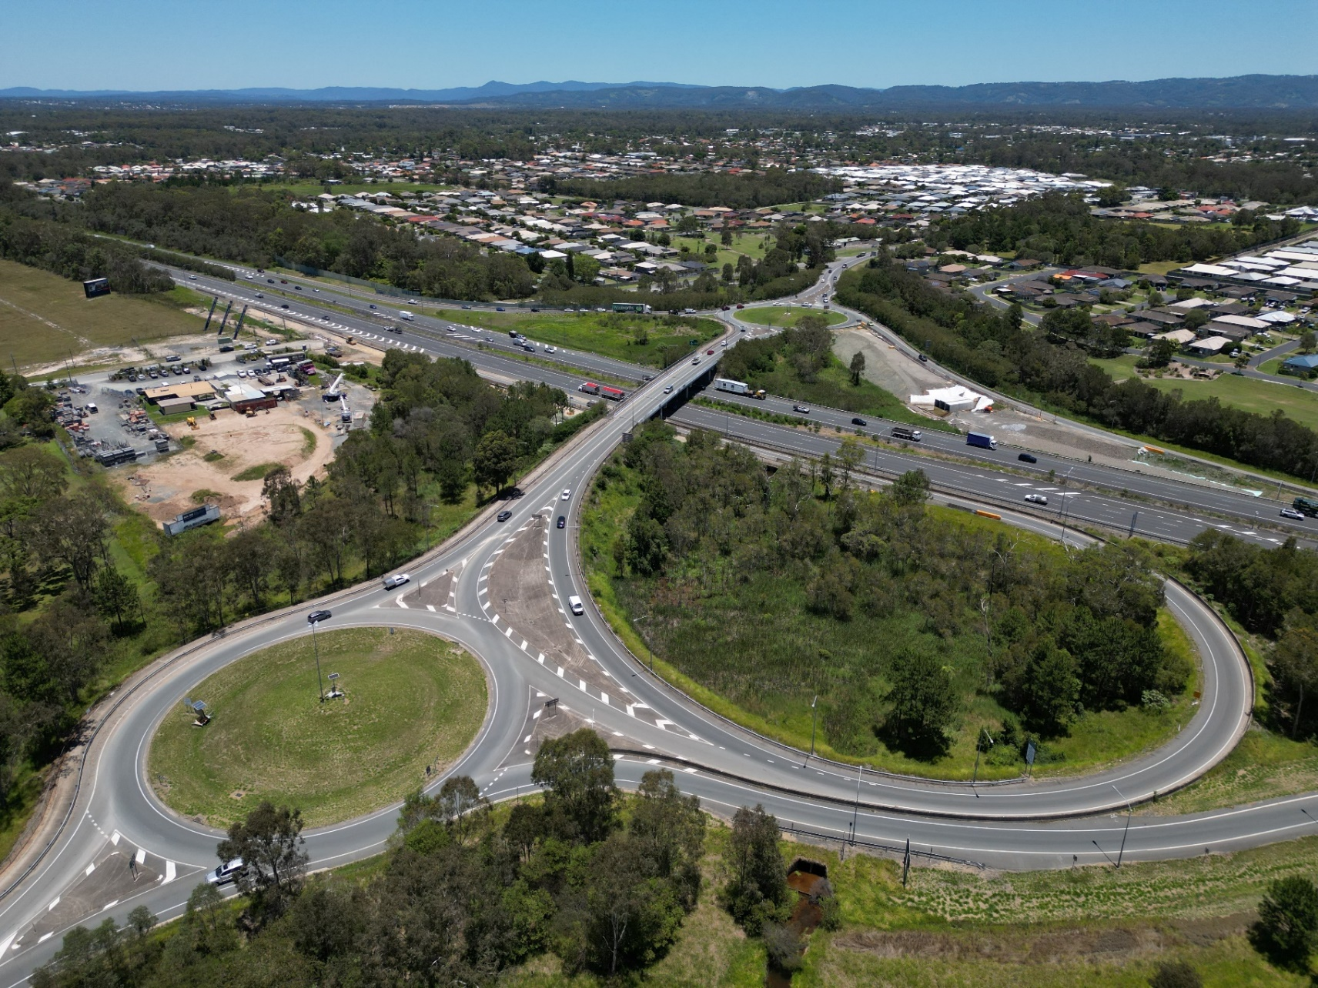
Image: Bruce Highway, Buchanan Road interchange. Source: TMR

13 GOV (13 74 68)

