Copyright
This publication is protected by the Copyright Act 1968.

© The State of Queensland (Department of Transport and Main Roads) 2024. All rights reserved.

Disclaimer
This publication is provided as a source of information only and the State of Queensland makes no statements, representations or warranties about its accuracy or completeness. To the extent permitted by law, the State of Queensland disclaims all responsibility for decisions or actions taken as a result of any data, information, statement or advice, expressed or implied, contained within and excludes all liability (including, without limitation, liability in negligence) for all expenses, losses, damages and costs that may be incurred.

Contact
Enquiries about the use of any material in this publication can be sent to the department at: copyright@tmr.qld.gov.au.

Overview
The Department of Transport and Main Roads (TMR) is undertaking a business case for a new bridge to Bribie Island and considering the future of the existing bridge. It aims to improve safety and reliability of the connection between Bribie Island and the mainland.
The business case builds on previous studies. Technical investigations and community consultation have informed development of a proposed concept design. The concept design proposes a new bridge that will feature two eastbound traffic lanes and a dedicated active transport path for bike riders, pedestrians and users of mobility devices. The active transport path on the northern side of the bridge will offer uninterrupted views of the iconic Glass House Mountains.
The existing bridge can support traffic use for the foreseeable future. The concept design proposes to fully utilise the existing bridge as a traffic asset by using it for two westbound traffic lanes.
Also, part of the Bribie Island Bridge planning is to widen the Caboolture-Bribie Island Road to 4-lanes between Bestmann Road East and Benabrow Avenue, as well as realigning the Sylvan Beach Esplanade intersection.
TMR has developed the Bribie Island Road Upgrade Strategy which identifies a program of works to deliver upgrade projects sequentially on Caboolture-Bribie Island Road. The road will be upgraded to 4-lanes for its entire length.

Community engagement
TMR undertook two phases of community consultation. The first consultation phase was held from January to February 2023. Feedback informed development of the proposed concept design. A report on phase 1 consulation is available on the TMR website.
The second community consultation phase ran from 11 January to 11 March 2024 and provided information on the proposed concept design including artist's impressions and a planning layout. Community feedback was received via online comments, reply-paid feedback forms, email, phone calls and community information sessions. Around 600 responses were received. The feedback contributed to further development of the business case and will also be considered in future detailed design and construction phases.
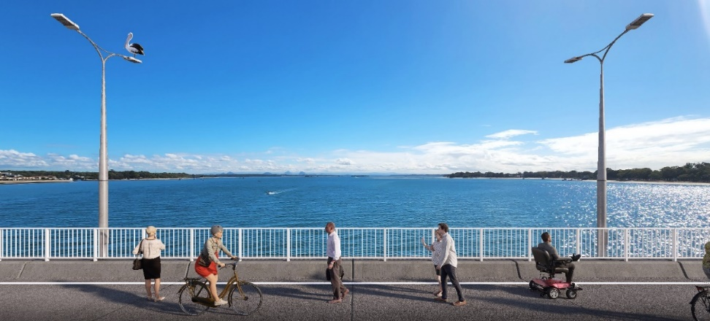
Image: TMR – Artist’s impression of the proposed active transport path.

Phase 2 community engagement

 | Consultation period  11 January to 11 March 2024
 | Letterbox drop  19,000 newsletters with surveys delivered  298 responses received
 | Online engagement  11,570 visitors  253 surveys completed
 | Community drop-in sessions  Sylvan Beach Esplanade, Bribie Island RSL Club and Bribie Island Shopping Centre  240+ people attended
 | Respondent location  62 per cent Bribie Island  21 per cent adjacent mainland  13 per cent unknown  4 per cent other areas
 | Social media  Three geotargeted TMR Facebook posts  4301 link clicks, 630 reactions, 350 comments, 74 shares
 | Email  Over 3400 sent  60 received

Feedback summary
- Feedback indicated support for the proposed concept design with generally positive comments submitted along with some negative, neutral and mixed responses.
- Supportive comments generally referred to the proposed concept design’s ability to improve travel reliability and safety, particularly for emergency services, with subsequent lifestyle improvements.
- There was support for specific features including additional traffic lanes, the ability to switch traffic between bridges if required and modifications to Sylvan Beach Esplanade intersection.
- Some comments also referred to the cost effectiveness and flexibility of retaining the existing bridge to provide westbound traffic lanes and the ability to widen the new bridge in the future.
- Comments on the proposed facilities for pedestrians, bike riders and mobility device users were generally positive.
- While there was general support for the concept design’s active transport path there were also some requests for separation between pedestrians and bike riders, seating and shade.
- Negative comments generally referred to preferences for an alternative design, particularly a new four-lane bridge with active transport on the existing bridge.
- Some respondents preferred a new bridge be built further north. Some suggested a lane for active transport, public transport or emergency services only, and some requested no upgrade at all.
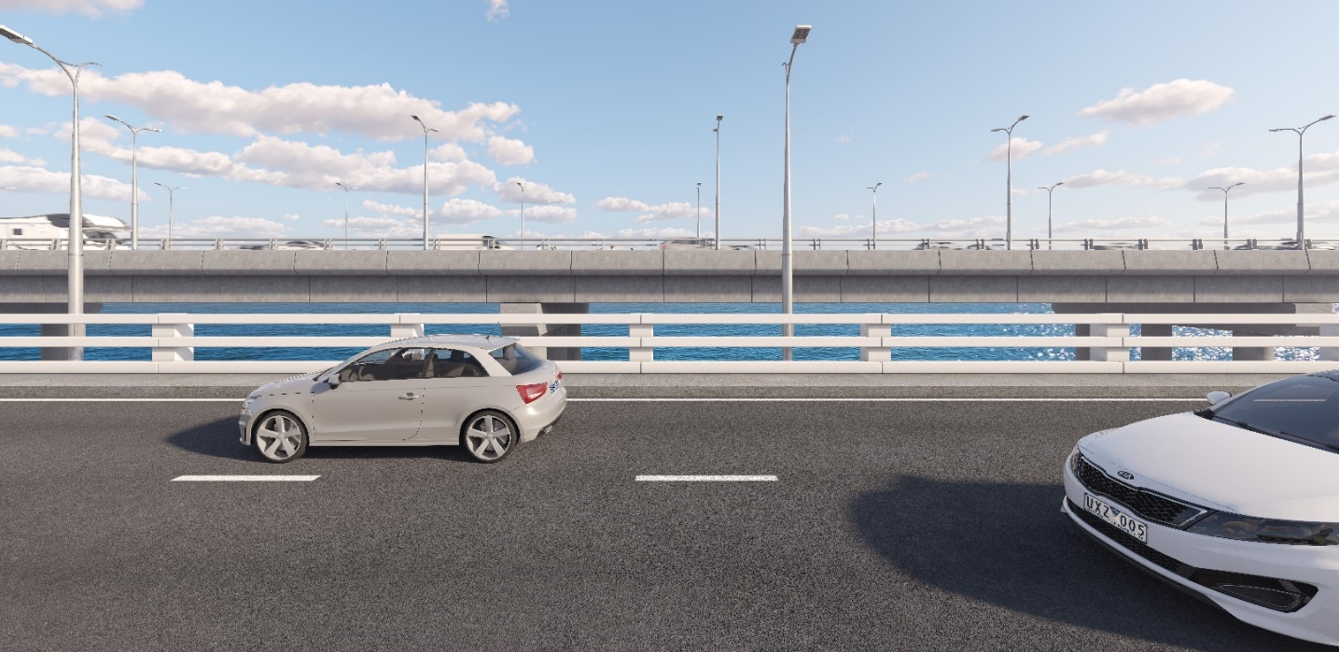

Image: TMR – Artist’s impression of the existing bridge with westbound lanes looking north to the future bridge.
- These responses were generally associated with a predicted limited lifespan for the existing bridge, expected increased costs of future widening works, concerns about increased traffic volumes and possible environmental and lifestyle impacts.
- There were various opinions regarding the lifespan of the existing bridge, with some respondents acknowledging investigations concluded it is in good condition and able to carry traffic for the foreseeable future, along with comments questioning how long it would remain in service and the cost of ongoing maintenance.
- Feedback included requests for improvements to Caboolture-Bribie Island Road and Benabrow Avenue.
- There were requests to address congestion and safety by providing four lanes and consistent speed limits on Caboolture-Bribie Island Road and concerns about existing issues on Benabrow Avenue (particularly Eucalypt Street roundabout) being exacerbated by bridge improvements.
- Some respondents opposed signalisation of the Sandstone Point Hotel access citing concerns about disrupted traffic flow, with requests to coordinate phasing with adjacent signals and suggestions to use Bestmann Road East as the only access point.
- While there was general support for the proposed changes to Sylvan Beach Esplanade, some respondents were concerned about the potential speed of eastbound vehicles turning left, with requests for guard rails, crossing facilities and signage.
- The safety of vehicles exiting Sylvan Beach Esplanade and crossing lanes to use the roundabout to access the westbound bridge was also raised by some respondents.
- Feedback on fishing included concerns about safety and waste with some requests for provision of improved, dedicated fishing facilities such as platforms, and references to fishing as a popular recreational activity for locals and visitors.
- Comments on the height of the new bridge included requests to lower the new bridge to improve visual amenity as well as requests to increase its height to allow access for masted vessels.
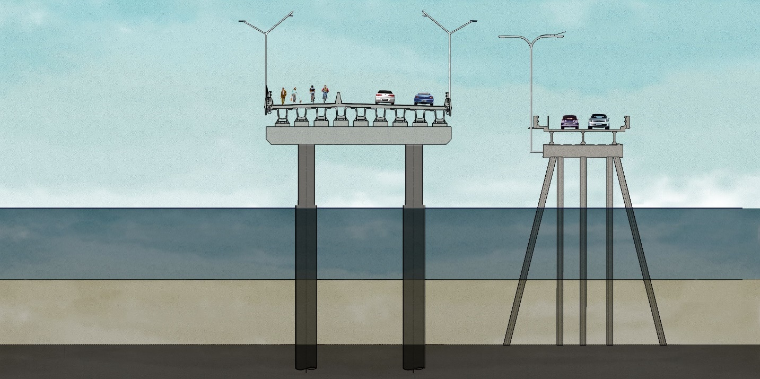
Image: TMR – cross section of the proposed concept design.
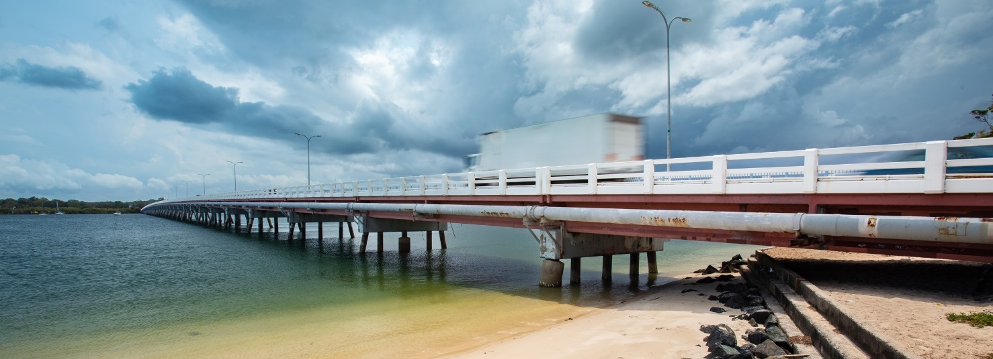Image: TMR – Existing Bribie Island bridge crossing the Pumicestone Passage.
- There were some requests for placemaking features such as gardens, cafes and markets, generally in reference to retaining the existing bridge for active transport.
- Access to Welsby Parade was raised in some comments and generally referred to eastbound traffic exiting the bridge experiencing difficulties using the roundabout to turn left at Welsby Parade. Suggestions included grade separated access.
- The condition of the existing bridge road surface was included in some feedback with requests to improve this either before or as part of a bridge upgrade.
- Pedestrian and bike rider safety feedback included requests for improved crossing facilities and fencing at the Sandstone Point Hotel access, crossing facilities on Benabrow Avenue and at the Sylvan Beach Esplanade intersection and connections to existing paths.
- Some respondents preferred use of the existing bridge for active transport as a safer option for pedestrians and bike riders because it would be separated from traffic and would not require people to cross over Caboolture-Bribie Island Road to access Sandstone Point Hotel.
- There were some references to the safety of elderly people, generally requesting slower moving stakeholders be considered in the design of active transport and the need for emergency access to the island for an older population.
- Feedback on timing generally requested construction of a new bridge to start soon or commented that the upgrade was overdue or needed urgently. There were also references to the Brisbane 2032 Olympic and Paralympic Games and 2024 State Election.
- Improved tourism opportunities and experiences was a theme raised in relation to the bridge upgrade providing better traffic flow, safety and active transport facilities.
- Use of the existing bridge as a ‘green bridge’ was also cited as a tourism opportunity.
- There were references to increases in visitor or population numbers as either a positive outcome for tourism and the economy due to new spending and opportunities; or a negative outcome for the local environment and community due to further traffic, development or impacts on services and infrastructure.
- Feedback on funding included requests for the cost of design and construction and questions about when funding would be committed.
- Environmental feedback included comments in support of the concept design as an appropriate solution and concerns about the impact of a new bridge. There is general support for environmental management to feature in design, construction and operation.
- Comments ranged from references to recycling and litter, impacts of increased traffic flow and four-wheel driving, vegetation management, protecting conservation areas and Bribie Island’s status as a flora and fauna sanctuary.
- There were comments supporting inclusion of pelican perches.
- Responses on visual amenity generally focused on what the new bridge would look like with requests that aesthetics be considered in the design to reflect Bribie Island’s heritage, environment and lifestyle. This included the main structure, railings, lighting, landscaping and art.
- There were requests to maximise views of the Glass House Mountains and Pumicestone Passage and concerns that views are impacted by the height of the new bridge.
- Some comments requested public transport improvements including introduction of
on-demand electric buses, ferries and park ‘n’ ride facilities located on the mainland.
- Cultural heritage references included specific mentions of Kal-Ma-Kuta, Yarun and Bungaree, inclusion of monuments, art and signage and retaining the existing bridge as a heritage asset.
- The small number of comments on construction impacts included how long work would take, the location of construction sites, noise, safety and traffic with requests to manage these along with any possible impacts on marine craft.
- The small number of comments on operational impacts included concerns about increased traffic noise with requests for mitigation measures such as noise barriers or road surface material and air quality, generally in reference to location of the active transport path next to traffic lanes.
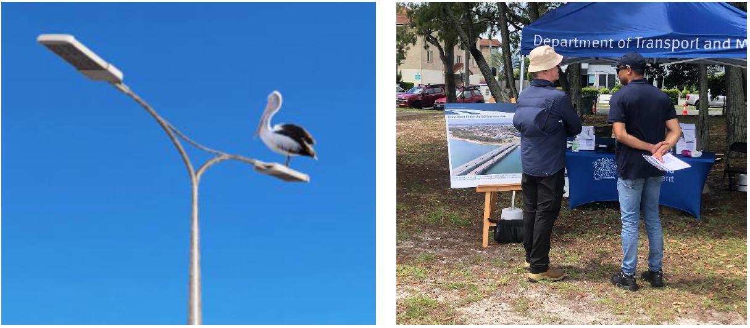
Images: TMR – Artist’s impression of pelican perches. A consultation event held at Sylvan Beach.
- There were a few references to accessibility, inclusivity or equity, generally in comments about improved active transport facilities providing better access for the elderly and people with disabilities along with requests for seating, shade and separate paths for bike riders and pedestrians.
- Feedback on consultation included appreciation for the opportunity to comment on the concept design, requests that alternative designs be presented to the community, the quality of communication material and processes and the requirement to register to access the online feedback tool.

Next steps
Feedback will be considered during finalisation of the business case phase and during the detailed design and construction phases. Further community consultation will be held during future project stages.

Contact us
- Email: Bribie.Island.Bridge@tmr.qld.gov.au
- Phone: 1800 783 016
- Website: www.tmr.qld.gov.au
- Postal address: TMR North Coast Region PO Box 1600 Maroochydore QLD 4558

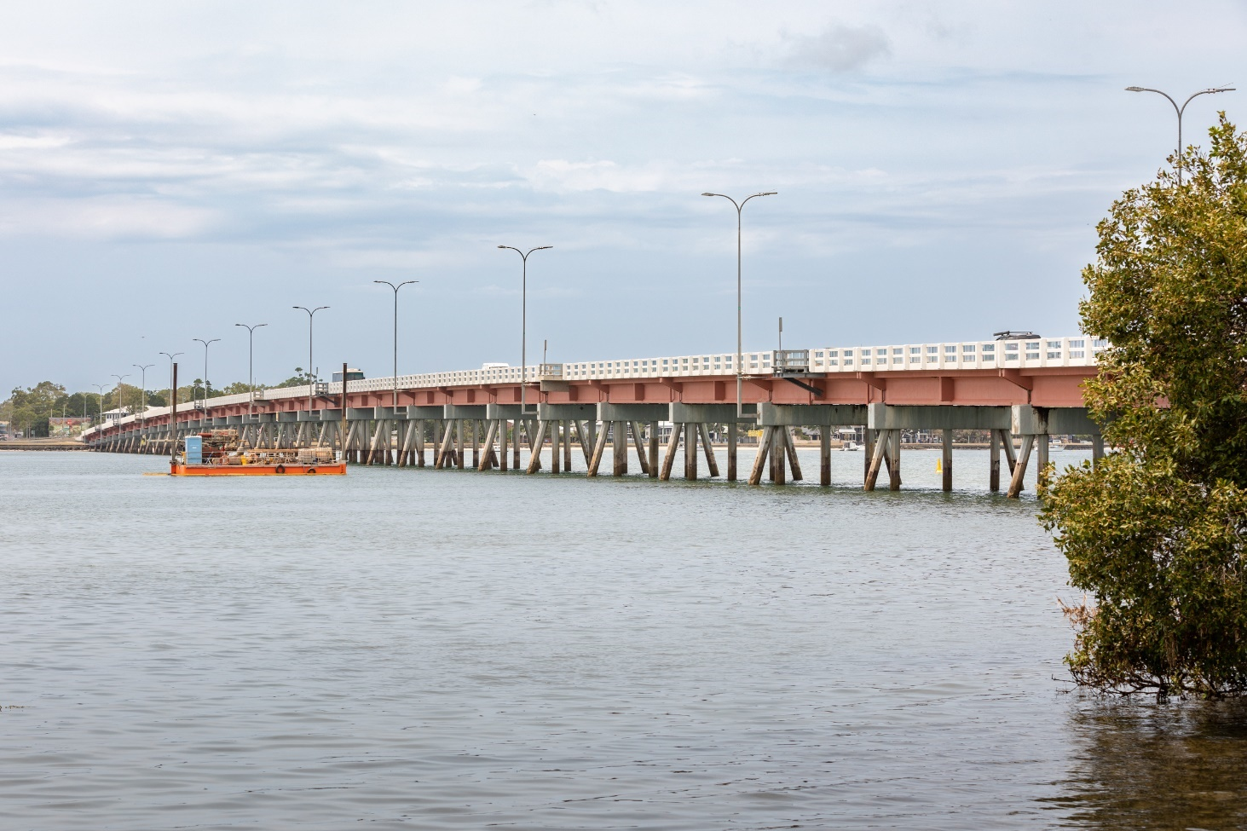
Images: TMR – Bribie Island bridge.

