Central Queensland Beef Roads
  - 10-year Investment Strategy
September 2025
Prepared by the Department of Transport and Main Roads
Translating and interpreting assistance
The Queensland Government is committed to providing accessible services to Queenslanders from all cultural and linguistic backgrounds. If you have difficulty understanding this publication and need a translator, please call the Translating and Interpreting Service (TIS National) on 13 14 50 and ask them to telephone the Queensland Government (Department of Transport and Main Roads) on 13 74 68.
Copyright
This publication is protected by the Copyright Act 1968. © The State of Queensland, 2025.
Disclaimer
While every care has been taken in preparing this publication, to the extent permitted by law, the State of Queensland accepts no responsibility and disclaims all liability (including without limitation, liability in negligence) for all expenses, losses (including direct and indirect loss), damages and costs incurred as a result of decisions or actions taken as a result of any data, information, statement or advice, expressed or implied, contained within. To the best of our knowledge, the content was correct at the time of publishing.

Front cover image: Clermont - Alpha Road (May 2024)

Contents
Introduction 3
Vision and Objectives 4
Overview 4
Stakeholder consultation and collaboration 5
What does the Strategy do? 6
What are the Central Queensland Beef Roads? 6
Challenges 7
What are we doing already? 9
Delivering the program 9
Going forward 12

Introduction
Queensland has the largest beef cattle herd in Australia at 42 per cent of the national herd. Australia represents 2 per cent of global beef cattle and 15.7 per cent of global beef meat exports. The beef industry is a significant regional employer and a major contributor to regional economies, including Central Queensland. Backing our beef industry will boost the economy, protect and create jobs and support regional communities. More than 10,000 Queenslanders are directly employed in the beef processing industry, with the industry value-add approximately $1 billion annually, making it one of the state’s largest manufacturing sectors.
An efficient freight network is critical to Queensland’s global competitiveness and economic performance. The beef industry supply chain relies on a combination of road, rail, and port access for the delivery of livestock and goods, including the transport of products to domestic and global customers. This supply chain includes a network of ‘beef roads’, supporting the beef industry by transporting livestock from regional grazing areas to markets, processing facilities, and ports. Many beef roads are unsealed, traversing remote and rural areas, and connecting cattle stations to major highways and transport hubs.
Central Queensland is renowned for its extensive grazing, cropping, and intensive production systems. Reflecting the importance of the beef industry in Central Queensland, the Australian and Queensland governments are investing $500 million in funding over the next 10 years. These funds will progressively seal priority sections of key beef corridors to achieve greater all-weather access, improve freight reliability, and road efficiency and safety.
Guiding this investment, are the Department of Transport and Main Roads (TMR), in partnership with the Australian Government and Queensland Beef Corridors (QBC) group. This group represents the seven Central Queensland local governments that assisted in developing the 10-year Central Queensland Beef Roads Investment Strategy (the Strategy) which will support the efficient and productive movement of beef in Central Queensland and improve safety for all road users.
When developing the Strategy, including its vision, objectives and investment priorities, TMR partnered with stakeholders, including the QBC group, transport operators, RACQ and primary producers.
Moving forward, the Queensland Government will work closely with the relevant local governments and the Australian Government to confirm the packaging and delivery strategy for the priorities outlined in the Strategy.

Vision and Objectives
The Strategy outlines a vision to provide:
“resilient road corridors and reliable access for primary producers, improved transport efficiency and livestock quality for the Central Queensland beef industry and associated supply chains”.
The Strategy aims to achieve the following objectives:
- improve efficiency of the beef supply chain from farm to port and processing facilities
- provide safer roads for all users
- improve reliability and resilience to weather events
- support economic activity along the corridor.

Overview
Across the state, there is a large and complex transport network supporting the Queensland beef cattle industry. This network comprises transport infrastructure including rail, road, air and sea transport. Transport is focused on live animals, processed beef and feed for feedlots. Given Queensland’s scale and the geographic scale of the industry, transport infrastructure and services are key to its success.
The Central Queensland Beef Roads (CQBR) are identified as a strategic road network that covers 218,000 square kilometres and supports the movement of around $1.7 billion in freight and agricultural produce – primarily Australian beef – each year from inland areas to saleyards, processing facilities and ports across the region.
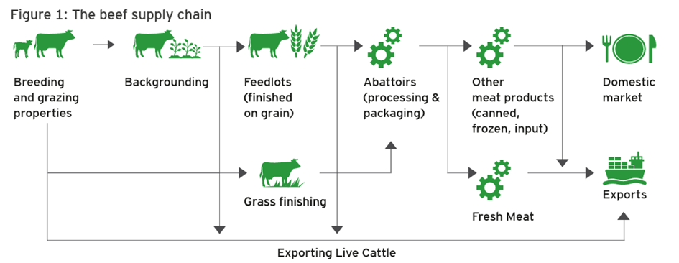
Source: The Queensland Beef Supply Chain, Queensland Government

The QBC is a collaborative advocacy group of the seven local government mayors within Central Queensland Region, which include Barcaldine, Central Highlands, Gladstone, Isaac, Rockhampton Regional Councils and Banana and Woorabinda Aboriginal Shire Councils. The QBC advocated for sealing the unsealed sections of nine identified beef roads in Central Queensland.
In 2024, the Australian and Queensland governments announced $500 million of road upgrades to support the state’s beef industry in Central Queensland over 10 years, comprising $400 million from the Australian Government and $100 million from the Queensland Government. For upgrades on the local government-controlled road network, there will be a $3 million co-contribution from the respective local government for these works.

Stakeholder consultation and collaboration
TMR worked with the QBC group, the Australian Government and key stakeholders in developing the Strategy. A Strategic Advisory Group (SAG) was established, consisting of Australian and Queensland government officials and representatives from the QBC advocacy group.
TMR and the SAG were supported by a Technical Working Group from the QBC local governments. Informing the investment priorities, TMR undertook a heavy vehicle access assessment, multi-criteria analysis and moderation process. CSIRO was also engaged to provide expertise in supply chain modelling using CSIRO’s Transport Network Strategic Investment Tool (TraNSIT).
An industry workshop was held and included the SAG as well as key stakeholders including transport operators, primary producers, Queensland Trucking Association and RACQ. The workshop aimed to understand industry stakeholder views on what investment was required, in what priority order and where to address critical issues and challenges within the CQBR network.
Key issues and challenges identified by stakeholders included:
- roughness and reliability of travel on unsealed sections
- narrow pavement seals and poor alignment
- condition of bridges and structures
- access constraints impacting productivity
- road closures due to flooding.
Engagement with stakeholders identified that sealing of unsealed roads was the highest priority. Stakeholder feedback played an important role in informing the investment priorities in the Strategy. While it is recognised key stakeholders sought to improve freight efficiency through increased heavy vehicle access, investigations by TMR indicated the required investment to upgrade the Burnett Highway (north of Biloela), and the Dawson Highway (east of Biloela) is significant. Such upgrades will need to be considered as a long-term objective, balancing other investment needs on these links.

What does the Strategy do?
The Strategy considered short, medium and long-term priorities for progressive sealing of unsealed roads across the beef roads in Central Queensland. It identifies priorities over the next 10 years under the $500 million funding commitment, with the aim to address all short-term priorities within the agreed scope, and deliver medium-term priorities subject to remaining available funding.

What are the Central Queensland Beef Roads?
The CQBR form a strategic agricultural supply chain of roads stretching more than 2000 kilometres from east to west across the region. These important roads allow beef to move through all stages of the production cycle – from breeding to backgrounding, feedlot to abattoir, market to export. Connecting with significant highways including the Inland Freight Route (an alternative north–south freight route from Charters Towers to Mungindi), Bruce Highway, Capricorn Highway and Dawson Highway, the CQBR are critical to the state’s economy.
As part of its advocacy to seek funding from the Australian and Queensland governments, the seven QBC local government mayors identified nine unsealed feeder roads as a priority for sealing. These works would improve all-weather access to connect primary producers to processing facilities and ports.
TMR, in partnership with Australian Government, worked with the SAG, QBC group and key industry stakeholders to determine the vision, objectives and investment priorities to inform the Strategy. This included progressive sealing of unsealed sections of the following nine roads:
- Clermont - Alpha Road
- May Downs Road
- Kilcummin - Diamond Downs Road
- Alpha - Tambo Road (within Barcaldine Regional Council)
- Dawson Developmental Road (within Central Highlands Regional Council)
- Fitzroy Developmental Road (Taroom - Bauhinia)
- Fitzroy Developmental Road (Bauhinia - Duaringa)
- Duaringa - Apis Creek Road (within Central Highlands Regional and Woorabinda Aboriginal Shire Councils)
- Glenroy Road (Rockhampton Regional Council local government road).

Challenges
In consultation with local government representatives, industry stakeholders and road users, key challenges were identified as part of development of the Strategy. The main challenges identified related to road roughness, the reliability of unsealed roads and driver fatigue caused by long distances, particularly on rough and unsealed roads. The surface of rough and unsealed roads constantly changes due to weather and traffic, making it challenging to maintain consistent driving conditions. This affects road safety and reliability, impacting on road users.
Road safety
Unsealed roads can be a hazard for traffic, especially during wet weather and when drivers encounter oncoming traffic. These roads can lead to increased vehicle stopping distances and an increased risk of skidding, sliding or rollover. Dust and loose gravel can also be thrown up by other vehicles, reducing driver visibility. Driving on unsealed roads requires extra attention by drivers and travelling long distances on unsealed roads can contribute to driver fatigue.
Reliability and resilience
Floods and seasonal road closures due to extreme weather are an ongoing challenge on many CQBR both on sealed and unsealed sections. Unsealed sections have less reliability, resilience and are more vulnerable to damage than sealed sections in rain events and flooding, including in minor flood events. Unsealed roads often remain closed for longer periods of time after floods to prevent further potential damage caused by traffic on waterlogged roads. Road closures not only prevent cattle reaching ports, feedlots and processing facilities, impacting productivity and animal welfare, but also isolate communities and farmsteads along the routes. Improving pavement resilience and flood immunity is critical.
Freight productivity and livestock welfare
Unsealed roads in poor condition negatively impact livestock transport by increasing stress on animals, potentially leading to injuries, reduced meat quality, and increased transport costs. These rough roads result in increased freight costs from longer travel times with lower travel speeds, higher vehicle operating costs and damage to vehicles and freight and animal health issues from dust, bruising, injuries and stress.
Increased freight costs are also experienced due to delays and additional travel via detours resulting from road closures caused by flooding and wet weather. Sealing unsealed sections improves driving and environmental conditions, reduces road closure times, reduces freight costs and improves overall health of livestock, therefore strengthening Central Queensland's beef supply chain.
Asset condition
Approximately 480 kilometres of the CQBR network is unsealed, with an additional 130 kilometres of sealed sections with high roughness and poor ride quality. A further 520 kilometres of sealed sections have pavements older than 30 years, and are in poor condition. Nearly half of the existing bridges are narrow, and 36 bridges have condition issues.
Unsealed roads present unique asset maintenance challenges due to their susceptibility to weather conditions, traffic volume, and material loss. Unsealed roads require more maintenance than sealed roads, as they are more susceptible to wear and tear. This increases road maintenance costs, particularly in areas where access to road materials, such as gravel, are limited.

What are we doing already?
The Australian and Queensland governments are progressing an early works package, including:
- paving and sealing sections along Clermont - Alpha Road, west of Craven Road
- paving and sealing sections along Clermont - Alpha Road, east of Pioneer Road
- paving, sealing and widening along Alpha - Tambo Road, northeast of Tumbar Road
- paving and sealing in sections along Fitzroy Developmental Road between Bauhinia and Duaringa
- paving and sealing sections along May Downs Road between Middlemount and Clarke Creek.
See the project locations map for the early works locations.

Delivering the program
Under the $500 million commitment, in partnership with the QBC local governments, will progressively seal unsealed sections of roads that form the CQBR network. The aim is to address all short-term priorities within the agreed scope, and deliver medium-term priorities subject to remaining available funding.
The sealing program aims to enhance the Central Queensland beef supply chain, while supporting development of the sector. This delivery and investment approach will enhance regional connectivity by providing opportunities for local economic development, by linking people to jobs and services, and goods to markets. It will also improve safety across the network, by reducing fatalities and serious injuries, and boosting freight transport efficiency.
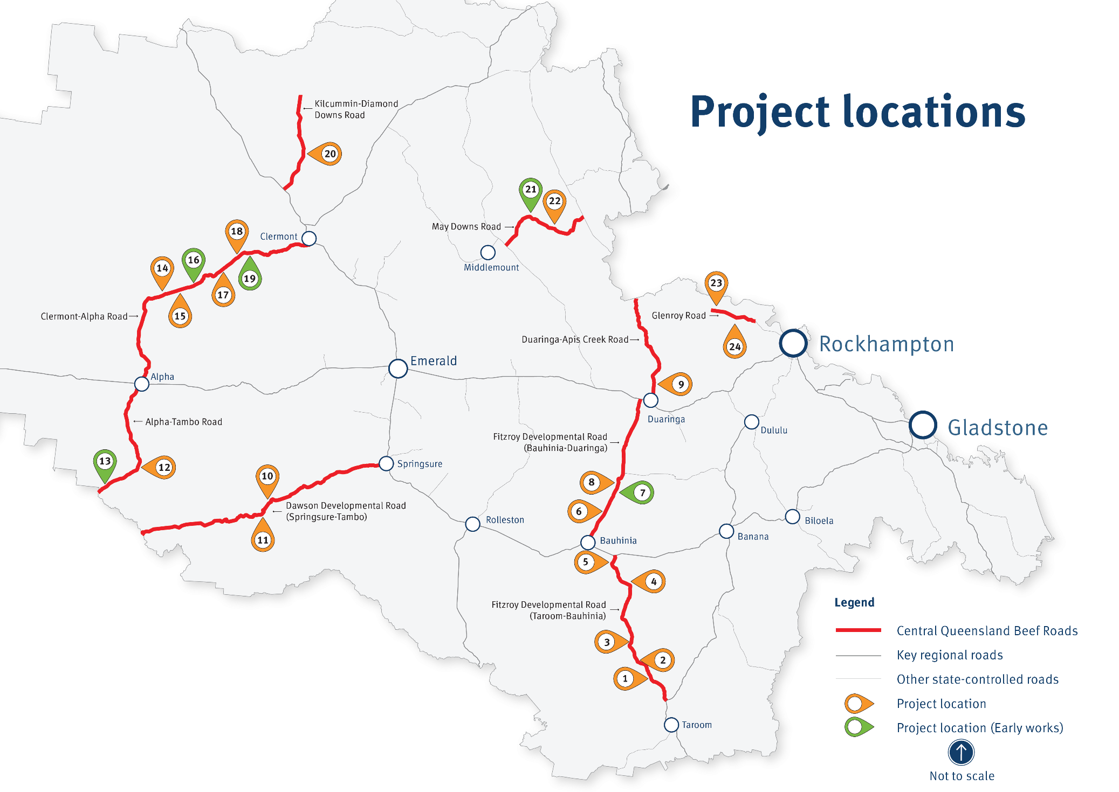
Map ID | Project | Short term | Medium term
Fitzroy Developmental Road (Taroom - Bauhinia) – approximately 60 kilometres of sealing
1 | Fitzroy Developmental Road (Taroom - Bauhinia) (14km north of the Leichhardt Highway turn off) | ●
2 | Fitzroy Developmental Road (Taroom - Bauhinia) (27km north of the Leichhardt Highway turn off) | ● | ●
3 | Fitzroy Developmental Road (Taroom - Bauhinia) (43km north of the Leichhardt Highway turn off) |  | ●
4 | Fitzroy Developmental Road (Taroom - Bauhinia) (85km north of the Leichhardt Highway turn off) | ● | ●
5 | Fitzroy Developmental Road (Taroom - Bauhinia) (107km north of the Leichhardt Highway turn off) | ●
Fitzroy Developmental Road (Bauhinia - Duaringa) – approximately 10 kilometres of sealing
6 | Fitzroy Developmental Road (Bauhinia - Duaringa) (26km north of Bauhinia) |  | ●
7 | Fitzroy Developmental Road (Bauhinia - Duaringa) (40km north of Bauhinia) | ●
8 | Fitzroy Developmental Road (Bauhinia - Duaringa) (45km north of Bauhinia) |  | ●
Duaringa - Apis Creek Road - approximately 8 kilometres of sealing
9 | Duaringa - Apis Creek Road (3km north of Duaringa) |  | ●
Dawson Developmental Road (Springsure - Tambo) – approximately 20 kilometres of sealing
10 | Dawson Developmental Road (Springsure - Tambo) (75km west of Springsure) | ●
11 | Dawson Developmental Road (Springsure - Tambo) (85km west of Springsure) | ● | ●
Alpha - Tambo Road – approximately 20 kilometres of sealing
12 | Alpha - Tambo Road (45km south of Alpha) | ● | ●
13 | Alpha - Tambo Road (83km south of Alpha) | ●
Clermont - Alpha Road – approximately 40 kilometres of sealing
14 | Clermont - Alpha Road (103km west of Clermont) |  | ●
15 | Clermont - Alpha Road (89km west of Clermont) | ● | ●
16 | Clermont - Alpha Road (86km west of Clermont) | ●
17 | Clermont - Alpha Road (55km west of Clermont) |  | ●
18 | Clermont - Alpha Road (45km west of Clermont) |  | ●
19 | Clermont - Alpha Road (42km west of Clermont) | ●
Kilcummin - Diamond Downs Road – approximately 15 kilometres of sealing
20 | Kilcummin - Diamond Downs Road (20km north of the Gregory Developmental Road intersection) | ● | ●
May Downs Road – approximately 15 kilometres of sealing
21 | May Downs Road (32km west of Clarke Creek) | ●
22 | May Downs Road (22km west of Clarke Creek) | ●
Glenroy Road (Rockhampton Regional Council controlled road) – approximately 15 kilometres of sealing
23 | Glenroy Road (21km west of Ridgelands) | ● | ●
24 | Glenroy Road (11km west of Ridgelands) | ●
● Represents early works projects.

Going forward
As part of the development of the Strategy, the SAG endorsed the short, medium, and long-term priorities to fully seal the nine identified CQBR. TMR will work with local governments, key stakeholders and the community to deliver the short-term priorities to scope. The medium-term priorities are subject to the availability of remaining funding to support reliable, sustainable and adaptable livestock arrangements that meet the sector's needs in Central Queensland.
TMR will continue to:
- work with the key stakeholders to identify opportunities and address challenges associated with the beef supply chain
- identify future planning and investment options for the beef processing industry, through the Queensland Transport and Roads Investment Program and the development of the Queensland Freight Delivery Plan. This freight plan will prioritise freight system innovation and improvements across the state and support regional economic growth and productivity.

Queensland Government, The Queensland Beef Cattle Supply Chain 2018
Ibid
Queensland Government, Queensland Beef Processing Strategy 2019-2022

