Logan and Gold Coast Faster Rail

Kingston station precinct, November 2025

Updated design
The 2023 Refined Reference Design (RRD) required the existing Kingston Road bridge to be rebuilt to accommodate the wider rail corridor underneath.
As part of the tender process for the Logan and Gold Coast Faster Rail (LGC) project, the Department of Transport and Main Roads (TMR) asked proponents to innovate and consider options to address prior community feedback.
As a result, TMR has adopted a solution which will better integrate the station with the Kingston butter Factory Cultural Precinct, an important historical community and cultural hub, with improved station entry points and bus stops off Milky Way.
Other updates to the design include:
- repositioning Kingston station away from the Kingston Road bridge avoids the need to rebuild the bridge, significantly reducing community disruption
- a rebalanced park ‘n’ ride on both sides of the station encourages improved access and capacity for customers
- on the southern side, the repositioned connection to the Kingston Butter Factory Cultural Precinct preserves melaleuca trees along Milky Way and ensures safe access from the car park and bus stops while enhancing pedestrian flow to cater for events.
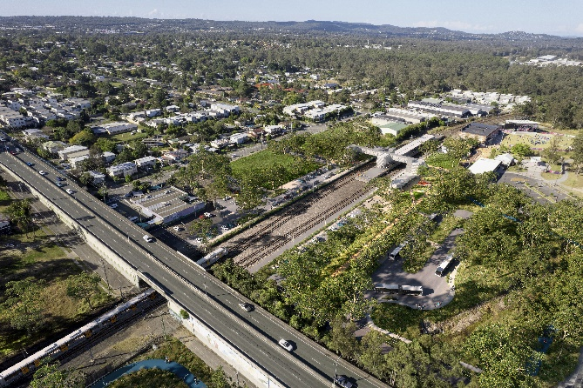

Figure 1 Artist impression of new Kingston station, subject to change

Kingston station precinct design
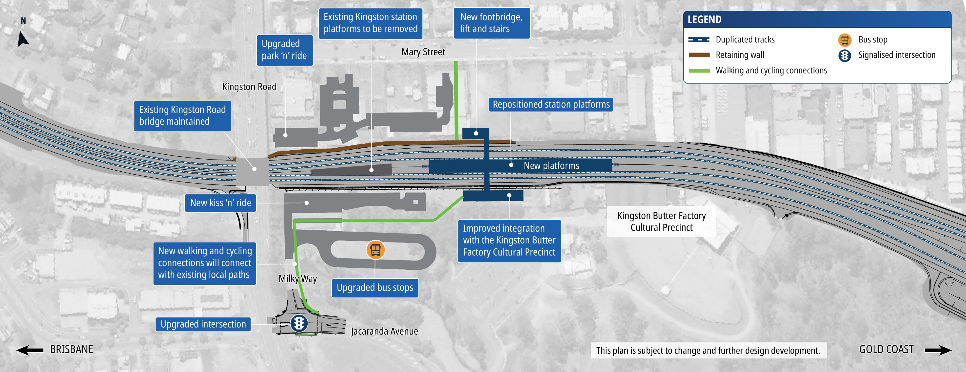

How community feedback shaped the updated design
In late 2023, TMR sought public feedback on the Refined Reference Design for the whole LGC project, including the removal of five level crossings between Kuraby and Beenleigh.
TMR has worked with ActivUs to incorporate community feedback into the updated design for the Kingston station precinct, to further improve accessibility, safety and customer experience.

What you told us
- Suggestions to better integrate Kingston station with bus connections and pedestrian paths.
- Better integration and connection with Kingston Butter Factory Cultural Precinct.

What we are doing
- A repositioned station connection to the Kingston Butter Factory Precinct enhances pedestrian flow and safe access to and from the car park and bus zone.
- A rebalanced park ‘n’ ride on the northern side of the station improves access and capacity for customers from the north and encourages future development along Mary Street.
- Repositioning the station away from Kingston Road bridge avoids the need to rebuild the bridge, significantly reducing community disruption.

Next steps
TMR, Queensland Rail and ActivUs have formed the LGC Rail Alliance to deliver the LGC Rail package.
The LGC Rail package scope of work includes doubling the number of tracks between Kuraby and Beenleigh from two to four, removing level crossings, modern station upgrades, and improving access and connectivity along the complex 20-kilometre project corridor.
ActivUs is currently undertaking site investigations to inform further design development ahead of major construction works starting later in 2026.
The $5.75 billion LGC Rail project is jointly funded (on a 50:50 basis) by the Australian and Queensland governments.
Scan the QR code to visit the online engagement hub at www.yoursay-projects.tmr.qld.gov.au/logan-and-gold-coast-faster-rail to have your say and sign up for updates.
1800 957 066 (all hours)
lgcrail@activusalliance.com.au
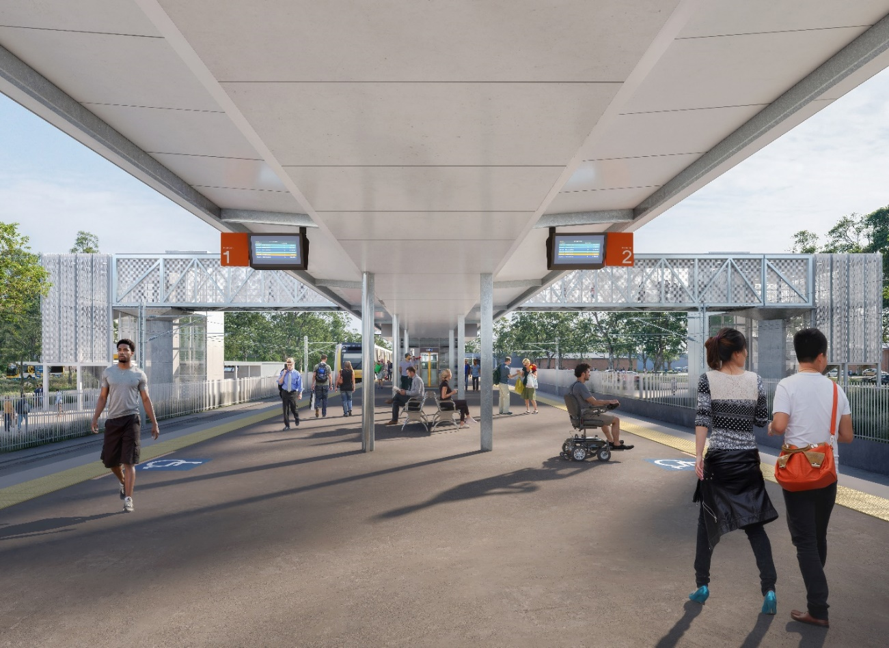

Figure 2 Artist impression of new Kingston station, subject to change.

