Logan and Gold Coast Faster Rail

Kuraby Level Crossing Removal, September 2025

Project overview
The Department of Transport and Main Roads (TMR) is removing five level crossings between Kuraby and Beenleigh, as part of the Logan and Gold Coast Faster Rail (LGC) project to improve safety, reduce traffic congestion, and improve cross corridor connections for local communities.
The level crossing at Beenleigh Road, Kuraby is the first to be removed.
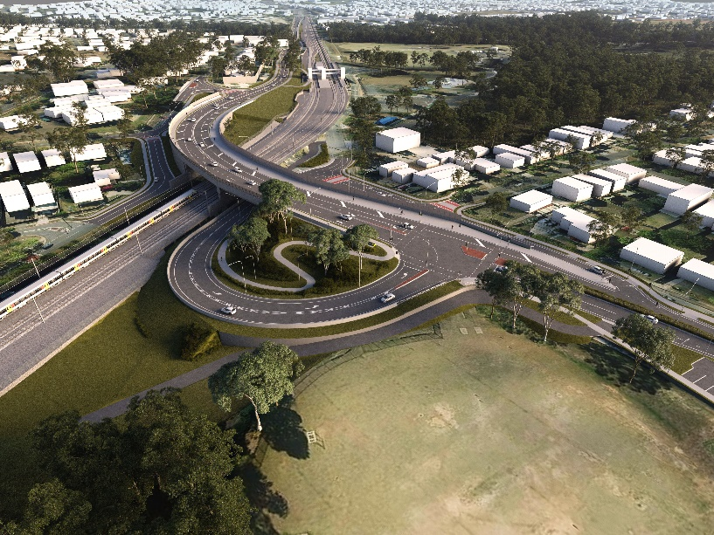

Figure 1 Artist impression of new road-over-rail bridge at Kuraby. Subject to change.

Level crossing design update
In September 2024, TMR awarded the design and construct contract to Bielby Hull Joint Venture (BHJV) to deliver the level crossing removal at Beenleigh Road, Kuraby.
The project is in the design phase and is further developing the previous reference design for the new bridge over the future four track rail line, improving access to important community facilities along Beenleigh Road.
In late 2023, TMR delivered engagement activities to seek community feedback on the level crossing removal reference design. This local knowledge and feedback provided valuable insights which have informed preliminary design development.
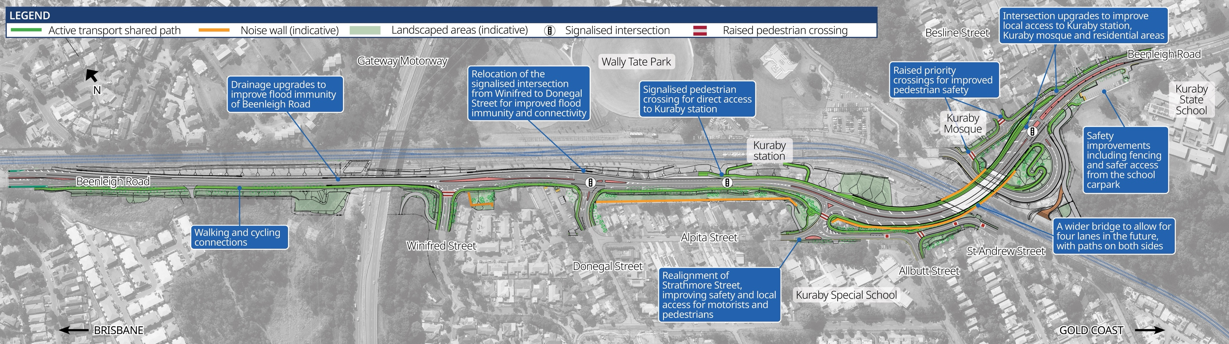

How community feedback has shaped the updated design

Connectivity
Community feedback received
- Strong support to improve pedestrian and cyclist connections to key locations such as Kuraby State School and Special School, Kuraby Mosque, and surrounding residential areas.
Updated design features
- Enhanced pedestrian and cyclist connectivity through new accessible pathways on Beenleigh Road and on both sides of the bridge, and safer crossings with raised pedestrian and signalised crossings.

Traffic flow
Community feedback received
- Support for level crossing removal and improvements to safety and traffic congestion.
Updated design features
- Road and intersection realignments to improve safety for all traffic movements, minimise traffic queuing and improve traffic flow.
- Enhanced pedestrian and cyclist connectivity through new accessible pathways on Beenleigh Road and on both sides of the bridge, and safer crossings with raised pedestrian and signalised crossings.

Local intersection upgrades
Community feedback received
- Interest in local intersection upgrades.
Updated design features
- Adjustments to local intersections, such as relocating the Beenleigh Road signalised intersection from the proposed location at Winifred Street to Donegal Street and upgrades to the intersection at St Davids Street.
Future-proof
Community feedback received
- Support for ensuring facilities consider future traffic and transport needs.
Updated design features
- A widened bridge design will allow future expansion of Beenleigh Road, with space for up to four lanes to accommodate future travel demands and paths on both sides of the bridge.
Confirmed design elements
The preliminary design for the level crossing removal on Beenleigh Road has been developed to achieve a design that is safe and suitable for all road users and best accommodates future traffic growth and the new four track railway. This process has allowed confirmation of the:
- Corridor and alignment
- Number of lanes
- Location of intersections.
Some elements of the design are subject to change and will be confirmed through further modelling and engagement with the community, including noise walls.

Kuraby station and track works
The Australian and Queensland governments have committed to $5.75 billion (50:50 basis) to deliver the Logan and Gold Coast Faster Rail project to unlock additional services to address the high travel demand between Brisbane and the Gold Coast.
The number of tracks will double from two to four between Kuraby and Beenleigh which increases the capacity of the rail line and reduces waiting times at stations. The project will also make it easier for everyone to access train services through modern station upgrades and improved walking and cycling connections, as well as improved safety and reduced traffic congestion for local communities through level crossing removals.
The Kuraby station upgrade and track works are being delivered through the LGC Rail package, which includes all major rail works along the 20km project corridor. In March 2025 TMR awarded ActivUs consortium the design and pre-construction contract for this package.
ActivUs has formed the LGC Rail Alliance with the Department of Transport and Main Roads and Queensland Rail to deliver these works. Further design and project planning activities have now commenced.

Next steps
Since early 2025, BHJV has completed further ecological surveys, geotechnical drilling and utility investigations which are now informing development of the detailed design.
Early construction works including services relocations will start in early 2026, ahead of major construction commencing.

Property requirements
The design has now been developed to a stage where the scope of the works and the impacts to the property are fully refined and clarified. TMR has contacted all property owners in Kuraby where impacts have changed and is continuing to work in alignment with the Acquisition of Land Act 1967.

Contact the project team
Telephone: 1800 957 066 (select option 3)
Email: lgc_olcr@bhjv.com.au
The

