Consultation Summary
July 2026

Kuraby Open Level Crossing Removal
Delivering a new road-over-rail bridge on Beenleigh Road, Kuraby as part of the Logan and Gold Coast Faster Rail project.

Key benefits for the community
- Improved safety
- Improved network efficiency
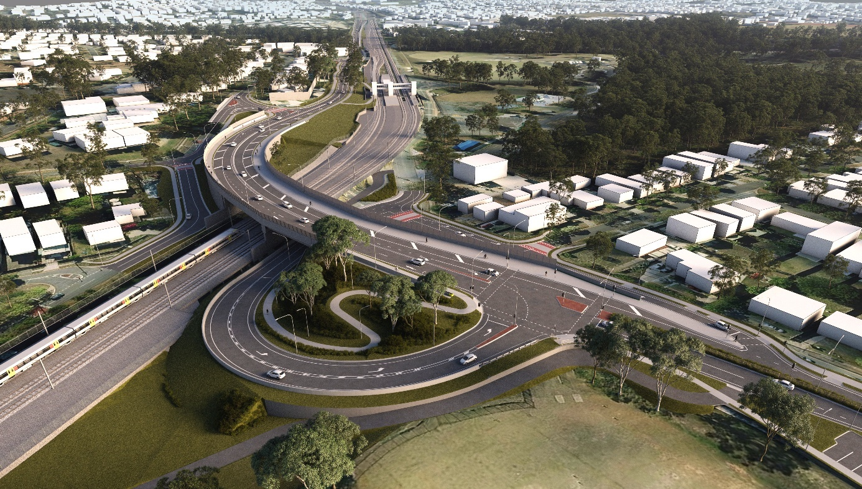
- Reduces peak hour congestion
Figure 1: Artists impression of new road over rail bridge on Beenleigh Road, Kuraby.

Overview
In late-2025, the Department of Transport and Main Roads shared the updated design for the Beenleigh Road, Kuraby level crossing removal.
In this summary you can find:
- What you told us
- Engagement snapshot
- Frequently asked questions
- What happens next?

Construction timeline
- Early works – began in 2025
- Major construction – started in March 2026
- Completion – Expected in 2028

What you told us
- Support for the level crossing removal and the safety benefits it will deliver.
- Strong interest in road and traffic changes, including to local access and intersections.
- Requests to explore opportunities for additional pedestrian connections or retention of existing pedestrian crossing.
- Interest in safe and convenient access to key community destinations, including schools and places of worship.

Engagement snapshot
How we engaged
- Online engagement survey
- 6 in-person information sessions
- Factsheets and flyers delivered to 1,900 households in Kuraby
- Targeted briefings with key stakeholders and elected representatives
How you participated
- 245+ in-person interactions
- 13,000+ online engagement hub views
- 27 online submissions
- 47 Q&As
- 13 emails to the project team
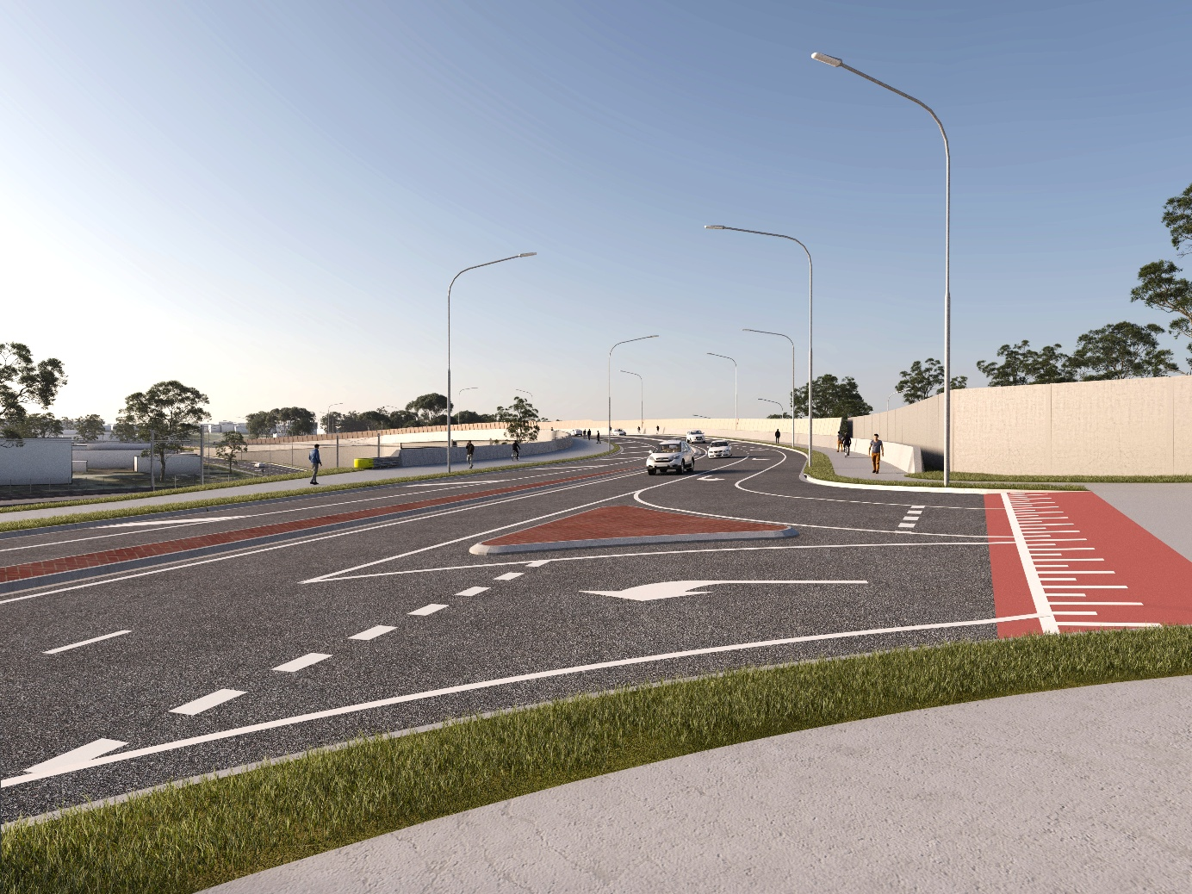
Figure 2: Artists impression of new shared user paths on Beenleigh Road, Kuraby. Source: TMR

Frequently Asked Questions
Why can’t a separate pedestrian only bridge or crossing be provided?
A range of options were considered, including a dedicated pedestrian only bridge. However, providing any pedestrian connection must be compliant with the Disability Discrimination Act 1992 (DDA).
This requires pedestrian bridges to include long ramps with gentle gradients, rest areas, and clear sightlines so they can be safely used by people with a disability, older people, and families with prams.
The final design provides the safest and most direct access possible within a tightly constrained area.
How will pedestrians access schools, Kuraby station, and community facilities?
The new road-over-rail bridge includes shared paths on both sides of Beenleigh Road to provide continuous, safe connections to local destinations including Kuraby station, nearby schools, places of worship, and other community facilities.
New accessible paths, improved sightlines, and safer crossings will make it easier for people to move through the area without waiting for trains to pass or finding gaps in traffic.
Why are the Strathmore and Winifred street intersections left turn only?
The new signalised intersection at Donegal Street will provide full turning movements, including a safe right turn onto Beenleigh Road for residents from the south-west Kuraby area.
Alternative right-turn locations were investigated, however, traffic modelling and safety assessments showed that providing right turn movements at a single signalised intersection will allow for safer and more efficient traffic flow overall.
How will the road changes manage congestion?
The removal of the level crossing will reduce congestion, as motorists will no longer need to wait at the boom gates for trains to pass.
The new signalised intersections are designed to manage traffic movements safely and efficiently, operating in a coordinated way to maintain steady flow and providing safe pedestrian connections.
The widened bridge and corridor design will allow future expansion of Beenleigh Road, with space for up to four lanes to accommodate future travel demand.

What happens next?
Thank you to everyone who shared valuable feedback. The insights you provided were considered as part of development of the final design and construction planning.
Major construction has now commenced on the new bridge, with site establishment and public utility services relocation works well underway.
We will keep you informed of construction timing and possible impacts as information becomes available, and prior to the start of work.

Stay up to date
Search on tmr.qld.gov.au: ‘Kuraby level crossing removal’
Email: LoganGoldCoastFasterRail@tmr.qld.gov.au
Call: 1800 957 066
Bielby Hull Joint Venture
Email: lgc_olcr@hbjv.com.au
Call: 1800 957 066 (select option 3)

For further information, or if you require translation or support services to access this document, please contact the project team on 1800 957 066 (9am – 5pm Monday to Friday).

https://www.yoursay-projects.tmr.qld.gov.au/logan-and-gold-coast-faster-rail/kuraby
13 QGOV (137468)
www.tmr.qld.gov.au | www.qld.gov.au

