


Key themes
The following key themes emerged from feedback collected during the engagement activities:
station accessibility
station design
access, parking and traffic management
local road connectivity/changes to local roads
local heritage
environmental considerations
bus stop locations and routes
active transport connectivity and access
cross-corridor and pedestrian connectivity
impacts to bus and train services, including rail replacement buses
construction timing and station closures
noise during construction and operations.
The Kuraby, Trinder Park, Woodridge and Kingston station precincts are being upgraded to improve accessibility, safety and customer experience.
Between 17 November and 19 December 2025, ActivUs Alliance undertook engagement activities for the Kuraby, Trinder Park, Woodridge and Kingston station precincts to seek feedback on the updated design.
Activities included in-person information sessions and an online engagement hub featuring:
- artist impressions of the updated stations precinct designs
- maps showing the updated design for each station precinct
- a have your say tool
- a question and answer (Q&A) tool.

What you told us
Desire for further consideration of the active transport provisions and cycling connectivity.
Positive support for elevated solution at Woodridge.
Importance of maintaining pedestrian and vehicle connectivity during construction.
Desire for further mitigation of environmental impacts, particularly in the vicinity of Trinder Park station.

Kuraby, Trinder Park, Woodridge and Kingston station precincts

May 2026
 | Engagement summary

Logan and Gold Coast Faster Rail

Subscribe for project updates
Scan the QR code to receive email updates and notifications. You can select the station precinct/s most relevant to you.

Engagement snapshot

How we engaged
5-week engagement period:
17 November to 19 December 2025.
Online engagement hub.
6 in-person engagement sessions.

How we promoted engagement
3100+ subscriber emails.
14,200+ flyers delivered to households and businesses along the project alignment from Kuraby to Beenleigh.
Signage installed at Kuraby, Trinder Park, Woodridge and Kingston stations.
Advertisements run in MyCity Logan publication.
Customer awareness-raising sessions at Kuraby, Trinder Park, Woodridge and Kingston stations.
Social media targeting the station precincts via Department of Transport and Main Roads Facebook and LinkedIn pages.

Who we engaged with
Residents and community.
Elected representatives.
Local council.
Businesses.
Key interest groups.


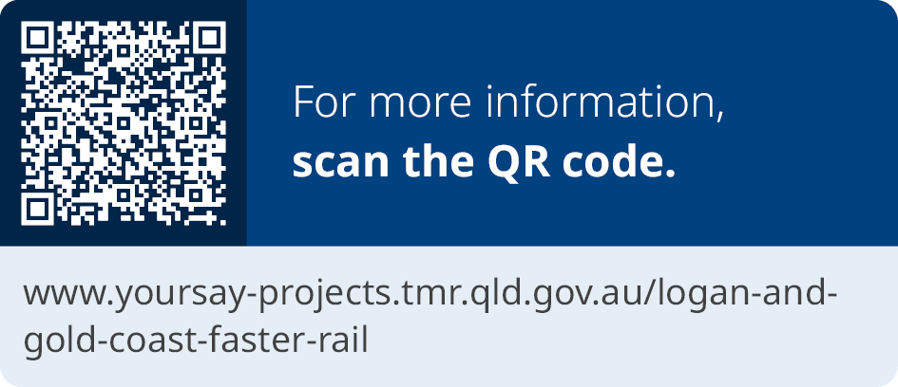

Stay up to date
 | Search on tmr.qld.gov.au:  ‘Logan Gold Coast Faster Rail’
 | Email: lgcrail@activusalliance.com.au
 | Call: 1800 957 066 (all hours)
For further information, or if you require translation or
support services to access the documentation,
please contact the project team on 1800 957 066
(9am – 5pm Monday to Friday).

How you participated
330+ in-person interactions.
8850+ online hub views.
73 Q&As.
43 emails to project team.
63 have your say forms submitted.

Next steps
A detailed summary of feedback for all station precinct upgrades will be shared following the completion of engagement.
Planning is underway to determine the construction staging and timings for all works along the 20km project corridor between Kuraby and Beenleigh.
Site investigation activities are continuing, in and around the rail corridor, which will help inform the design development and planning for future construction activities.
Establishment activities and early works have started across the project corridor, ahead of major construction works this year.

13 QGOV (137468)
www.tmr.qld.gov.au | www.qld.gov.au

