Factsheet
May 2026

Logan and Gold Coast Faster Rail
The Australian and Queensland governments are delivering the Logan and Gold Coast Faster Rail (LGC) project to meet the growing travel demand between Brisbane and the Gold Coast.
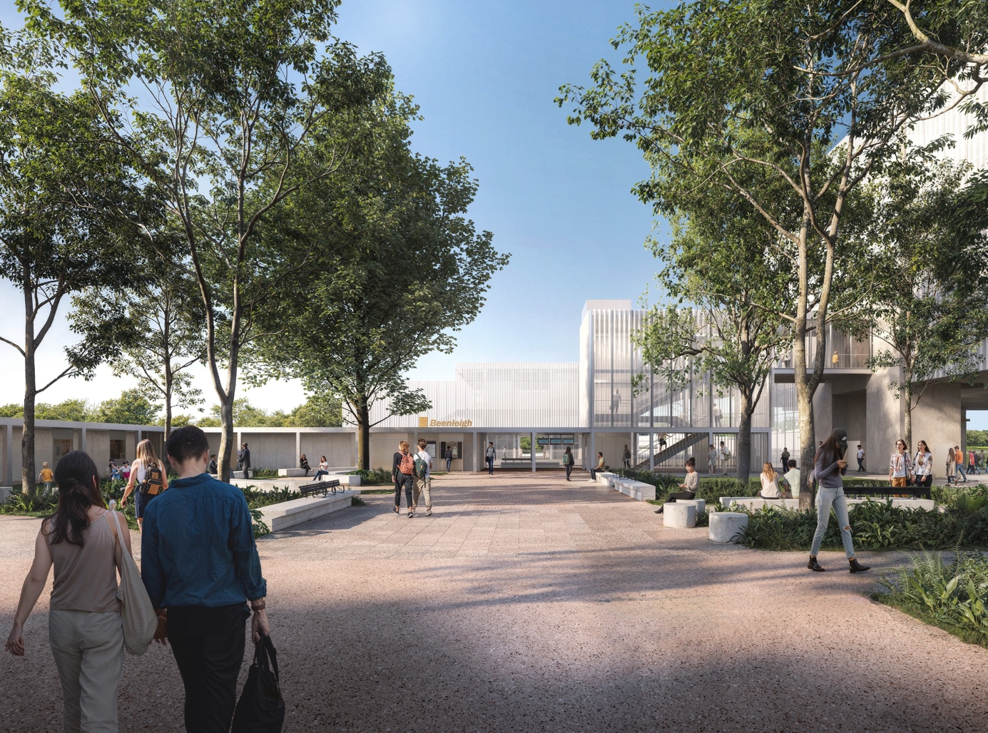

Key benefits for the community
- Improved accessibility at stations
- Increase the rail network capacity by doubling the tracks
- Improved safety by removing level crossings
- Safer and easier to walk and cycle to stations

Project overview
The LGC project will improve travel between Brisbane and the Gold Coast and help meet South East Queensland’s transport needs well beyond the 2032 Olympic and Paralympic Games
The project will allow more trains to operate, improve reliability and reduce end-to-end journey times for customers, making it easier and safer for people to travel to work and essential services.

Key features
- Doubling the tracks between Kuraby and Beenleigh to support more frequent and reliable train services
- Modern, safer, more accessible stations, to make train travel easier for customers
- Removing five level crossings to improve safety for both rail and road users
- Enabling works for the new European Train Control System to make the network safer and more reliable
- Better walking and cycling connections to stations, making it easier to access public transport.
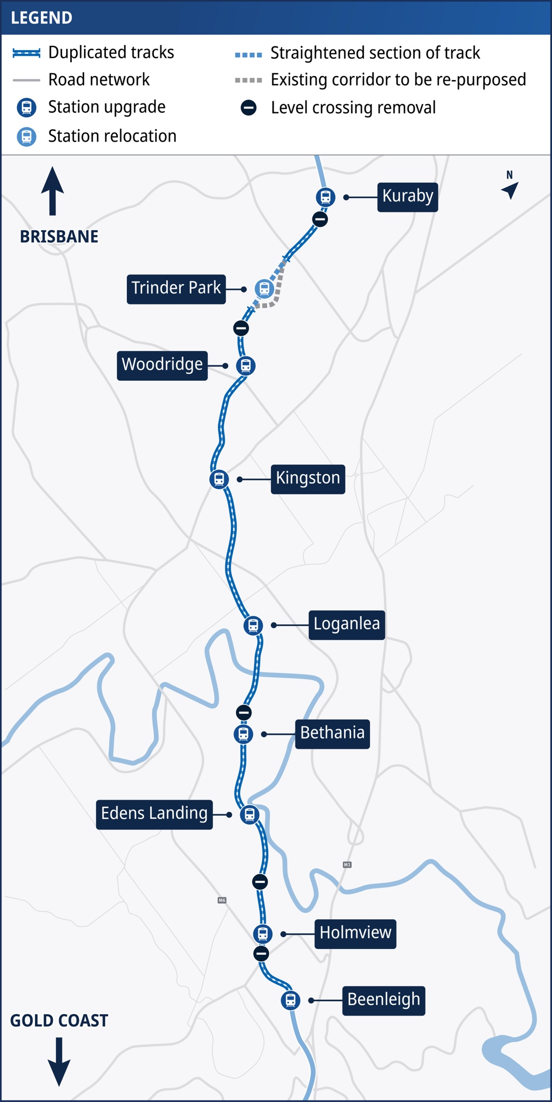
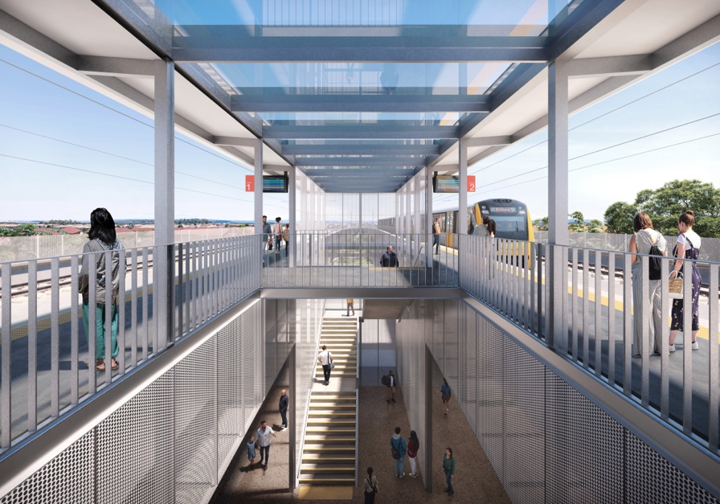
Working with the community
We continue to work closely with our local residents, businesses and key stakeholders to keep them informed of the project’s progress and potential impacts. We also engage with accessibility, environmental, active transport and First Nations groups to recognise their vital role in shaping a project that reflects community needs, protects the environment, and delivers inclusive, culturally informed outcomes.

Stay up to date
Search on tmr.qld.gov.au: ‘Logan Gold Coast Rail’
Email: logangoldcoastrail@tmr.qld.gov.au
Call: 1800 957 066
For further information, or if you require translation or support services to access the documentation, please contact the project team on 1800 957 066 (9am – 5pm Monday to Friday).

www.tmr.qld.gov.au/logangoldcoastrail
13 QGOV (137468)
www.tmr.qld.gov.au | www.qld.gov.au

