Factsheet
June 2026

Loganlea Station Relocation project
The Australian and Queensland governments are relocating Loganlea station to better connect customers with nearby health, education, and community services.
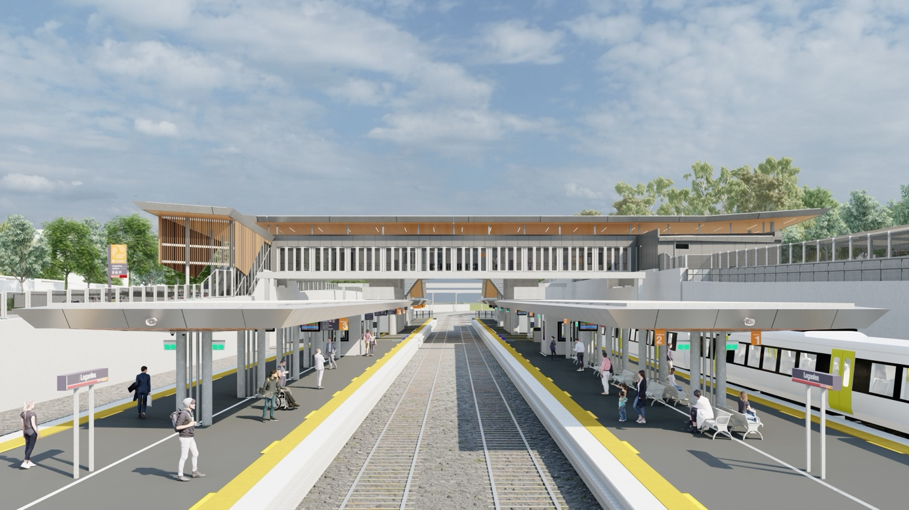

Key benefits for the community
- Improved accessibility
- Better connections to nearby services
- Improved safety
- Improved network efficiency

Key features
The new Loganlea station will be conveniently located 500m to the south, opposite the Logan Hospital and closer to other health, education and community services. It will continue to be a key transfer location between all-stops and express services on the Beenleigh and Gold Coast train lines. The existing Loganlea station will remain open during construction.
- Improved accessibility including lifts and ramp access, directional signage and hearing loops
- Improved safety and security with additional lighting and CCTV
- Better connections to community services
- Better walking and cycling connections to the station
- Better walking and cycling connections to stations, making it easier to access public transport.

Project milestones

Late 2024
Martinus Degnan Joint Venture (MDJV) was awarded construct only contract

2025
Site establishment and early works

Early 2026
MDJV and Queensland Rail commenced major construction on:
- platform 1
- park ‘n’ ride
- pedestrian overpass bridge
- new tracks.

Mid 2026
New tracks planned to be completed

Late 2026
Station building works planned to commence along Armstrong Road

2027
Road upgrades, station and platform works complete. New station and park ‘n’ ride open.

Loganlea station layout
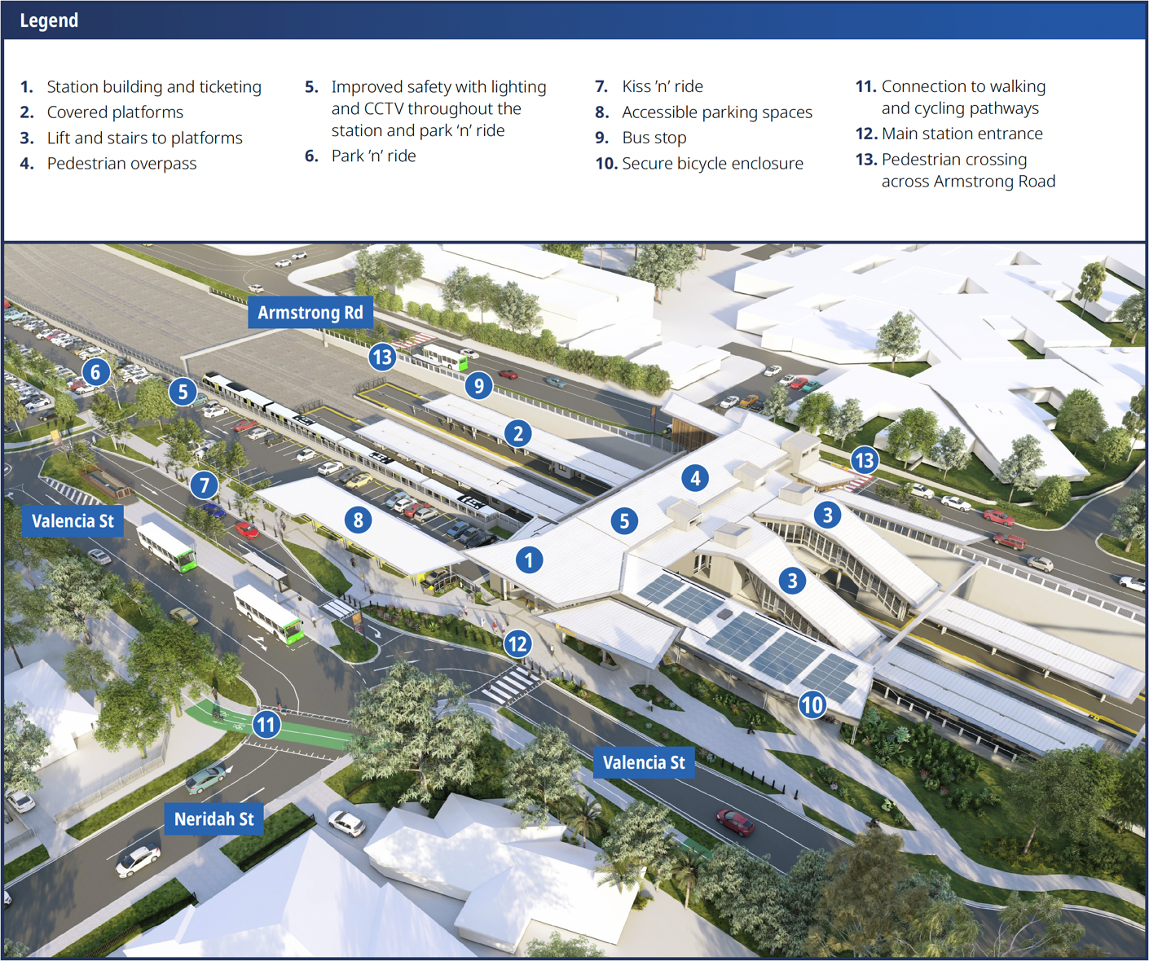
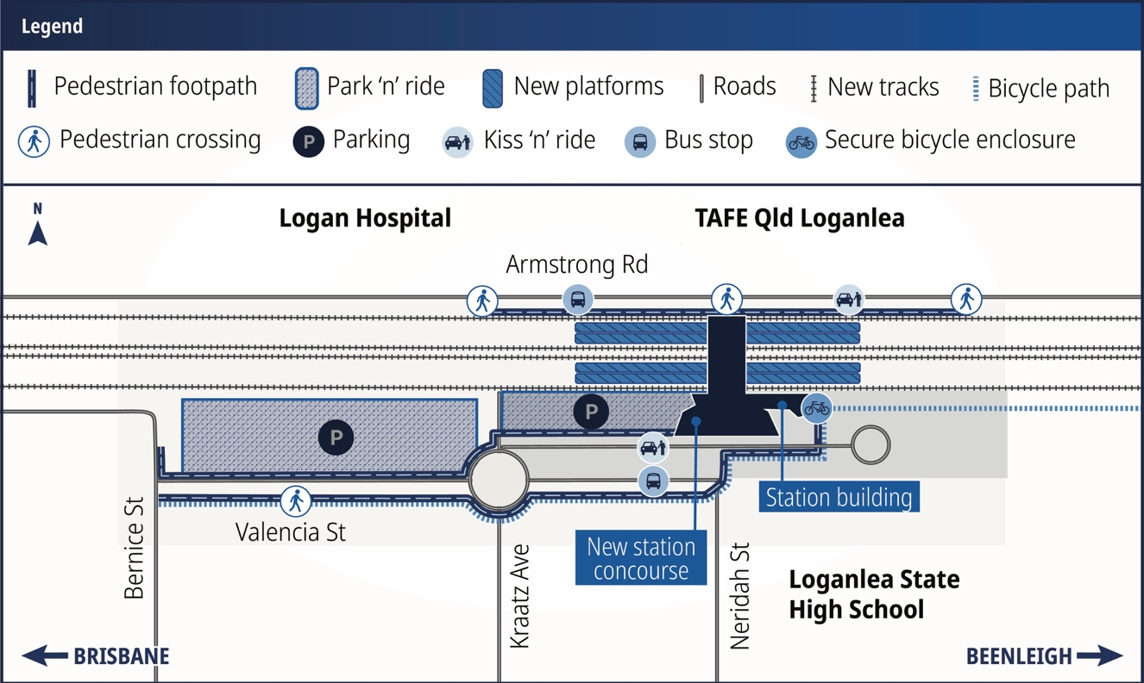

What’s changing on Valencia Street, Loganlea

Street changes
- Valencia Street, Loganlea will be:
- one-way from Bernice Street to Kraatz Avenue
- two-way from Kraatz Avenue to Loganlea State High School.
- Access from Valencia Street to Bernice Street will be via Kraatz Avenue and Neridah Street.

Parking changes
- Some car parking will be removed on:
- Valencia Street
- Armstrong Road, between Logan Hospital and TAFE Qld Loganlea campus
- Kraatz Avenue and Neridah Street, near the Valencia Street intersection, to ensure safe turning.

Stay up to date
Search on tmr.qld.gov.au: ‘Loganlea Station Relocation’
Email: Loganleastationrelocation@tmr.qld.gov.au
Call: 1800 957 066
For further information, or if you require translation or support services to access this document, please contact the project team on 1800 957 066 (9am – 5pm Monday to Friday).

https://www.yoursay-projects.tmr.qld.gov.au/logan-and-gold-coast-faster-rail/loganlea-station-relocation
13 QGOV (137468)
www.tmr.qld.gov.au | www.qld.gov.au

