Gateway Motorway, Bracken Ridge to Pine River and Bruce Highway, Gateway Motorway to Dohles Rocks Road upgrades
March 2026
The Department of Transport and Main Roads (TMR) is undertaking the staged delivery of upgrades to the Gateway Motorway and the Bruce Highway in north Brisbane and the southern Moreton Bay Region. These critical infrastructure improvements will accommodate growing traffic demands and enhance safety along these vital transport corridors.
First stage – Gateway to Bruce Upgrade (G2BU)
This stage combines the delivery of the Gateway Motorway, Bracken Ridge to Pine River upgrade and the Bruce Highway (Brisbane - Gympie), Gateway Motorway to Dohles Rocks Road upgrade (Stage 1). Construction is expected to commence late 2026, subject to environmental approvals.
Next stage – Bruce Highway, Gateway Motorway to Dohles Rocks Road upgrade (BGD) (Stage 2)
This stage includes constructing collector-distributor roads on either side of the Bruce Highway that link Dohles Rocks Road with the Gateway Motorway and Gympie Arterial Road including two new bridges over the Pine River. This project is currently in the design phase, with delivery subject to further project development, site investigations and consideration.
For more information about the staged upgrades, including details about upcoming information drop-in sessions and how to contact the Project Team, visit yoursay- projects.tmr.qld.gov.au/gateway- motorway-bruce-highway-upgrades

Map overview

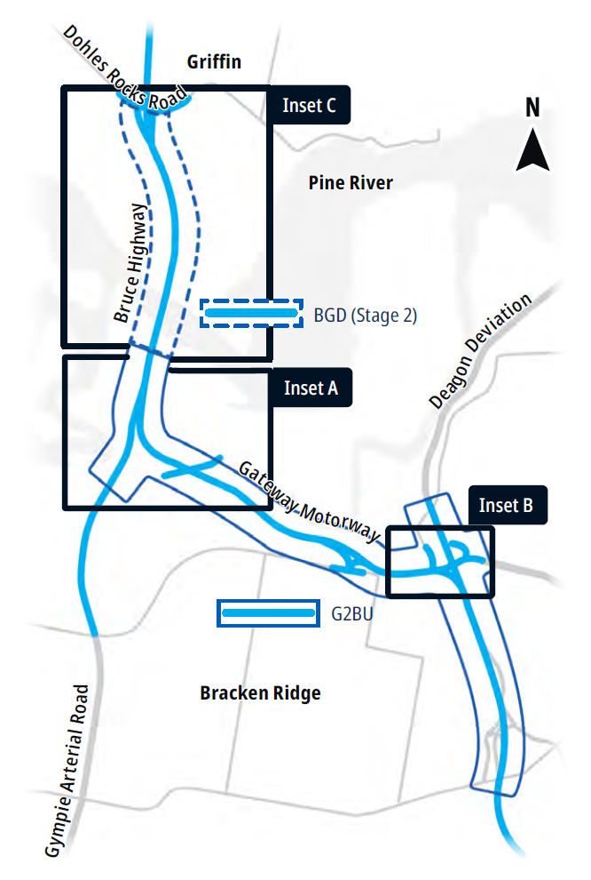

Gateway to Bruce Upgrade (G2BU)
The G2BU will tackle long-standing congestion and safety issues on north Brisbane’s busiest transport corridor.
It upgrades the Gateway Motorway from Bracken Ridge to where it joins the Bruce Highway, south of the Pine River.
The Gateway Connect Joint Venture (GCJV), comprising of CPB, BMD & Georgiou, has been appointed to design and construct G2BU.
The inset maps show the design developed by GCJV, building upon the work undertaken during the planning phase.

Key features:
- Additional lanes on the Gateway Motorway
- Upgrade to the Gateway Motorway curve at Bracken Ridge to accommodate 100km/h
- Removing the existing Wyampa Road Bridge and providing a new road under the motorway connecting with Kluver Street
- Staged improvements to the Gateway Motorway, Bruce Highway and Gympie Arterial Road interchange
- New shared path adjacent to the motorway
- Fauna fencing along Tinchi Tamba Wetlands Reserve and other areas
- Two fauna underpasses
- Noise barriers with locations to be determined during detailed design.
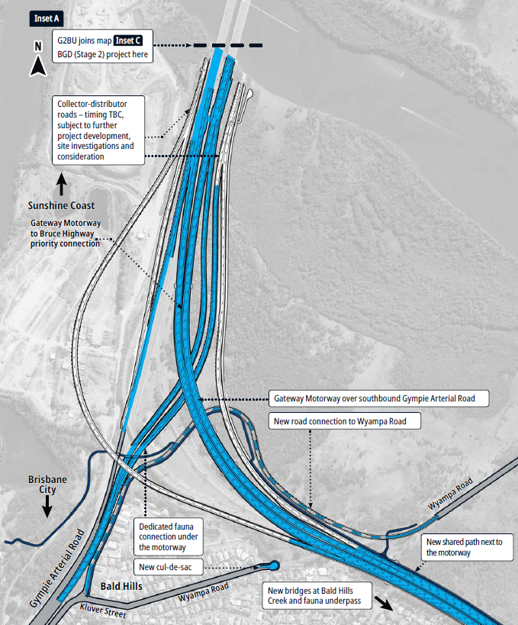
Key location: Gateway Motorway curve, Bracken Ridge
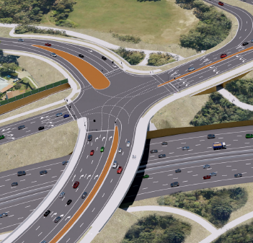
The upgrade will realign the Gateway Motorway to the north and lower it to ground level, with Bracken Ridge Road passing over the motorway.
Key benefits:
- Safe motorway speed of 100km/h consistent with adjoining National Highway.
- Increased capacity and reduced congestion.
- Improved bike riding facilities and connectivity.
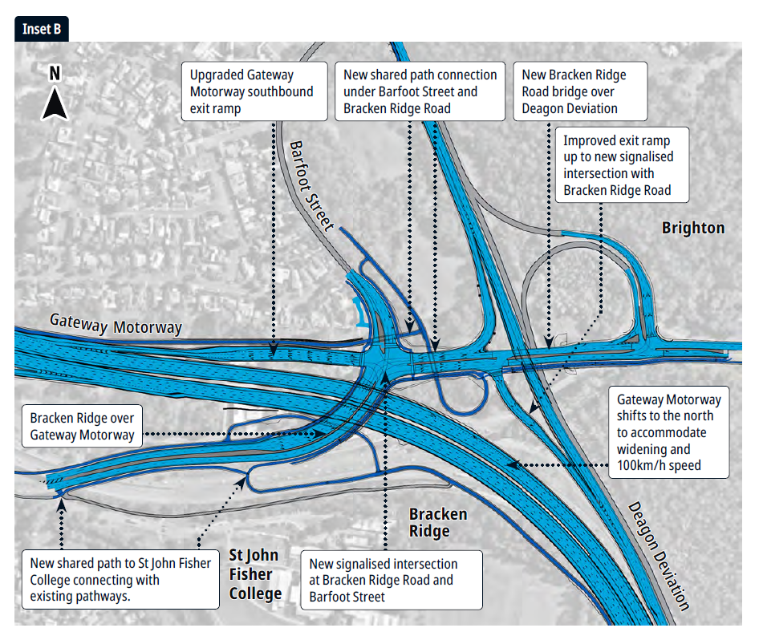
Timeline
- Late 2025 – detailed design started
- 2026 – Detailed design continues (we are here). Construction to start late 2026, subject to environmental approvals
- 2027 – 2031 – Construction, weather and conditions permitting.
Keeping the community updated throughout construction
Construction is anticipated to commence late 2026, subject to environmental approvals. The upgrade will require complex traffic staging to prioritise the safety of both workers and road users during motorway works. To minimise disruptions, some night works will be undertaken when traffic volumes are lower.
Ahead of construction, detailed information will be provided to the local community and motorists to outline what to expect during the works.

Bruce Highway, Gateway Motorway to Dohles Rocks Road upgrade (BGD) (Stage 2)
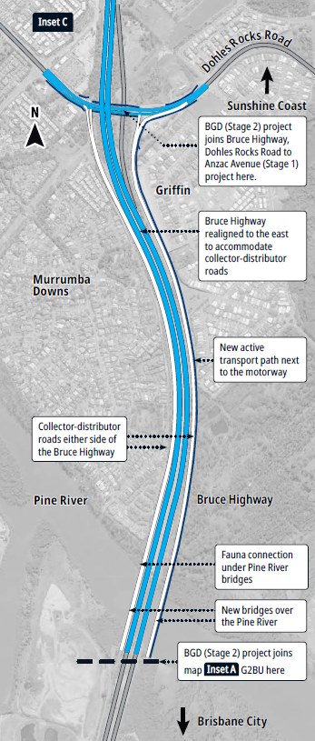
This next priority stage is currently in the design phase, with additional funding required for construction.
Key features:
- collector-distributor roads on either side of the highway that link Dohles Rocks Road with the Gateway Motorway and Gympie Arterial Road
- two new Pine River bridges for the collector-distributor roads
- shared active transport pathway along the Bruce Highway corridor north over the Pine River to Dohles Rocks Road
- fauna underpass under the north side of the Pine River bridges.
Collector-distributor roads
Collector-distributor roads are built alongside and separate to the main highway.
They will help make the highway safer and easier to use by diverting local traffic and short-distance traffic off the highway.
This will also reduce the need for cars to change lanes or weave through traffic on the highway.
Timing
- Late 2025 – preliminary design
- 2026 – detailed design commences mid-2026
- Construction TBC pending funding

Local community changes
TMR recognises these upgrades will create changes to the local area and are committed to minimising impacts as much as possible.
Noise
- TMR is looking into the effects of road traffic noise and installing noise barriers where necessary.
- Detailed design will determine the extent and location of noise barriers.
Environment
- The area around the upgrades, including the Tinchi Tamba Wetlands Reserve, is home to a variety of animals and plants.
- To help protect local wildlife, we’re installing fauna fencing along the motorway and providing fauna underpasses at Bald Hills Creek, the Gateway Motorway, Bruce Highway, Gympie Arterial Road Interchange, and the north side of the Pine River bridges.
- TMR is committed to using a range of measures to care for and preserve the natural environment as much as we can.
Stay up to date
yoursay-projects.tmr.qld.gov.au/gateway-motorway-bruce-highway-upgrades
Contact us
Phone: 1800 607 755 (Monday to Friday, 9am – 5pm) Email: gmbhu@tmr.qld.gov.au
Website: tmr.qld.gov.au/projects/programs/ gateway-motorway-and-bruce-highway-upgrades

