Bridge construction factsheet
June 2026

Rockhampton Ring Road

Enhancing safety, connectivity, and flood resilience for Central Queensland.

Key benefits for the community
- Improves safety
- Reduces travel time
- Improves network efficiency
- Improves flood immunity

Project overview
Construction is well underway on 16 new bridges as part of the 14.7 kilometre Rockhampton Ring Road, a Bruce Highway Upgrade Program project jointly funded by the Australian and Queensland governments. The project will transform the city’s road network, creating a western link from the Capricorn Highway to the Rockhampton-Yeppoon Road intersection.
The ring road will significantly improve access to key destinations, including Rockhampton Airport, Rockhampton Hospital, and major defence, education, industrial, and leisure precincts. It will enhance safety, reduce congestion, improve freight efficiency, and provide vital flood-resilient infrastructure to support growth and improve reliability for road users across Central Queensland.
A major feature of the project is the construction of 18 bridges including:
- bridges over Lion Creek and Limestone Creek, completed in 2025
- a high-level connection ramp from the Capricorn Highway
- six bridges and five overpasses across the floodplain from the Capricorn Highway to the Fitzroy River
- a critical third crossing of the Fitzroy River between Pink Lily and Parkhurst
- three overpasses from the river to the Yeppoon Road intersection.
These bridges have been carefully designed to suit the region’s unique site conditions and floodplain environment.

Concrete components on bridges
Bridges on the Rockhampton Ring Road have been designed with uniformity in mind, optimising construction outcomes and ensuring consistency with the Yeppen South bridge. This includes the use of Super T-girders, deck units, or box girders. Each component has unique characteristics that make it suitable for different bridge designs.

Super T-girder bridge cross-section
Super T-girders are longer in length and have a greater standard depth. They are used for bridges where the spans are greater than 25 metres long.
Example: Limestone Creek bridge
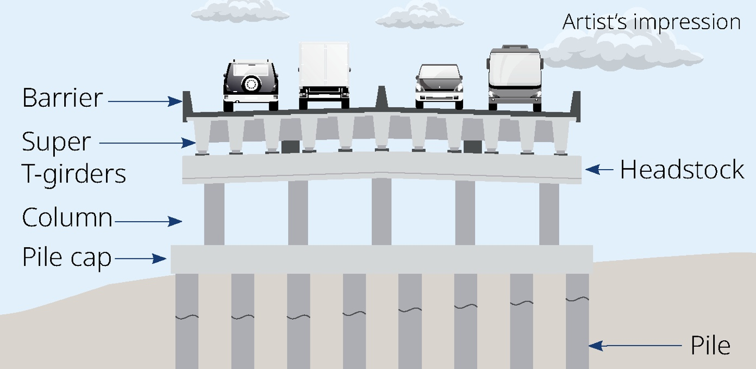

Deck unit bridge cross-section
Deck units are shorter in length compared to Super T-girders and will be used to construct four overpasses. They have a shallower depth and are more economical for shorter spans.
Example: Lion Creek bridge
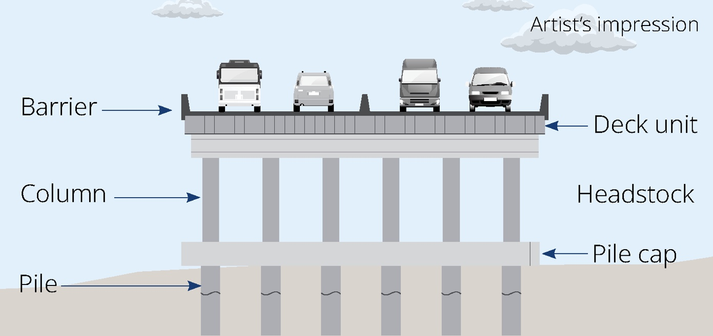

Box girder bridge cross-section
Box girder segments will be used to construct the third Fitzroy River crossing. Using box segments in the construction of the bridge allows for spans over 80 metres to be factored into the construction design, which accommodates the needs of primary river users.
Example: Third Fitzroy River crossing
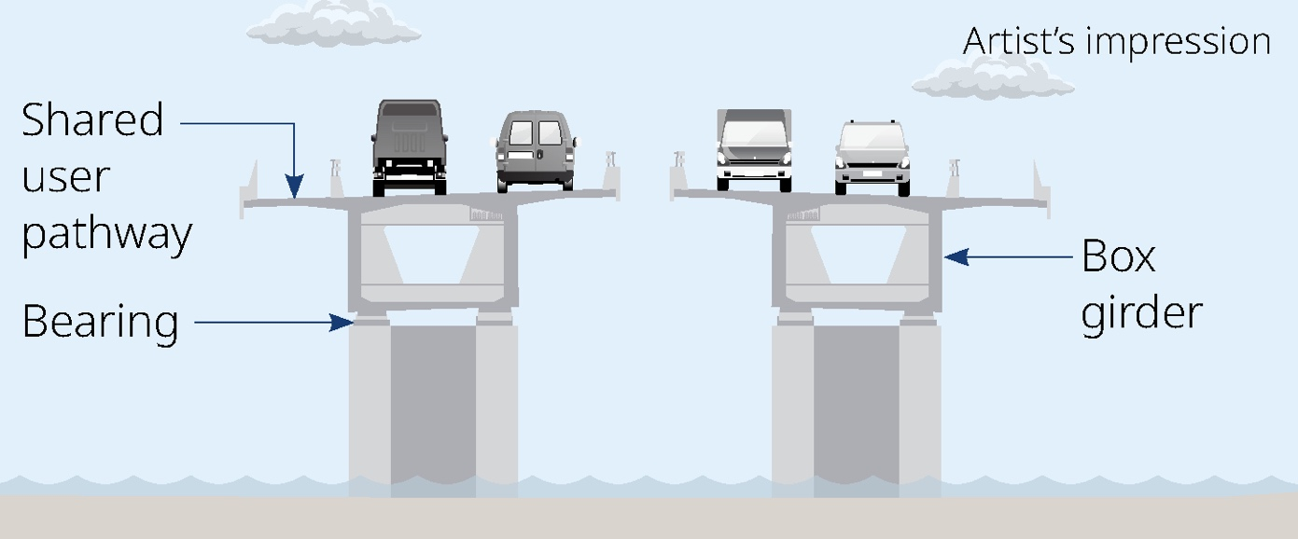

Bridge design
All bridges are designed to meet technical standards with key features including:
- capacity to support future traffic volumes
- a 100-year design life
- Q100 flood immunity (equivalent to a one-in-one-hundred-year flood).

Three foundation types
Precast concrete octagonal piles – precast pre-stressed octagonal concrete piles driven directly into the ground using a pile driver. This is the main piling method that will be adopted on the southern alignment.
Cast in place piles – reinforced concrete piles contained in open-ended steel liners. The liners are hammer-driven to the required foundation level and filled with reinforced concrete.
Driven steel tubes – these piles are thick-walled steel tubes that are driven to a founding level and partially excavated. The void is filled with reinforced concrete pile shafts.

Crossing the Fitzroy River
The third crossing over the Fitzroy River will stretch 435 metres between Pink Lily and Parkhurst, constructed using a precast segmental design and balanced cantilever construction.
More than 300 concrete box girder segments will be locally manufactured and lifted into place by large cranes to form a seamless structure. This method reduces the number of piers in the river and enables efficient construction.
There are only a handful of bridges like it in Australia, including the Second Gateway Bridge, Hunter Expressway viaducts, Sydney Metro’s Western Sydney viaduct, and the new Bridgewater Bridge in Hobart.

How bridges are built
At each bridge site, you will notice:
- access roads being built to deliver heavy equipment and bridge components
- temporary work platforms to support heavy machinery and bridge materials in areas with soft ground conditions
- piling rigs being mobilised
- traffic controls or detours in place during installation of large bridge components.

List of bridges (south to north)
Bridge | Name | Length (metres)
1 | Capricorn Highway connector | 841
2 | Floodplain bridge | 985
3 | Nine Mile Road overpass | 677
4 | Lotus Lagoon bridge 1 | 67
5 | Lotus Lagoon bridge 2 | 67
6 | Lotus Lagoon bridge 3 | 67
7 | Floodplain bridge | 407
8 | Ridgelands Road overpass | 542
9 | Six Mile Road overpass | 33
10 | Lion Creek bridge*^ | 69
11 | Milner Road overpass^ | 441
12 | Pink Lily Lagoon bridge | 370
13 | Edmistone Road overpass | 22
14 | Fitzroy River bridge | 435
15 | Alexandra Street overpass | 50
16 | McLaughlin Street overpass | 25
17 | Monier Road overpass | 67
18 | Limestone Creek bridge* | 214

* Completed in 2025
^ Leading to the Rockhampton Ring Road alignment

Bridge locations and girder delivery routes
Girder deliveries will be limited to 9pm to 5am, Sunday to Thursday
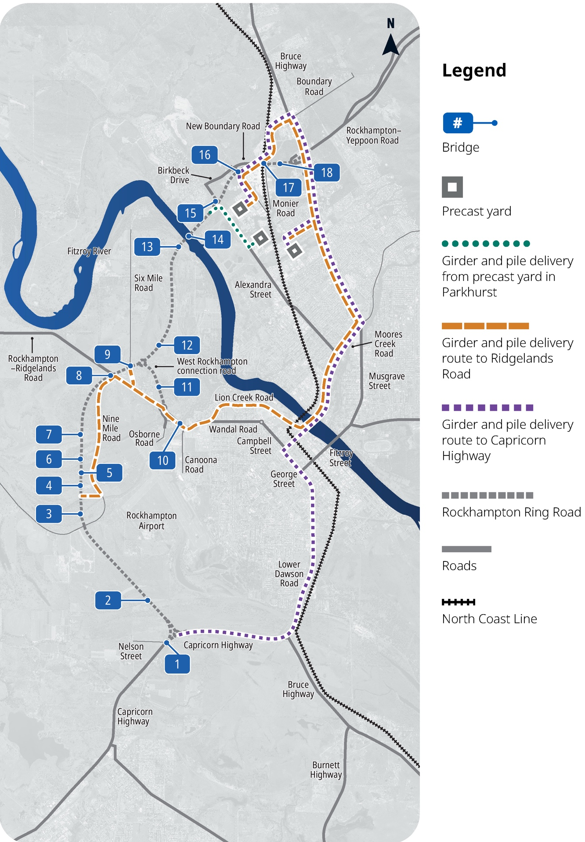

How concrete components are made
Concrete components are precast offsite in Rockhampton. Once manufactured, they are transported to site and lifted into place.
- Super T-girders are made in precast concrete facilities by placing high-strength steel reinforcement and tendons into a mould, which is then filled with concrete. After a controlled curing process and the concrete reaching strength, the tendons are tensioned, creating pre-stressed concrete.
- Deck units for bridges are made as precast concrete beams, often pre-stressed. They are manufactured by pouring concrete into moulds and allowing it to cure, with internal lifting anchors and often cast-in features for connections to other bridge components. The process includes casting the concrete around steel reinforcement and pre-stressing tendons to give the units strength.
- Concrete box girders are made by prefabricating segments off-site. Segments are match-cast so they perfectly fit the adjacent segment. They have shear key connection points for alignment during installation. They are shaped around a void to reduce weight and materials.

Delivery of concrete components
The project will make, move, and lift manufactured concrete components to different sites within the project footprint. These will be transported from three precast yards in North Rockhampton using oversize and overmass (OSOM) vehicles on the road network, escorted by pilot vehicles. The project team is committed to minimising impacts by scheduling OSOM vehicle deliveries at night between 9pm and 5am, Sunday to Thursday.

Concrete components
- 976 precast Super T-girders up to 34 metres long
- 162 deck units up to 25 metres long
- 312 box girder segments
- 2,419 piles up to 40 metres long

Key features of the upgrade
- 3.4 million tonnes of earthworks
- 633,682 tonnes of rock and gravel
- 279,264 tonnes of pavement
- 481,546 tonnes of bitumen

What to expect
This large-scale project includes
17.4 kilometres of new roadway, including 14.7 kilometres of ring road alignment. The majority of the alignment is located through greenfield sites, with local and state-controlled roads being used for construction transport.
- During construction, road users can expect:
- traffic changes with detours, lane closures, and reduced speed limits
- increased heavy vehicle movements with frequent truck deliveries and transport of large bridge components
- noise generated by piling activities and other construction works.

How we’re minimising disruption
To reduce the impact on residents, businesses, and motorists:
- piling activities are limited to occur between 6am to 6pm, Monday to Saturday
- traffic management measures will be in place to maintain two-way traffic flow where possible
- oversize overmass vehicle deliveries will be limited to 9pm to 5am, Sunday to Thursday
- advance notice of construction works will be provided to help you plan ahead.

Construction hours
Day works: 6am to 6pm, Monday to Saturday.
Night works: Sunday to Thursday, after 6pm.

Stay up to date
For more information and to register for project and construction updates:
Email: rockhamptonringroad@tmr.qld.gov.au
Call: 07 4931 1500 (9am - 5pm Monday to Friday)
Bielby-BMD Joint Venture (North including Fitzroy River bridge)
Email: rrr-north@rockyjv.com.au
Call: 1800 772 272
Acciona-Fulton Hogan Joint Venture (South)
Email: enquiries@rrrsouth.com.au
Call: 1800 531 855
If you require translation or support services to access project documentation, please contact the project team on 07 4931 1500 (9am - 5pm Monday to Friday).
For more information visit www.tmr.qld.gov.au/rockhamptonringroad

13 QGOV (137468)
www.tmr.qld.gov.au | www.qld.gov.au

