Project update
June 2026

Rockhampton Ring Road

Momentum is building on regional Queensland’s largest road project, jointly funded by the Australian and Queensland governments
Construction of the Rockhampton Ring Road is well underway, with major works progressing across multiple locations on this transformative project for the Bruce Highway.
Activity is focused on delivering the bridges and overpasses that will connect communities and enhance accessibility across the region.
With activity ramping up, the scale and complexity of work highlights the detailed planning and coordination required to keep the project moving forward. Construction is advancing through challenging terrain, including floodplains and over the Fitzroy River, as part of efforts to deliver a more efficient and resilient road network for Central Queensland.

Construction update mid-2026
The Rockhampton Ring Road features 18 bridges, including eight road overpasses all currently under construction. Constructing an overpass involves several key stages including design, excavation, and the construction of abutments, retaining walls, piers, girders, and deck units, followed by surfacing and finishing. Current progress includes:
- Nine Mile Road overpass – piling deliveries commence June
- Ridgelands Road overpass – abutment civils complete, piling underway
- Six Mile Road overpass – pile deliveries complete July
- Milner Road overpass – piling and abutments complete, girder installation commences July
- Edmistone Road overpass – earthworks underway
- Alexandra Street overpass – piling and abutments complete, pier one complete June
- McLaughlin Street overpass – piling, abutments, and retaining walls are complete
- Monier Road overpass – piling, abutments, and piers are complete.

Interesting facts
- 3.5 million tonnes of earthworks
- 2,340 piles
- 976 Super T-girders
- 251 local businesses engaged on RRR in 2026

Crossing the floodplain
The project is committed to protecting the Fitzroy River floodplain and its important wetlands, including:
- Pink Lily Lagoon
- Lotus Lagoon
- Black Duck Lagoon.
These wetlands are classified as having ‘High Ecological Significance’ and provide vital habitats for migratory birds and aquatic species.
Construction complies with the strict conditions under the Environment Protection and Biodiversity Conservation Act 1999 and follows Environmental Management Plans to minimise impacts. Measures include controlling erosion, sediment, and pollution to prevent runoff into wetlands or waterways. Bridges and culverts are designed to maintain natural water flow and connectivity during floods.
Monitoring and compliance are key to the project’s environmental management, with annual reports developed to track vegetation clearing, water quality, rehabilitation, and wildlife impacts.
Disturbed areas are rehabilitated with native vegetation replanted to restore habitats and prevent erosion.

136 animal species recorded during environmental surveys
- 105 birds
- 18 mammals
- 9 reptiles
- 4 amphibians

Crossing the Fitzroy River
Work has commenced on installing a temporary bridge over the Fitzroy River, which will serve as a work platform for constructing the third river crossing between Pink Lily and Parkhurst. Spanning the river from bank to bank, the temporary bridge will support piling rigs, cranes, and other heavy vehicles.
The temporary bridge will allow construction equipment and materials for the permanent bridge to move safely across the river and reduce the need to transport materials through Rockhampton.
A partial river-width exclusion zone was established in April 2026 to ensure the safe installation of the temporary bridge. This exclusion zone provides a 50-metre navigation channel to maintain public access. As construction progresses, the exclusion zone will expand to cover the full width of the river from 13 July 2026 and will remain in place until mid-2028.
Access to the river between the Fitzroy River Barrage and the exclusion zone, approximately 4.5 kilometres upstream, remains unaffected. River access upstream of the exclusion zone is available at the Rockhampton Water Ski Club at Laurel Bank.
For bridge construction and exclusion zone enquiries, contact BMD Bielby Joint Venture on 1800 772 272 (8am - 5pm Monday to Friday) or email
rrr-north@rockyjv.com.au

Temporary bridge facts
- 270 metres wide
- 40 pilings and 20 piers
- 250t and 400t cranes
- 175t piling rig

Map of exclusion zone
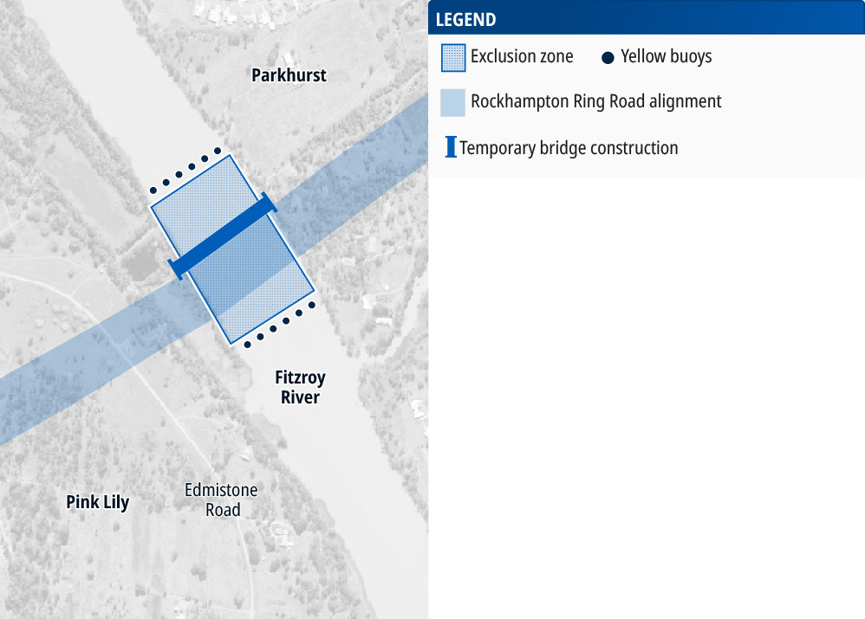

What to expect in mid-2026
Bridge piling underway (6am - 6pm Monday to Saturday):
- Capricorn Highway connector until mid-June
- Ridgelands Road overpass until August
- Pink Lily Lagoon bridge until August
- Floodplain bridge (Nelson and Dunganweate Lagoons) from August to December
Temporary traffic impacts:
- Capricorn Highway night works until August
- Ridgelands Road during June
- New Boundary Road ongoing
- McLaughlin Street ongoing
- Alexandra Street as required
Girder movements:
Girder deliveries are scheduled to begin early to mid-July 2026. Each girder measures 34 metres in length, 1.85 metres in height, and weighs 86 tonnes. To minimise disruption to traffic, they will be delivered at night, under escort, between 9pm and 5am, from Sunday to Thursday. For more information about girder movements, refer to the bridge construction fact sheet on the project website.

Stay up to date
For more information and to register for project and construction updates:
Email: rockhamptonringroad@tmr.qld.gov.au
Call: 07 4931 1500 (9am - 5pm Monday to Friday)
Bielby-BMD Joint Venture (North)
Email: rrr-north@rockyjv.com.au
Call: 1800 772 272
Acciona-Fulton Hogan Joint Venture (South)
Email: enquiries@rrrsouth.com.au
Call: 1800 531 855
If you require translation or support services to access project documentation, please contact the project team on 07 4931 1500 (9am - 5pm Monday to Friday).
For more information visit www.tmr.qld.gov.au/rockhamptonringroad

13 QGOV (137468)
www.tmr.qld.gov.au | www.qld.gov.au

