Sunshine Motorway (Mooloolaba – Peregian), West Coolum Road, upgrade interchange
  - Community consultation summary report
Consultation period: 2 April 2026 to 15 May 2026

Translating and interpreting assistance
The Queensland Government is committed to providing accessible services to Queenslanders from all cultural and linguistic backgrounds. If you have difficulty understanding this publication and need a translator, please call the Translating and Interpreting Service (TIS National) on 13 14 50. If you are deaf, hard of hearing, or have a speech difficulty please contact us via the National Relay Service (NRS). Select from the NRS call numbers and links, and ask them to telephone the Queensland Government (Department of Transport and Main Roads) on 13 23 80.
Copyright
© The State of Queensland (Department of Transport and Main Roads) 2026. All rights reserved.
Enquiries about the use of any material in this publication can be sent to the department at: copyright@tmr.qld.gov.au.
Disclaimer
This publication is provided as a source of information only and the State of Queensland makes no statements, representations or warranties about its accuracy or completeness. To the extent permitted by law, the State of Queensland disclaims all responsibility for decisions or actions taken as a result of any data, information, statement or advice, expressed or implied, contained within and excludes all liability (including, without limitation, liability in negligence) for all expenses, losses, damages and costs that may be incurred.

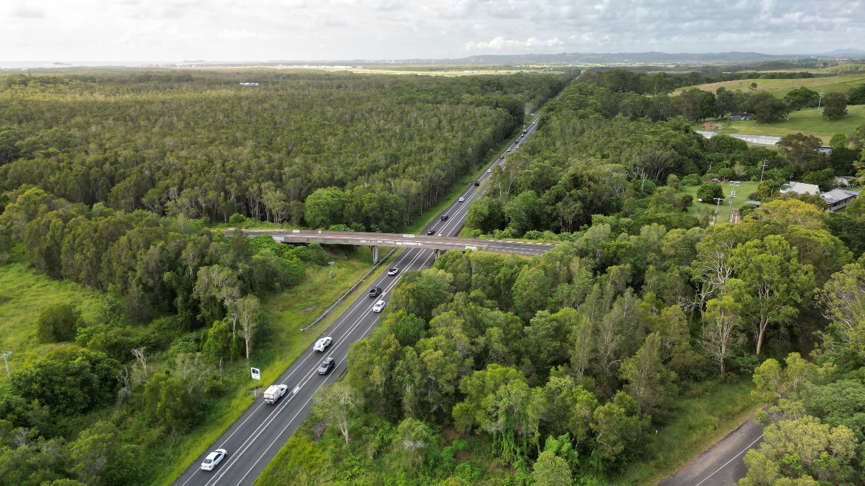
Image: West Coolum Road overpass looking southeast along the Sunshine Motorway.

Overview
The Department of Transport and Main Roads (TMR) is undertaking planning for south-facing ramps on the Sunshine Motorway at West Coolum Road, Mount Coolum, as part of a broader staged upgrade of the Sunshine Motorway (Mooloolaba - Peregian), David Low Way to Yandina - Coolum Road, duplication, planning.
More than 31,000 vehicles use the section of Sunshine Motorway between Pacific Paradise and Coolum daily and traffic volumes are expected to increase as the region grows.
The proposed interchange at West Coolum Road would provide more direct access to the Sunshine Motorway from Coolum Beach, Mount Coolum, Yaroomba and Marcoola, enhancing network resilience and reducing delays.
Project benefits include:
 | Improves network efficiency |  |  |  | Better road access
 | Reduces travel time

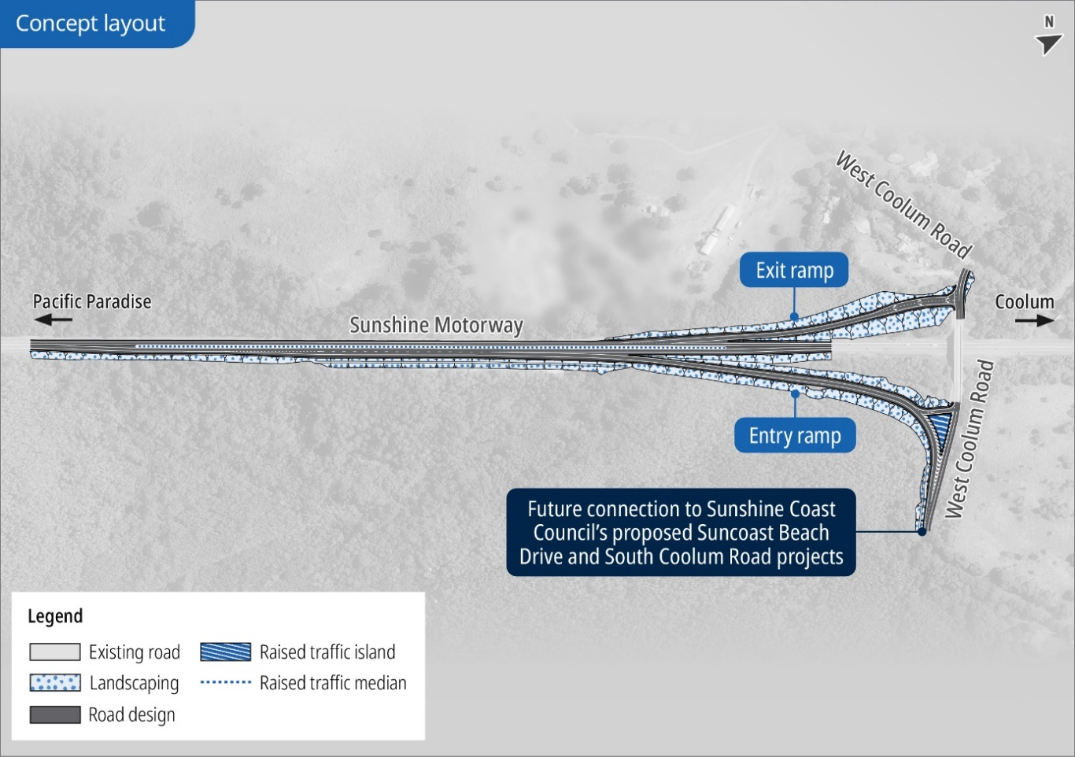

Figure 1 – Concept layout of the interchange

Community consultation
TMR undertook community consultation from 2 April 2026 to 15 May 2026 to gather feedback on the interchange concept layout for the two new south-facing ramps.
This consultation followed the 2023 engagement on the future duplication of the Sunshine Motorway between David Low Way, Pacific Paradise and Yandina-Coolum Road, Coolum Beach. Feedback received in 2023 informed the development of the West Coolum Road interchange upgrade concept layout.
This consultation report provides a summary of the feedback received on the Sunshine Motorway (Mooloolaba - Peregian), West Coolum Road, upgrade interchange concept layout. It will be considered during the detailed design phase of the project.

Feedback summary
 | 123 feedback submissions |  | 3100 flyers delivered
 | Online engagement: 1598 visitors, 105 surveys completed |  | Project news email sent to 543 subscribers  18 emails received and responded to by the project team
 | 10,760 impressions, 6530 people reached, 446 link clicks, 40+ engagements on Facebook |  | Feedback location  74% 4573*  22% Other  4% Unknown  * Coolum Beach, Marcus Beach, Mount Coolum, Peregian Beach, Peregian Springs, Point Arkwright, Yaroomba.
 | Directly impacted landowners consulted

Feedback themes and responses
  Project design | - Respondents expressed general support, citing the project as long overdue and essential for improving traffic flow, safety, and reducing congestion  - Use of the existing overpass infrastructure was seen as a cost-effective approach  - Several calls for the inclusion of north-facing ramps and a full interchange upgrade to more effectively improve traffic flow and reduce congestion  - Requests to include safe bike riding routes, pedestrian crossings, and bike lanes on key roads like Suncoast Beach Drive.
  Traffic and connectivity | - Respondents emphasised the need for a four-lane motorway, grade-separated interchanges, and future-proofed designs to ensure improved long-term traffic flow, safety, and economic viability for the Sunshine Coast  - West Coolum Road ramps considered a much-needed infrastructure improvement that will help alleviate congestion  - While many supported the proposed interchange to alleviate pressure on the Yandina-Coolum Road roundabout, others were worried it will shift congestion to local roads and exacerbate bottlenecks on the single-lane Sunshine Motorway  - Suggestions included road widening, improved pedestrian and cyclist infrastructure, traffic calming measures, and integration with Sunshine Coast Council roads to address capacity and safety issues comprehensively.
  Community impacts | - Some respondents believed the project will make commuting more convenient and efficient for residents  - Residents valued the area’s quiet, safe, and community-focused environment, which they felt would be disrupted by noise, speeding, and increased traffic volumes  - Feedback emphasised the need to balance infrastructure development with preserving community safety, liveability, and sustainability.  - Respondents urged sustainable planning that respects the area's cultural, ecological, and community values.
  Safety and accessibility | - Several concerns were raised about pedestrian, bike rider, and driver safety, predominantly along Suncoast Beach Drive with the increased traffic  - Requests for traffic calming measures and improved pedestrian crossings along Suncoast Beach Drive  - Some comments noted the project will provide better motorway access, offering an alternative to the Yandina-Coolum Road roundabout  - Concerns were raised about the safety of driveways in areas with increased traffic flow.
  Engagement and delivery | - Submissions emphasised the importance of community consultation and integrating local knowledge into planning to address safety and liveability issues effectively  - Residents emphasised the importance of completing both the TMR-led West Coolum Road interchange upgrade with the Council-led local road connections simultaneously to maximise benefits and avoid disruptions  - Concerns were raised about the cost efficiency of building ramps now if future motorway duplication requires their reconfiguration  - Feedback highlighted potential engineering complexities and called for better long-term planning to ensure sustainable use of taxpayer funds.

Next steps
Community feedback provided valuable insight into local traffic conditions, safety considerations, and future network needs. This feedback will inform future project phases.
TMR is working closely with Sunshine Coast Council during planning to ensure decisions are coordinated, local network impacts are understood, and the TMR-led West Coolum Road interchange upgrade is aligned with Council-led planning for the surrounding road network, including proposed future connections of Suncoast Beach Drive and South Coolum Road to West Coolum Road.
Feedback received by TMR relating to the local road network is shared with Council to ensure community concerns are heard.
Ongoing direct consultation is taking place with key stakeholders, including Traditional Owners and impacted property owners.
Planning is also underway for future upgrades to duplicate the Sunshine Motorway between Pacific Paradise and Coolum.
As the project progresses, the project team will continue to engage with the community and provide updates on key milestones.

Further information
To sign up for project updates and for more information about the West Coolum Road south-facing ramps visit: Sunshine Motorway Mooloolaba Peregian West Coolum Road upgrade interchange | Department of Transport and Main Roads.
Information about Council-led projects is available on Council’s website including details on the Suncoast Beach Drive and South Coolum Road projects.

Contact us
- Email: NCR_Planning_Comms@tmr.qld.gov.au
- Phone: 07 5451 7055 | Monday to Friday: 8:30 am to 4:30 pm
- Website: Sunshine Motorway Mooloolaba Peregian West Coolum Road upgrade interchange | Department of Transport and Main Roads
- Post: Department of Transport and Main Roads | North Coast Region
PO Box 5505 | MAROOCHYDORE BC QLD 4558.

