What is a safe active street?

Find out more about safe active streets

Safe active streets are a safe and welcoming environment for people to ride bikes or use Personal Mobility Devices (PMDs) on local streets. They provide an alternative to travelling on busy main roads and encourage active travel.
Safe active streets:
- Have a central lane that is shared by drivers and people who ride bikes or use PMDs
- Use pavement marking and surface textures to help people share the lane safely
- have speed limits of between 30km/h and 50km/h
- have low traffic volumes.
A typical safe active street has:
- a central shared lane that is 3–3.5m-wide
- yellow advisory bike symbols marked on the central shared lane
- textured or contrasting overrun areas to highlight the street as an active travel route.
These features alert drivers to the potential presence of people riding bikes or using PMDs on the street, and encourages them to slow down and share the space safely.
In Queensland, safe active streets are also called ‘cycle streets’. In other states and countries, they may be called ‘bicycle boulevards’ or ‘local street bikeways.’

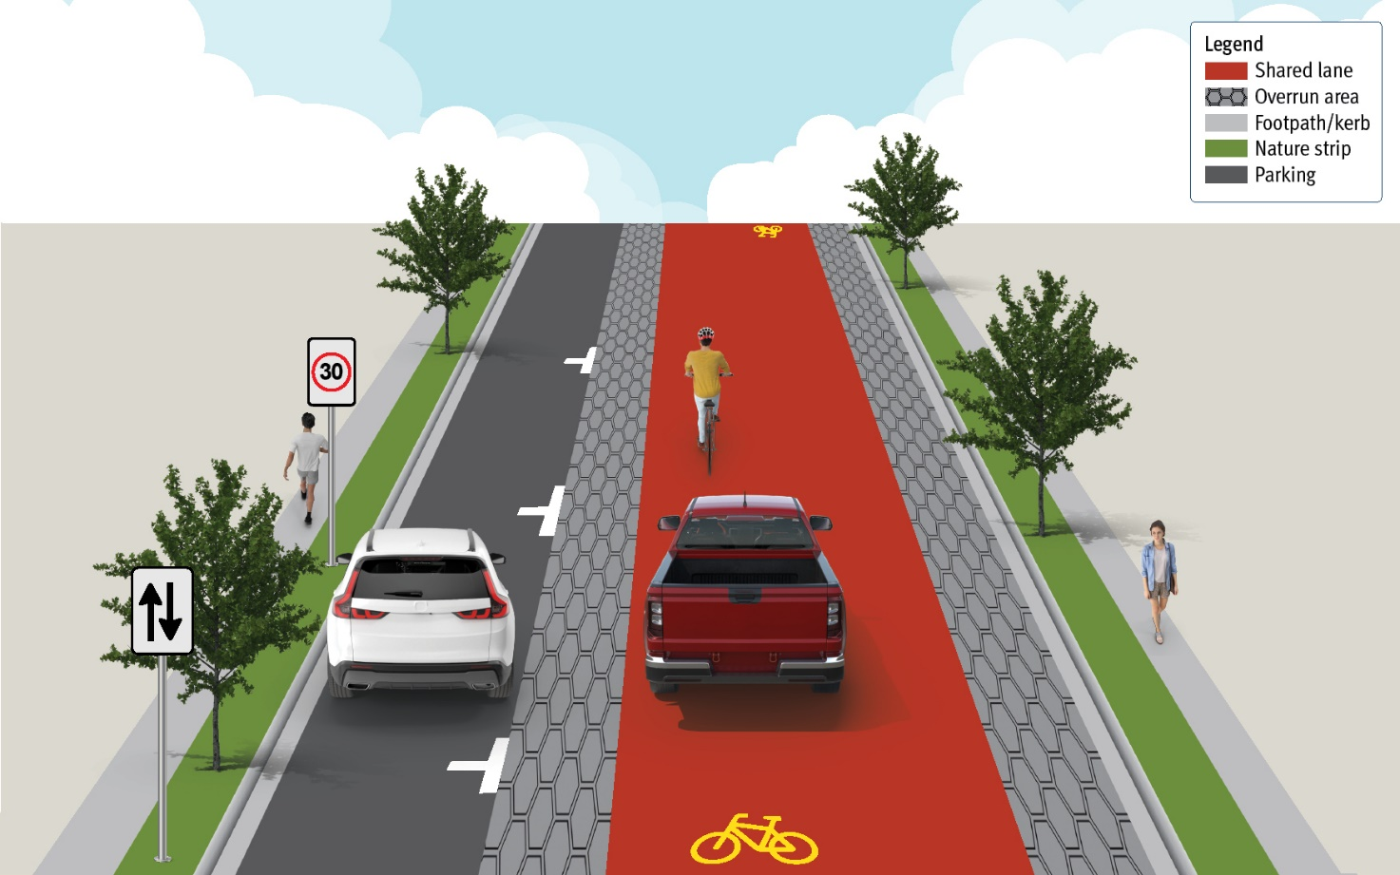
Pictured above: Typical layout of a safe active street.

Using a safe active street

People riding and driving in a safe active street share the central lane. Bike riders are encouraged to travel within the lane, to the right of overrun areas and clear of all kerbside hazards. This reduces the risk of a collision in the door opening zone of parked motor vehicles.
Drivers must maintain a safe distance behind bike riders at all times.
To safely overtake them, drivers must leave at least a one metre passing distance.
Like all other Australian streets and roads, bike riders are permitted to ride single file or two abreast on a safe active street. Where a footpath is available, less confident bike riders can ride on the footpath.

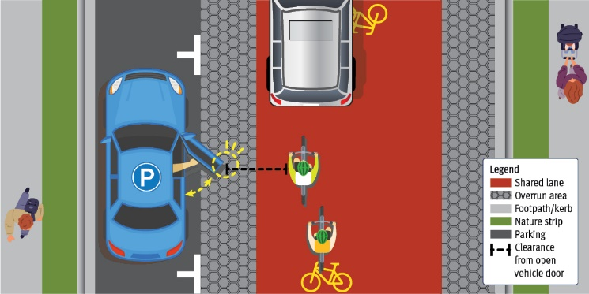
Pictured above: Bike riders and drivers travel within the central shared lane, clear of kerbside hazards, when no vehicles or bikes are approaching from the opposite direction.

Safely passing oncoming traffic
Safe active streets are designed to allow sufficient space for two vehicles to pass at the posted speed limit.
When approaching an oncoming driver, bike or PMD rider, drivers should move left and use the textured road shoulder to create a safe passing space (if safe to do so).
Riders should maintain a direct and predictable line of travel at all times.

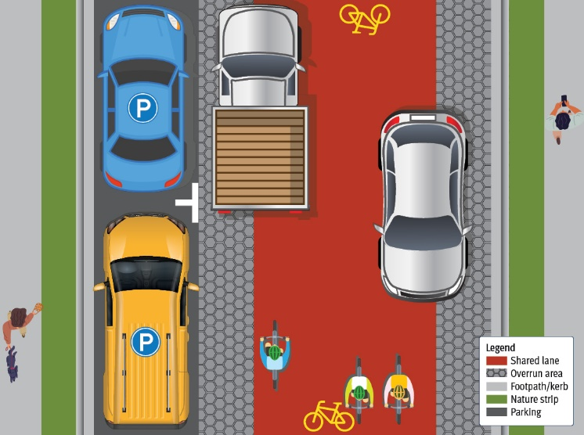
Pictured above: Drivers using the textured road shoulder to safely pass oncoming vehicles and bikes.

Overtaking a bike or PMD rider
Like all other Queensland streets and roads, drivers on a safe active street can overtake a bike or PMD rider if it is safe to do so. Drivers must:
- have a clear view of the street ahead with no oncoming traffic
- be able to safely move to the right of the street.
If a driver can safely overtake a rider, they must:
- leave at least a one metre passing distance
- not exceed the speed limit.

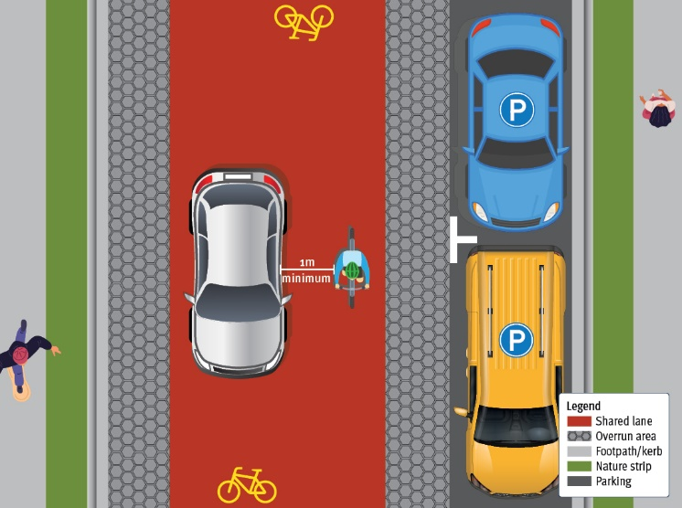
Pictured above: Driver safely overtaking a bike rider.

Benefits of safe active streets

- Safer for more people to use the street in different ways.
- Low-cost to install and easy to retrofit.
- Fill missing links in bike riding networks where there aren’t exclusive bike lanes or off-road paths.
- Allow on-street parking on one or both sides of the road.
- Create safer, more continuous riding routes, giving people of all ages and abilities more options to travel actively and sustainably.
- Improve safety and comfort for people walking by reducing the number of bikes and PMDs on the footpath.
- Improve the safety of riders and drivers, including those getting out of or into their kerbside parked vehicle.
- Improve personal safety for bike and PMD riders by having drivers travel at safer speeds.
- Enhance visibility by riding through residential areas.
- Improve neighbourhoods by creating calmer, low-speed streets that discourage ‘rat-running’.

