Warrego Highway, Bremer River westbound bridge, strengthening project

Community update

February 2026
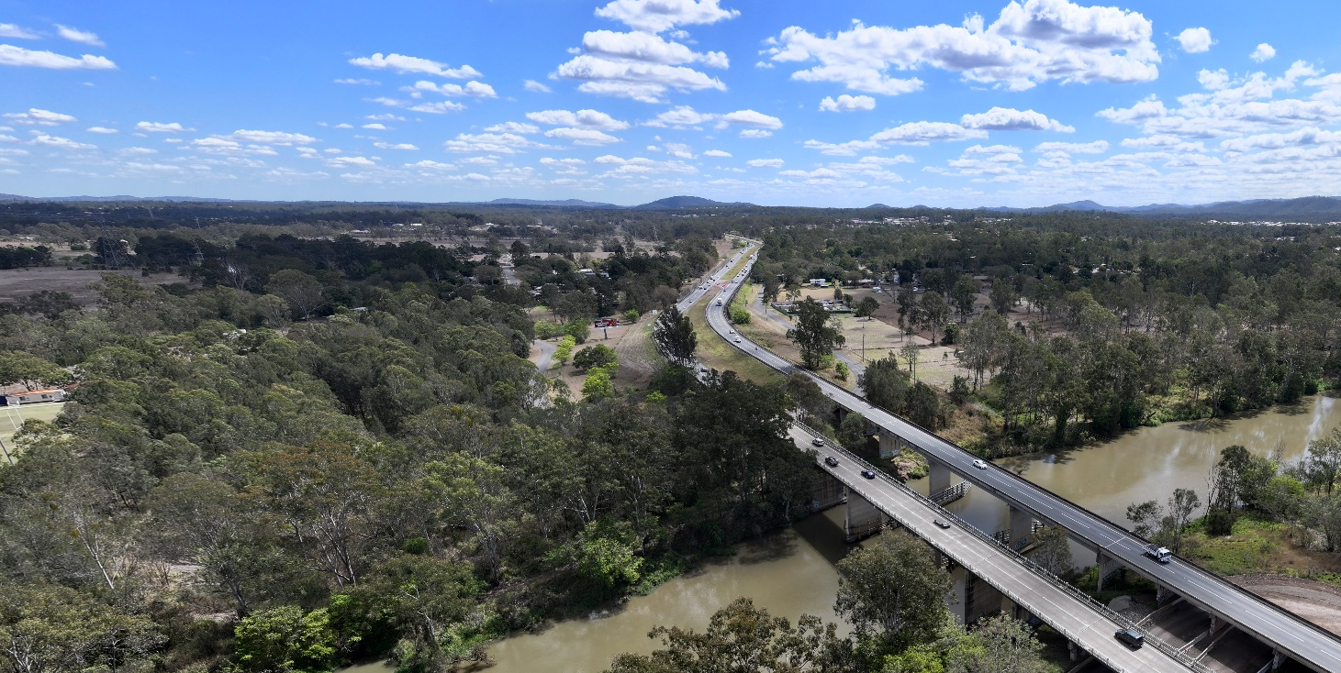
Image: Bremer River Bridges. Source: The Queensland Government.
The Bremer River westbound bridge is a 213m long, 14-span structure located on the Warrego Highway, at Karalee. The bridge forms a critical part of the National Land Transport Network and supports freight and commuter access from Brisbane to Toowoomba and beyond.
About 32,000 vehicles cross the Bremer River westbound bridge every day, including over 6,000 heavy vehicles.
Two separate bridges make up the Warrego Highway’s crossing of the Bremer River – an eastbound concrete bridge, built in the 1980s, and the westbound steel-concrete composite bridge, which was opened to traffic in 1958.
In late 2023, the Queensland Government identified fatigue cracks in some welded connections on the westbound bridge. These cracks were caused by many years of loading from heavy vehicles, which are now much heavier than when the bridge was originally designed and built.
To address this, we imposed speed and load restrictions on the structure. These restrictions were necessary to safely manage loads on the westbound bridge, reduce the risk of existing cracks growing, and prevent new cracks from forming.
In early 2024, we constructed median crossovers at both ends of the bridge to provide a westbound travel route for oversize overmass vehicles, and reduced speed limits were implemented on the eastbound carriageway to enable the safe use of these crossovers.
Throughout 2024, we undertook detailed investigations, material testing, and structural analysis to understand the extent and impact of the identified defects. Early assessments identified a potential solution for bridge redecking, however further examination of traffic impacts during construction prompted a search for alternate options with reduced traffic impacts for the community and heavy vehicle industry.
The rehabilitation of the existing structure was identified as the most appropriate solution following thorough investigations and concept design development in 2025. With the planning now complete, we are progressing with the delivery phase of the rehabilitation works.


Bremer River westbound bridge rehabilitation solution
The solution consists of a range of rehabilitation works and new structural elements to strengthen the bridge. This includes the installation of additional edge girders on both sides of the bridge, and replacement of fatigue-prone welded connections with bolted steel plates.
The solution will extend the service life of the bridge and enable the current speed restrictions to be removed. After completion, some larger oversize overmass vehicles will still be required to use the eastbound bridge for westbound travel, as was the case prior to identification of the bridge defects in 2023. This solution will be achieved with significantly reduced construction phase traffic impacts, compared to other options.


Works will include:
- installing additional edge girders and cross-girders
- strengthening works to the approach span piers
- replacing fatigue-prone welded connections with bolted steel plates
- repairing welds on approach span girders
- resurfacing the bridge deck
- upgrading the bridge safety barrier.


Benefits
- Improves the safety of the bridge and network.
- Maximises the use of the existing bridge.
- Increases the service life of the bridge.
- Enables removal of the current speed restrictions.
- Improves safety by providing an upgraded bridge barrier.
- Improves rideability.
- Minimises traffic impacts during works.


Timeline
Rehabilitation works will continue throughout 2026. We will provide updates to the community as the project progresses.


Funding
The Queensland Government has committed $42.5 million towards these essential rehabilitation works and secured a matching funding commitment from the Australian Government, bringing the total funding amount to $85 million.
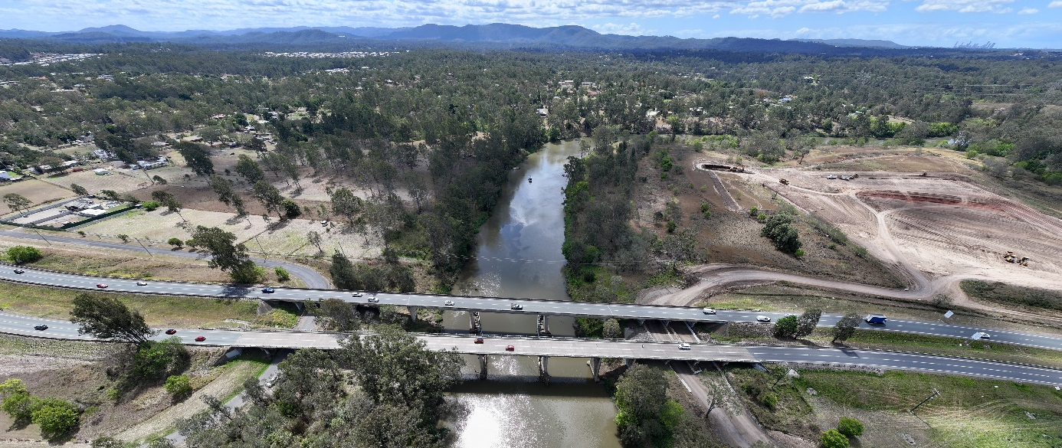
Image: Bremer River Bridges. Source: The Queensland Government.


FAQs
Why isn’t the Queensland Government building a new bridge?
The existing bridge can be rehabilitated and continue to suitably carry traffic. Building a new bridge would cost significantly more and take several years to plan, design and build, meanwhile the existing structure would still require rehabilitation works to keep it safe while a new bridge was built.
Why has the speed limit on the eastbound carriageway been reduced?
The 70km/h limit recognises that the speed environment has changed, even during the day – with new traffic signals, signs, and pavement markings. At night, it gives motorists more time to react to queued vehicles, reducing the risk of crashes. In contrast, a 100km/h speed limit would decrease reaction time, increasing both the likelihood and severity of crashes.
Why not change speed limit signs on the eastbound carriageway at night?
Changing traffic signs on a highway is not a trivial task – this would require the use of night-time traffic control workers and a crash safety barrier truck to make lane closures and other changes. The scale and cost of the operation needed to temporarily reduce the speed limit to allow oversize overmass vehicles to use the eastbound carriageway are significant and impractical.

Contact us
Phone: (07) 3066 4338
Email: metropolitanregion@tmr.qld.gov.au
Web: tmr.qld.gov.au/BremerRiverBridge
Post: Metropolitan Region
Department of Transport and Main Roads
PO Box 70, Spring Hill, Qld 4004
Contact us for available alternate accessible formats.
13 QGOV (137468)
www.tmr.qld.gov.au | www.qld.gov.au

