


Queensland Transport and Roads Investment Program (QTRIP) 2025-26 to 2028-29
Industry Briefing
Sal l y Stan n ard
Di r ector - G en eral

19 August 2025

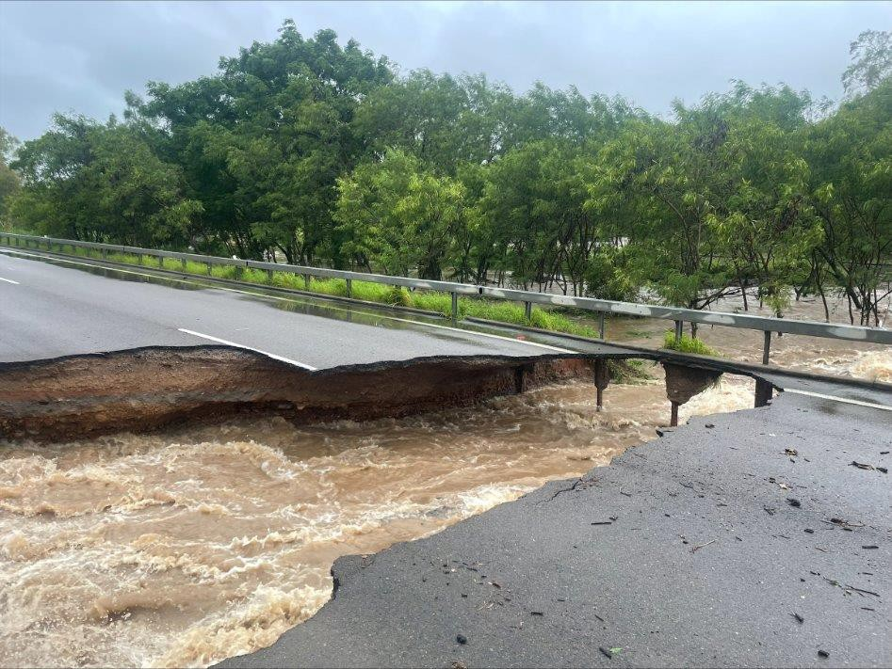
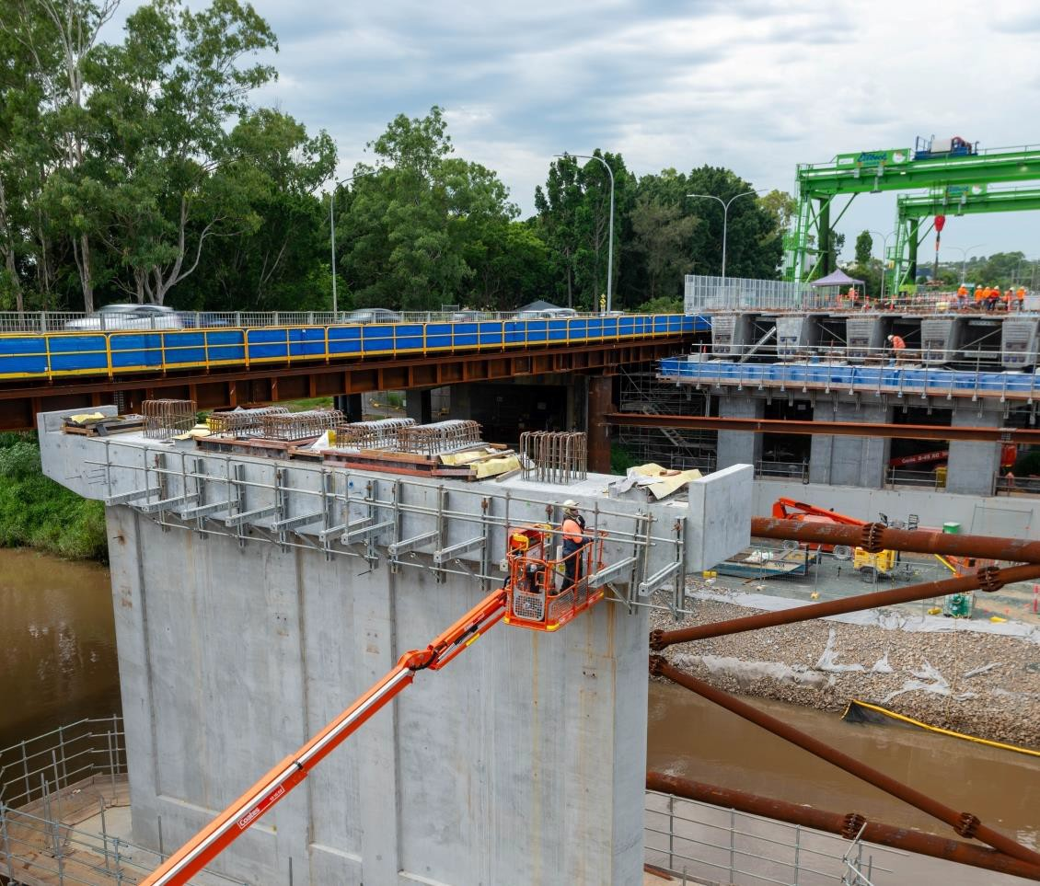
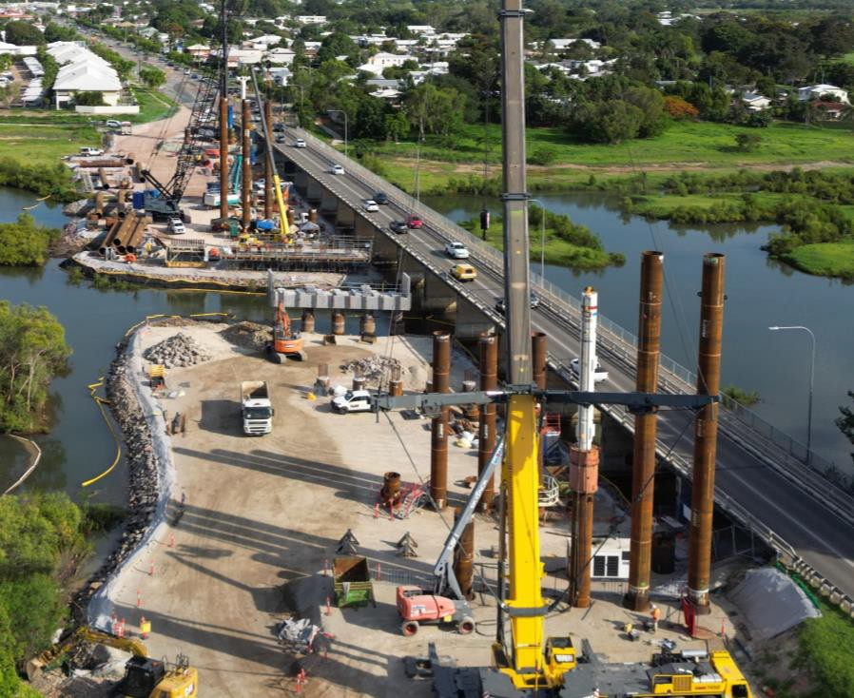
Managing uncertainty and building resilience

3

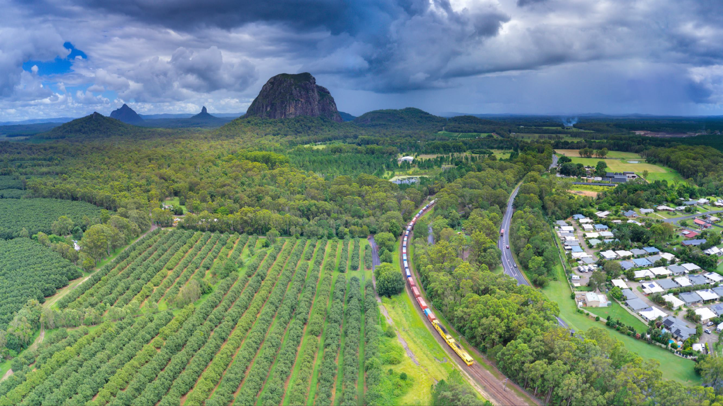
Targeting investment and delivering value

Department of Transport and Main Roads 4

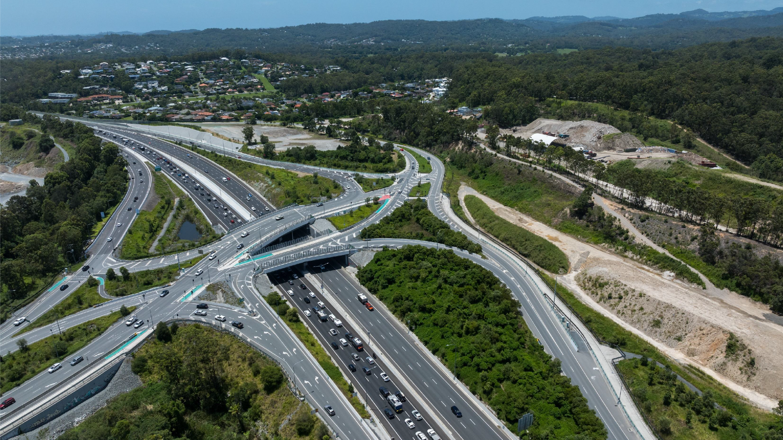
QTRIP 2025-26 to 2028-29

$5.75 billion Logan and Gold Coast Faster Rail
$3.5 billion Coomera Connector Stage 1
$1.65 billion European Train Control Systems
$1 billion Inland Freight Route
$1.98 billion Rockhampton Ring Road
$500 million Queensland Beef Corridors
$100 million Country Roads Connect
$5.6 billion Maintenance of the network

Department of Transport and Main Roads 5

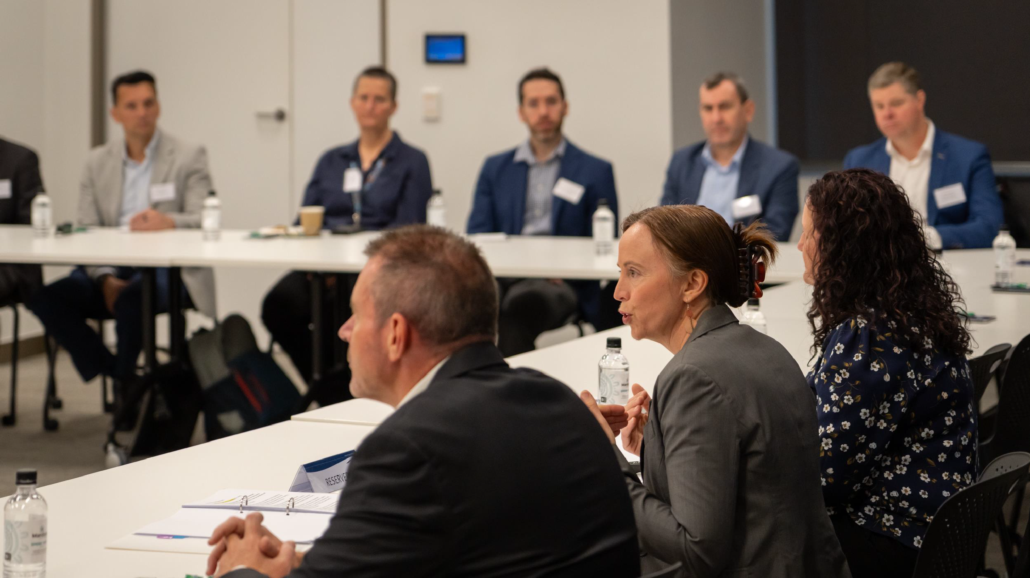
Working in partnership

6






Thank you and stay connected
www. tmr . ql d. gov . au

TMRQld @TMRQld TMRQld Department of Transport and Main Roads

