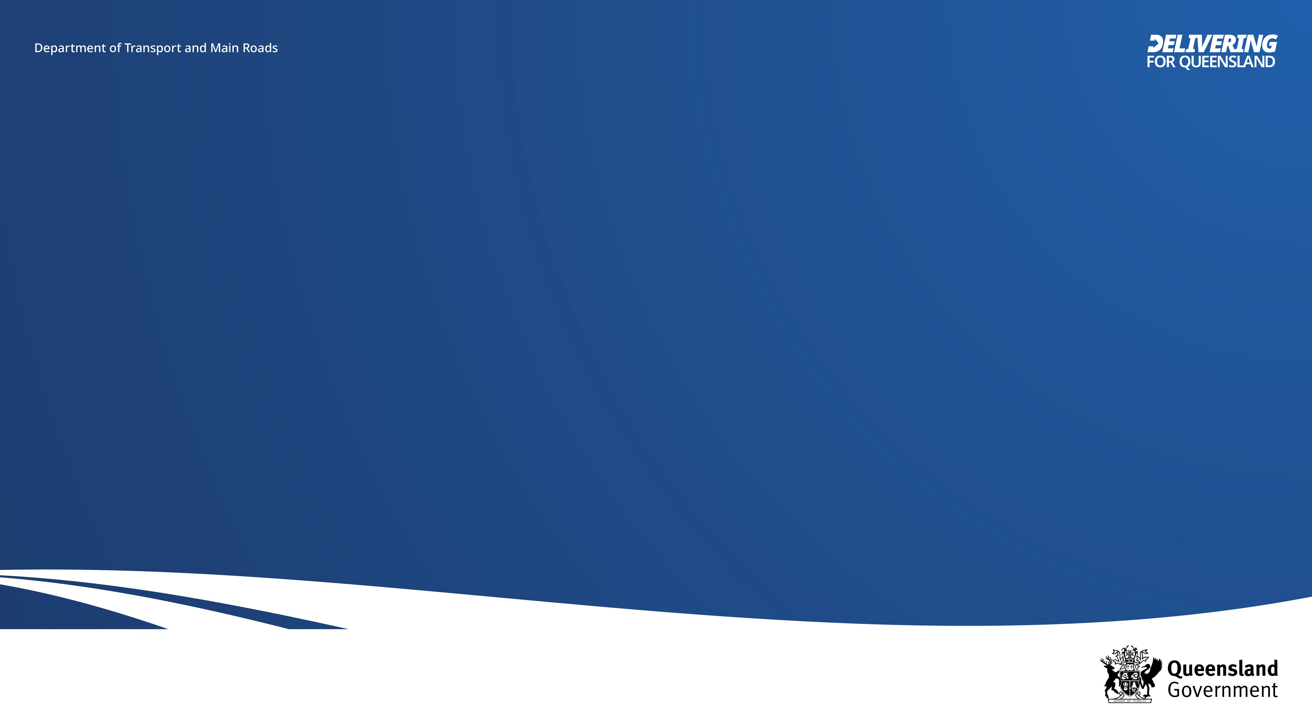
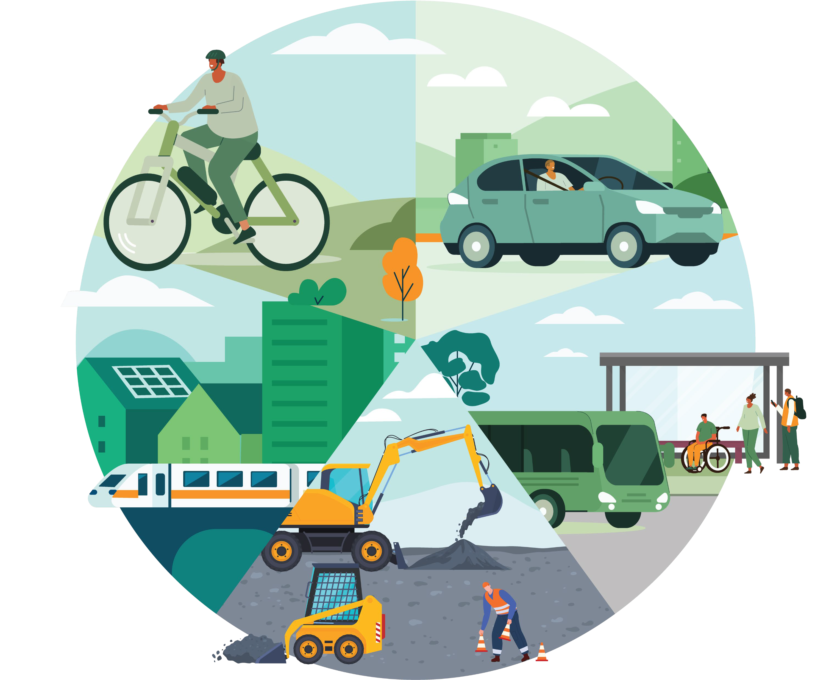
Queensland Transport and Roads Investment Program (QTRIP) Industry Briefing 2025-26 to 2028-29

Ra il Div isio n
P e t e r P a p a n t o n i o u
G en era l M a n a g er – R a i l Infrastructure Delivery

19 August 2025

Rail Division QTRIP and Leadership
Paul Hoffmann
Deputy Director-General
Peter Papantoniou
General Manager – Rail Infrastructure Delivery Office
Genevieve de Michele
Project Director – The Wave
Nathan Angus
General Manager – Passenger Rollingstock and Signalling
Jane Brander
General Manager – Strategic Rail

Department of Transport and Main Roads
2

Key QTRIP projects
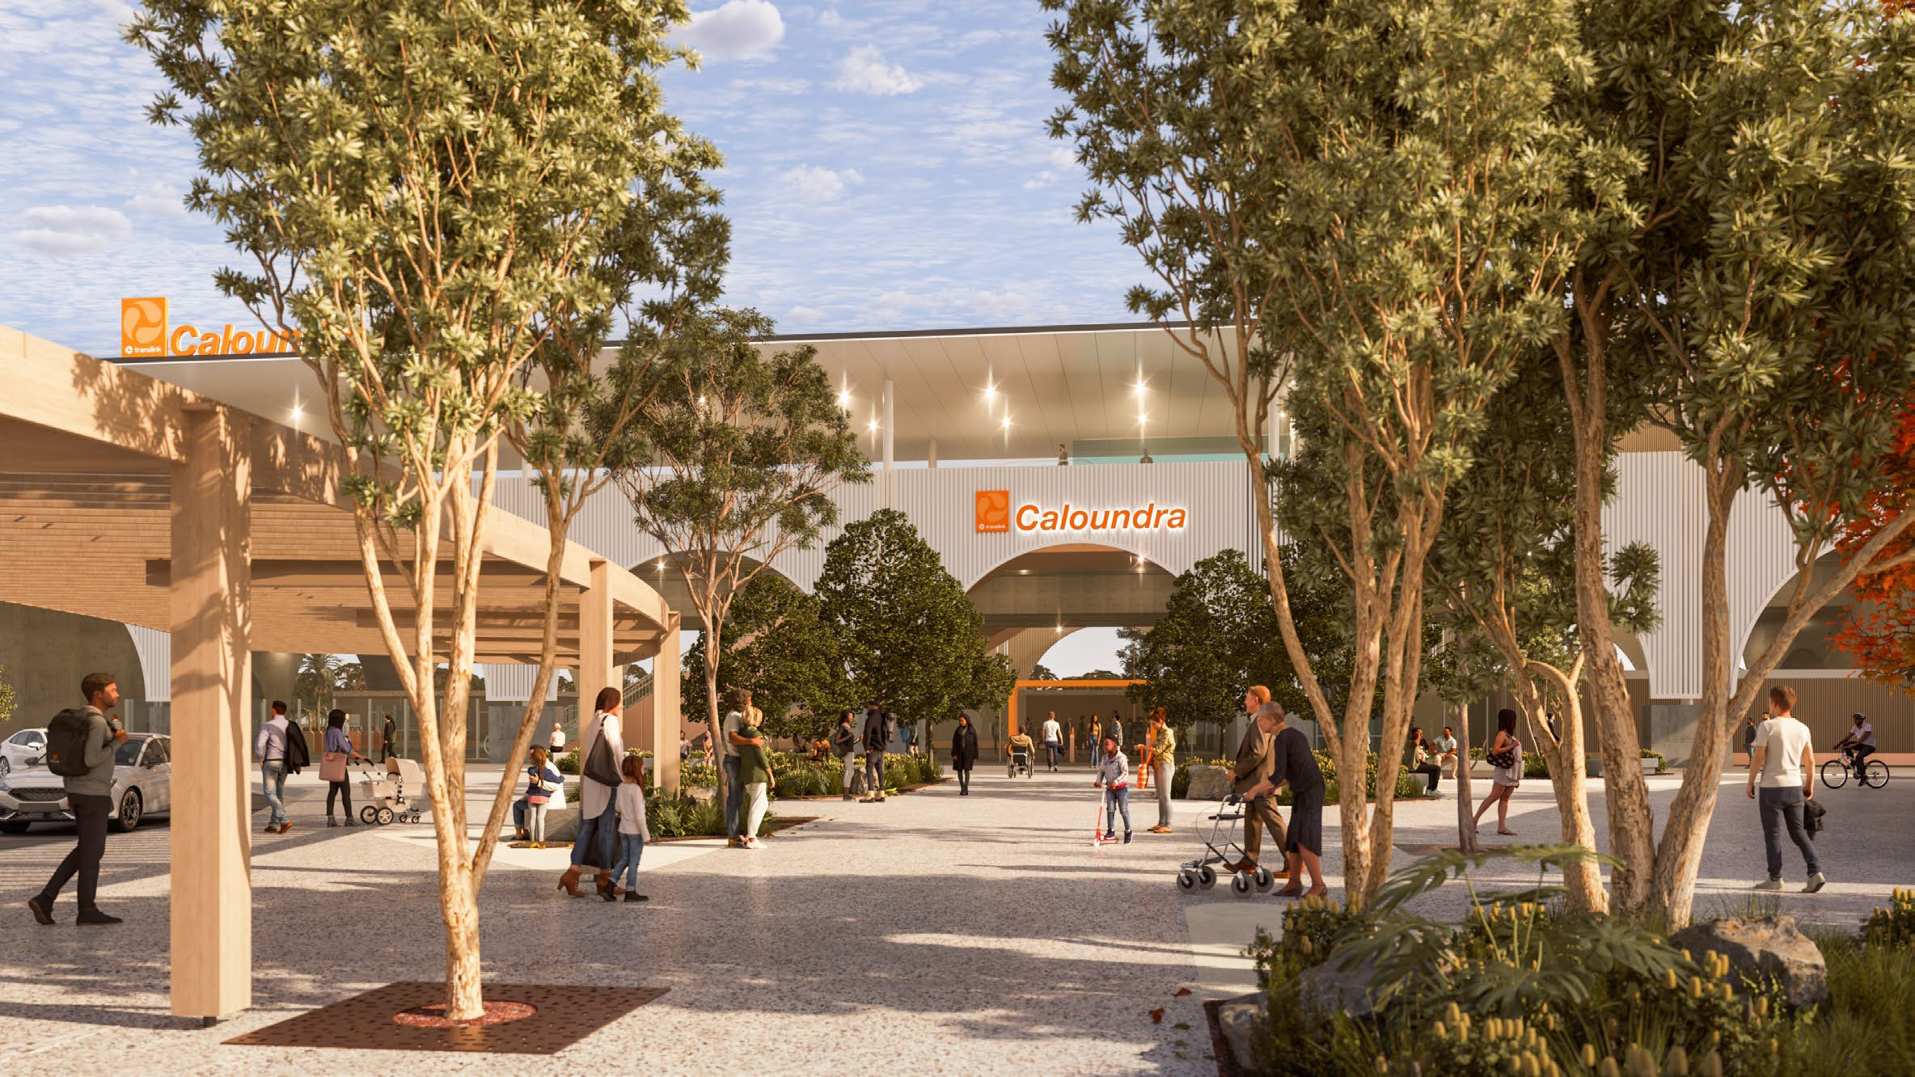
 The Wave (Rail) Stage 1
•
The Wave – Caloundra Station concept
$5.5 billion

Logan Gold Coast Faster Rail
•
$5.75 billion

Queensland Train Manufacturing Program –
•
Torbanlea & Ormeau
$4.869 billion

Department of Transport and Main Roads
3

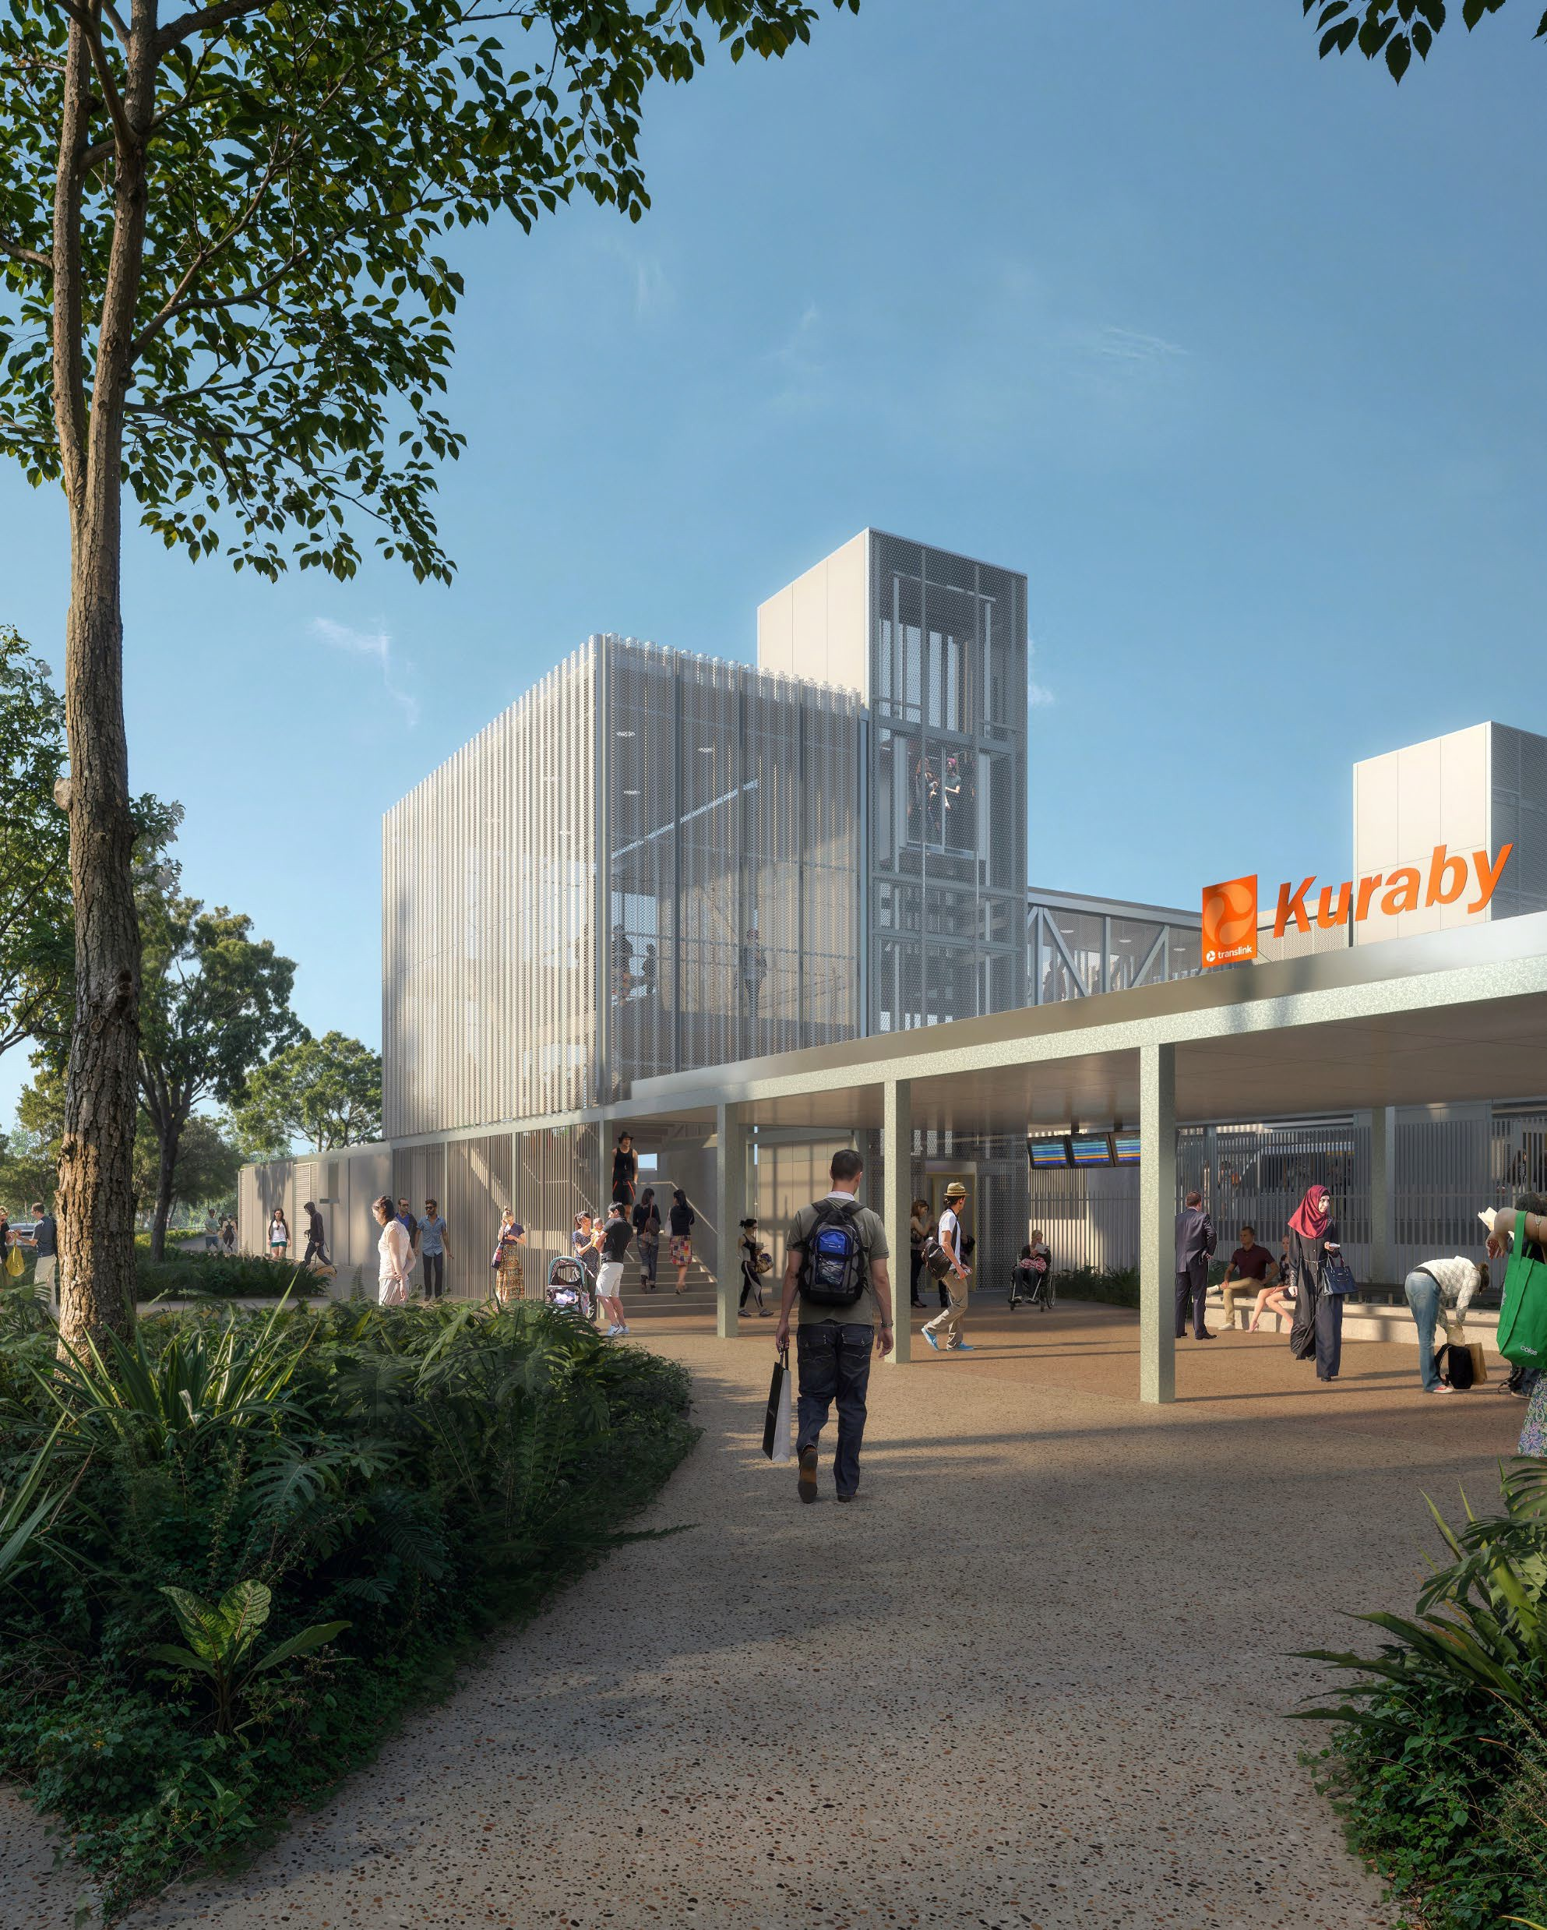
Logan and Gold Coast Faster Rail
The Australian and Queensland governments have committed $5.75 billion (50:50 basis) to double the tracks from two to four between Kuraby and Beenleigh, which will increase the capacity of the rail line and reduce waiting time at stations.

Works Package Update

Rail package | - March 2025 – Commenced design  - July 2025 – Received federal EPBC approval  - September 2025 – Enter into Project Alliance Agreement  - Through 2026 – Continue design, and construction expected to commence.
Open level crossing removal package | - Early 2025 – Geotechnical and site investigations to inform design  - Through 2025 – Design development  - Late 2025 – QR enabling works  - Late 2025 – Site establishment for major construction in early 2026

Department of Transport and Main Roads
Remove caption if not required.
4

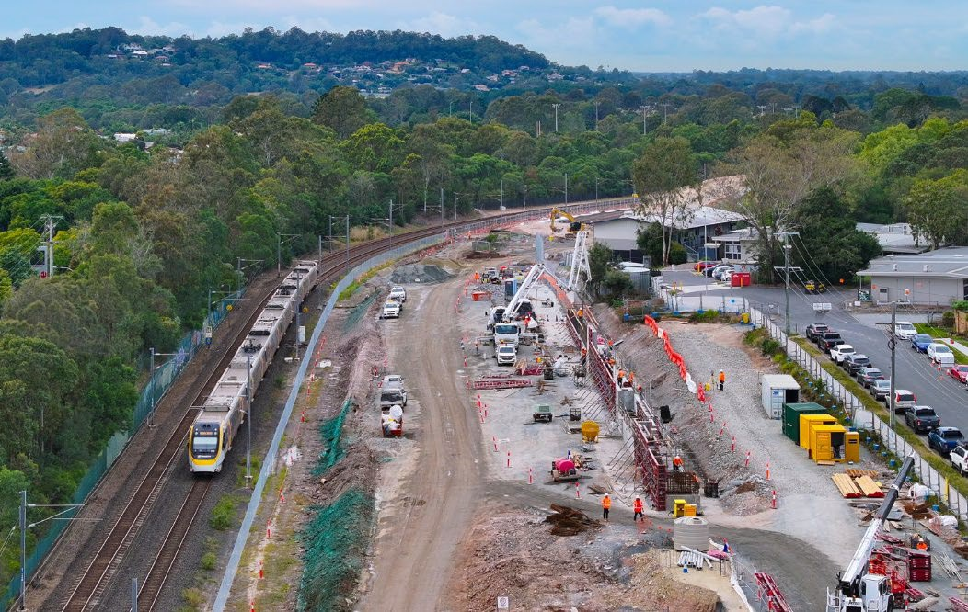
Loganlea Station Relocation

The Australian and Queensland governments have jointly committed $173.8 million to deliver this project. An at-grade park ‘n’ ride at the new station is being funded separately.
As of 30 June 2025, 28% of works are complete.
Loganlea Station is being relocated 500 metres south, opposite the Logan Hospital to better connect customers to this health precinct and other education and community services and improve accessibility and safety at the station.

Project update
Remove caption if not required.
5

Late 2024-25 | Site establishment and Valencia Street works
Through 2026 | Track, station and road works
2027 | Ongoing and completion works
Department of Transport and Main Roads

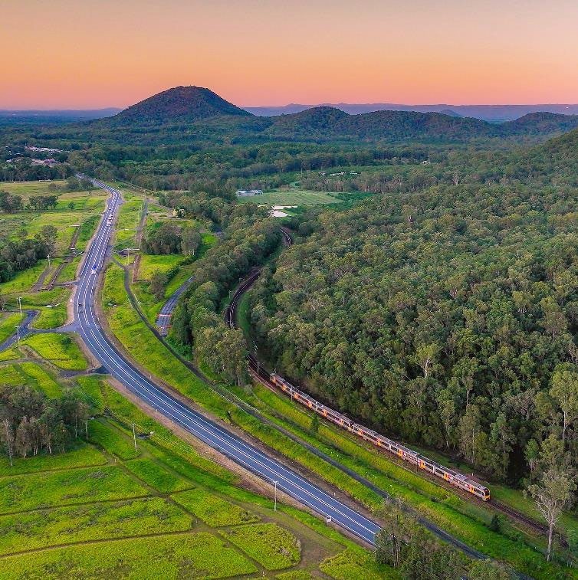
Beerburrum to Nambour Rail Upgrade
Realigned section of Steve Irwin Way, Glass House
Mountains.
Completed in 2023 as part of B2N early works.
This project will increase capacity and improve reliability for passenger and freight services in the growing Sunshine Coast region.
Project update

Funding | $1.004 billion  ($616.7 million Australian Government,  $387.5 million Queensland Government)
Stage 1 Scope | - Collaborative Project Delivery Agreement awarded to a John Holland Queensland Seymour Whyte Join Venture  - Construction enabling works commenced August 2025  - Duplicate the rail line between Beerburrum and Beerwah  - Deliver three new bridges  - Address three level crossings  - Expand three park ‘n’ ride facilities
Department of Transport and Min Roads

6

The Wave (Rail) – Stage 1 and 2
Stage 1 includes:
- Delivery of a new dual-track rail line and associated infrastructure, and protection of the revised alignment to Caloundra
- Beerwah Station upgrade and two new stations at Aura (Bells Creek) and Caloundra
- Planning, design and market engagement to confirm delivery costs and timeframes to deliver the rail line to Birtinya
Stage 2 includes:
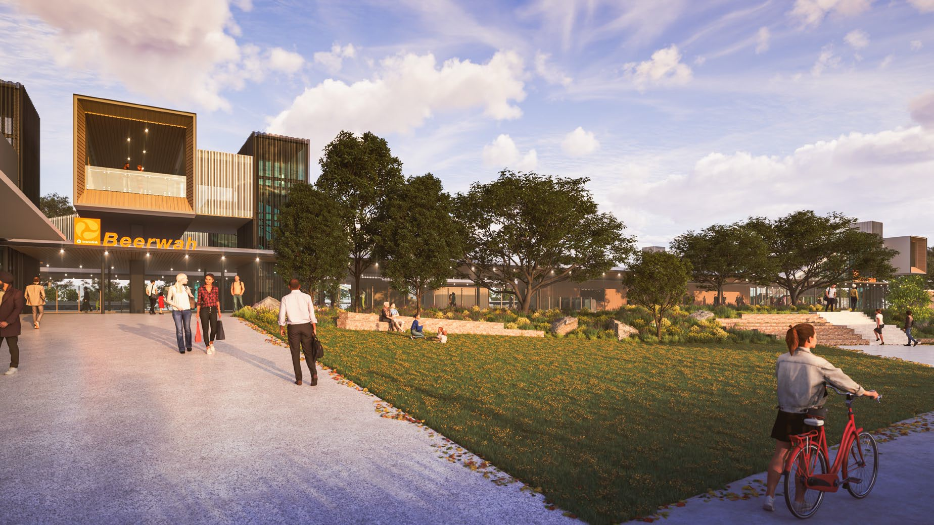
- Delivery of an additional 7km dual-track rail line (and associated infrastructure, including a 1km tunnel) from Caloundra to Birtinya
Beerwah Station concept
- Two new stations at Aroona and Birtinya
Project update
Funding | $5.5 billion (Stage 1)
2024-25 | - Readiness for market: design and site investigations  - Procurement commenced for Stage 1 (major works packages)  - Queensland Government commitment to deliver The Wave
2025-26 | Procurement continues for Stage 1,and commences for Stage 2
Department of Transport and Min Roads

7

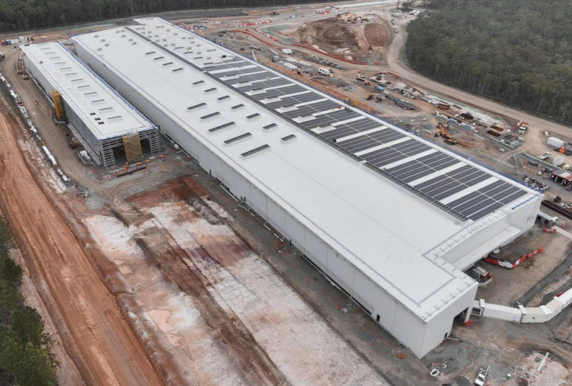
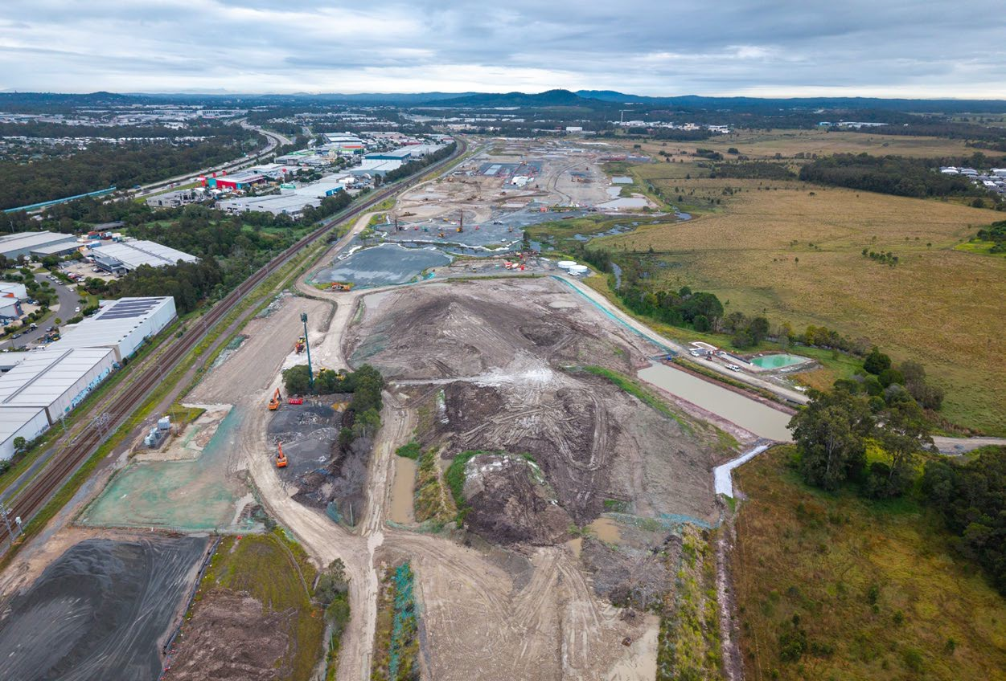
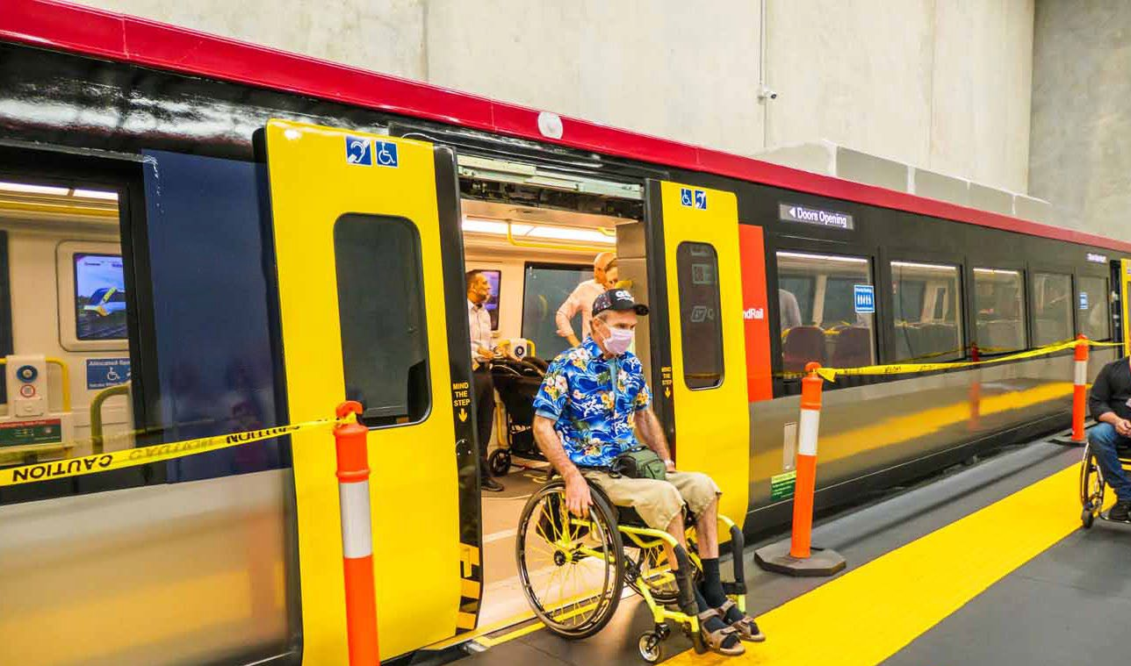
Queensland Train Manufacturing Program (QTMP)
Torbanlea train manufacturing facility – July 2025
High-Fidelity train mock-up – May 2025
Ormeau rail facility – May 2025
The total program value is $9.5 billion, which includes the costs of 35 years of maintenance of the delivered assets.
Delivery Phase is continuing with major construction now underway,
and all trains expected into service by 2032.
High-Fidelity train mock-up now in Brisbane for design validation and
user testing.

Funding | $4.869 billion
Scope | - manufacture of 65 six-car passenger trains  - construction of a purpose-built train manufacturing facility at Torbanlea on the Fraser Coast  - construction of a new rail facility, for maintenance and stabling at Ormeau on the Gold Coast  - construction of a test track  - construction of a new stabling yards and facilities  for train presentation and cleaning.
Department of Transport and Min Roads

8

European Train Control System (ETCS)

9
Modern digital signalling system that improves safety and operational performance, enabling trains to run closer together, increasing network capacity and service frequency and supporting our rapid growing population by making better use of existing infrastructure.
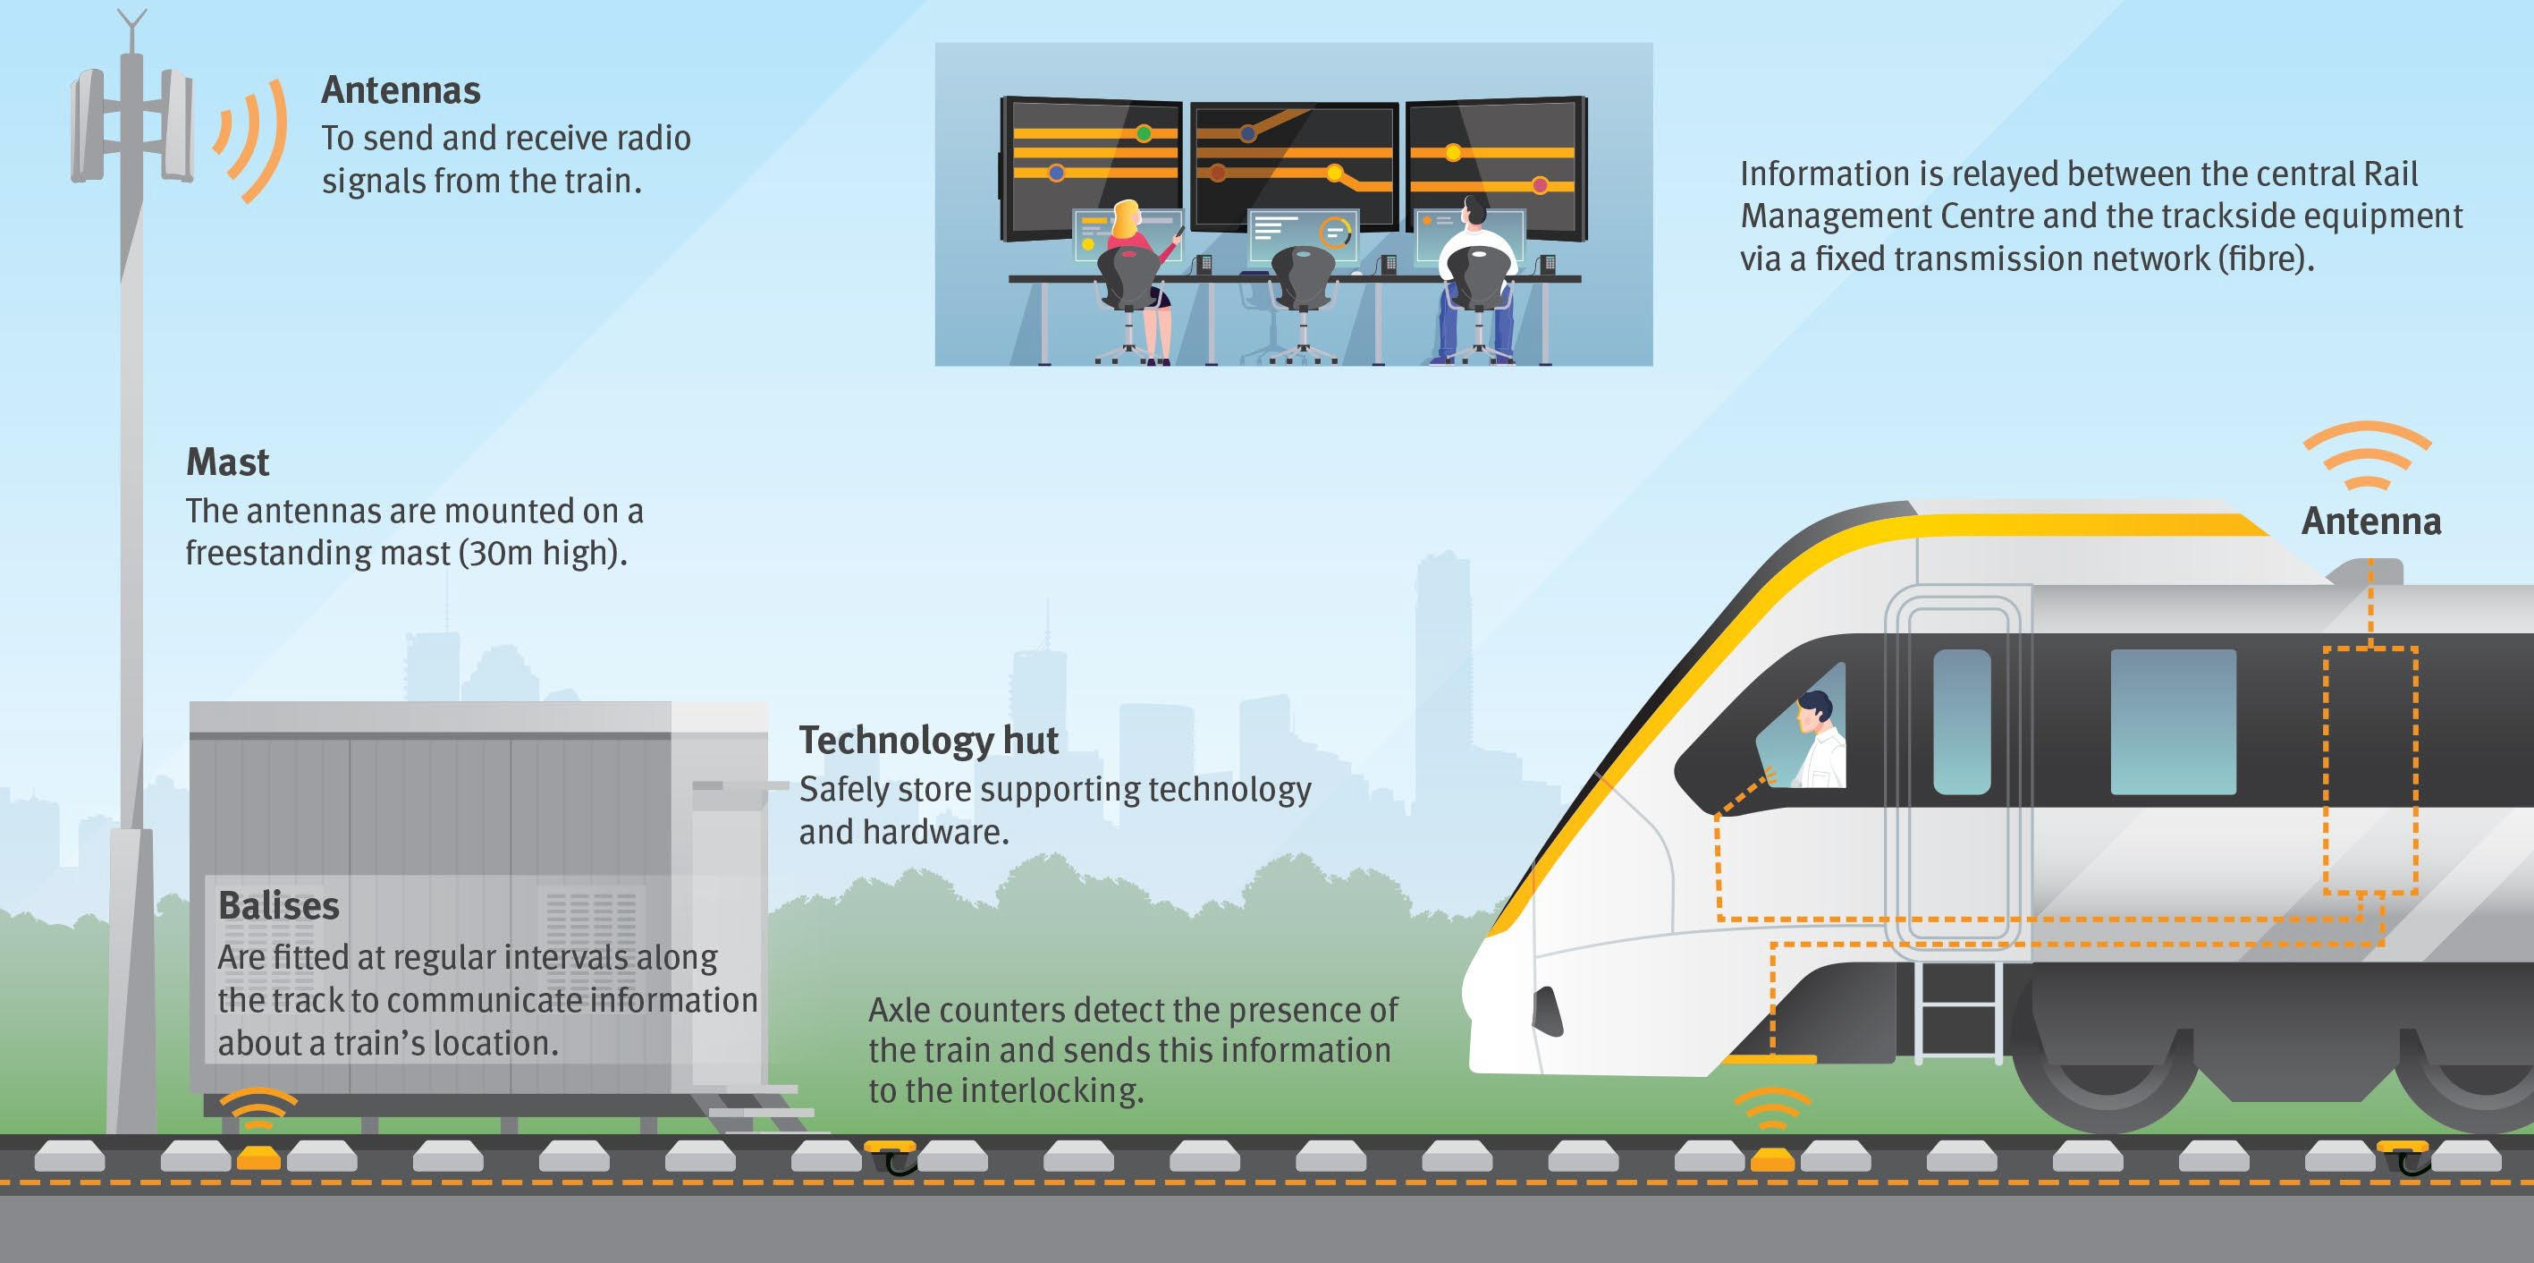
Funding | $1.65 billion
Project Details | - The Queensland Government has committed $1.318 billion to deliver ETCS on Cross River Rail and south to Moorooka, and  $339 million for delivery between Beenleigh to Varsity Lakes  - Planning underway for future rollouts aligned to Logan and Gold Coast Faster Rail and The Wave

ETCS diagram
Department of Transport and Min Roads






Thank you and stay connected

www.tm r.q ld .g o v.au

TMRQld @TMRQld TMRQld Department of Transport and Main Roads

