


Bruce Highway Targeted Safety Program

A llan Uhlm ann, Pro g ram D ire c
to r

19 August 2025



About the new program
A safer Br u c e Hi g h way

2

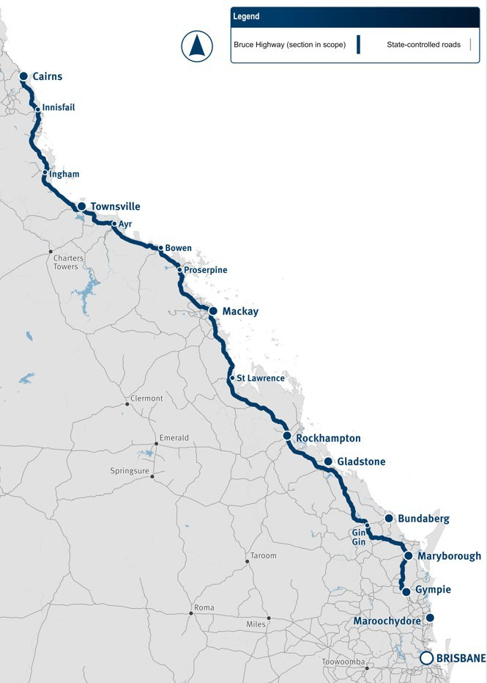
Building a safer Bruce
3


$9 billion for new safety works under the 80:20 joint funding arrangement

Accelerated delivery

Prioritising sections with high safety risk to combat crashes

Department of Transport and Main Roads

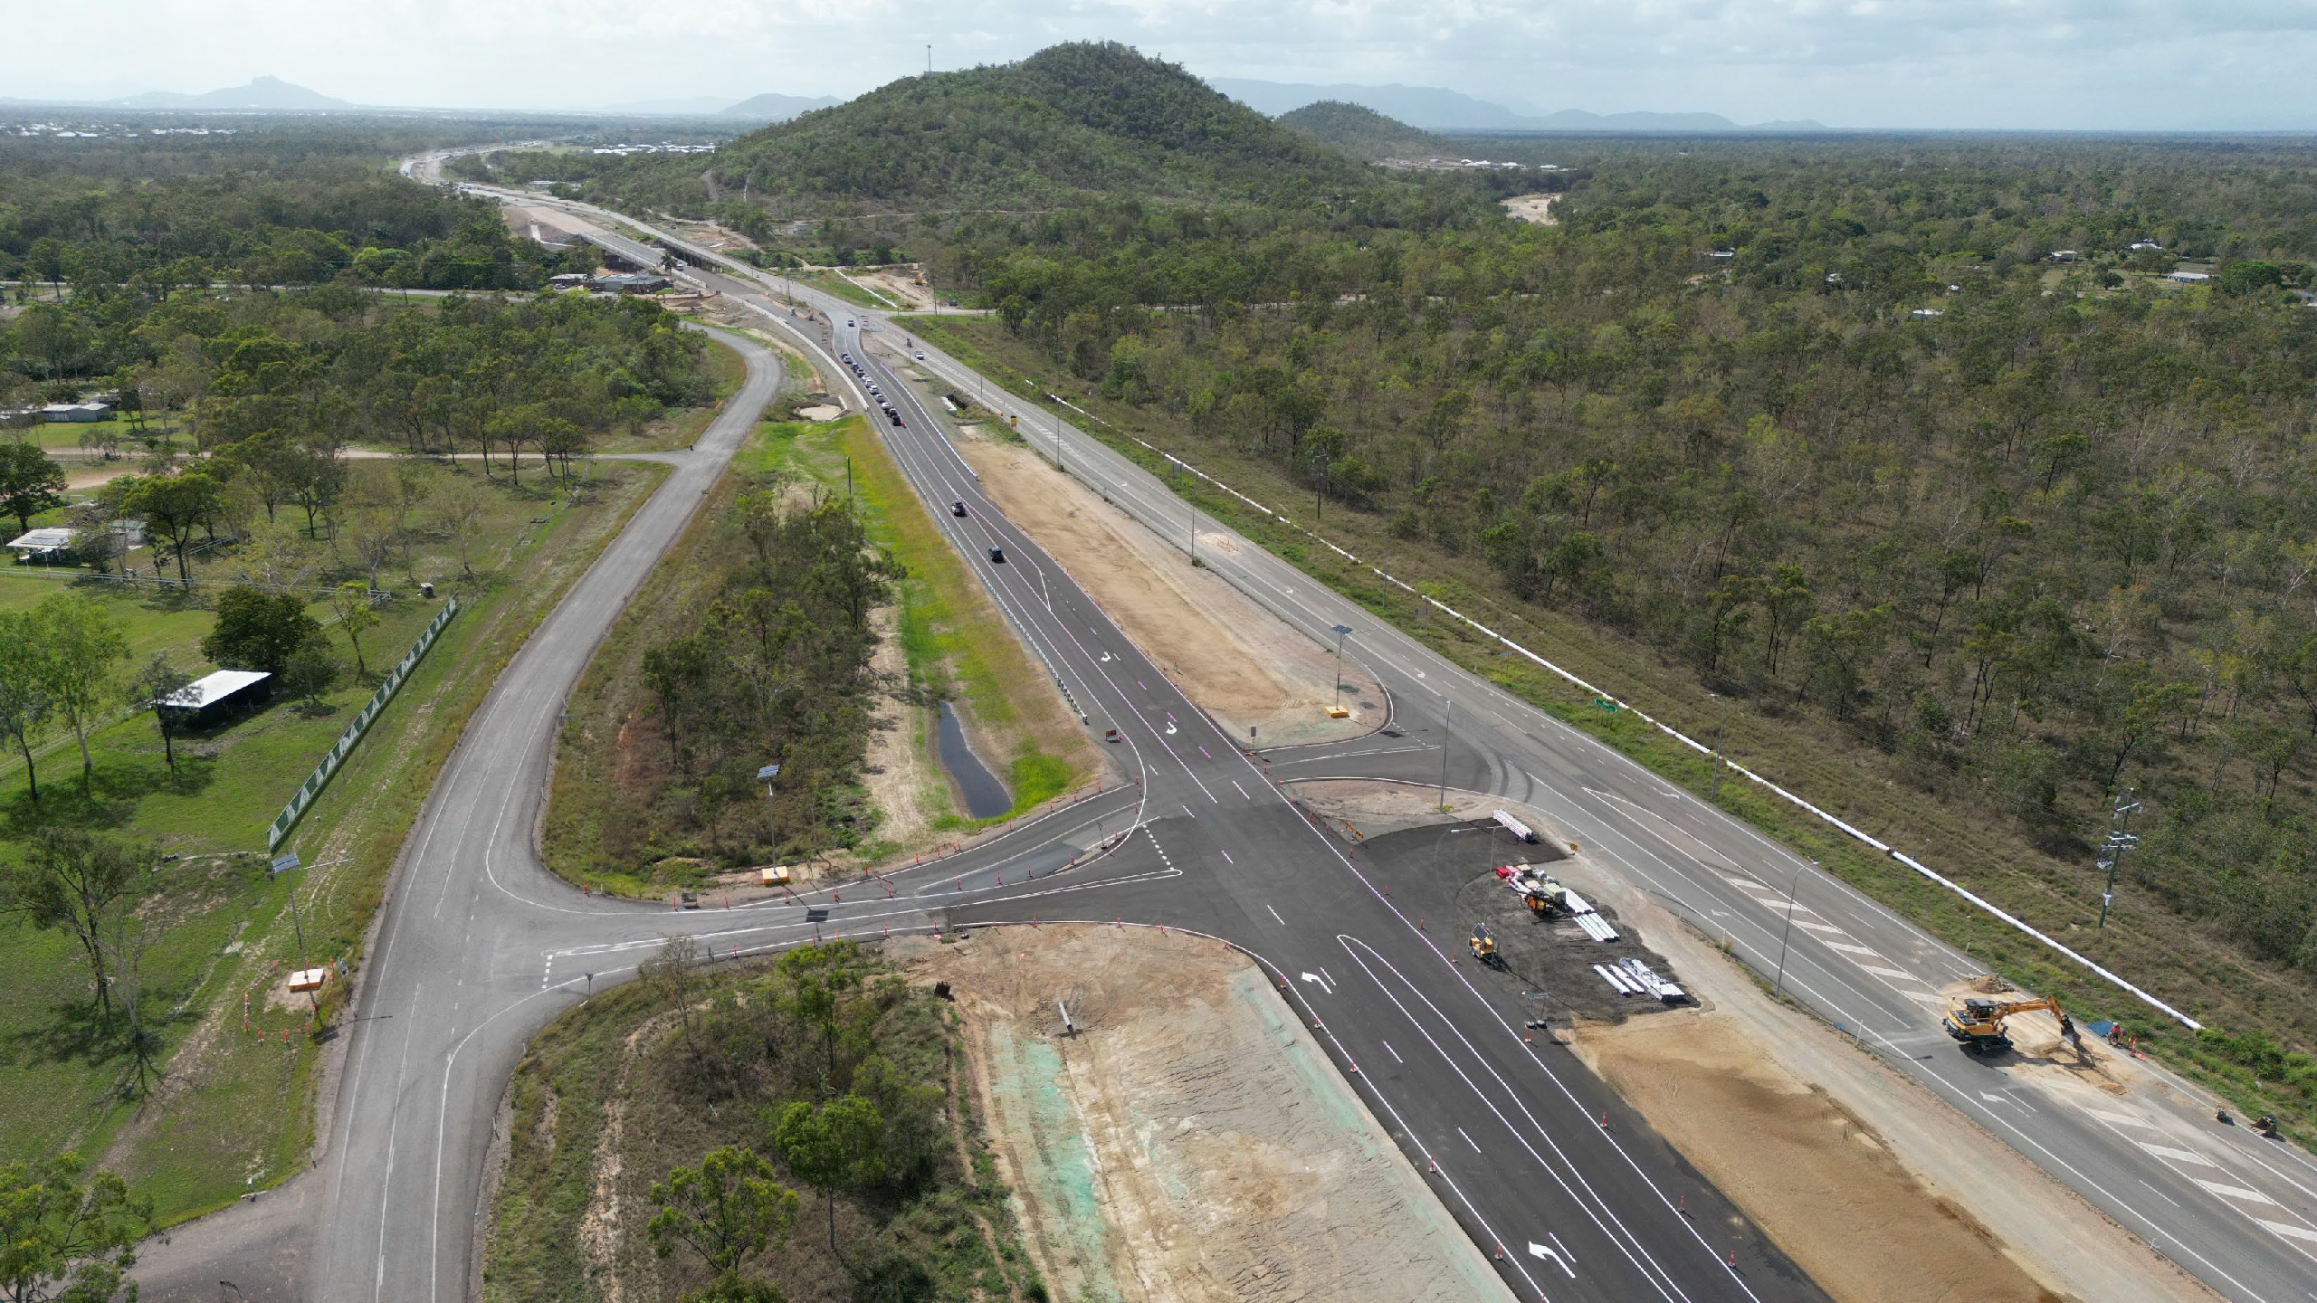











Proposed work types
Wide centre line treatments, includes road widening and audio tactile line marking
Pavement strengthening
Overtaking lanes
Intersection upgrades

Widen narrow structures

Fatigue management and rest areas

Department of Transport and Main Roads 4

Bruce Highway – location of work

North Queensland Region

Far North District

Northern District

Central Queensland Region
TMR office
Mackay-Whitsunday District

Fitzroy District

Southern Queensland Region
Wide Bay-Burnett District

Department of Transport and Main Roads
5

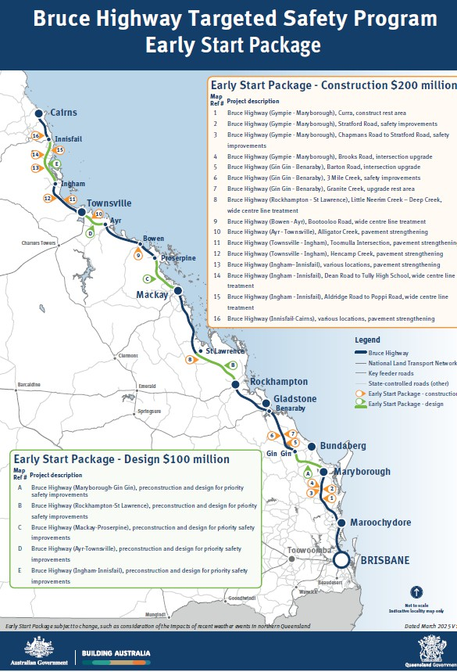
Early Start Package
Construction

Commenced March 2025


Address sections with high safety risk

Engaging contractors through existing arrangements
Design
Commenced March 2025

Building towards development and delivery of overall pipeline of works
Direct engagement of designers by TMR

Department of Transport and Main Roads

Construction – Strong progress
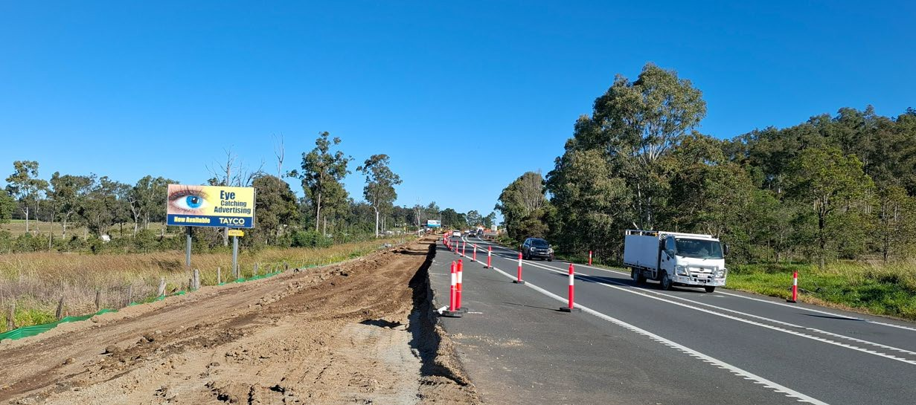
16 priority projects fast-tracked
to construction:
- 1 x complete
- 8 x under construction
- All remaining projects commencing this year
Above: Works are progressing to upgrade the Brooks Road intersection north of Gympie with a channelised right turn facility. Source: TMR image

Department of Transport and Main Roads
7

Delivery – Next Steps
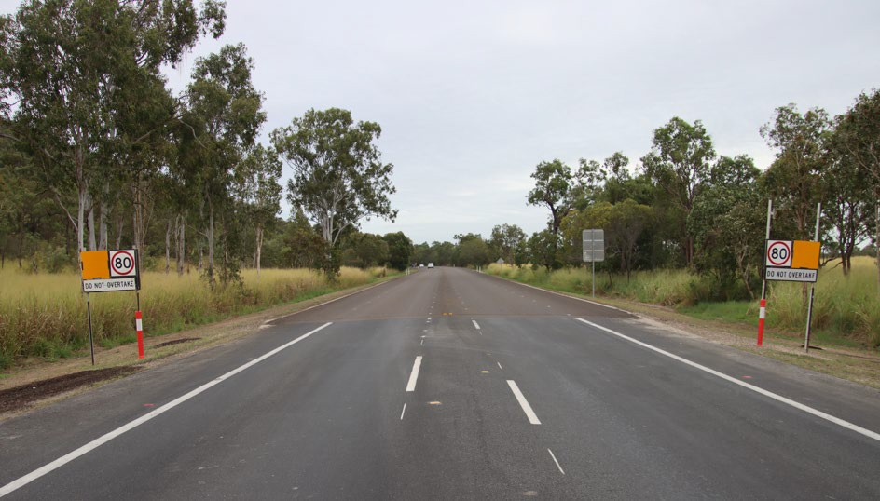
- Next round of construction following early start design – construction activities to commence in 2026.
- Priority pavement strengthening works – commencing in 25/26.
- Further details to follow in
regional updates.
Above: Pavement strengthening undertaken near Hencamp Creek Road, Townsville as part of the Early Start Package.
Source: TMR image

Department of Transport and Main Roads
8

Main Program – Update

Deficiencies confirmed and prioritised
PPR submitted to Australian Government on 29 July 2025
Additional interim projects identified
Panels established 2025
Contracts awarded through Panels 2026

Department of Transport and Main Roads
9

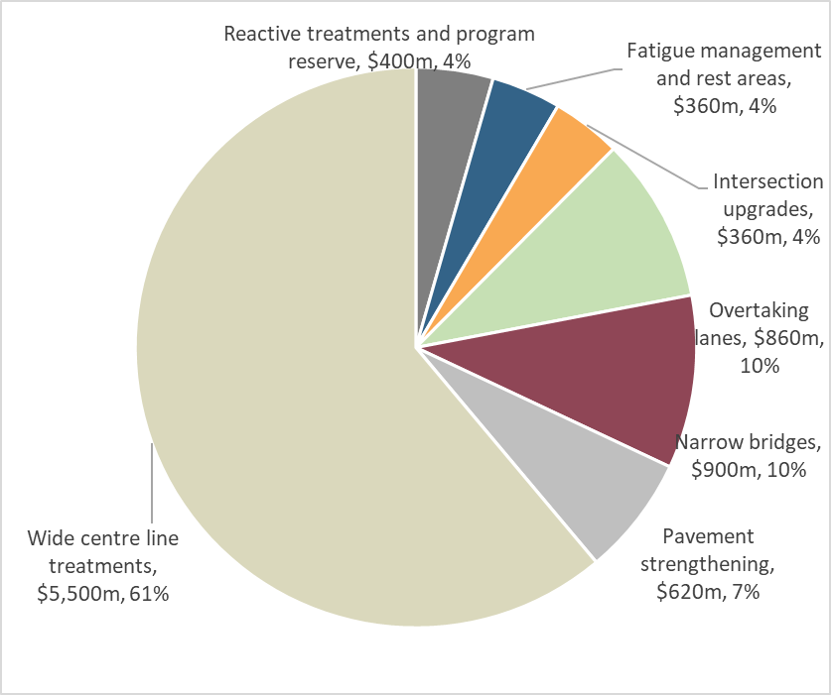
Notional funding allocations by work type

Work type | Notional allocation ($m)
Overtaking lanes | 860
Intersection upgrades | 360
Narrow bridges | 900
Wide centre line treatments | 5,500
Fatigue management and rest areas | 360
Pavement strengthening | 620
Program reserve | 400
Total | 9,000

Department of Transport and Main Roads
10

Notional funding allocations by District

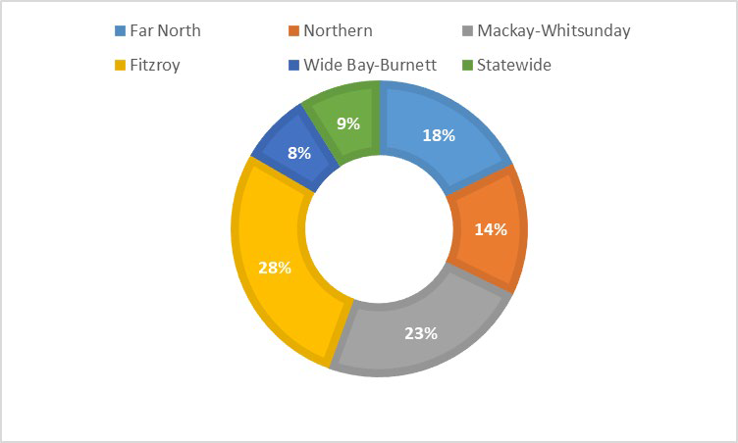
District | Notional allocation ($m)
Wide Bay Burnett | 700
Fitzroy | 2,500
Mackay Whitsunday | 2,100
Northern | 1,300
Far North | 1,600
Statewide / Program Reserve | 700
Total | 9,000

Department of Transport and Main Roads
11


Interactive Industry Briefing
Optional industry questionnaire
- 76 organisations responded
Key insights
- Agreement proposed approach will help accelerate procurement timelines and reduce tendering costs
- Readiness to contribute – capability and interest from across the market
- Industry wants more detail as it is available.

145 TMR staff and
365 industry representatives attended Diverse representation
63 questions raised and answered during 3 sessions

Very high levels of satisfaction with briefing: providing informative content – 90% opportunity to contribute feedback – 93%

Department of Transport and Main Roads 12

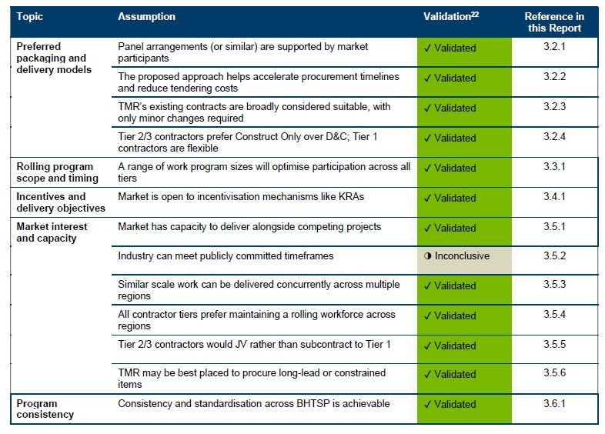
Interactive Industry Briefing – Survey

Department of Transport and Main Roads 13

Delivery Strategy Overview

- Broaden Access to Market – Tiered packaging and program approach (particularly for local and Tier 2 and 3 Constructors and local Designers).
- Expedite Procurement – Dedicated BHTSP Panels for Constructors, Designers and Contract Administrators. Will also help facilitate a strong rolling program of works.
- Panel Establishment Launching Soon – From August 2025. Procurement from Panels 2026 onwards.

14

Key Areas of Focus

Elements |  | Project packaging from prioritised deficiencies | Establish Panels (Constructor, Designer, CA)  Contract Types | Capability Uplift | Develop demand profiles for key inputs | Program Standards | Re-use relevant existing processes
Outputs |  | Flexibility in project sizing to limit overlap with competing major projects | Mix of Program D&C contracts and Construct- Only contracts | Joint industry training | Supply chain risk mitigations | Design note,  Temp Traffic Management note, Rest Area design note, Real time traveller information | BHUP reporting and performance measures
Key Areas of Focus | Manage market constraints & inflationary pressures | Yes |  |  | Yes
Key Areas of Focus | Build industry capacity (upskilling, local suppliers, indigenous participation) | Yes | Yes | Yes | Yes | Yes | Yes
Key Areas of Focus | Mitigate impact on other BH projects | Yes |  |  | Yes
Key Areas of Focus | Procurement & delivery efficiency and productivity |  | Yes | Yes | Yes | Yes
Key Areas of Focus | Manage community and transport disruption |  |  |  |  | Yes

Packaging
- Iterative process considering:

  - work type
  - priority
  - location
  - estimated value
  - work complexity
  - interfaces
  - pre-construction and planning already available
  - contract type (design, construct only, design and construct)
  - other projects or commitments
  - local TMR insights.

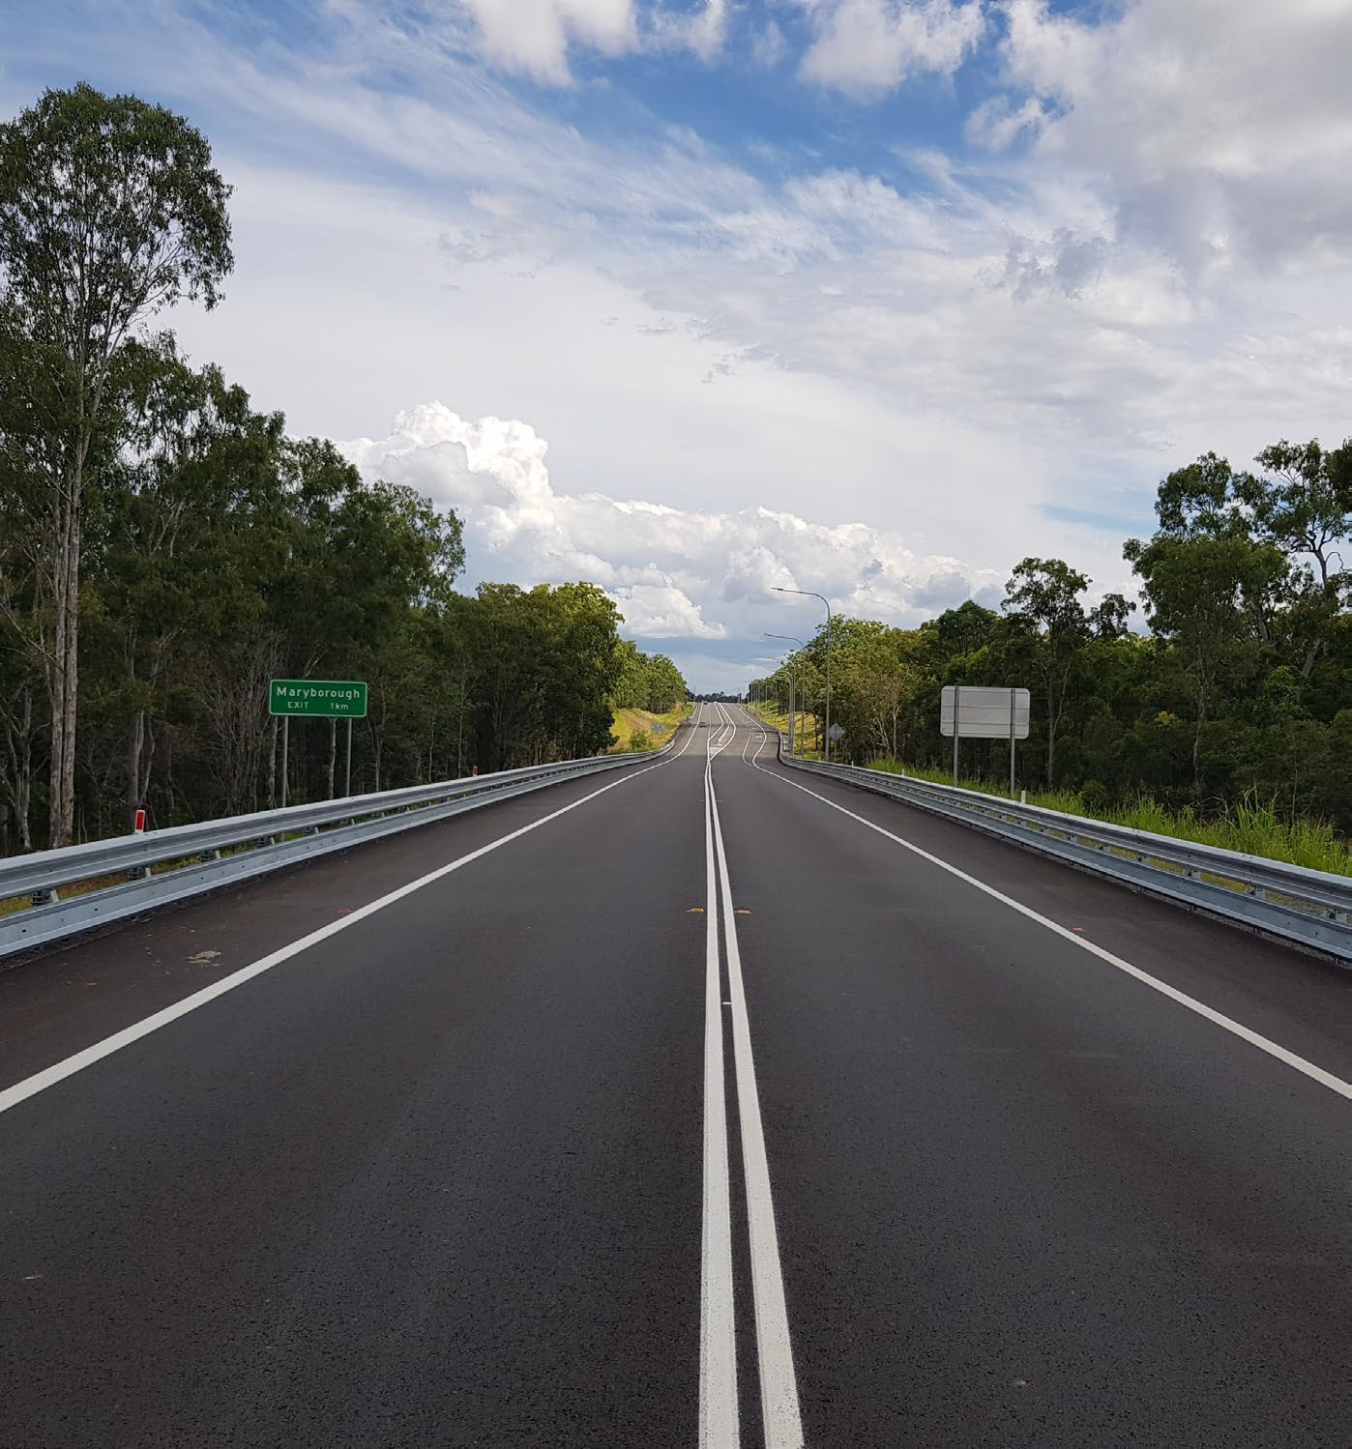
16

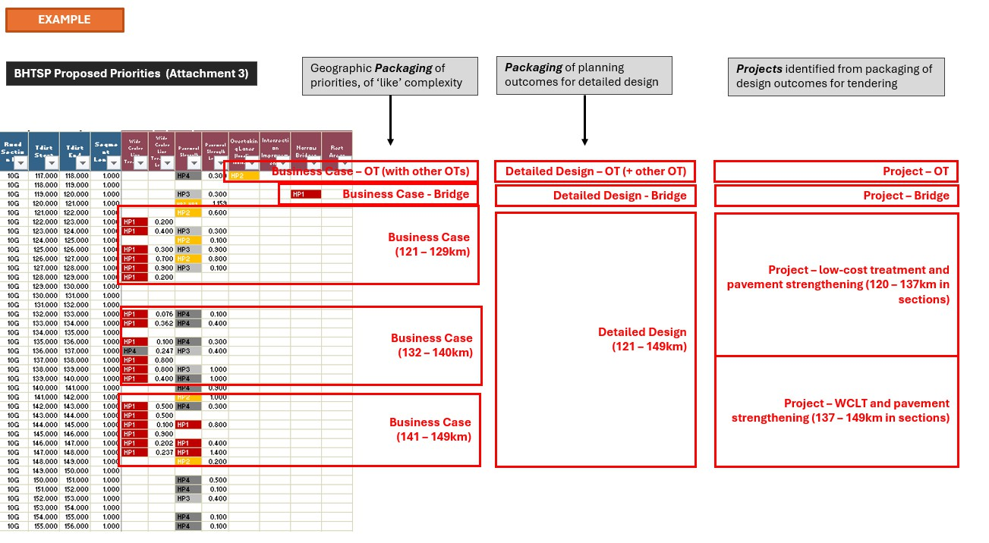
Packaging
Packaging

17
17

Panel Establishment
Panel Establishment

Initial Panel establishment:
- Constructors
- Designers
- Contract Administrators

Further Panels can be considered based on industry feedback and market risks and opportunities.
Department of Transport and Main Roads 18

General Panel Establishment process

Proponents nominate:
- Location preference
- Prequalification status
- Project team
- Current commitments
Proponents agree to:
- Unamended Panel Conditions
- Unamended BHTSP specific contracts (including D&C designer subcontracts)
- Performance (KRA/KPI) requirements
- Specified commercial terms (including margin/fee caps for contractors)

Department of Transport and Main Roads
19

Delivery approach

Decide to deliver as an individual project or as a program via the construction panel/s
Procure Initial Work Package (IWP)
Program contractor delivers IWP
Program contractor delivers AWP

TMR accepts offer as VFM

TMR evaluates performance against Key Result Areas (KRAs)

Procure and deliver individual project
Not performing

Offer does not represent Value For Money (VFM)

Performing
Program contractor develops offer for Additional Work Package (AWP) – multiple opps.








Department of Transport and Main Roads 20

Procurement of works under the Panel

  - Default position for procurement of all projects and programs is a two-stage RFP process
  - Under certain / exceptional circumstances an EOI process or a 3-2-1 dual procurement process may be undertaken.
Figure 1: Shortlist and competitive procurement process under the panel
Stage 1

Two- stage RFP
Process

Up to 3 Panel members invited to submit a Stage 1 proposal

Evaluate responses.
Shortlist up to 2 Panel member

Invite shortlisted tenderers to submit Stage 2 proposal

Evaluate tender responses including VfM assessment
Contract Award

Undertake approvals, negotiate and award contract to preferred tenderer
Stage 2

Procurement of works under the Panel

District Office invites Panel members based on the following key factors:
- Estimated contract value (i.e. </> $50m)
- Risk and complexity
- BHTSP performance
- Other factors
District Office undertakes a VfM Assessment including:
- Assessment of costs and quantities included in pricing proposal
- Verification by Independent Cost Estimator in reference to State developed estimate For instances where only 1 proposal is received, value for money will be tested against benchmarking and historical performance outcomes, or the project / program will be re- tendered

21 |

Contract Types
22 |
Contract Types
- Contractors must use BHTSP sub- contract for design works under TIC- TC
- Mandatory sub- contract agreement
- State side procurement (e.g. develop design for TIC-CO)
- TMR existing ‘Consultants for Engineering Projects’ (CFEP)
- Design & construction
- Standalone projects or program of projects
- Low to high risk / complexity
- New contract with adapted TIC-CO general terms
- Construction only (no design)
- Standalone projects (not program of projects)
- Low to medium risk
- TIC-CO base contract modified for BHTSP
Approach
- Contractor engaged to develop and finalise design and deliver the works
- State shares project cost risk and reward
BHTSP Construction Panel Agreement
BHTSP Design Panel Agreement

TIC-CO (Construct Only)
TIC-TC (Target Cost)
TMR (State Side) Consultant Contracts
Contractor (D&C Side) Design Consultants

Approach
- Design prepared by District Office
- Contractor engaged to deliver construction works

TIC-CO Key Terms
TIC-CO Key Terms

Proposed amendments to the TIC-CO commercial framework to enable greater transparency and comparability of pricing at tender and for variations.

Current TIC-CO commercial framework*
(Form M1 – Schedule of Rates or M2 – Schedule of Prices)

Schedule of Rates and / or Amounts
(All-in Amounts)

All-in rates inclusive of any overheads, profit and contingency

* Not including Lump Sum alternative
23 |
Proposed BHTSP TIC-CO commercial framework
(Use of form C7810.M10.TIC with updates)
Bid back contingency pool
Contingency
Offsite overheads and profit
Onsite overheads
Schedule of Rates - Direct Job Costs (DJCs) only

Capped % applied to DJCs and onsite overheads

Bid back % applied to DJCs

Unit pricing for labour, plant & equipment reflecting DJCs only exclusive of any overheads, profit or contingency

23

TIC-TC Key Terms
TIC-TC Key Terms
Gain/pain share outcomes illustration
Potential Gainshare
Contractor’s Fee (Offsite overheads and profit)
Reimbursable Costs

Target Cost

Department of Transport and Main Roads
24 |

Gainshare Amount
Where Actual Costs < Target Costs:
- Gainshare amount is shared 50:50 (Contractor and State)
- Contractor’s share is capped at 50% of Contractor’s Fee

Painshare Amount
Where Actual Costs > Target Costs:
- Painshare amount is shared 50:50 (Contractor and State)
- Contractor’s share is capped at 100% of Contractor’s Fee

24

Program Notes – Technical Guidance

Design:
- Clarity of In and Out of scope elements
- Stipulates cross sectional widths, intersection standards and other safety treatments
- Guidance on pavement strengthening outcomes

Department of Transport and Main Roads
Temporary Traffic Management:
- Focus on
  - Road user experience
  - Worker and motorist safety
- Achieved by
  - Maintaining traffic flow
  - Selecting suitable speeds
  - Minimising travel time impacts
25

Working with you
Co l l ab o r ati o n as Stan d ar d

26






Thank you and stay connected
www.tm r.q ld .g o v.au

TMRQld @TMRQld TMRQld Department of Transport and Main Roads

