

Queensland Transport and Roads Investment Program (QTRIP) Industry Briefing 2025-26 to 2028-29

South Coast R eg i on
A n d r ew W h eeler , R e g ion a l D ir e ct or

19 August 2025

South Coast QTRIP and Leadership

QTRIP investment:
- $4.8b – 2025–26 to 2028–29
- $2b – 2025–26
Andrew Wheeler

Regional Director


Belinda Stewart
Deputy Regional Director

Gavin Massingham
Deputy Regional Director

2

Department of Transport and Main Roads

Key QTRIP projects
3
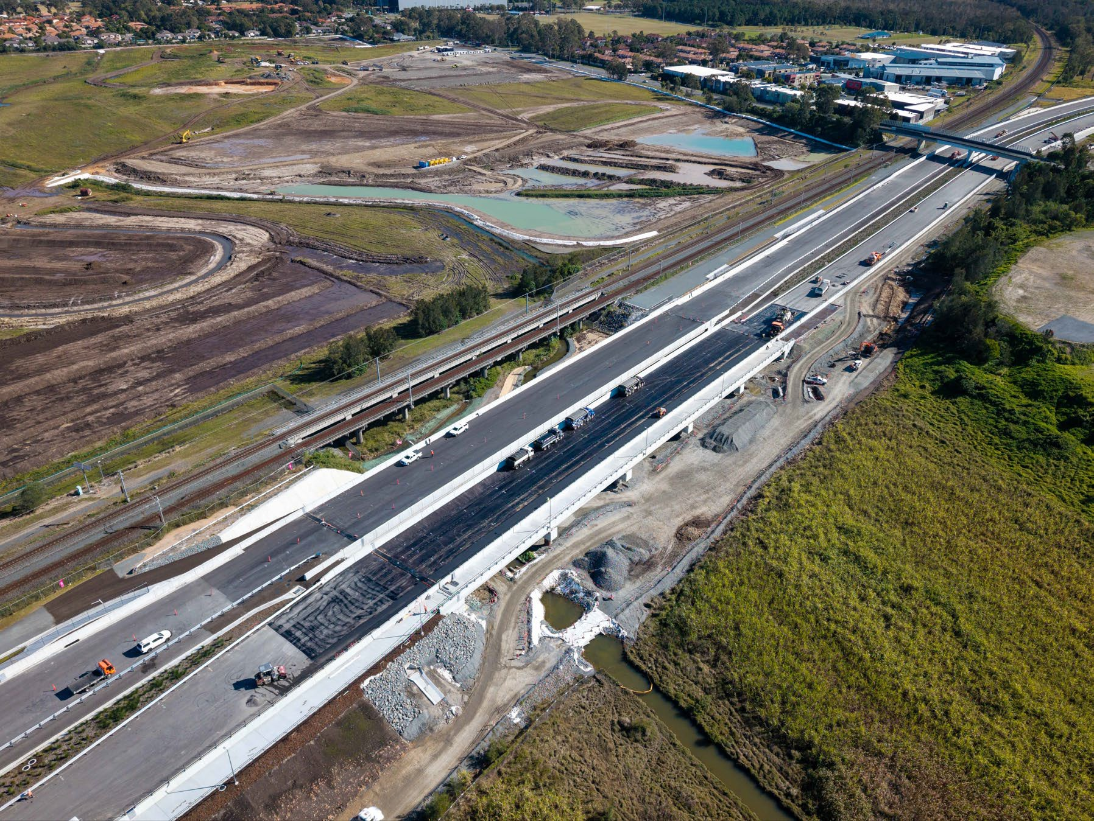
Key QTRIP projects:
- Coomera Connector (Stage 1), Coomera to Nerang
- Coomera Connector (Stage 2), Shipper Drive to Yawalpah Road
- Pacific Motorway, Exit 45 (North), Ormeau
- Gold Coast Light Rail (Stage 3), Broadbeach South to Burleigh Heads
- Cunningham Highway (Ipswich - Warwick), 2020 Disaster Recovery Funding Arrangements reconstruction works

New Coomera River bridge delivered as part of Coomera Connector Stage 1

Department of Transport and Main Roads

Construction projects
4

Project name | Indicative length (km) | Work type | Contract Type* | Procurement method | Prequal levels* | Approximate quarter to be called | Indicative contract value
Beaudesert-Beenleigh Rd and Mundoolun Connection Rd intersection, 2612588 Beaudesert-Beenleigh Rd and Mundoolun Rd intersection, 2613290 | 1.0  (in sections) | Intersection Upgrade | TIC-CO | Open Market, Single Stage | R3, F10 | Jul-Sep 2025 | Up to $10m
Burleigh Connection Road and Varsity Lakes Train Station, upgrade bus infrastructure, 3055682 | 0.3  (in sections) | Passenger Transport | TIC-CO | Open Market, Single Stage | R3, F10 | Oct-Dec 2025 | Up to $10m
Currumbin Creek Road and Bienvenue Drive intersection, 1776744 | 0.4 | Intersection Upgrade | TIC-CO | Open Market, Single Stage | R3, A3, F10 | Mar-Jun 2026 | Up to $10m
Natural Disaster Program, event 25N Ex-cyclone Alfred - Package 1 | 8.0  (in sections) | DRFA REPA  Construction | TIC-CO | Open Market, Two Stage | R3, A2, F75 | Apr-Jun 2026 | $50m-$100m
Natural Disaster Program, event 25N Ex-cyclone Alfred - Package 2 | 5.0  (in sections) | DRFA REPA  Construction | TIC-CO | Open Market, Two Stage | R2, A2, F50 | Apr-Jun 2026 | $50m-$100m
Natural Disaster Program, Event 24F - Package 1 | 4.0  (in sections) | DRFA REPA  Construction | TIC-CO | Open Market, Single Stage | R3, B1, A1, F50 | Oct-Dec 2025 | $25m-$50m
Natural Disaster Program, Event 24F - Package 2 | 3.0  (in sections) | DRFA REPA  Construction | TIC-CO | Open Market, Single Stage | R2, B1, A1, F20 | Oct-Dec 2025 | $10m-$25m
Natural Disaster Program, event 25E | 2.0  (in sections) | DRFA REPA  Construction | TIC-CO | Open Market, Single Stage | R2, A1, F20 | Apr-Jun 2026 | $10m-$25m
Mudgeeraba Creek Causeway Upgrade | 0.3 | DRFA REPA  Construction | TIC-CO | Open Market, Two Stage | R3, B1, A1, F20 | Jul-Sep 2025 | Up to $10m
Department of Transport and Main Roads *See Endnotes for Contract Type, Procurement and Prequalification terms

Natural Disaster Program event 25N

5
Ex-cyclone Alfred - Package 1 & Package 2
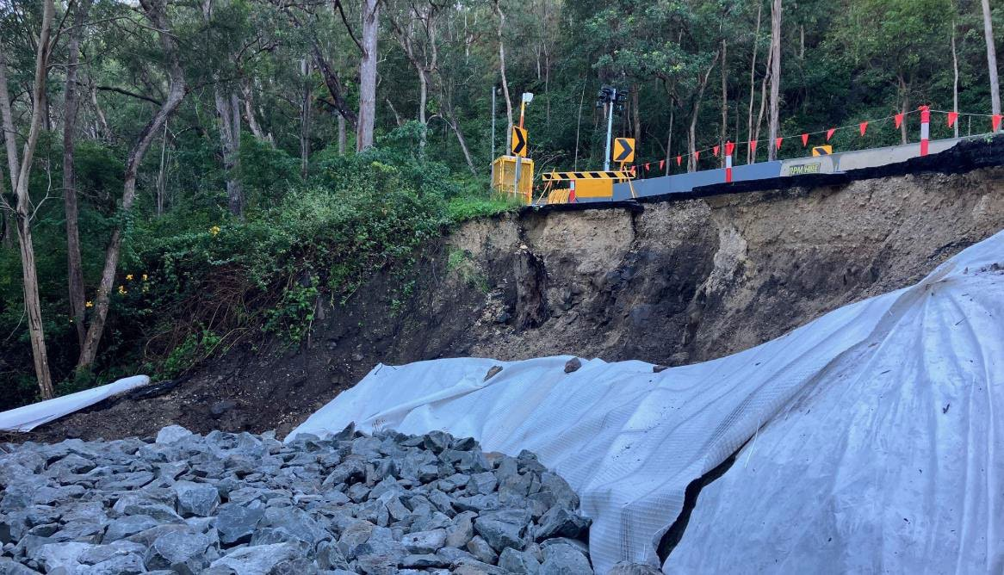
Project description | Disaster Recovery Funding Arrangements (DRFA), Reconstruction of Essential Public Assets (REPA) works
Procurement method | Open Market, Two Stage
Prequal levels* | R2, A2, F50
Approximate quarter to be called | Apr-Jun 2026

Damaged site associated with Ex-cyclone Alfred

Department of Transport and Main Roads *See Endnotes for Contract Type, Procurement and Prequalification terms

Natural Disaster Program, Event 24F - Package 1 & Package 2

6
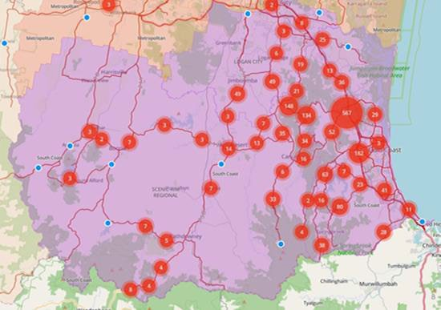
Project description | Disaster Recovery Funding Arrangements (DRFA), Reconstruction of Essential Public Assets (REPA) works
Procurement method | Open Market, Single Stage
Prequal levels* | R2, R3, B1, A1, F50
Approximate quarter to be called | Jul-Sep 2025

Event 24F damage log sits indicative locality map

Department of Transport and Main Roads

Design projects
7

Project name | Indicative length (km) | Work type | Contract Type* | Procurement method* | Prequal levels* | Approximate quarter to be called | Indicative contract value
Gold Coast Highway (Burleigh Heads), wildlife crossing, pre-construction, 3545458 | 0.1 | Design | CFEP | Open Market, Single-stage VBS | BD2, HE1, HD1, GE1, CE1 | Oct-Dec 2025 | Up to $10m
Beaudesert-Beenleigh Road, Bannockburn Road and Belivah Road intersection (Windaroo), install traffic signals, 3515374 | 0.2 | Design | CFEP | Open Market, Single-stage VBS | HE2, HD1, GE1, CE2, ITS1 | Jul-Sep 2025 | Up to $10m
Beenleigh Connection Road and City Road (Beenleigh), upgrade intersection, 2352626 | 0.2 | Design | CFEP | Open Market, Two-stage VBS | HE2, HD2, GE1, CE2, ITS1, TE2 | Oct-Dec 2025 | Up to $10m
Pacific Motorway, Exit 45 (North) Ormeau, design and pre-construction, 3654207 | 0.4 | Design | CFEP | Open Market, Two-stage QBS | BD3, HE3, HD2, GE3, CE3, ITS3, TE3 | Oct-Dec 2025 | Up to $10m
Coomera Connector (Stage 2), Shipper Drive to Yawalpah Road, planning and design, 3646282 | 5.4 | Design | CFEP | Open Market, Two-stage QBS | BD3, GE3, HE3, HD3, ITS3, TE3, TLUM3 | Jul-Sep 2025 | $25m-$50m

Department of Transport and Main Roads *See Endnotes for Contract Type, Procurement and Prequalification terms

Coomera Connector (Stage 2), Shipper Drive to Yawalpah Road

8
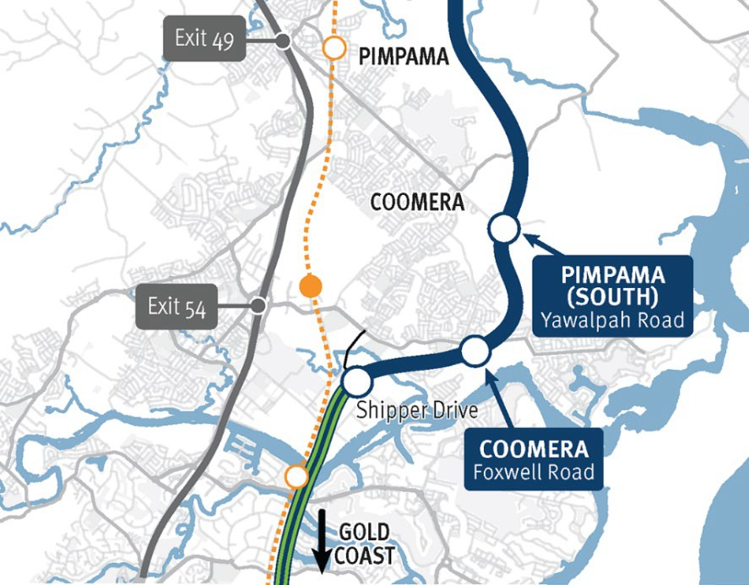
Project description | The next priority stage is the 4.9km section between Yawalpah Road and Shipper Drive, referred to as Coomera Connector Stage 2 including:  - Connection and extension of the main line constructed as part of Coomera Connector Stage 1 at Shipper Drive  - Grade separated interchanges at Shipper Drive and Foxwell Road and overpass structure at Oakey Creek Road  - Bridge structures over Oakey Creek and the wetlands to the south of Oakey Creek Road and bridge over McCoys Creek
Procurement method | Open Market, Two-stage Qualification Based Selection
Prequal levels* | BD3, GE3, HE3, HD3, ITS3, TE3, TLUM3
Approximate quarter to be called | Jul-Sep 2025

Coomera Connector (Future stages) indicative locality map
Department of Transport and Main Roads *See Endnotes for Contract Type, Procurement and Prequalification terms

Pacific Motorway, Exit 45 (North) Ormeau, design and pre-construction

9
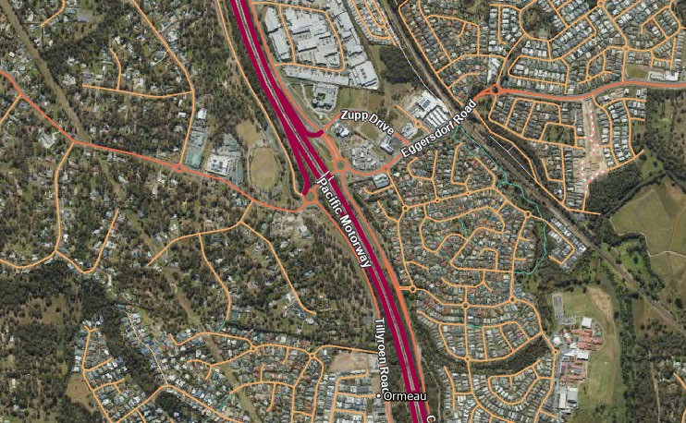
Project description | Overpass bridge duplication with signalised intersections replacing adjacent roundabouts
Procurement method | Open Market, Two-stage Qualification Based Selection
Prequal levels* | BD3, HE3, HD2, GE3, CE3, ITS3, TE3
Approximate quarter to be called | Oct-Dec 2025

Exit 45 (North) Ormeau
Pacific Motorway
Exit 45 (North) Ormeau indicative locality map

Department of Transport and Main Roads *See Endnotes for Contract Type, Procurement and Prequalification terms


Planning projects
10

Project name | Indicative length (km) | Work type | Procurement method* | Pre-qual levels* | Approximate quarter to be called | Indicative contract value
Nerang to Broadbeach public transport route, business case, 3113540 | TBC | Planning | Open Market, Two-stage QBS | BD2, CE3, ES3, FC3, GE2, HE2, HD2, ITS2, TE2, TP2, TLUM1 | Oct-Dec 2025 | Up to $10m
Tamborine - Oxenford Road, Regatta Avenue East to Gray Willow Boulevard, improve safety and capacity, planning, 3135496 | 1.2 | Planning | Restricted Tender | CE2, GE2, HD2, TE2, TP2 | Jul-Sep 2025 | Up to $10m
Beenleigh Connection Road, Main Street, Martens Road, M1 Exit 35, improve roundabout, planning | 0.4 | Planning | Open Market, Two-stage QBS | CE2, ES2, GE2, HE2, HD2, ITS2, TE2, TP2 | Jan-Mar 2026 | Up to $10m
Beaudesert – Boonah Road, install passing lanes, planning | 3.0  (in sections) | Planning | Restricted Tender | CE2, GE1, HE1, HD1, TE1 | Apr-Jun 2026 | Up to $10m
Beaudesert – Boonah Road, Teviot Brook Bridge (Coulson) replacement, planning | 0.6 | Planning | Open Market, Two-stage QBS | BD2, CE2, GE2, HE2, HD2, TE2 | Apr-Jun 2026 | Up to $10m
Salisbury to Beaudesert rail line, corridor protection, 1487103 | 54 | Planning | Restricted Tender | BD3, CE3, GE3, HD3, TLUM3, TP3 | Jul-Sep 2025 | Up to $10m

Department of Transport and Main Roads *See Endnotes for Contract Type, Procurement and Prequalification terms

Material demand
11

Materials | Jul-Sep 2025 | Oct-Dec 2025 | Jan-Mar 2026 | Apr-Jun 2026 | Total
Asphalt - Estimated demand (tonnes) | 10,652 | 14,822 | 42,473 | 26,219 | 94,166
Bitumen - Estimated demand (litres) | 31,145 | 956,151 | 352,210 | 102,544 | 1,442,050
Granular - Estimated demand (m3) | 2,345 | 6,965 | 156,348 | 85,117 | 250,775
Concrete - Estimated demand (m3) | 1,108 | 1,528 | 9,211 | 7,511 | 19,358
Culvert - Estimated demand (linear metres) | 234 | 625 | 1,362 | 3,386 | 5,607
Deck Units - Estimated demand | 0 | 0 | 0 | 150 | 150

Department of Transport and Main Roads

Endnotes
Contract Type, Procurement and Prequalification terms
A | Asphalt
B | Bridgeworks
BD | Bridge Design
CE | Cost Estimating
CFEP | Consultants for Engineering Projects
CPA | Collaborative Project Agreement
DAI | Data Analysis & Insights
ECI | Early Contractor Involvement
EE | Electrical Engineering
ENV | Environmental Services
EOI | Expression of Interest
ES | Economic Studies
ETI | Early Tender Involvement
F | Financial Level
FC | Financial / Commercial
FREW | First Response Emergency Works
GE | Geotechnical Engineering
HD | Hydraulic Design
HE | Highway Engineering
IBCP | Infrastructure Building and Construction Panel
ITS | Intelligent Transport Systems
MIC-CO | Minor Infrastructure Contract – Construct Only
MIC-DC | Minor Infrastructure Contract – Design and Construct
MIC-SI | Minor Infrastructure Contract – Sole Invitation

PAF | Project Assessment Framework
PD | Pavement Design
PM | Project Management
PPP | Public-Private Partnership
QBS | Qualification Based Selection
R | Roadworks
RAMC | Road Asset Maintenance Contract
RM | Risk Management
RMPC | Road Maintenance Performance Contract
SE | Structural Engineering
SOA | Standing Offer Arrangement
SSMW | Small Scale Minor Works
TE | Traffic Engineering
TIC-CO | Transport Infrastructure Contract – Construct Only
TIC-DC | Transport Infrastructure Contract – Design and Construct
TIC-SI | Transport Infrastructure Contract – Sole Invitation
TLUM | Transport & Land Use Modelling
TP | Transport Planning
VBS | Value Based Selection

12

Department of Transport and Main Roads

Contact
13

For further information about our program email:

southcoast@tmr.qld.gov.au

Department of Transport and Main Roads






Thank you and stay connected
www.tm r.q ld .g o v.au

TMRQld @TMRQld TMRQld Department of Transport and Main Roads

