


Collaborative Transport Infrastructure Program
Pre s e n te d by De an n e Hawk s wood Ch i ef Pr o c u r emen t Offi c er

19 August 2025

Our journey: From concept to reality
The why

A growing program with increased workforce competition
Challenges around capacity, capability and culture
Sustainable processes and behaviours support a sustainable industry



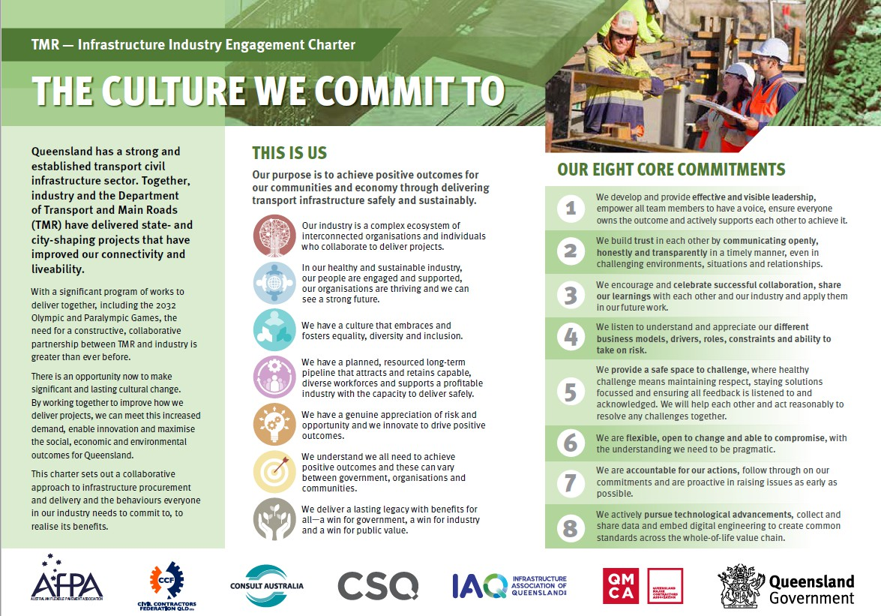






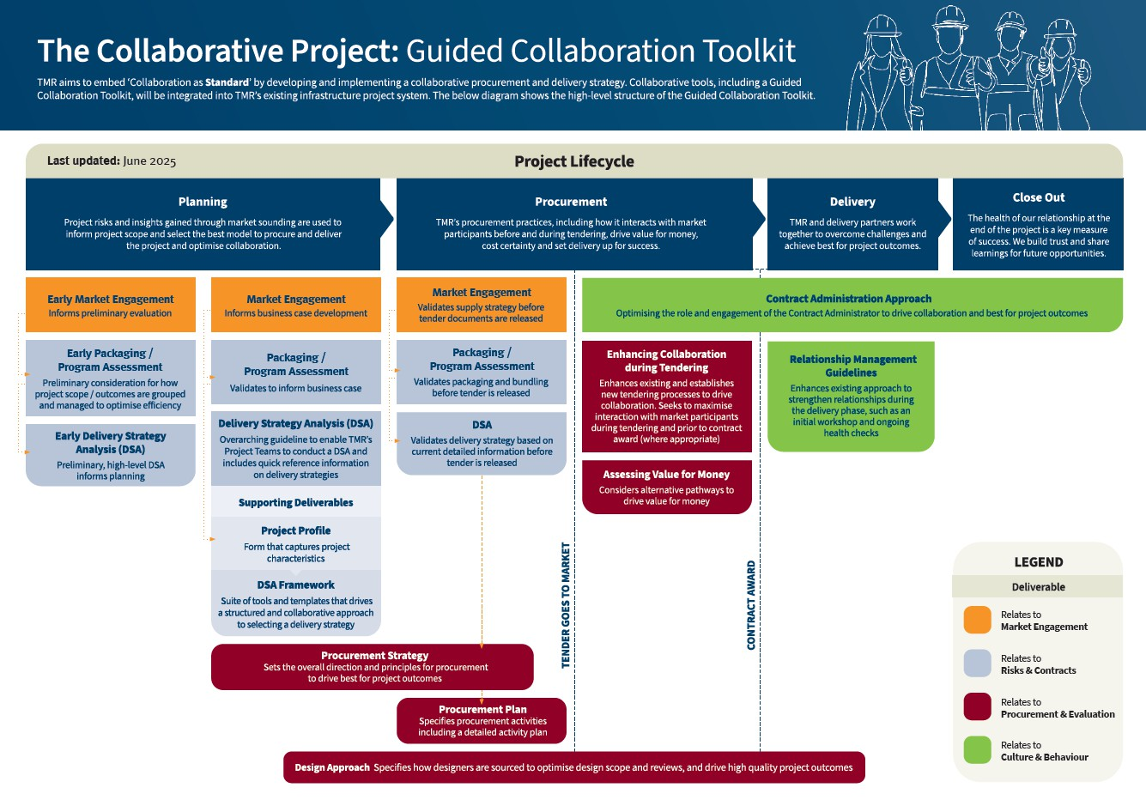
The how The what

2
2


Our end goal
Enhancing collaborative procurement and delivery and adopting a ‘collaboration as standard’ approach

- Unlock planning to streamline delivery
- Work with the market
- Enhance the tendering process
- Evaluate tenders differently
- Streamline project delivery
- Scalable solutions for use across all TMR projects

3


2025 in focus

- Development of Guided Collaboration Toolkit

- Optimising risk allocation and mitigation

- Rollout and implementation

- Stakeholder engagement and consultation

- Training and capability uplift

4







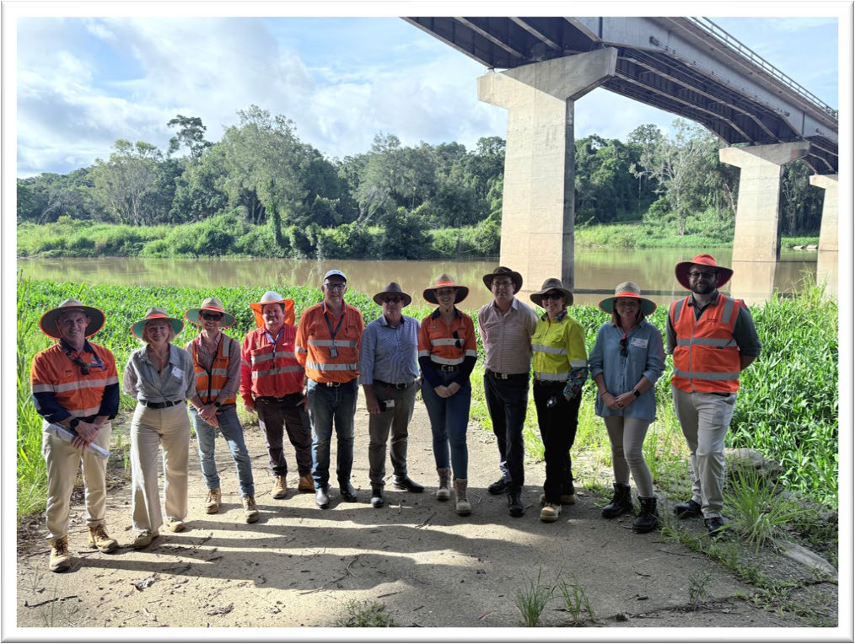
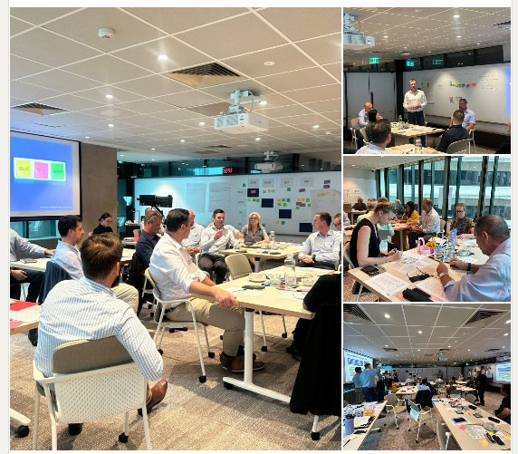
Collaboration in action
Market Engagement
- Caboolture-Bribie Island Road, Hickey Road to King Johns Creek
Delivery Strategy Analysis
- Barron River Bridge
Relationship Management Guidelines
- Loganlea Station Relocation Project
- Hamilton Plains Flood Immunity Upgrade
- Dallachy Flood Immunity and Cowley Safety Barrier Installation
Contract Administration Approach
- Establishment of Contract Administrators Working Group

5


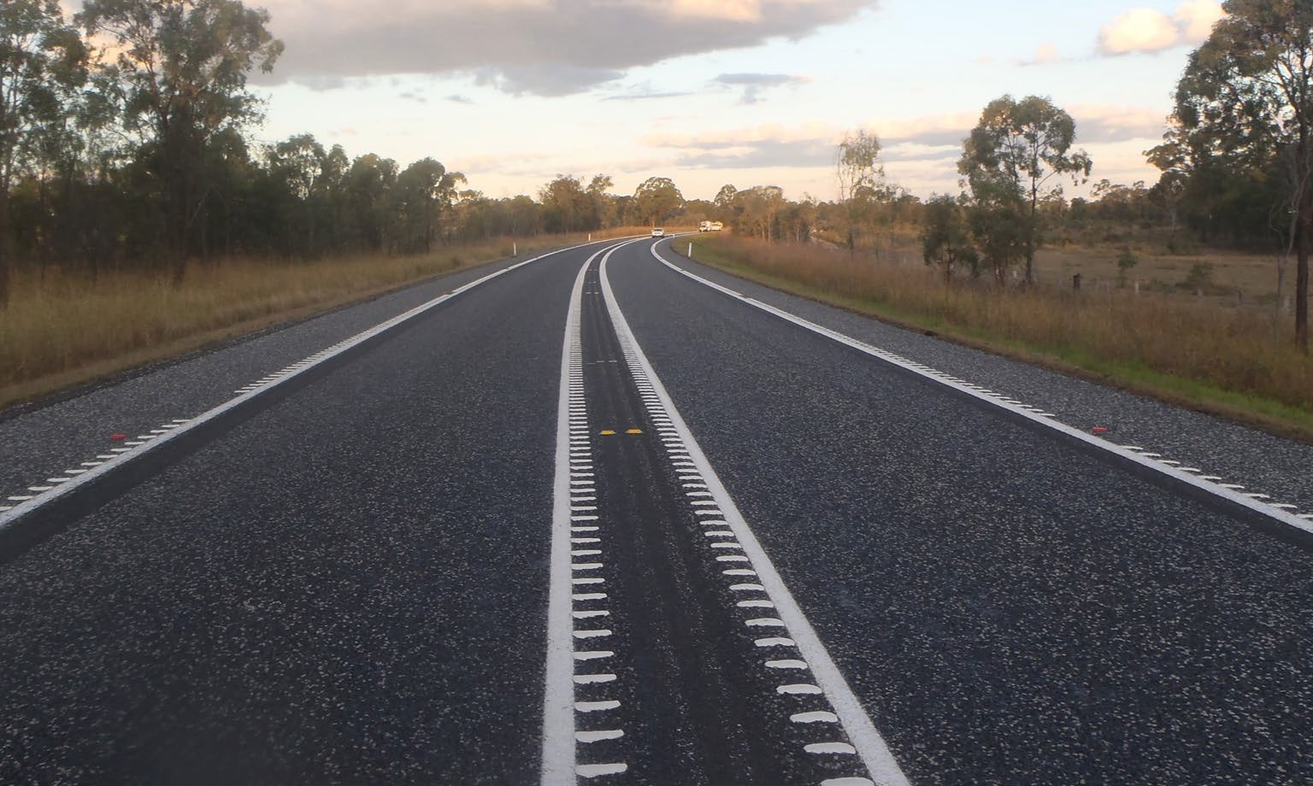


Our catalyst for change
✓
Valuing performance
✓
Streamlining procurement
✓
Team continuity
✓
Enabling innovation and change
Collaboration as standard on the Bruce Highway Targeted Safety Program

We’ll be testing We’ll focus on
Market Engagement
Program and packaging approach
Delivery Strategy Analysis
Assessing value for money differently

6


The road ahead
Collaboration for cost certainty
Improving design quality and correctness

Targeted earlier investigations to manage risk exposure through design and delivery Address uncertainty with appropriate estimate allowances and contingency Improving business case and pre-tender estimates including independent reviews
Value engineering to maximise whole-of-life benefits
Early industry and partner engagement and collaborative risk management

7









Thank you
To those who have been on the journey with us

We extend our thanks to our Transport Infrastructure Advisory Board members, contractors, subcontractors, suppliers, contract administrators, consultants, designers, industry representatives, and TMR colleagues who have provided such a valuable contribution to our CTIP initiatives.

We couldn’t have done it without you!
8






Thank you and stay connected
www.tm r.q ld .g o v.au

TMRQld @TMRQld TMRQld Department of Transport and Main Roads

