
Active Transport Investment Program Technical Guidance
  - November 2025
Translating and interpreting assistance
The Queensland Government is committed to providing accessible services to Queenslanders from all cultural and linguistic backgrounds. If you have difficulty understanding this publication and need a translator, please call the Translating and Interpreting Service (TIS National) on 13 14 50 and ask them to telephone the Queensland Government (Department of Transport and Main Roads) on 13 74 68.
Copyright
This publication is protected by the Copyright Act 1968. © The State of Queensland, 2025.
Disclaimer
While every care has been taken in preparing this publication, to the extent permitted by law, the State of Queensland accepts no responsibility and disclaims all liability (including without limitation, liability in negligence) for all expenses, losses (including direct and indirect loss), damages and costs incurred as a result of decisions or actions taken as a result of any data, information, statement or advice, expressed or implied, contained within. To the best of our knowledge, the content was correct at the time of publishing.

Contents
1. Introduction 3
2. Purpose 3
3. Eligibility and performance requirements 4
3.1 Eligibility 4
3.2 Performance requirements 4
4. On-road bicycle lanes and cycle tracks 5
4.1 Level of traffic stress (LTS) and treatment types 5
4.2 Bicycle lanes and on-street parking 11
4.3 Intersections 12
4.4 Drainage and utilities 13
5. Off-road requirements 14
5.1 Land use and path provision for walking 14
5.2 Path intersections and widths 14
5.2.1 Bike infrastructure path widths 15
5.2.2 Walking infrastructure path widths 16
5.3 Path sight lines 17
5.4 Path joints 18
5.5 Path pavement marking and signs 18
5.6 Path and driveway conflict/s 19
5.7 Objects adjacent to paths 19
5.8 Shade provision 21
5.9 Access management 21
5.10 Shared path longitudinal grade 22
5.11 Transitions between on-road and off-road facilities 23
6. References 24

1. Introduction
The Department of Transport and Main Roads (TMR) Active Transport Investment Program (ATIP) was established in 2006, and provides funding for bike riding infrastructure, planning and programs, and walking initiatives, to encourage more people to ride bikes and walk more often in line with the visions of the Queensland Cycling Strategy 2017-2027 and Queensland Walking Strategy 2019-2029.
The ATIP funds active transport (AT) infrastructure for transport and utility trips that connect to major attractors, such as schools, universities, shopping complexes, public transport and workplaces.
The ATIP funds projects which provide AT facilities on the state network delivered directly by TMR, and also projects on the local network delivered by Queensland local government areas through funding grants provided by TMR’s Active Transport Grants Program (ATGP). The ATGP is a sub-program of the ATIP.

2. Purpose
The purpose of this document is to outline the relevant existing technical standards and treatments for AT infrastructure in Queensland and provide guidance on how the ATIP will consider these in prioritisation and development of the AT network through projects funded by the ATIP.

This document seeks to provide guidance around technical considerations when:
- undertaking planning for projects that might be funded by the ATIP in the future
- developing funding applications for the ATIP
- developing designs for ATIP projects.

For clarity, this document does not present new technical standards or treatments.

This latest version (November 2025) incorporates learnings and clarifications resulting from previous relevant ATIP funded infrastructure projects.

3. Eligibility and performance requirements

3.1 Eligibility
The ATGP guidelines will outline the project eligibility requirements specific to those programs including alignment and, where required, compliance with relative network plans.

3.2 Performance requirements
Evidence suggests that high quality AT facilities which are comfortable, low-stress, accessible, convenient, direct, safe and competitive with other modes of travel encourages more people to ride bikes and walk more often.

Further to this, and consistent with the Safe System approach adopted in TMR’s Road Safety Policy, the ATIP is focused on supporting facilities and treatments that do not expose active transport users to crash forces that could lead to fatal and/or serious injury outcomes. The ATIP also prioritises the separation of modes, where feasible and appropriate for project and location context.

Taking these key matters into consideration, the ATIP prioritises the adoption of desirable treatments over minimum treatments to support delivery of infrastructure that:
- meets best practice design and construction standards;
- completes missing links and/or removes barriers that present significant obstacles to bike riding or walking;
- improves access to key destinations;
- contributes to the delivery of priority network outlined in a Principal Cycle Network Plan (PCNP) and/or Walking Network Plan (WNP); and
- anticipates and supports future demand and use.

To help projects achieve this, this document:
- outlines the desirable treatments prioritised by the ATIP;
- references (and is consistent with) the relevant Austroads’ guidelines and the accompanying Queensland-specific documents, and other relevant stand-alone TMR standards, guidelines and associated specifications; and
- flags certain treatments and designs that are unlikely to support ATIP objectives.

4. On-road bicycle lanes and cycle tracks

4.1 Level of traffic stress (LTS) and treatment types
With respect to comfortable and low-stress travel by bicycle, ATIP funding is prioritised towards projects that incorporate physical separation from motorised traffic. This means supporting treatments which aim to achieve at least level of traffic stress(LTS)2 and preferably LTS1 – refer Figure 1.

Figure 1 – Level of Traffic Stress (LTS) categories

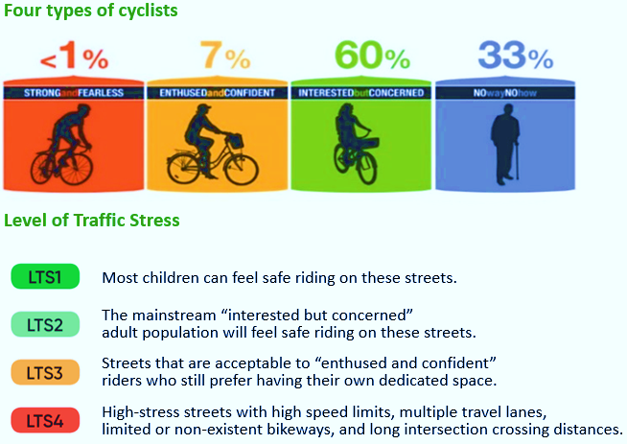

Facilities that are consistent with a Safe System approach are more attractive and address perceived safety concerns and therefore encourage a larger proportion of the population to ride or walk more regularly for more trip purposes.
This does not generally include on-road bicycle lanes (e.g. line marking only), as separation of vulnerable road users (such as bike riders and pedestrians) from motor vehicles is preferred in most cases and is required for roads that carry higher traffic volumes – refer Figure 2.

Figure 2 – Separation of bike riders and motor vehicles along preferred bicycle routes

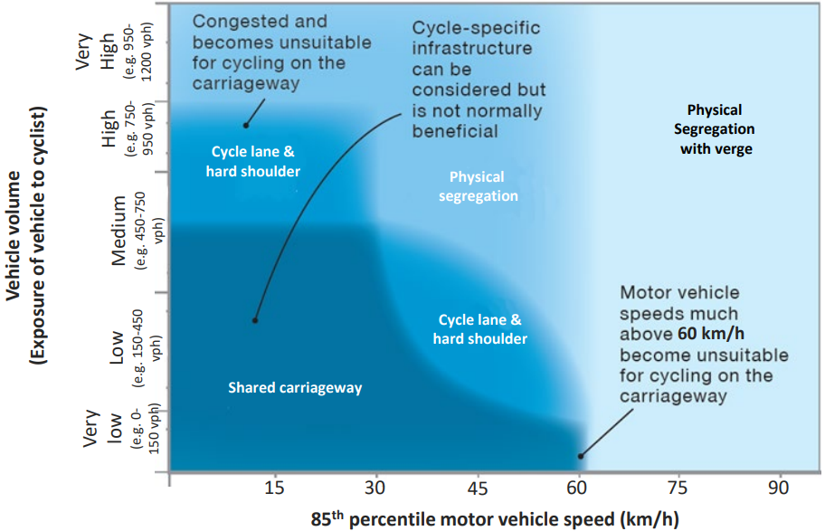

If separation isn’t practicable (e.g. at road crossings and/or property accesses) then the target operating speed of the motor vehicle within the conflict area should not be greater than 30 km/h – refer Figure 3 (preferably 20 km/h – refer Figure 4).

Figure 3 – Relationships between a motorised vehicle collision speed and probability of a fatality for different crash configurations

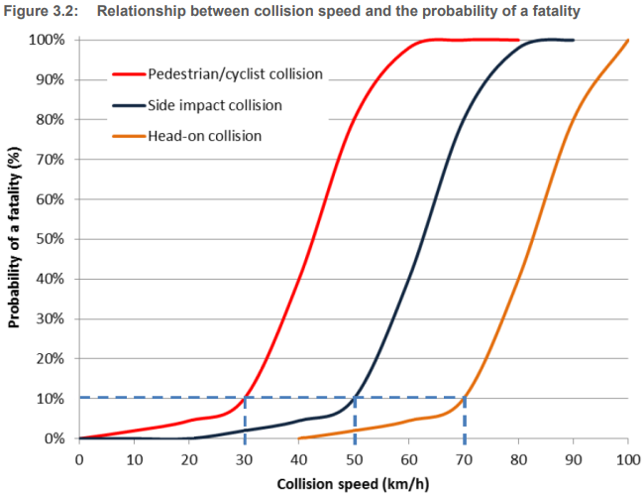

Figure 4 – Probability of serious injury versus bullet vehicle impact speed in different crash types
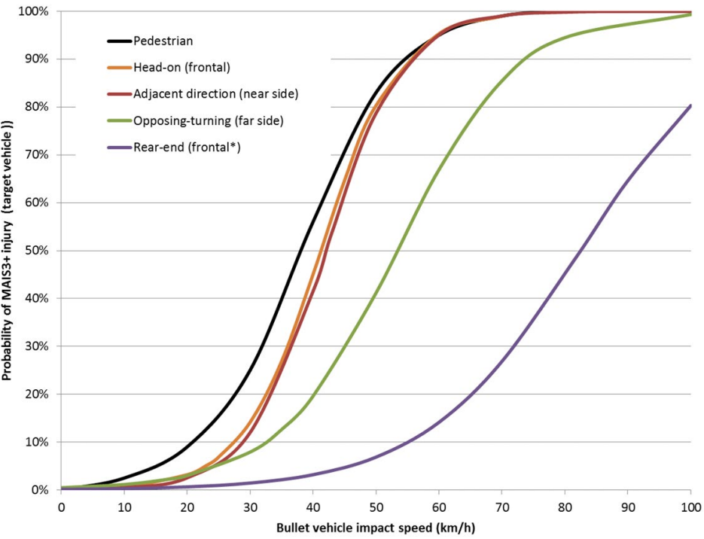
Achieving comfortable, low-stress and safe travel by bike is typically achieved through adoption of the following facilities:
- Stand-alone bikeway/cycleway – physically separated by wide verge, grade separation and/or independent of adjacent infrastructure;
- Separated path (cycle track)/s – physically separated by verge and/or kerb (bicycle path alongside footpath);
- Protected on-road bicycle lane/s – separated/delineated by separation devices and provision of conflict protection through turning movement speed management/restrictions at intersections/accesses;
- Cycle street – low volume local access roads with speed management devices;
- Raised priority crossing/s;
- Shared path/s (with low pedestrian volume) – preferably at least 3.0 m wide.

Whilst not an exhaustive list, applicable reference documents related to the above bicycle facilities are summarised in the references at the end of this document. Alternative standards, guidelines and innovative treatments not covered by the reference documents will be assessed by ATIP on a case-by-case basis in consultation with TMR’s Engineering and Technology Branch.

The following treatments for bicycle infrastructure are not typically supported by the ATIP:
- Bicycle Awareness Zone/s;
- Part-time bicycle lanes;
- On-road bicycle lanes without separation devices (unless the exclusion of separation devices is supported by relevant guideline/s and justifiable on engineering grounds); and
- Shared path/s less than 3.0 m wide (without justification).

Physical separation from motorised traffic assists in improving perceived and actual safety issues in road environments with higher traffic speeds and volumes. Physical separation can be achieved by:
- “hardening” a bicycle lane with a physical device, refer Queensland Guide to Traffic Management (QGTM) Part 10 – Physical separation devices for protected bicycle lanes and cycle tracks guideline (Jul 2025);
- establishing a Cycle Track, refer TMR’s Selection and design of cycle tracks guideline (Jul 2025); or
- establishing a bicycle path (incorporating priority crossing/s to maintain safety and directness).

Recommended bicycle lane widths for the ATIP are outlined in Table 1. Minimum width bicycle lanes should only be considered at localised constrictions such as drainage grates or where significant constraints restrict relocation of the kerb line.

Bicycle lane set out shall be based on the alignment of the adjacent traffic lane, not the kerb alignment.

Urban traffic lanes may need to be marked less than 3.5 m wide in order to establish a bicycle lane. There is limited evidence to support wide traffic lanes in urban areas. Refer to TMR’s RPDM Edition 2 Volume 3 Supplements to Austroads Guide to Road Design Parts 1, 3 and 4A (formerly RPDM and Guidelines for road design on brownfield sites) for further detail.

Table 1: Recommended Bicycle lane widths for ATIP projects (Based on AGRD Part 3, Table 4.18, Feb 2021)
Posted speed limit | Recommended Width for ATIP projects^{Note1} | Reference
30 km/h or less | Consider active street priority, such as a Cycle Street | TRUM Volume 1 Part 8
50 km/h | 2.0 m (physical separation^{Note 2} possible) | QGTM Part 10 – Physical separation devices for protected bicycle lanes and cycle tracks guideline
60 km/h or 70 km/h | 2.0 m with physical separation | QGTM Part 10 – Physical separation devices for protected bicycle lanes and cycle tracks guideline
80 km/h or higher | 2.0 m with physical separation, or bike path (separated bikeway) | QGTM Part 10 – Physical separation devices for protected bicycle lanes and cycle tracks guideline
Note 1: At localised constrictions/constraints, or where justified in constrained areas, narrower facility width/s are to be determined in accordance with TMR’s Selection and design of cycle tracks guideline.
Note 2: Along very low volume and constrained streets without on-street parking, physical separation may not be required.

4.2 Bicycle lanes and on-street parking
When on-street car parking is reduced, arterial roads have improved safety and reduced motor vehicle congestion, and generally allow room for the separation of moving vehicular traffic from people riding. Furthermore, provision of additional paths and crossings enables parking in side roads and safe walking access to destinations.

Alternatively locating a separated bicycle lane kerbside with vehicle parking adjacent is an efficient method to protect people riding bikes from moving vehicular traffic. This lane configuration provides a safe full-time facility for people riding bikes, as well as enabling clearway operation and off-peak parking to provide for motor vehicle capacity when needed. For more detail refer TMR's Selection and design of cycle tracks (Jul 2025) guideline and Figure 4.41 in Austroads' Guide to Road Design Part 3: Geometric Design (Feb 2021).

4.3 Intersections
ATIP priorities for providing for pedestrians and bike riders at intersections are safety, directness and comfort. This is often addressed by providing priority for people riding bikes riders and pedestrians at intersections.

Designing to ensure appropriate vehicle speeds so that people are not exposed to crash forces that would lead to fatal and serious injury outcomes is very important and is consistent with the Safe System approach.

The following TMR guidelines should be referred to for further information:
- Selection and design of cycle tracks (Jul 2025), Section 4 provides comprehensive guidance on a variety of intersection treatments.
- Raised priority crossings for pedestrians and cycle paths (Sep 2025) provides guidance for shared path crossings at side roads, roundabouts, and slip lanes. Furthermore, in locations of high demand, near key destinations or with a high-proportion of vulnerable users (such as children), raised priority crossings should be considered to maintain priority for those walking and riding.
- RPDM Edition 2 Volume 3 Supplement to Austroads Guide to Road Design Part 4B: Roundabouts (Jul 2025), Section 5 provides further guidance for treatment/s at roundabouts (as does the Providing for People Walking and Riding at Roundabouts guideline, Aug 2020).
- https://www.tmr.qld.gov.au/Safety/Road-safety/Road-Safety-Policy. Where slip lanes must be retained (removal preferred), wombat (raised zebra) crossings are expected to be installed, refer Section 2.6.3 in Raised priority crossings for pedestrians and cycle paths (Sept 2025) and TMR's RPDM Edition 2 Volume 3 Supplement to AGRD Part 4 (Jul 2025). Treatments other than a wombat crossing which are proposed for ATIP funded projects will only be considered in exceptional circumstances with appropriate engineering justification.

Minimising changes in grade from verge/island level to road level and vice versa benefits all active transport users, including people with disabilities. Crossing solutions that remove the need for people to navigate kerb ramps (whilst providing an appropriate tactile cue, e.g. TGSI) are desirable for ATIP funded projects.

4.4 Drainage and utilities
Drainage is an essential design component to ensure road and path longevity and safety. Guidance relating to drainage design is covered in TMR’s RPDM Edition 2 Volume 3 Supplement to AGRD Part 5 (Jan 2024), Part 5A (Jan 2024), Part 5B (Aug 2025) and Part 6A (Jul 2025).

Field inlets, cross drainage and/or seepage management may need to be considered to prevent paths being submerged during rainfall and reduce collection of debris on the path, slip resistance issues and ongoing maintenance.

Where transverse drainage may impact path user safety, flow depth and velocity checks should be undertaken at transverse drainage locations.

Where facilities are proposed adjacent to or within a drainage channel, special considerations for both the minor and major storm event are required – these will be considered by ATIP on a case-by-case basis as required.

Metal surfaces in the travelled way can be a slip resistance safety issue for people riding bikes. The ATIP suggests that covers located in the travelled way provide equivalent slip resistance to surrounding surfaces in all weather conditions and suggests the same be considered for covers within 1.0 m of the travelled way. Concrete infill covers are a good way to ensure durable slip resistance.

Drain grates and utility covers should comply with Australian Standard 3996 Access Covers and Grates and non-compliant gully grates should be replaced.

Where possible, new gullies in urban areas should be recessed into the kerb to allow the grate to line up with the lip of channel (i.e. lip in line rather than kerb in line). Preferably recessed gullies will also not impact upon adjacent path width.

Where bicycle lanes are retrofitted on streets with encroaching grates, adoption of minimum bicycle lane width as per Table 1, immediately adjacent the grate/s may be acceptable (bike/heel safe grate requirements remain, as applicable). Existing stormwater gullies could also be reconstructed to reduce grate interaction with the bicycle lane.

5. Off-road requirements

5.1 Land use and path provision for walking
If the project is providing a path/s to fulfill a WNP only, refer to Table 2.
Table 2: Land use and recommended footpath provision for walking ^{Note 3}
Land use | New roads – Preferred | New roads – Minimum | Existing roads – Preferred | Existing roads – Minimum
Commercial and industrial | Both sides | Both sides | Both sides | Both sides
Residential (on arterial or collector roads) | Both sides | Both sides | Both sides | Both sides
Residential (on local streets) | Both sides | Both sides | Both sides | One side
Three to ten dwellings per hectare | Both sides | One side | One side | Shoulders on both sides
Fewer than three dwellings per hectare | One side | Shoulders on both sides | One side | Shoulders on both sides
Note 3: Based on Table C1 2 in Austroads Guide to Road Design Part 6A: Paths for Walking and Cycling (Feb 2021)

5.2 Path intersections and widths
Intersections of paths (including intersections of paths near crossings and kerb ramps) shall include 2.5 m corner radii or a chamfer of equivalent size – refer Figure 5.

Figure 5 – Corner radii for path intersections
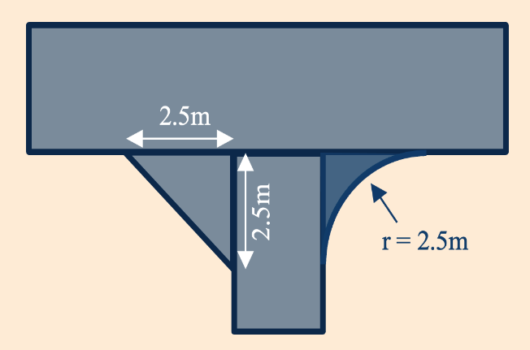

5.2.1 Bike infrastructure path widths
To achieve the program intent for bike riding infrastructure, key path design criteria are set out in Table 3.
Table 3: Key shared path design criteria for ATIP projects
Path design criteria | Desirable value | Minimum value | Rationale
Width (m) | 3.0^{Note 4} | 2.5^{Note 5} | 3.0 m wide paths have 50% greater capacity than 2.5 m wide paths and generate fewer path user complaints and interaction issues.
Design speed on midblock level grade (km/h) | 30 | 25^{Note 6} | Appropriate for commuter use. Design speed variance should consider gradient/s and intersection priority.
Note 4: Minimum value for stand-alone treatments along major roads.
Note 5: Justification is required for adoption of 2.5m rather than desirable 3.0m.
Note 6: Where justified in constrained areas, a lower minimum design speed may be considered.
A reduction in these design criteria values may be considered at localised constraints such as significant poles or structures but this must be explicitly documented as to why a better facility standard cannot be achieved.

Provision of paths both sides of urban arterial and collector roads may provide a case for reduced path widths when co-located with cycle tracks or bicycle lanes.

Where a significant number of people walking and bike riding are expected, a separated path (cycle track) may be required to maintain an appropriate level of service. TMR's Selection and design of cycle tracks (Jul 2025) guideline provides additional guidance on separated paths and path treatments at intersections with side streets.

5.2.2 Walking infrastructure path widths
If the project is providing infrastructure to fulfill a WNP only, refer to Table 4
Table 4: Minimum footpath widths by predicted use ^{Note 7}
Predicted pedestrian use | Minimum clear through route width for pedestrians | Scenario and context
Medium use | 2.0m - 3.0m | - In walk-up catchment of a public transport station  - Near medium density residential areas  - Near small to medium sized schools  - Small to medium local shopping areas  - Passing of wider wheeled devices can occur within footpath width but walking in a group is uncomfortable.  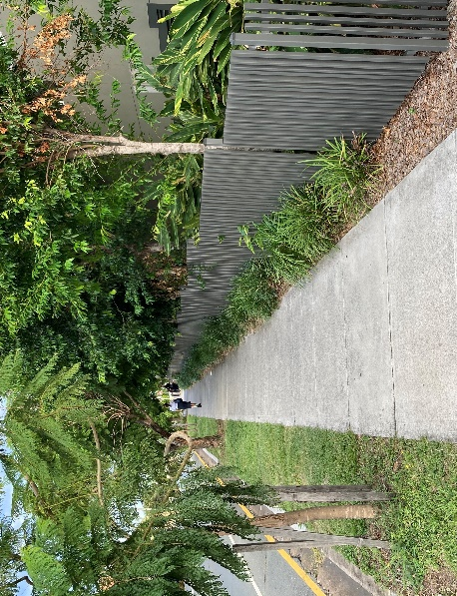
Medium-High use | 3.0m+ | - Near to public transport stations  - Medium to large commercial and shopping areas  - Large metropolitan central city streets  - Near to large schools  - Passing of wider wheeled devices can occur within footpath width and group walking is anticipated. If walking in groups is expected, 4.0m is desirable.  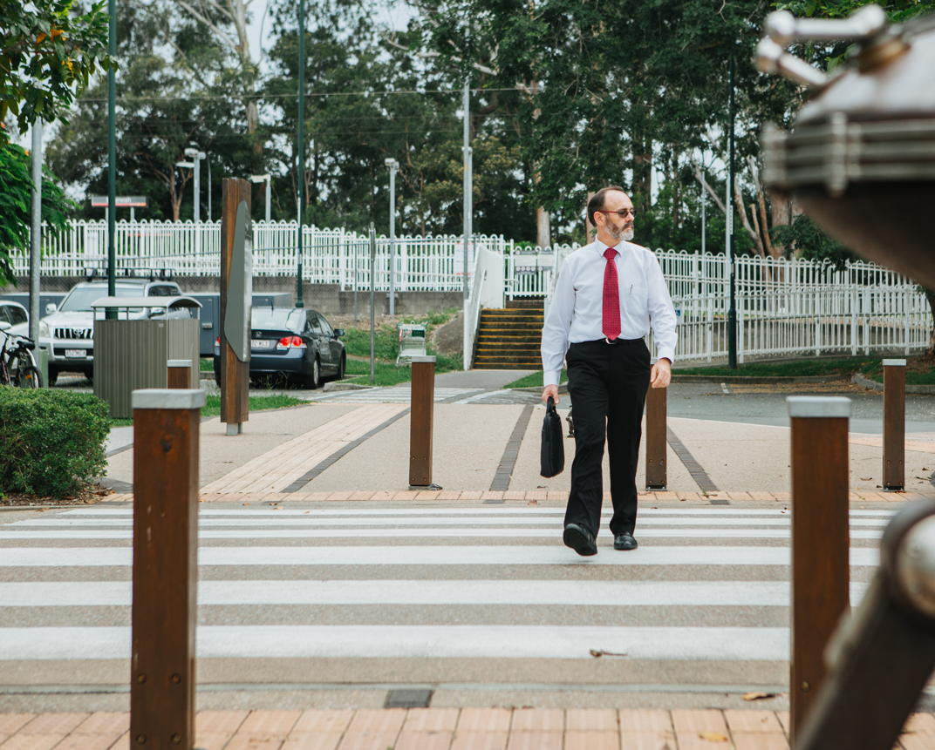

Note 7: Adapted from IPWEA Street Design Manual, Part 2 Detailed Design Guidelines (2020) and TfNSW Walking Space Guide Summary Version 2, 2020. TMR images.

5.3 Path sight lines
Path corridors must be designed to provide appropriate unobstructed sight lines. Intersection visibility splays and visibility requirements for two-way paths must be considered in addition to other general visibility checks.

5.4 Path joints
Where an existing path is to be widened, longitudinal joints in paths are only to be considered where a physical divider, such as a kerb, can be used to cover this joint.

Transverse joints shall be designed to be smooth; this is usually achieved through sawcut joints or using a proprietary jointing system. Tooled joints are not acceptable.

Where possible, pathways should be positioned so they are clear of the roots of established trees. In constrained locations where paths will be within the root zone of trees, pathway joint systems between slabs should be used to minimise any displacement of slabs that could form a hazard. Refer TMR’s TN197 Provision of shade along paths (Jul 2021) for root zone considerations.

5.5 Path pavement marking and signs
Wayfinding signage is desirable to encourage and orient new users. Refer TMR’s guideline Wayfinding and signage for people walking (Dec 2020).

Pavement marking should be easily identifiable. Where a warning colour is used at an intersection with another path, crossings or driveway, green surfacing shall only be used on a path designated “Bicycle Only”. Green surfacing is not to be used on shared paths. Coloured surface treatments should be used sparingly. Other treatments such as exposed aggregate surfacing may offer enough visual and tactile differentiation at a lower whole-of-life cost.

Pavement marking of some signs may be used in lieu of vertical signs, which can reduce sign clutter and may improve sign visibility for path users.

Shared path signage is not necessary as Queensland Road Rule 250 permits people to ride on footpaths – refer also TMR's Queensland Manual of Uniform Traffic Control Devices Part 9: Bicycle facilities (Jul 2024).

5.6 Path and driveway conflict/s
Paths intersecting driveways shall be constructed to provide a smooth joint between the two facilities using measures to control joint displacement such as dowels or other proprietary devices.

Where existing driveways do not meet the cross-fall requirements of proposed shared paths, they should be reconstructed to join smoothly to the pathway grade and cross-fall. Where driveways are being installed or reconstructed, the kerb crossing should not include a vertical lip at the invert.

Sight lines between drivers entering or exiting driveways, and path users should also be provided. On commercial driveways, further treatments such as road humps are usually required to reinforce low vehicle speeds and path priority.
Driveways should be visually delineated to maintain the appearance of the path being continuous through the driveway.

5.7 Objects adjacent to paths
A 1.0 m clearance should be provided from the edge of the rideable surface of any bike facility or shared path to any potentially hazardous object adjacent to the path/facility. Fencing, balustrades and vegetation should be placed to ensure unobstructed sight lines are available.

Selection of vegetation adjacent to paths should consider the effects of leaf, seed and other plant debris on path slip resistance and maintenance. Planting of vegetation adjacent to paths must ensure clearances and sight lines are easily maintained as the planting matures.

Designing to minimise the extent of fencing is recommended. Landscaping or low shrubbery (up to 0.5 m high) is a desirable alternative to fencing in many situations.

Fencing is intended to protect path users from hazards however it does not necessarily need to follow the edge of path. For example, fencing the headwall and wings of a culvert protects path users from the hazard while maximising clearance to the path. Fencing constructed directly adjacent to the path shall incorporate flared terminals, refer TMR Fencing and edging treatments for cycling infrastructure (Feb 2019) guideline for details and Figure 6.

Figure 6 – Fence alignment at drainage/creek crossing
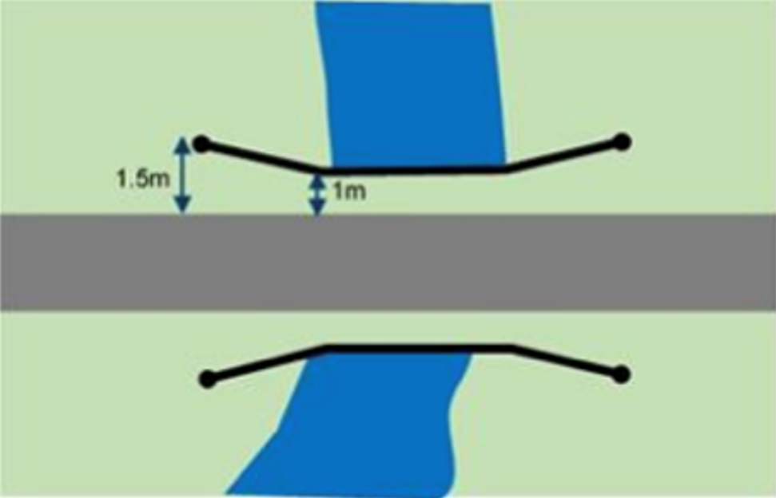
Fencing incorporating vertical bars is not considered smooth. Rub rails are not considered an effective mitigation measure, as varying rider heights reduce their ability to prevent contact with the vertical elements of the fence. Fence types with openings of 20 mm or less are considered to have smooth features. Smaller apertures are more desirable and may be required if anti-climb features are required. The smoothest side of fence products should face towards the path such as in Figure 7.

Figure 7 – Closely spaced mesh fencing
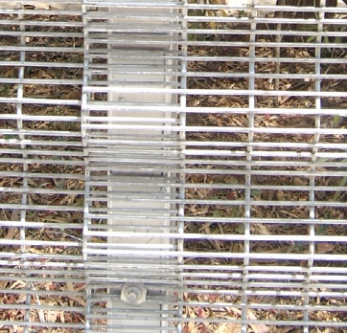
Fencing with continuous smooth profiles eliminates the need to consider an offset top rail on bicycle paths as handlebars and pedals will not be caught on the tightly spaced horizontal wire. This should also have the benefit of reducing the cost of the fencing. This security mesh (e.g. 358 anti-climb mesh) can also be formed with the edges rolled at the top and bottom to further increase strength and remove the need for top or bottom rails. Figure 6A-1 in TMR's RPDM Edition 2 Volume 3 Supplement to Austroads Guide to Road Design Part 6A: Paths for Walking and Cycling (Jul 2025) notes the projecting deflection rail is not required when snag-free infill panels are provided. This is the preferred full barrier fencing style on ATIP projects.

There is often a need for fencing of pathways across bridges, particularly where pathways pass close to the back of guardrail. If guardrail is located within 1.0 m of the path edge it is to be treated to minimise path user collision severity. If adopted, fencing needs to be designed to ensure it does not interfere with guardrail effectiveness in the event of a motor vehicle collision, and/or guardrail type selected/modified to minimise risk of impact with fencing. The path should diverge away from the guardrail as soon as practicable to minimise the amount of path with clearance constraints and the need for fencing.

5.8 Shade provision
For comfort and attractiveness and to increase the shade and cooling effect for walking and riding environments, planting of mature trees should be considered, with canopies above/outside sightlines and 2.5 m vertical clearance for riders. Refer to TMR’s TN197 Provision of shade along paths (Jul 2021) for details on providing one tree per 15 m along paths.

5.9 Access management
Access management devices such as bollards and fencing deflection rails shall not be used to generate slow points or force riders to dismount to safely navigate through the treatment.

Access management treatments at path terminals should not be considered unless there is infrastructure along the pathway, such as lightweight bridges, that could be damaged by unauthorised access by a motor vehicle and no alternative solution is available. Where access management devices are required, they shall be placed in the safest location possible (for example, in a visible location clear of curves and steep grades) and be implemented to maintain path capacity and minimise conflict between path users. The clear opening width shall be not less than 1.6 m and approach delineation shall be marked from 5-10 m on approach to any potentially hazardous feature.

Protection of structures from authorised motor vehicle access can potentially be managed by load limit signage, subject to local authority management.

Appendix C in TMR's QGTM Part 6: Intersections, Interchanges and Crossings Management (2020) (Nov 2024) provides further guidance on safe vehicle restriction treatments for bicycle paths and shared paths.

5.10 Shared path longitudinal grade
TMR’s RPDM Edition 2 Volume 3 Supplement to Austroads Guide to Road Design Part 6A: Paths for Walking and Cycling (Jul 2025) and Austroads Guide to Road Design (AGRD) Part 6A: Paths for Walking and Cycling (Feb 2021) (AGRD Part 6A) provide guidance on bike path and shared path longitudinal grade.

With respect to shared path/s, Section 5.4, Section 5.4.1 and Table 5.8 in AGRD Part 6A reference AS 1428.1 (Jun 2021). Accordingly, AS 1428.1 is a relevant reference document for ATIP projects, including shared path/s. This design approach is consistent with:

- the requirements of the Disability Discrimination Act (DD Act);
- guidance from the Australian Human Rights Commission (AHRC) that advises “premises” should be read to include “streetscapes”, which includes “public footpath” – refer Section 3 and Section 8.7 in the AHRC Advisory Note on streetscape, public outdoor areas, fixtures, fittings and furniture, 8 February 2013; and
- TMR’s vision "Connected Communities in a sustainable, thriving and inclusive Queensland" – refer TMR’s Accessibility and Inclusion Strategy.

It is acknowledged that a significant portion of the projects delivered through the ATIP are within brownfield sites (developed areas) and therefore delivering shared path/s accessible to all can in some locations be a considerable challenge. In these instances, it is required that thorough consideration of plausible design solutions be investigated and appropriately documented. It is also recommended these considerations be undertaken in consultation with:
- TMR’s internal Accessible Transport Network team (for TMR projects) and/or relevant local representative group/s; or
- Council’s internal accessibility team and/or relevant local representative group/s (for Council projects).

5.11 Transitions between on-road and off-road facilities
For bicycle route connections, transition ramps should be considered between roadway corridor and off-road corridors. The additional off-road option allows people riding bikes to choose which facility they use based on their confidence and the traffic conditions at the time. Existing single dwelling residential driveways constructed without a vertical lip may function as a transition ramp. For detail on bicycle specific transition ramps refer Austroads Guide to Road Design Part 3: Geometric Design Figure 4.45 (Feb 2021).

6. References
At the time of publication of this ATIP Technical Guidance (v2.0, November 2025), the versions of references listed in the above table were current, however all project teams should refer to and adopt the most recent version/s of any reference document.
Reference and location | Guidance on…
TMR Road Planning and Design Manual (RPDM)  Available at  www.tmr.qld.gov.au | Reduced urban traffic lane widths - Refer to TMR RPDM Edition 2 Volume 3 Supplements to Austroads Guide to Road Design Parts 1, 3 and 4A (formally RPDM and Guidelines for road design on brownfield sites)  Minimum corner radii for path intersections - Section 6.4, TMR RPDM Edition 2 Volume 3 Supplement to Austroads Guide to Road Design Part 6A: Paths for Walking and Cycling (Jul 2025)  Intersection sight-lines (visibility splays) - Figure 6A-2, TMR RPDM Edition 2 Volume 3 Supplement to Austroads Guide to Road Design Part 6A: Paths for Walking and Cycling (Jul 2025)  Visibility requirements for two-way paths - Section 5.7, TMR RPDM Edition 2 Volume 3 Supplement to Austroads Guide to Road Design Part 6A: Paths for Walking and Cycling (Jul 2025)  Projecting deflection rail not required - Figure 6A-1 in TMR RPDM Edition 2 Volume 3 Supplement to Austroads Guide to Road Design Part 6A: Paths for Walking and Cycling (Jul 2025)  Longitudinal grade - Section 5.4 and Section 5.4.1, TMR RPDM Edition 2 Volume 3 Supplement to Austroads Guide to Road Design Part 6A: Paths for Walking and Cycling (Jul 2025)  Roundabout treatments - Section 5, TMR's RPDM Edition 2 Volume 3 Supplement to Austroads Guide to Road Design Part 4B: Roundabouts (Jul 2025)  Road and bikeway lighting - TMR RPDM Edition 2 Volume 6: Lighting (Mar 2021)

Reference and location | Guidance on…
Traffic and Road Use Management Manual (TRUM)  Available at  www.tmr.qld.gov.au | Cycle Streets - TRUM Volume 1 Part 8
TMR Standard Drawings  Available at  www.tmr.qld.gov.au | Kerb ramps – TMR Std Drg No. 1446  Median and island crossing – TMR Stg Drg No. 1447  TGSI installation – TMR Std Drg No. KRG1 and KRG2
Road Safety Policy  Available at  www.tmr.qld.gov.au | Safety Intervention and Improvement Guidelines for TMR projects.
Queensland Guide to Traffic Management (QGTM)  Available at  www.tmr.qld.gov.au | Bicycle lane separation devices - QGTM Part 10 – Physical separation devices for protected bicycle lanes and cycle tracks guideline (Jul 2025)  Vehicle restriction treatments - Appendix C, QGTM Part 6: Intersections, Interchanges and Crossings Management (2020) (Nov 2024)
TMR Options for Designers of Pedestrian and Cyclist Bridges to achieve value-for-money Guideline  Available at  www.tmr.qld.gov.au | TMR supplement to Design Criteria for Bridges and Other Structures Manual
Queensland Manual of Uniform Traffic Control Devices (QMUTCD)  Available at  www.tmr.qld.gov.au | Bicycle Facilities – Part 9
TMR MUTCD Q-series and Traffic Control (TC) signs
Available at
www.tmr.qld.gov.au
TMR Technical Notes and Cyclist and Pedestrian Guidelines  Available at  www.tmr.qld.gov.au | Cycle tracks - Selection and design of cycle tracks (Jul 2025)  Segregated paths - Selection and design of cycle tracks (Jul 2025)  Level of Traffic Stress - Figure 2.2, Selection and design of cycle tracks guideline (Jul 2025)  Intersection treatments - Section 4, Selection and design of cycle tracks (Jul 2025)  Crossings at side roads, roundabouts, and slip lanes – Raised priority crossings for pedestrians and cycle paths (Sep 2025)  Delineated driveways - Treatment options to improve safety of pedestrians, bicycle riders and other path users at driveways guideline (Feb 2021)  Fencing and edge treatments - Fencing and edging treatments for cycling infrastructure guideline (Feb 2019)  Pedestrian demand forecasting – Pedestrian Demand Forecasting Guideline and Tool (Feb 2021)  Shade near paths – Technical Note 197 Provision of shade along paths (Jul 2021)  Wayfinding – Wayfinding and signage for people walking guideline (Dec 2020)  Roundabout treatments – Providing for people walking and riding bikes at roundabouts (Aug 2020)
Queensland Road Rules [Transport Operations (Road Use Management—Road Rules) Regulation 2009]  Available at  www.legislation.qld.gov.au | Shared paths - Rule 250  Road-related area – Rule 13  Bicycle lanes – Rule 153  Special purpose lanes – Rule 158
Street Design Manual  Available at  www.ipwea-qnt.com | Recommended footpath provision for new developments - IPWEA Street Design Manual, Part 2 Detailed Design Guidelines.
TfNSW Walking Space Guide  Available at  www.standards.transport.nsw.gov.au | - Walking path widths  - Walking Space Guide summary, Table 1, version 2
Disability Discrimination Act  Available at  www.legislation.gov.au | - Accessibility requirements of the Disability Discrimination Act
Australian Human Rights Commission (AHRC) Guidance  Available at  www.humanrights.gov.au | - Accessible streetscapes – Section 3 and Section 8.7, AHRC Advisory Note on streetscape, public outdoor areas, fixtures, fittings and furniture (8 February 2013)
Austroads Guides to Road Design, Traffic Management and Road Safety  Available at  www.austroads.com.au | Relationship between speed and injury - Figure 2.1, Austroads Guide to Road Safety Part 2: Safe Roads (Jul 2021) [and Figure 2.4 in Austroads' Guide to Road Safety Part 2: Safe Roads (Jul 2024)]  Path joints - Figure C 4, Austroads Guide to Road Design Part 6A: Paths for Walking and Cycling (Feb 2021)  Longitudinal grade – Section 5.4, Section 5.4.1 and Table 5.8, Austroads Guide to Road Design (AGRD) Part 6A: Paths for Walking and Cycling (Feb 2021)  Physical separation - Figure C9 1, Austroads Guide to Traffic Management Part 4: Network Management Strategies (Apr 2020)  Bicycle transition ramps - Figure 4.45, Austroads Guide to Road Design Part 3: Geometric Design (Feb 2021)
Australian Standards  Available at  www.saiglobal.com | Access Covers and Grates - AS 3996  Design for Access and Mobility – AS 1428.1  Tactile Ground Surface Indicators (TGSI) – AS 1428.4.1  Lighting for roads and public spaces - AS 1158 (including AS 1158.0, AS 1158.1.1, AS 1158.1.2, AS 1158.2, AS 1158.3.1, AS 1158.4 and AS 1158.5)

https://www.tmr.qld.gov.au/Safety/Road-safety/Road-Safety-Policy
In many instances paths are also used by people riding wheeled recreational devices (WRDs), motorised mobility devices (MMDs) and/or personal mobility devices (PMDs). People using these devices are valid path users, their utility, size, speed and interaction with other path users should be considered during infrastructure design.
Projects that provide only minimum provisions for bike riders rather than good practice are unlikely to be competitive for funding.
Refer Figure 2.2 in TMR’s Selection and design of cycle tracks guideline (Jul 2025)
Refer Figure C9 1 in Austroads’ Guide to Traffic Management Part 4: Network Management Strategies (Apr 2020)
Refer Figure 2.1 in Austroads’ Guide to Road Safety Part 2: Safe Roads (Jul 2021) [and Figure 2.4 in Austroads' Guide to Road Safety Part 2: Safe Roads (Jul 2024)]
Refer Figure 2.2 in Austroads’ Guide to Road Safety Part 2: Safe Roads (Jul 2021) [and Figure 7.1 in Austroads' Guide to Road Safety Part 2: Safe Roads (Jul 2024)]
Refer Section 6.4, TMR RPDM Edition 2 Volume 3 Supplement to Austroads Guide to Road Design Part 6A: Paths for Walking and Cycling (Jul 2025)
Refer Section 5.1, TMR RPDM Edition 2 Volume 3 Supplement to Austroads Guide to Road Design Part 6A: Paths for Walking and Cycling (Jul 2025)
Refer Figure 6A-2, TMR RPDM Edition 2 Volume 3 Supplement to Austroads Guide to Road Design Part 6A: Paths for Walking and Cycling (Jul 2025)
Refer Section 5.7, TMR RPDM Edition 2 Volume 3 Supplement to Austroads Guide to Road Design Part 6A: Paths for Walking and Cycling (Jul 2025)
Refer Figure C 4, Austroads Guide to Road Design Part 6A: Paths for Walking and Cycling (Feb 2021)
Refer Part 9, Queensland Manual of Uniform Traffic Control Devices (Jul 2024)
Refer TMR Treatment options to improve safety of pedestrians, bicycle riders and other path users at driveways guideline (Feb 2021)
Refer TMR Treatment options to improve safety of pedestrians, bicycle riders and other path users at driveways guideline (Feb 2021)
Refer TMR Treatment options to improve safety of pedestrians, bicycle riders and other path users at driveways guideline (Feb 2021)
https://www.legislation.gov.au/C2004A04426/latest/text
https://humanrights.gov.au/our-work/disability-rights/publications/advisory-note-streetscape-public-outdoor-areas-fixtures
https://www.tmr.qld.gov.au/About-us/Our-organisation/Accessibility-and-inclusion
Refer Section 5.4, TMR’s RPDM Edition 2 Volume 3 Supplement to Austroads Guide to Road Design Part 6A: Paths for Walking and Cycling (Jul 2025); TMR's RPDM Edition 2 Volume 3 Supplement to Austroads Guide to Road Design Part 1 (formally RPDM and Guidelines for road design on brownfield sites); and the DD Act; for further detail.

