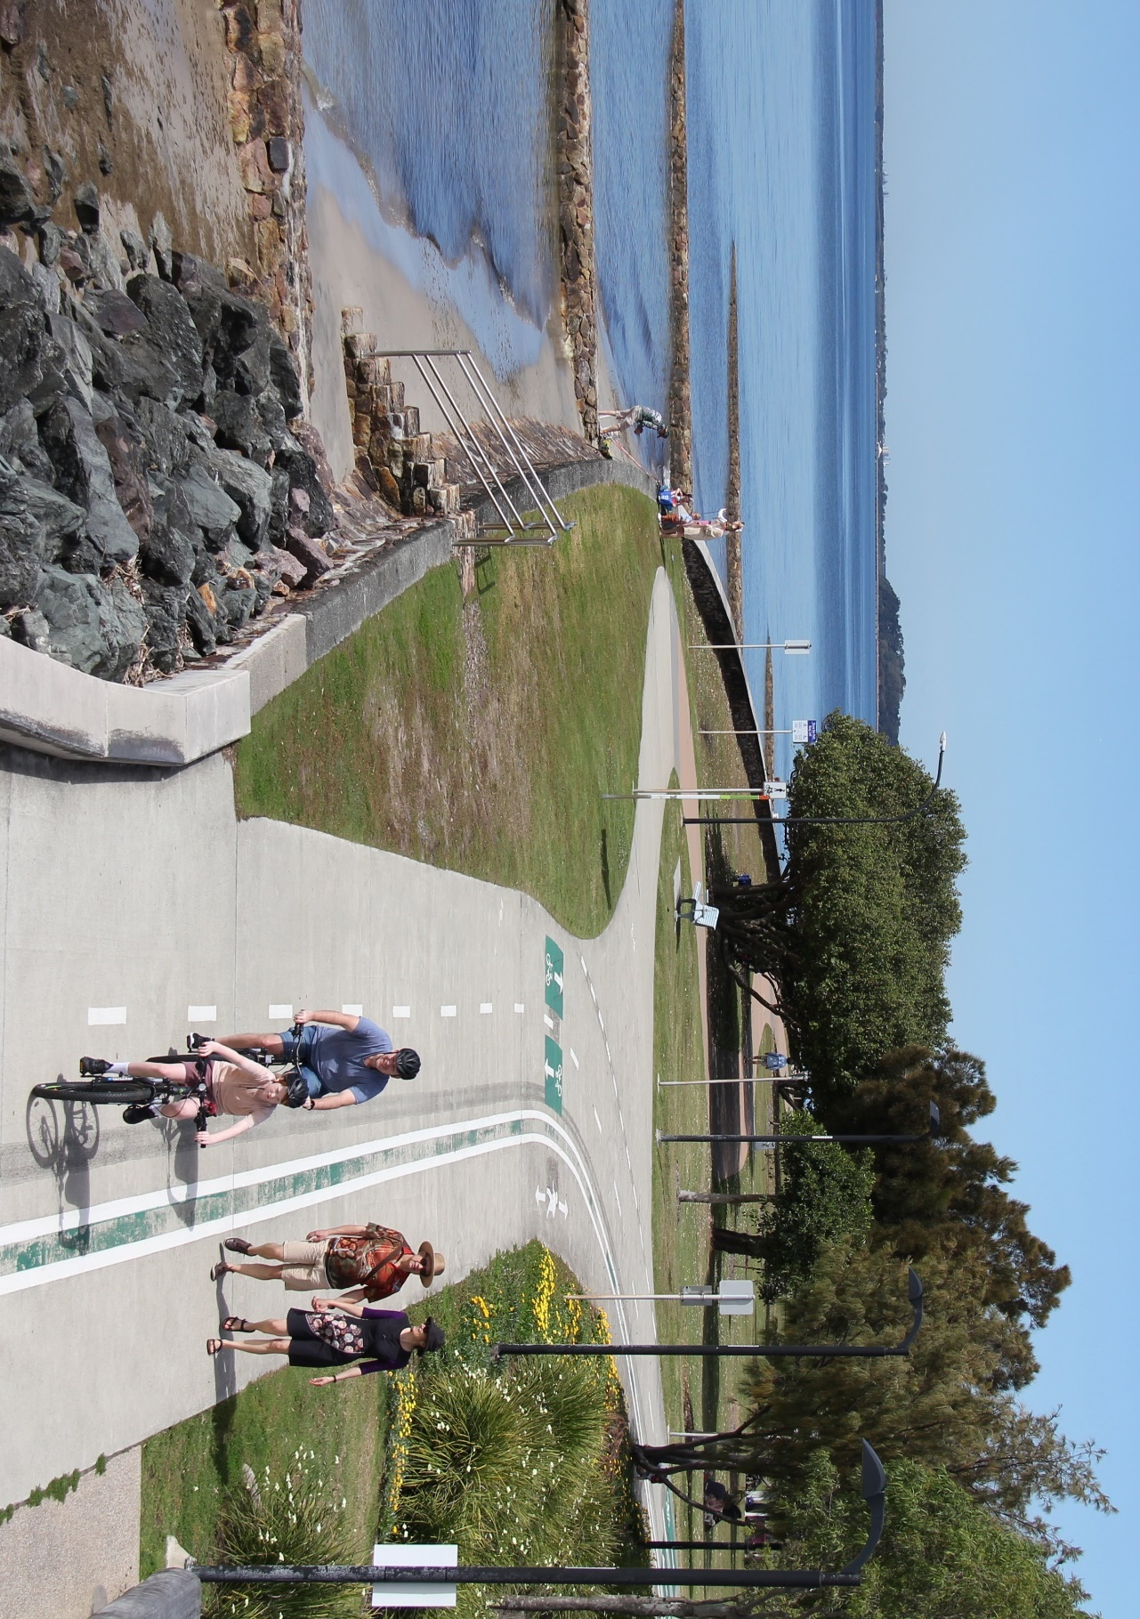


Moreton Bay Cycleway

Masterplan Summary
February 2024

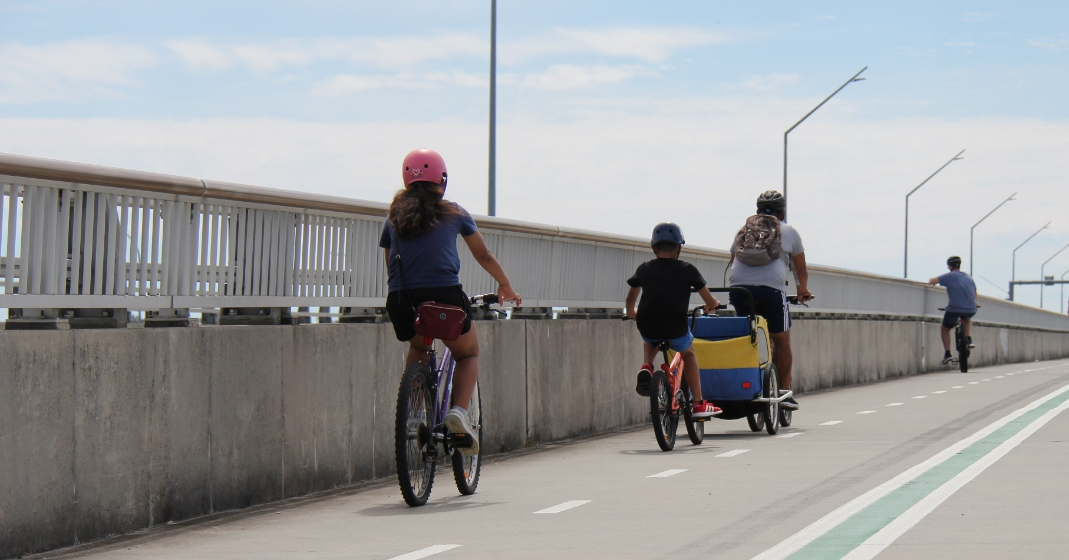

Vision

‘A scenic coastal path that showcases the natural beauty, history and very best experiences that the Moreton Bay coastline has to offer.’

Guiding principles

- Accessible
- Connected
- Healthy
- Journey
- Place
- Safe
- Scenic
- Shared

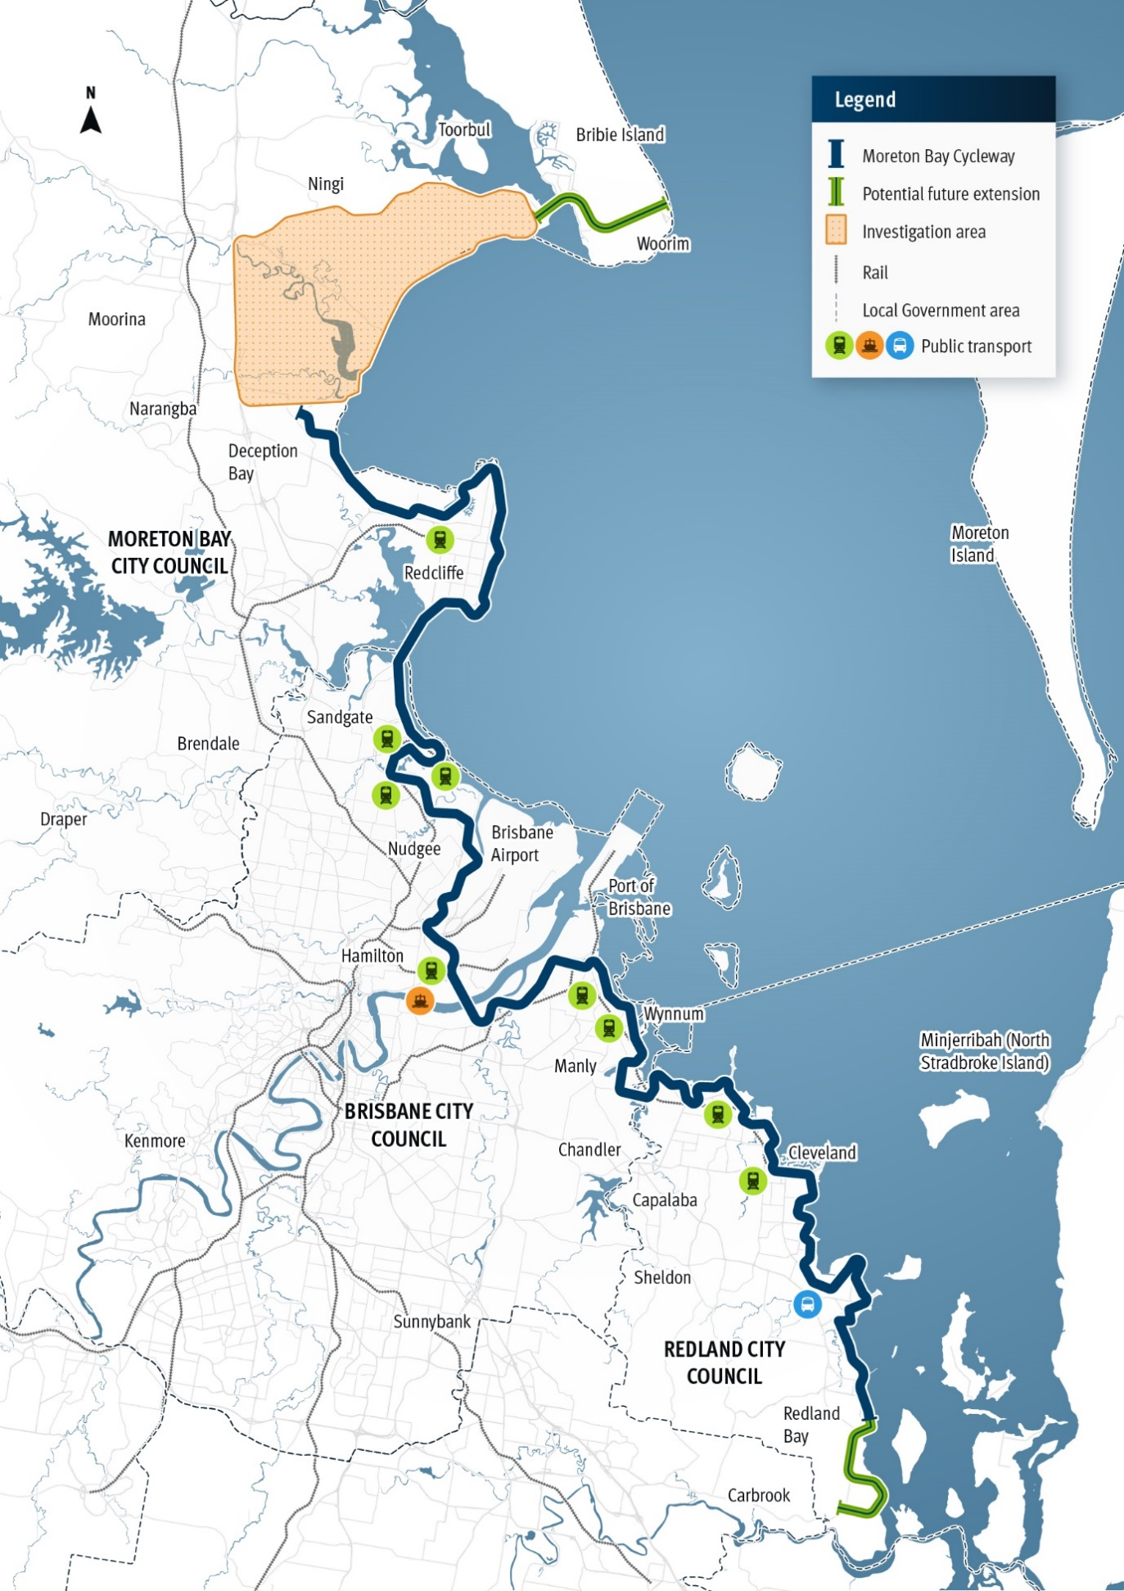



The Moreton Bay Cycleway

The Moreton Bay Cycleway
Spanning from Deception Bay to Redland Bay, the Moreton Bay Cycleway (MBC) travels along some of South East Queensland’s most stunning coastline, linking the region’s fastest growing communities.

The 150km MBC connects many of the region’s major attractions, including the Redcliffe Peninsula, Sandgate / Shorncliffe foreshore, Wynnum / Manly foreshore and Redland Bay. The MBC could also be extended to connect to Bribie Island in the north, and further south in Redland Bay – linking up to 200km of coastline.

The opportunity
The natural beauty of the MBC, and its proximity to major urban areas, presents a significant opportunity to attract more visitors to the region. By providing access to the wetlands, bay and islands, the MBC can facilitate increased day trips and overnight visits to generate benefits for local businesses.

Because the MBC already provides a vast range of experiences, there is an opportunity to promote those experiences now, while working to transform the MBC into a holistic, connected ‘experience’ that locals and visitors can enjoy.

There is a lucrative national market for bicycle tourism experiences (estimated at around $1.95 billion a year) and significant latent demand for bicycle tourism products like the MBC. Queensland Government research identified that half day, whole day and multi-day off-road trails offering great bicycle tourism experiences all have strong market appeal.

The masterplan
Since its original conception in 2003, the MBC has been progressively developed through partnership between state and local governments.

In recognition of the potential opportunities the MBC presents, and the important role it plays in the local area and regional tourism profile, key partners including the Department of Transport and Main Roads (TMR), Moreton Bay City Council (MBCC), Brisbane City Council (BCC) and Redland City Council (RCC) actively contributed to the development of the MBC masterplan.

Other stakeholders have been consulted including the Department of Tourism and Sport (DTS), Tourism and Events Queensland (TEQ), Brisbane Economic Development Agency (BEDA) and Bicycle Queensland (BQ).

The masterplan explores the best ways to optimise the MBC route, and provide a consistent, fit-for-purpose connection that meets the demand and expectations of a wide variety of people and offers a wide range of experiences.

The masterplan does this through a review of the existing condition of infrastructure, outlining suggested infrastructure improvements and alignment-wide initiatives, as well as highlighting the next steps in terms of delivery.

Ultimately, the masterplan will be used by local and state agencies as a blueprint for the future planning, delivery and operation of the MBC.

The masterplan has been informed by four working papers that explored the MBC vision, opportunities to enhance the visitor experience, infrastructure improvements to improve safety and connectivity and wayfinding and other alignment-wide initiatives that should be implemented.

Next steps
As the MBC spans three local government areas, travels along state and local government-controlled roads, plays a key role in the regional tourism profile, and is a significant active transport connection in South East Queensland, a collaborative cross-government and industry approach is needed to deliver the masterplan.

The successful implementation of this masterplan is dependent on effective delivery and governance mechanisms. An interagency MBC coordination group will be established to support stakeholders to work together to progress MBC initiatives.

The coordination group will enable development of a consistent approach to branding, marketing, wayfinding and interpretive signage, ensuring consistency across infrastructure treatments and implementation of alignment-wide initiatives.

It will also enable effective coordination and efficient allocation of funding to deliver on agreed priorities.

The coordination group will be led by TMR, and includes members from BCC, DTS, MBCC, RCC and TEQ. Other stakeholders will also be consulted on a project-by-project basis (including Traditional Owners, and advocacy groups such as BQ, BEDA, local businesses and community members).

Source: Bike Tourism in Queensland – Research Report, Department of Transport and Main Roads, 2022

