Accessible Electric Vehicle Charging Guidelines
Guidance for government and business

Copyright information
© State of Queensland (Department of Transport and Main Roads) 2024.

The Queensland Government is committed to providing accessible services to Queenslanders of all cultural and linguistic backgrounds. If you have difficulty understanding this publication and need a translator, please call the Translating and Interpreting Service (TIS National) on 13 14 50 and ask them to telephone the Queensland Department of Transport and Main Roads on 13 74 68.

Disclaimer
While every care has been taken in preparing this publication, the State of Queensland accepts no responsibility for decisions or actions taken as a result of any data, information, statement, or advice, expressed or implied, contained within. To the best of our knowledge, the content was correct at the time of publishing.
Contact us for alternate accessible formats via email at zevstrategy@tmr.qld.gov.au.

Acknowledgement of Country
The Department of Transport and Main Roads (TMR) acknowledges the Traditional Owners of the lands and waterways. We also acknowledge their ancestors and Elders both past and present. The Department of Transport and Main Roads is committed to reconciliation among all Australians.

Artwork: ‘Travelling’ by Gilimbaa
Table of Contents

Our commitment to accessibility 1
About this document 1
Application 2
How can I apply this to my project? 2
Moving around the site 3
Location 3
Parking bay 3
Surfaces 4
Bollards 5
Signage 5
Shading 6
Using the charger 8
Circulation space 8
Reach 9
Cables 10
Handles 10
Where to next? 10
Useful resources 11

Our commitment to accessibility
The Department of Transport and Main Roads (TMR) is committed to providing accessible transport products, services, information, and infrastructure on our journey to net zero emissions by 2050. On our emissions reduction journey we must make sure accessibility, equity and inclusivity are considered.
It recognises the diversity of all Queenslanders and the unique requirements they may have when visiting an electric vehicle (EV) charging facility in Queensland, with a particular focus on the needs of Queenslanders with disability.
The development of this guidance has been underpinned by a commitment to universal design and extensive engagement and co-design with Queenslanders with disability, advocacy groups, transport experts and industry.

About this document
TMR is obliged to comply with all disability, anti-discrimination, and human rights legislation as a department. How to support the fulfilment of these obligations as it relates to EV charging projects is not currently specified in a singular standard or specification.
The Accessible EV Charging Guidance seeks to remedy this and act as a supplementary, education resource to improve TMR’s continued delivery of accessible EV charging facilities in Queensland, in alignment to legislated anti-discrimination, human rights and disability obligations including the Disability Discrimination Act 1992 (Cwth).

Application
Any reference to ‘charging facilities’ in this document includes the EV charging infrastructure (i.e., charger, cables, screens) and surrounding environment (i.e., parking bay, shading, location).
The Accessible EV Charging Guidance does not replace or override any relevant law, Australian standards, or building codes. It is not a TMR technical standard and is recommended for consideration with the aim to:
- Offer recommendations to support the installation of accessible EV charging facilities in a non-enforceable manner
- Ensure that Queenslanders installing EV charging facilities retain ultimate discretion to modify the recommendations to the characteristics of unique locations
- Empower parties to incorporate the guidance as a consideration as part of their project processes
- Not be applied retrospectively to projects funded by the Queensland Government, except where all stakeholders are in agreeance.
This guidance will be continuously monitored and transitioned to a TMR technical publication upon the release of national and/or state government standards, design specifications and/or regulatory requirements, as appropriate.

How can I apply this to my project?
This document provides important guidance, and projects are encouraged to align with its core principles to ensure successful and consistent project delivery. Project teams may develop subsidiary operating requirements to: add policy certainty, design guidance, and demonstrate ‘adherence’ to the Accessible EV Charging Guidance such as through the provision of project-specific requirements (i.e., measurements, design, etc.).
It is the sole responsibility of the project team to determine the definition of ‘adherence’ whilst still ensuring mandatory compliance with legislative obligations. Importantly, adherence to the Accessible EV Charging Guidance solely does not constitute compliance with legislative obligations.
Project-specific and/or operational requirements provided by project teams should remain responsive to changes in new Australian Standards or statutory guidelines and enable updates within a reasonable timeframe.

Moving around the site

Location
Sites should be located in convenient and safe locations where there are existing amenities such as cafes, restaurants, and shops that are accommodating to people with differing needs (i.e., ramp/lift access; step free; equipped with visual aids). This will allow site users to easily charge their EVs, enjoy a short break and prepare for a safe onward journey.
On-street parking has a higher crash risk than off-street parking. This risk is even greater for vulnerable road users such as children, elderly, and people with disability. Off-street parking is preferred from a safety perspective.
It also is useful to consider the time-of-day people will use the charging facilities. EVs may need to recharge at your facility during, or overnight – project teams should consider ways they can mitigate the high risk involved with this. This may include:
- Ensuring the charging facility has appropriate lighting
- Installing security cameras
- Ensuring the charging facility is not located in an isolated area

Parking bay
Austroads AP-G98-22 provides information on the required layout of accessible EV charging bays. This document recommends an ‘allowance of a minimum of 2400mm parking space width to cater for common vehicle dimensions and an additional allowance of 400mm to allow for potential side entry vehicle charging ports’.
Whilst consideration should be given to any actual or perceived impact on the adjacent traffic movement and mitigation measures, safety remains a central consideration in the design of the parking bays in compliance with Austroads AP-G98-22.
Visibility for drivers entering and exiting the parking bay and roadway into and out of the facility must be considered.

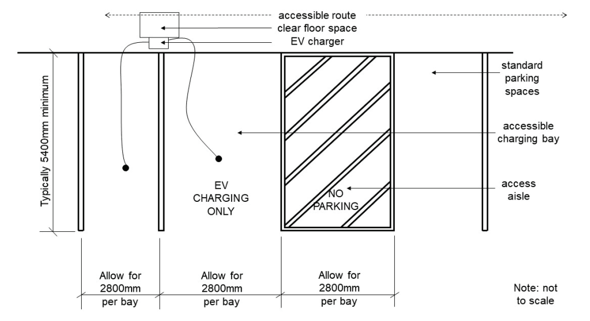
Figure 1: Austroads AP-G98-22 recommended bay format (2 bay facility)

Surfaces
The surface area of the parking space should be level, slip-resistant, firm and step-free. Installers may also choose to label the parking bay surface using an indicative symbol/image.
Installers should also consider if ramps and/or changes to the kerb are required to facilitate an accessible route to the charger.
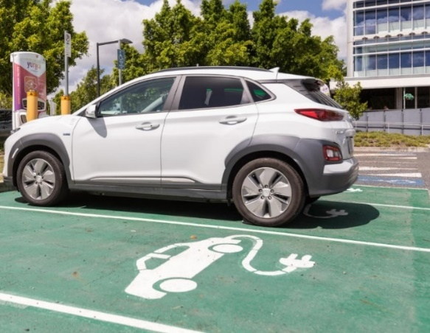
Figure 2: EV parking bay marking

Bollards
Bollards offer robust protection for the chargers and any vehicles or people moving around the charging site. Where bollards are required, they should not block access to the EV charger, particularly for persons using a wheelchair, mobility scooters and other mobility devices.
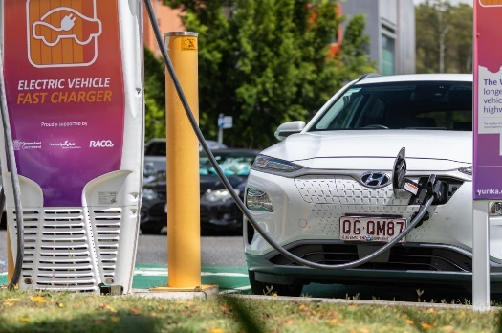
Figure 3: Fast charging unit protective bollard
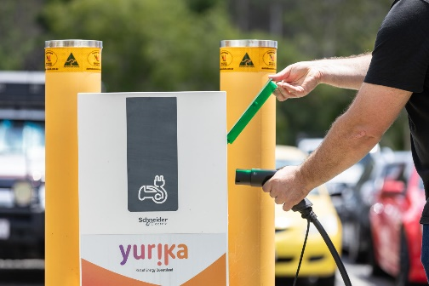
Figure 4: Slow charging unit protective bollard
The height and colour of bollards at charging sites should provide the driver using the space continuous and clear visibility of the bollard whilst navigating their vehicle. When procuring bollards installers should ensure they are of a clearly visible colour at a luminance contrast to the pavement of not less than 30 per cent.

Signage
The Manual of Uniform Traffic Control Devices, Part 6: Tourist and Services Signs (MUTCD) provides specific information on the requirements for traffic control, including for EV charging facilities. Any additional signage provided at the charging facility should have a high level of visual contrast between the two surfaces – for example dark text on a light background or light text on a dark background.
Section 203C of the Transport Operations (Road Use Management—Road Rules) Regulation 2009 provides further information on the rules for stopping in a parking area for the charging of an EV, and penalties for those breaking these rules.
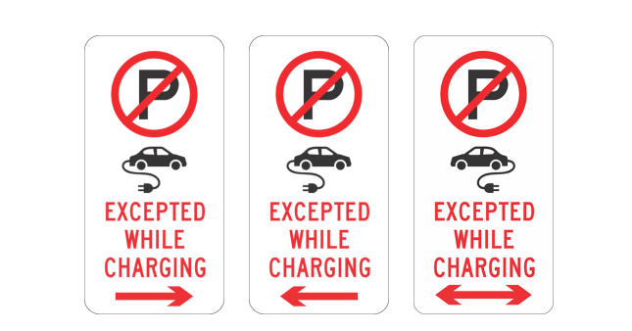
Figure 5: Transport Operations (Road Use Management—Road Rules) Regulation 2009 EV signage
You may wish to consider if it is suitable to install the relevant signage to ensure the use of a charging bay, which is not provided under AS2890.6:2009 Parking facilities – Off-street parking for people with disabilities but is limited to those that hold a disability parking permit in accordance with the Transport Operations (Road Use Management) Act 1995.

Shading
Did you know that many people, including some people with disability and the elderly, are more likely than others to be affected by high temperatures and hot weather?
Where possible, shading should be installed to ensure a safe and enjoyable charging experience, and to protect users from impact of the elements (i.e., sun, rain, hail). Shading should be installed at a height that does not obstruct typical use of the charger and surrounding environment (i.e., not too low).
You may wish to consider using existing shading options such as those in open-air shopping centre car parks or hospitals. Installation of charging facilities in proximity to existing natural shading and/or installation of natural shading (i.e., trees) is also another practicable option.
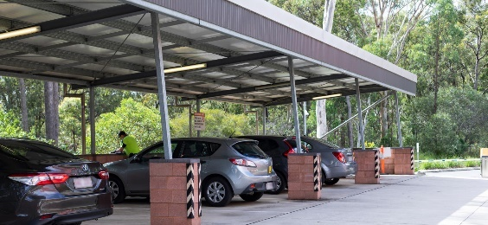
Figure 6: Shading example (off-street)
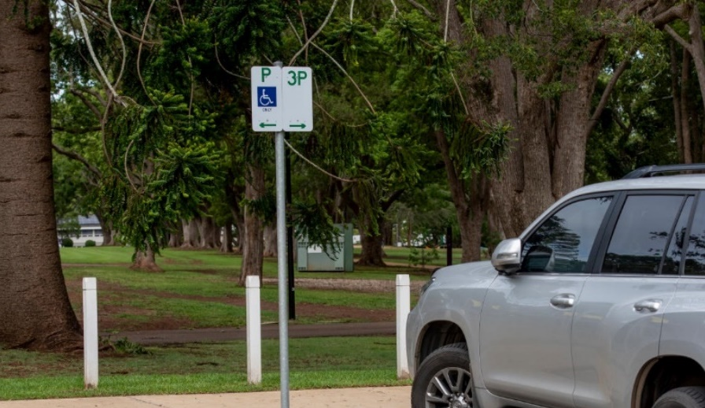
Figure 7: Shading example (natural)

Using the charger
EV chargers come in many shapes and sizes. Whilst the format of the charging site may change from location to location, there are several standard components of chargers that can impact accessibility. The following sections outline aspects of the charger itself that may affect accessibility, and considerations - for project teams.

Circulation space
Circulation space involves providing dedicated area across the facility including in front, behind or next to the charging unit and either side of the parking bay – and ensures clear multi-directional site access and ease of movement around the facility for all visitors, particularly those using a wheelchair, mobility scooters and other mobility devices.
Circulation space around the charging unit should promote unobstructed access to all components required to charge including the unit interface, handle, holster, and payment systems.
Circulation space beside parking bays should be provided on both sides, allowing visitors to exit/access their vehicle from either side and move around with ease. Where space is limited, you may choose to install a shared circulation space between two separate parking bays.
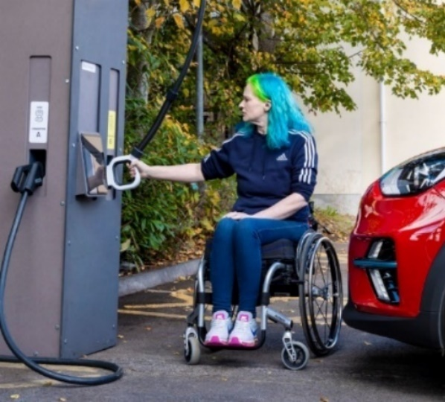
Figure 8: Surrounding area example
Installation of additional equipment in this area should be avoided unless provided for safety reasons (i.e., bollards) as they may pose a barrier or tripping hazard. Where this type of equipment is necessary consideration should be given to mitigating the impact on visitors using a wheelchair, mobility scooters and other mobility devices.

Reach
Handles, holsters, payment hardware and fixtures that must be gripped or handled – such as plugs and connectors – should ideally be in a zone of common reach for all users in a similar way that petrol bowsers are.
Installers of chargers should make sure that a person can easily reach all components of the charger whether they are sitting or standing. This includes ensuring the user is able to get close enough to the charger to read displays, troubleshoot, or obtain extra leverage if something is caught or out of place.
Installers should seek to understand the impact of where the charger is placed – does the placement of the charger on a raised kerb add undue height and decrease the overall reach range? If so, installers should consider ways to mitigate this where possible.
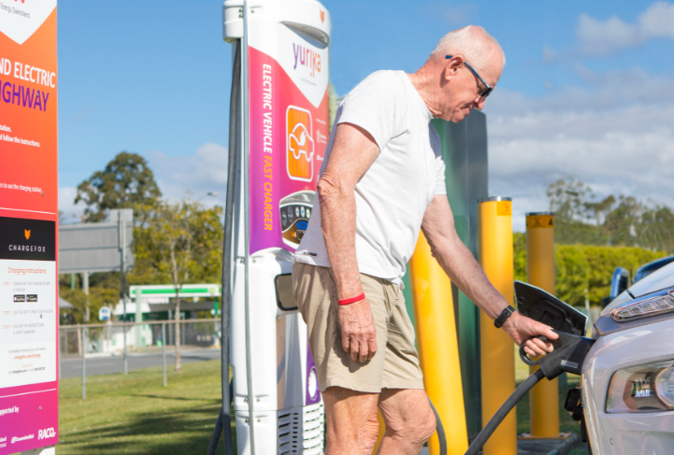
Figure 9: Fast charging reach range example
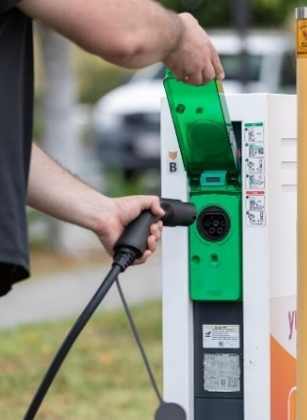
Figure 10: Slow charging reach range example

Cables
The length and manoeuvrability of the charging cable, connecting the charger to the vehicle, should be considered to ensure it can accommodate movement around different vehicle sizes, socket locations (on the vehicle) and parking positions (i.e., reverse; nose-in; parallel).

Handles
Depending on the design of the charging handle, people with disability, limited dexterity or the elderly may struggle to appropriately lift or hold a charging handle.
All parts of the charging handle should require low physical effort, and limit or avoid tight grasping, pinching, or twisting of the wrist. Access to the charging handle holder itself should be unobstructed and require minimal manoeuvring to access.

Where to next?
Building an accessible and inclusive transport system is key to TMR delivering on the expectations of our customers, travellers to Queensland, and our partners. TMR sees this guidance as a key part of ongoing discussions and work, both in Queensland and across Australia, relating to accessible EV charging.
TMR continues to advocate for the introduction of a nationally consistent standard for accessibility of EV charging to ensure individuals have equitable access to charging facilities. We also continue to work with our industry partners to improve the accessible design of infrastructure that will be central to an inclusive, equitable and fair EV transition.

Useful resources
- Design Guidelines for Accessible EV Charging Stations (RAA Australia)
- Low and Zero Emission Vehicle Charging Infrastructure Installation (Austroads)
- Electric Vehicle Charging Infrastructure: Practice note (Economic Development Queensland)
- Queensland Manual of Uniform Traffic Control Devices Part 6: Tourist and services signs
- PAS 1899:2022, Electric vehicles - Accessible charging – Specifications (British Standards Institution)
For more information contact zevstrategy@tmr.qld.gov.au.

