Disability Action Plan 2026 - 2028
  - Department of Transport and Main Roads

How to use this plan


We are the Queensland Government Department of Transport and Main Roads (TMR).
We wrote this plan




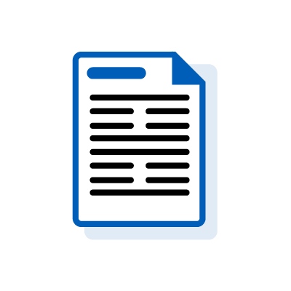
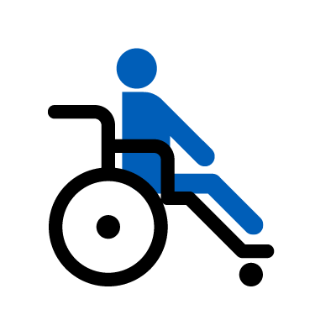
This is an Easy Read summary of our Disability Action Plan 2026–2028.
It only includes the most important ideas.

You can find the plan on our website.
www.tmr.qld.gov.au/travel-and-transport/disability-access-and-mobility/disability-action-plan

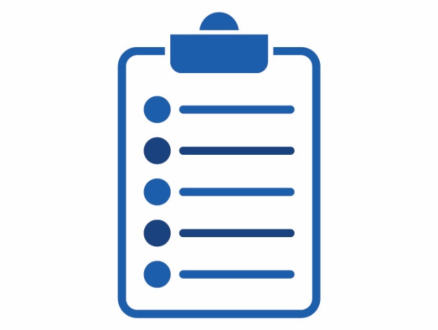
We wrote some words in bold.
We explain what these words mean.


You can ask someone you trust for support to:
- read this plan
- find more information

What’s in this plan?
About our plan
How we made our plan
What we heard
Our actions
Work together for better transport
Improve stations and stops
Make sure vehicles are accessible
Provide accessible information
Provide enough taxis and rideshare vehicles
Contact us

About our plan

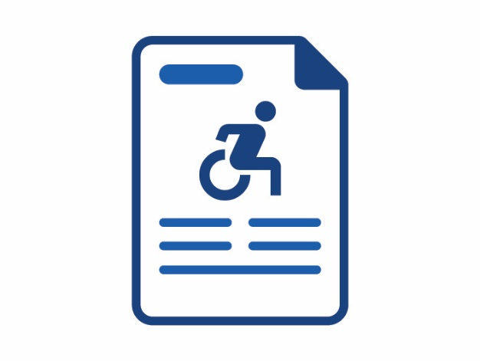

This is our Disability Action Plan.
We call it our plan
.
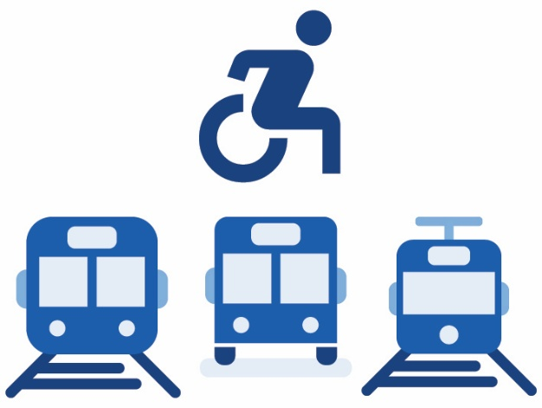
Our plan is about making transport in Queensland more accessible for people with disability.

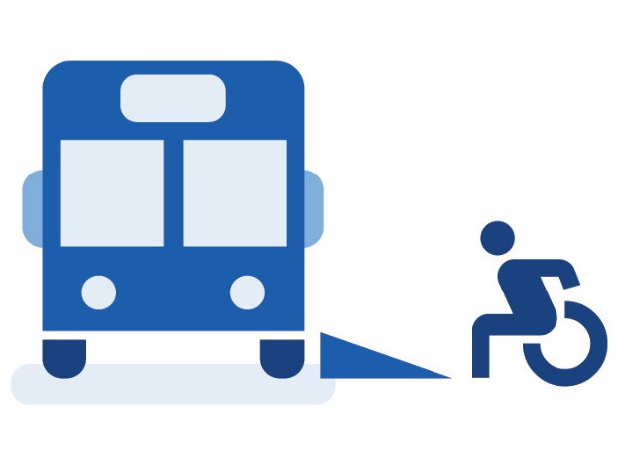
When transport is accessible, it is easy for people to:
- find and use
- get to where they need to go.

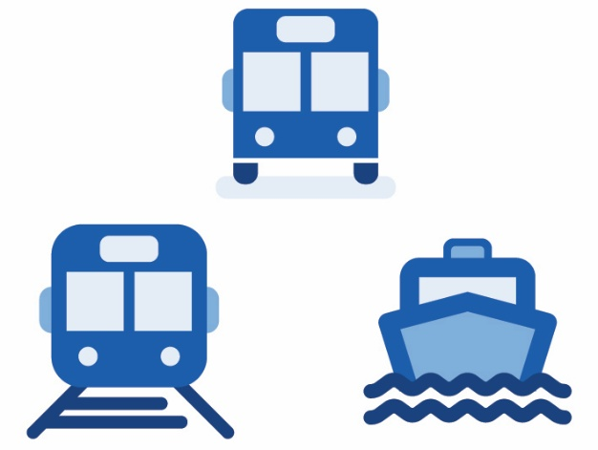
When we talk about transport, we mean:

- vehicles – like buses, trains and ferries

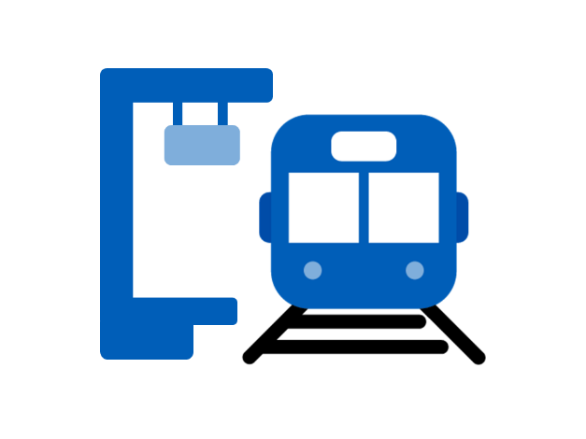

- places – like stations and stops

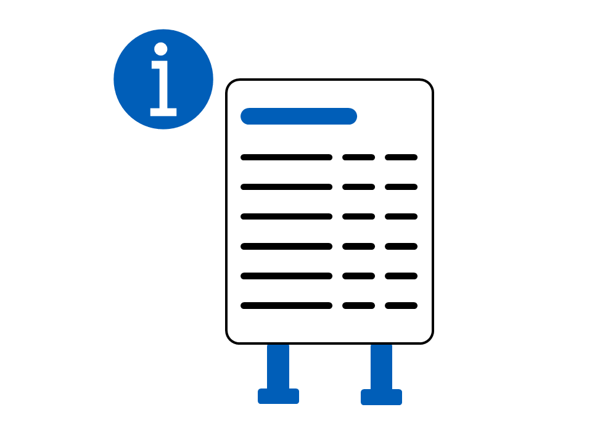
- information – like signs and timetables

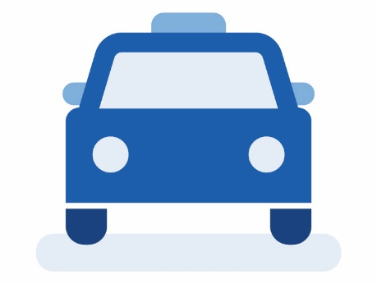
Rideshare services are companies that let you book someone to drive you where you want to go


Our plan will help make transport accessible for the Olympic and Paralympic Games in 2032.

How we made our plan

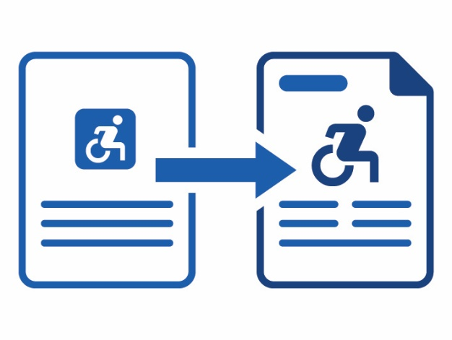
We have had Disability Action Plans before.
This plan builds on the work we have already done.

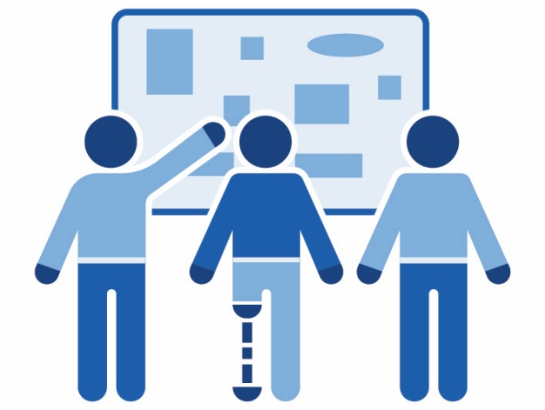

This was the first time we used
co-design to make our plan.

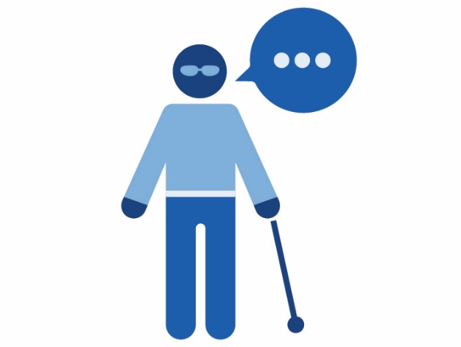
Co-design is when people work together to hear different ideas when they plan or create something new.
Co-design makes sure people who will use or be affected by something get to have their say.
Our co-design included:

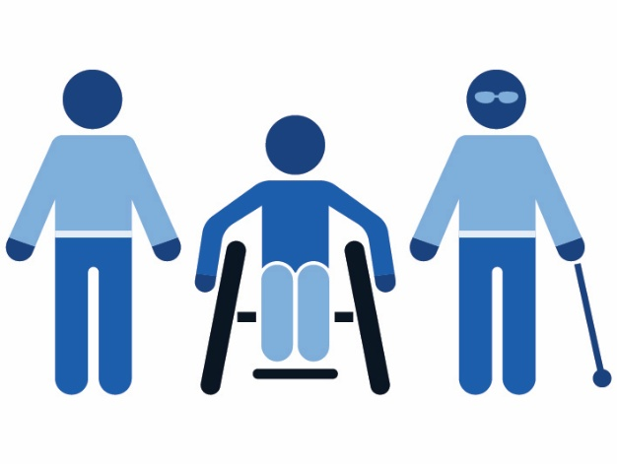
- people with disability

- carers

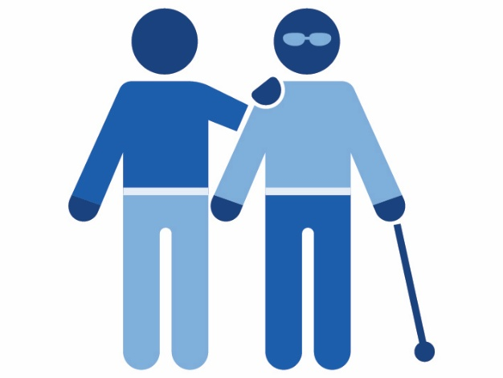
- People who help people with disability.

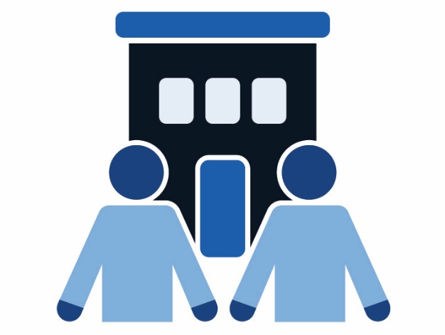
Our co-design also included:
- organisations that work in transport


- other parts of the government

What we heard

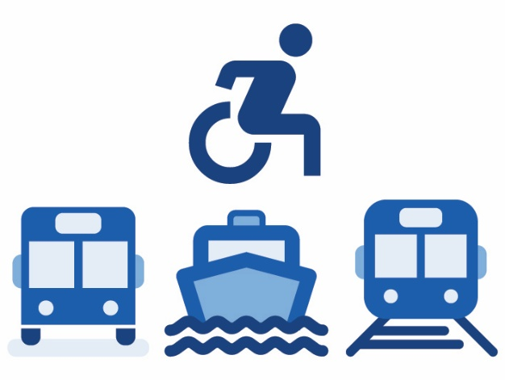
People told us we have already made transport more accessible.
But there is still more work to do.

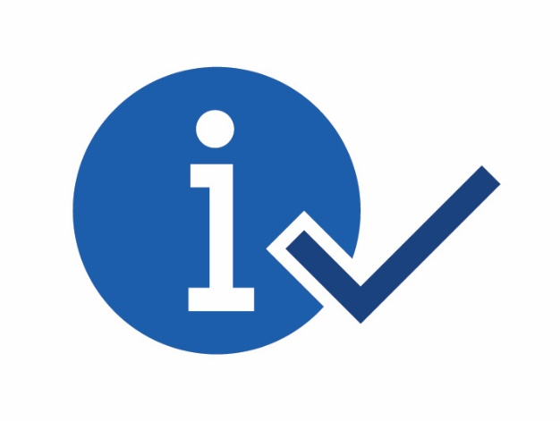
We heard that people need information about transport that is:
- clear
- accessible
- up to date.
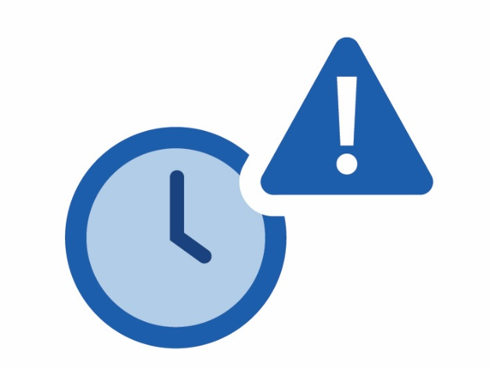
We heard that people need:
- transport to arrive when it should

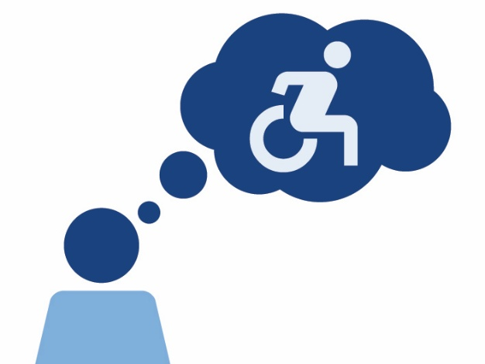
- have drivers and staff who understand disability


- This helps people feel safer to use transport.

Our Actions

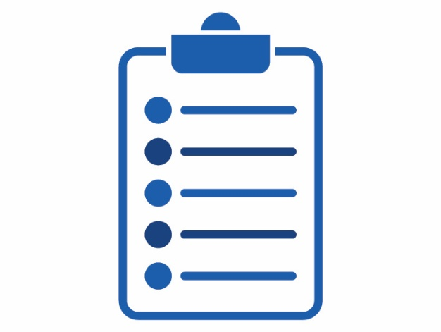
Our plan has 5 main chapters that explain what we will do to make transport more accessible for people with disability.
These chapters are:

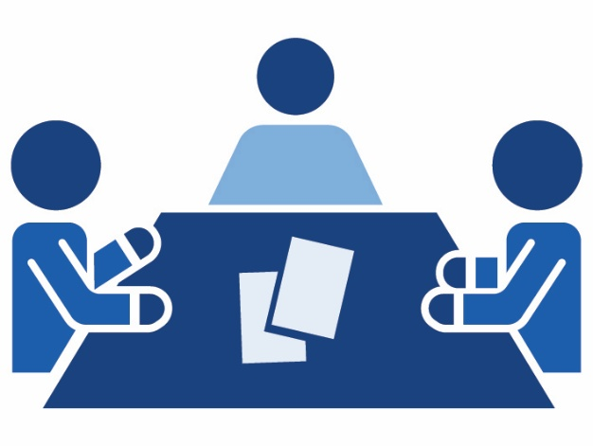
Work together for better transport

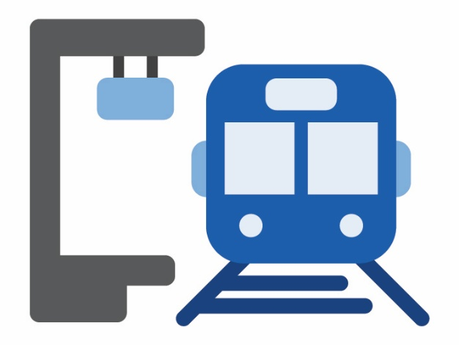
Improve stations and stops

Make sure vehicles are accessible

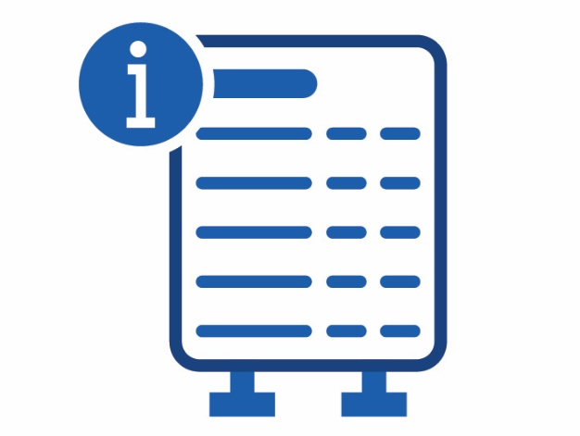
Provide accessible information and services

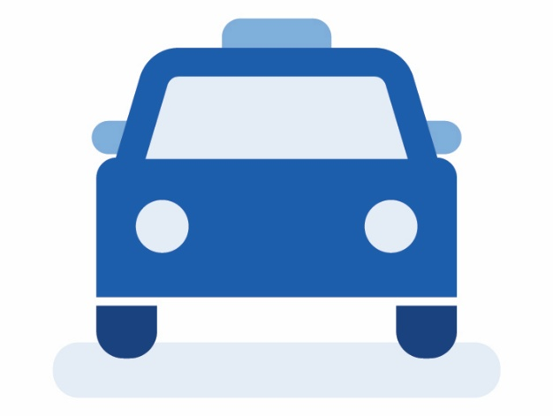
Provide accessible taxis and rideshare services.

Work together for better transport


We want to work better with:
- people from the community

- transport organisations

- other parts of the government.

  - What we are doing now
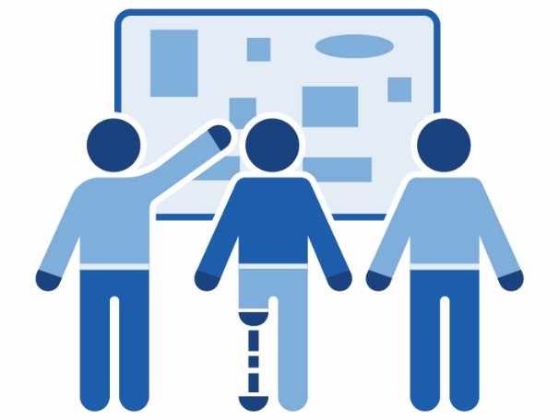
We are:
- using co-design when we create transport plans and projects

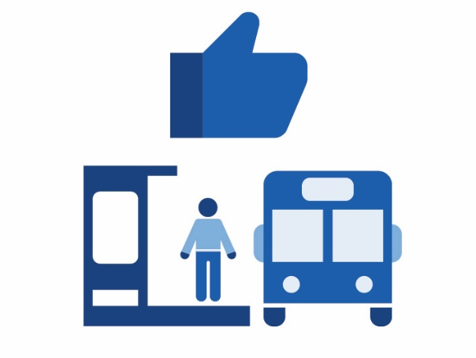
- making it easier for people to get to stations and stops


- providing transport that people can afford.

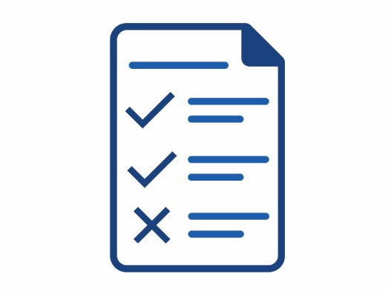
- helping the Australian Government make the rules about accessible transport better.

  - What we will do next

We will keep working with the community when we plan and make new transport projects.

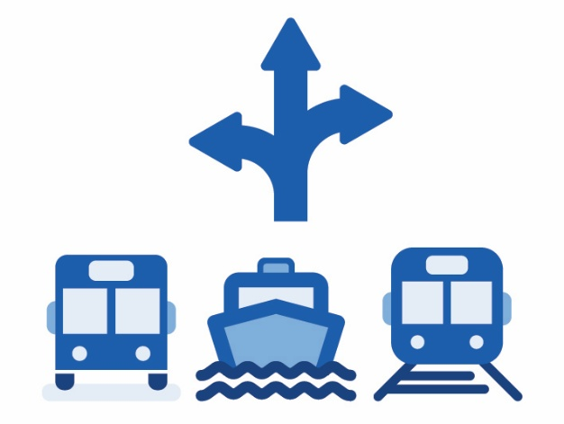
We will keep testing new options for local transport services

We will make sure everyone can afford to use transport

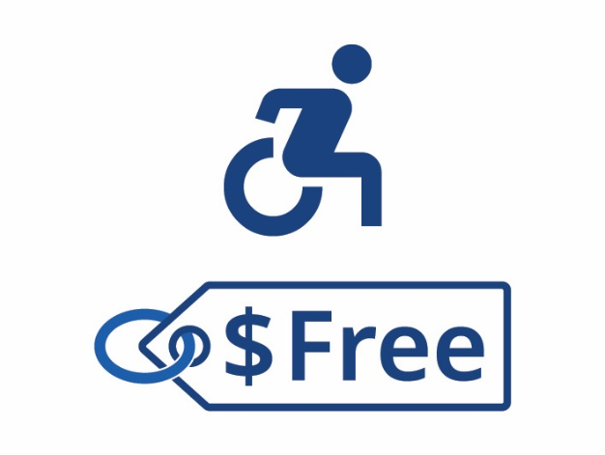
This includes offering free travel to eligible people with disability.

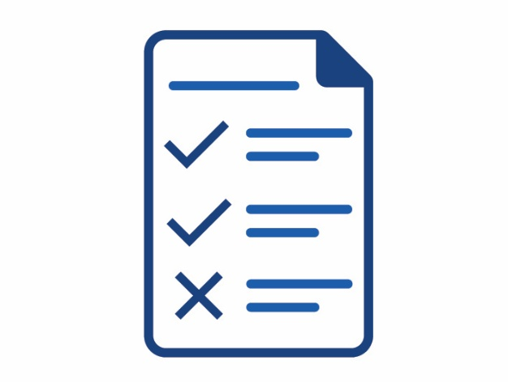
Eligible means that you meet the rules to get something


We will work with others to provide accessible transport for the Olympic and Paralympic Games.

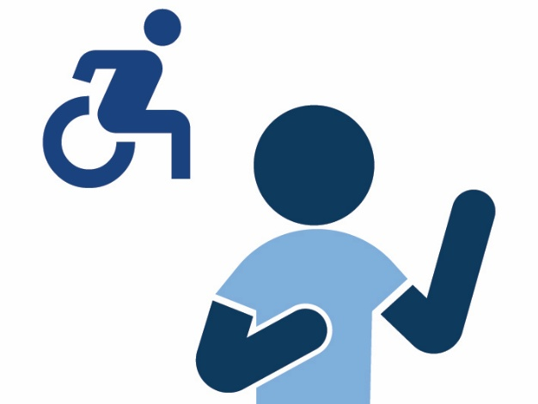
We will work with other parts of the government to support school travel for students with disability.

  - Improve stations and stops

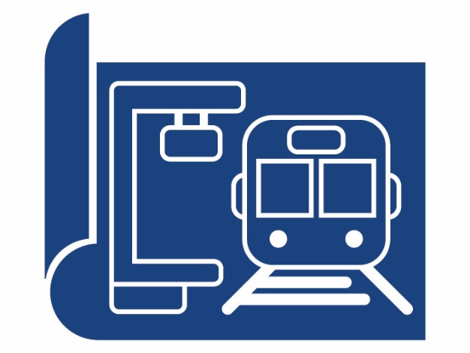
We want to improve the design of stations and stops.

We want everyone to be able to:
- use transport services safely


- know what to do and where to go.

  - What we are doing now

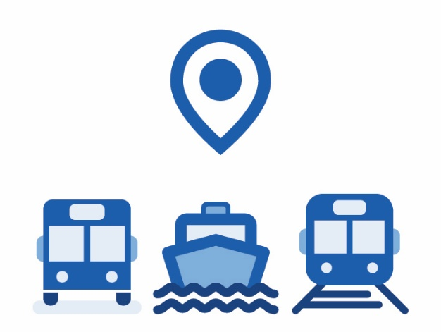
We are upgrading and building accessible:
- bus stops
- ferry stops
- train stations.

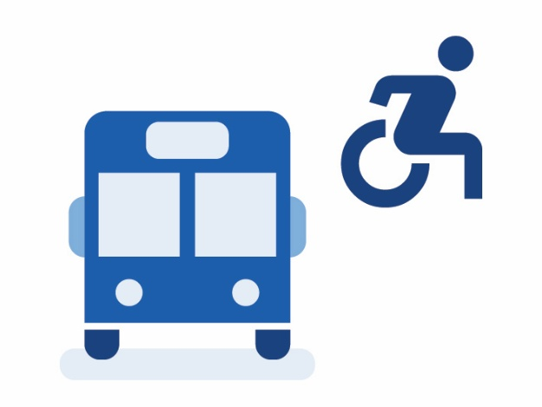
We are looking into how we can make it easier to catch a bus.

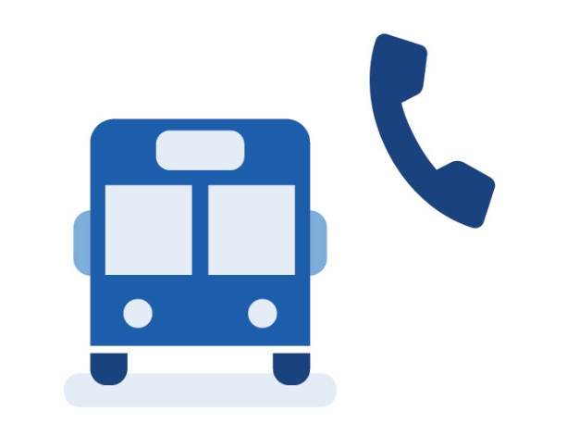
For example, providing help phones at bus stops that let people tell the bus driver they are waiting.

  - What we are doing now


We are working with people with sensory disabilities to improve stations and stops.



A sensory disability affects your senses.
For example, how bright lights or loud noises affect you.

  - What we will do next

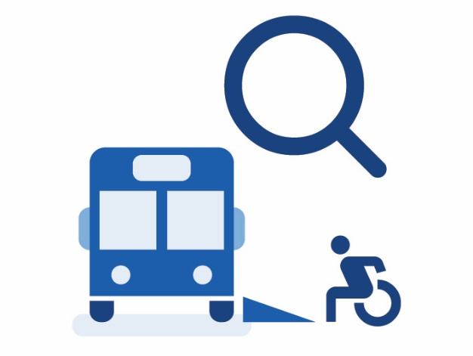
We will check how accessible bus stops are in Queensland.
This will help us find out how much work we have to do.

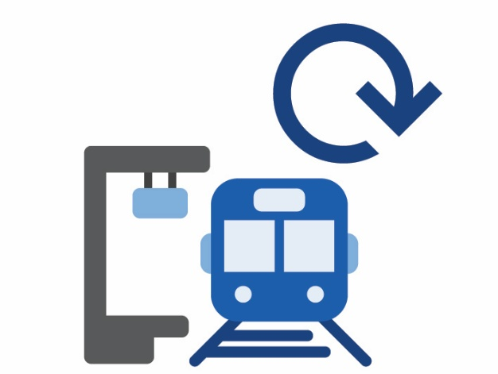
We will work with others to keep upgrading stations and stops.

Make sure vehicles are accessible

We want to make sure all transport vehicles are accessible.

  - What we are doing now

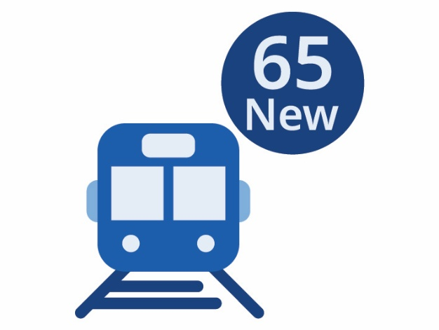
We are building 65 new trains.

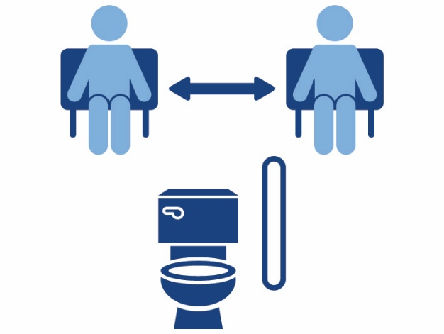
These trains include accessible features.
For example, wide aisles and accessible toilets.

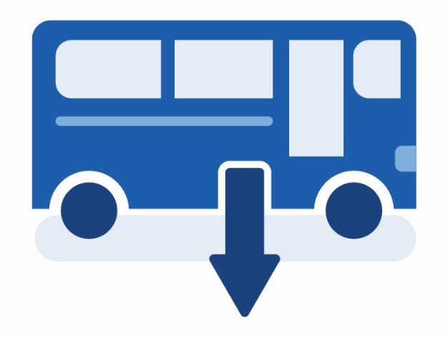
We are also adding new accessible features to our low floor buses.

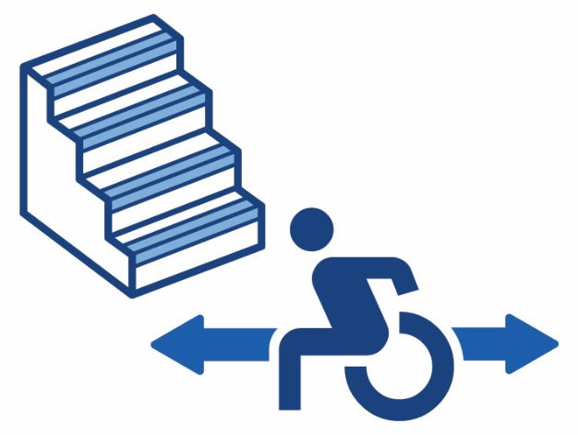
For example, yellow step edges and space for two wheelchairs.

  - What we will do next

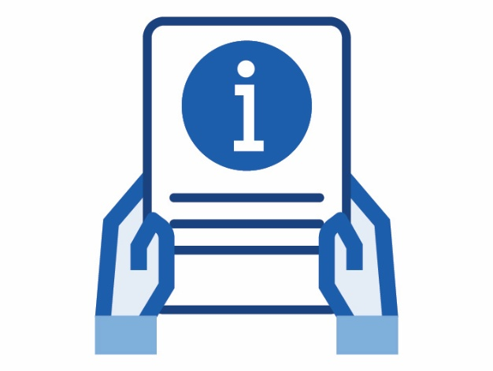
We will share information about how we have upgraded transport vehicles.

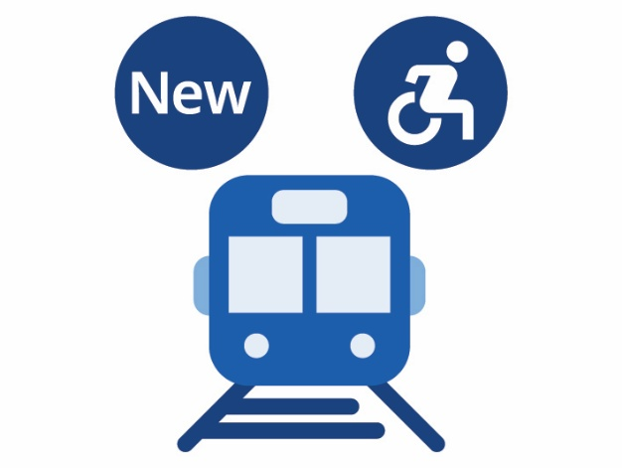
We will start using the new accessible trains.

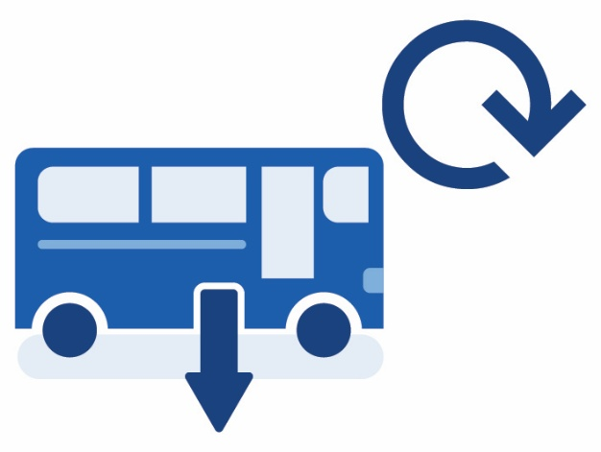
We will upgrade low floor buses we already use with new accessible features.

Provide accessible information

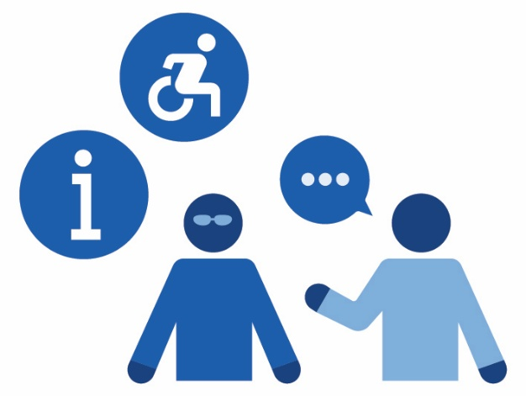
We want to make sure our information is accessible.


This includes:
- online information
- information at stations and stops
- information people can get from staff and other people travelling.

  - What we are doing now


We are helping the community and transport providers understand how to help make transport better for everyone.

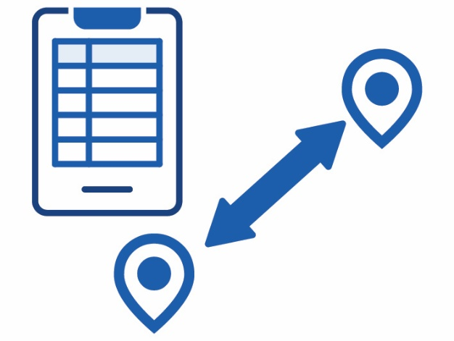
We created a new app to help people plan their transport journey.

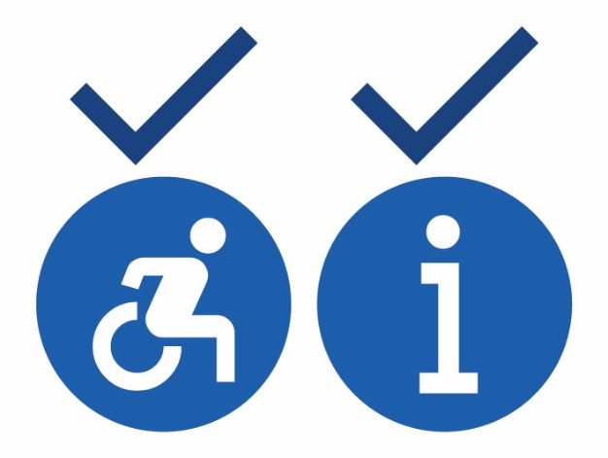
We are making sure the app:
- is accessible
- gives people the information they need.

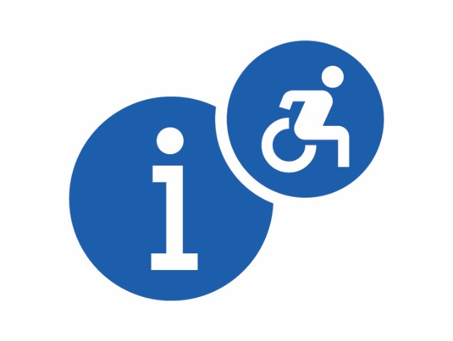
We are providing more accessible information.


This includes:
- making sure our websites are accessible
- Easy Read information
- maps that are easier to read.


We have many ways for people to give us feedback.


When you give feedback, you tell someone what they:
- are doing well
- can do better.


This is an important part of how we make transport better.

  - What we will do next

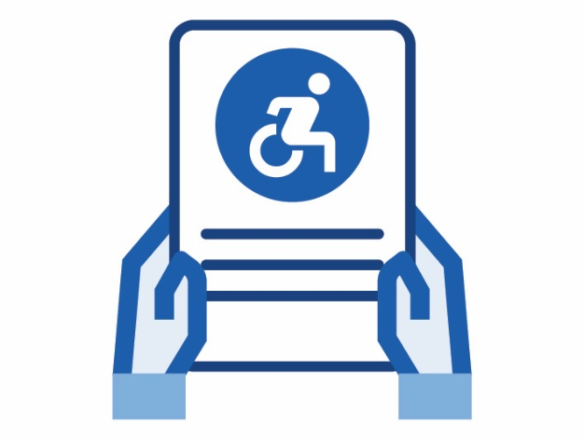
We will share updates on social media about how we are improving accessible transport.

Provide enough taxis and rideshare vehicles

We want to make sure people can get taxis and rideshare vehicles when they need them


People should be able to rely on these services

  - What we are doing now

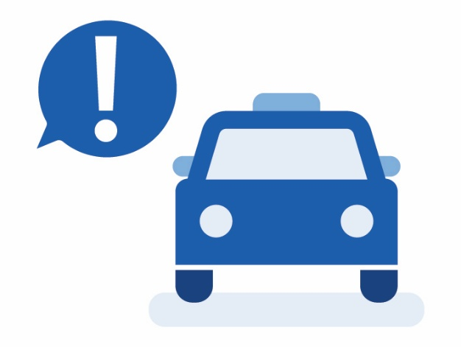
We work with people with disability to understand what they need from taxis and rideshare vehicles

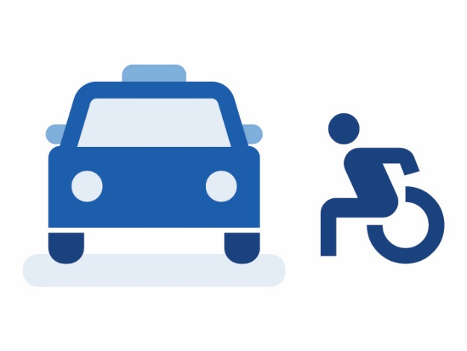
We are looking at ways to make sure there are enough taxis for people who use wheelchairs


We are supporting people with disability to pay for taxis.
This includes paying part of the cost for some people.

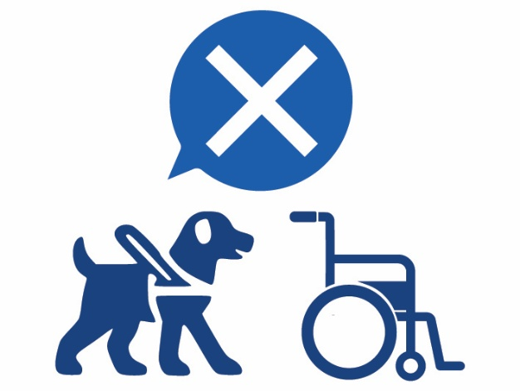
We are working with taxi services to make sure drivers don’t say no to people with:
- service animals
- wheelchairs

  - What we will do next


We will use surveys to find out if people think taxis and rideshare vehicles are accessible.

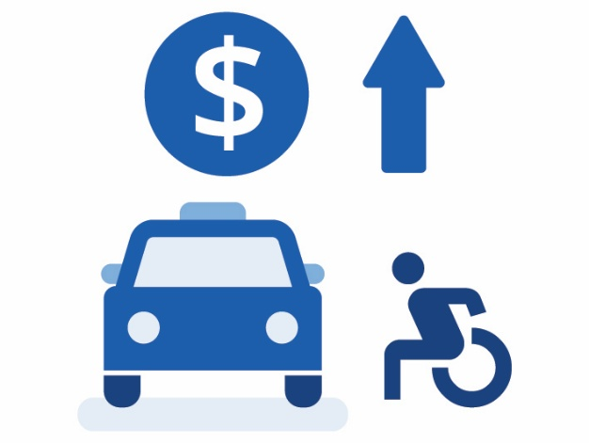
We will keep paying drivers extra money to transport people who use wheelchairs.

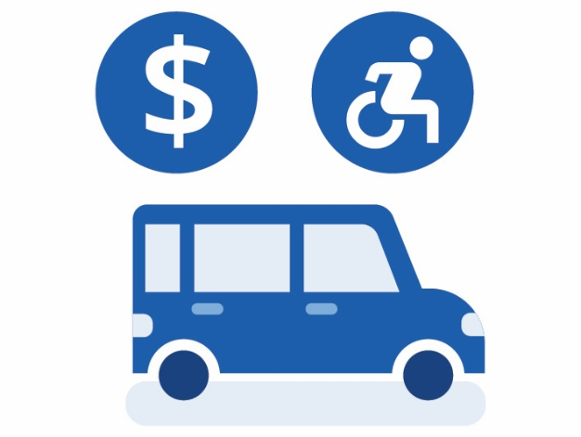
We will keep giving money to replace old taxis with new wheelchair accessible taxis.

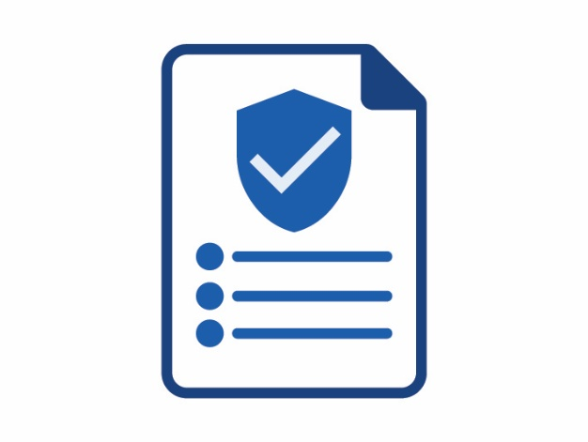
We will give wheelchair accessible taxi services a safety checklist to put in their vehicle.
This will help make sure wheelchairs don’t move while the taxi is moving.

We will keep paying some of the cost for eligible people to use taxis.

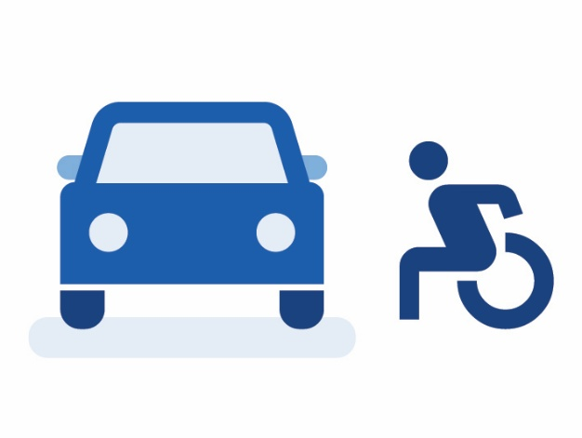
We will also think about how we can make it easier through the law for people to use rideshare vehicles.

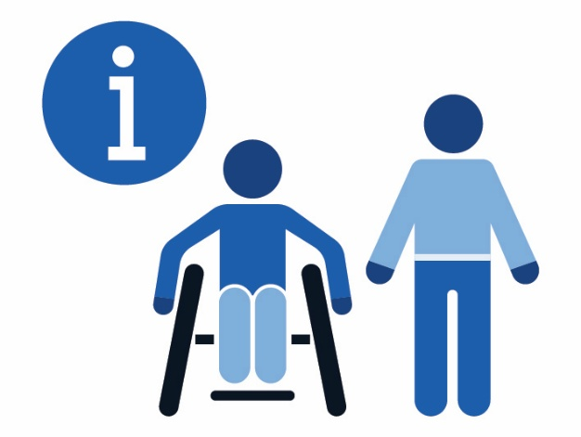
We will share more information with drivers about how to support people with disability to travel.

How you can contact us


Call us
13 23 80


Our website
www.tmr.qld.gov.au/
Contact-us

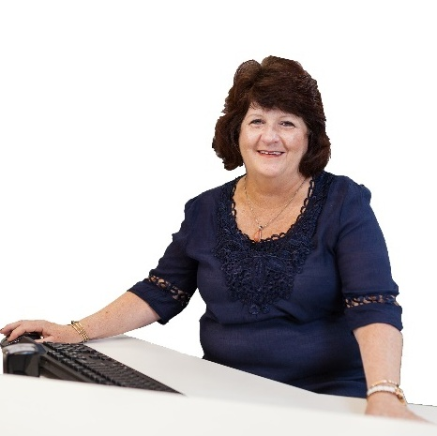
Go to a Customer Service Centre
This website shows where to find one qld.gov.au/transport/
contacts/centres

If you need an interpreter


The Translating and Interpreting Service can help you talk to someone in your language.
Call 13 14 50
Ask them to call us 13 23 80

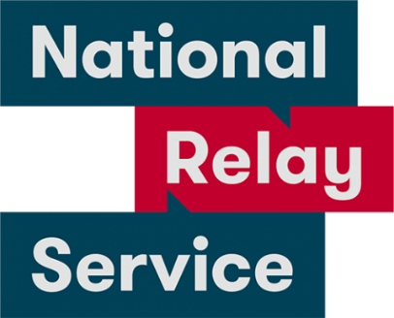
The National Relay Service can help you if you are hard of hearing or deaf
Voice Relay number 1300 555 727
TTY number 133 677
SMS relay number 0423 677 767
Then ask them to call us 13 23 80

