NOTICE
AMENDMENT OF PARK RIDGE AND BEAUDESERT – BRISBANE SERVICE CONTRACT AREA/ROUTE
Notice is hereby given under section 42B of the Transport Operations (Passenger Transport) Act 1994 that on and from 6 December 2024 the Park Ridge and Beaudesert - Brisbane service contract area/route, as previously declared by public notice dated 5 September 2014 and subsequently amended from time to time in accordance with sections 181 and 203 of TOPTA, is amended as shown in the map below.

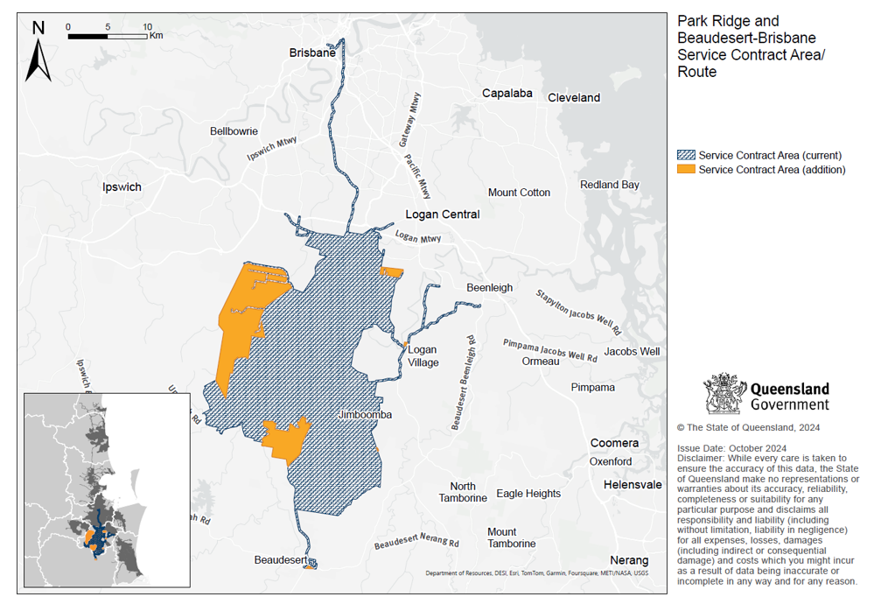
For maps describing in more detail the amended service contract area/route, please contact James Jennings, Principal Project Advisor 07 3338 4425.

Andy Meyer
Executive Director – Service Planning and Infrastructure
Delegate of the Director-General
Department of Transport and Main Roads
Date: 02/12/2024

