School Transport Information Statement No. 11/2026

School Transport Assistance Scheme Isolation Package

In recognition of the unique circumstances faced by families living in isolated parts of the state, the Queensland Government provides assistance under the School Transport Isolation Package. This package provides increased assistance under the School Transport Assistance Scheme (STAS) for eligible students.

The school transport isolation package consists of the following five components:

- Class I conveyance allowance – payable for students who live outside the south-east Queensland school transport zone (see map on page 5) or other nominated areas and reside over 16 kilometres to the nearest state and the nearest non-state school of type, and over 16 kilometres to the nearest approved bus service which will transport the student to the nearest school. Class I is paid at significantly higher rates that other conveyance allowance classes.

- Carpooling – Class I conveyance allowance is paid on a per family basis. Eligible families in receipt of Class I who carpool will each receive payment of the allowance. Other forms of conveyance allowance are paid on a per vehicle basis.

- Reduced student numbers for subsidised service – A reduction in the number of students required for a subsidised school bus service to be instituted in those areas classified as isolated.

- Designated bus service – Special consideration in relation to identifying the designated bus service for students living in isolated areas.

- Assistance for senior secondary students travelling to P-10 schools – Senior secondary students travelling to certain P-10 schools for tutoring and study may be eligible for assistance even though they are not enrolled at the nearest P-10 school.

Class I conveyance allowance
Financial assistance is available to parents in the form of Class I conveyance allowance for students in isolated areas who travel to and from school by private arrangement. The following conditions apply:

- Class I is not payable for the same journey for a student in receipt of Class A, C or D conveyance allowance or drought assistance (additional conveyance allowance).
- Class I is calculated weekly and paid four times a year at the end of each school term. Students who travel less than 10 trips per week will have their weekly payment adjusted. For example, students who travel two trips per week will be paid 20% of the weekly allowance. Payment will only be made for the number of weeks the student travels to school.
- Class I must be applied for prior to 31 December in the year assistance is sought. Retrospective claims for travel in previous years cannot be approved.
- Eligible applicants will receive an approval letter outlining the details of their assistance, including the approved scale and method of payment.

Allowance details
The maximum amounts to be paid per family for conveyance allowance Class I in 2026 are:

Class I
Approved scale |  |  |  | Weekly rate
1 | 16.01km | to | 20km | $44.75
2 | 20.01km | to | 30km | $84.80
3 | 30.01km | to | 40km | $143.35
4 | 40.01km | to | 50km | $201.95
5 | 50.01km | to | 60km | $260.55
6 | 60.01km | to | 70km | $319.10
7 | 70.01km | to | 80km | $377.70
8 | 80.01km | to | 90.00km | $436.25
9 | 90.01km | to | 100.00km | $494.85
10 | 100.01km+ |  |  | $553.40
Note: Scale 10 is the maximum rate for Class I conveyance allowance

Carpooling
Class I conveyance allowance is paid on a per family basis rather than per vehicle basis, as is the case with Class A, C and D conveyance allowance. This is to promote carpooling which will assist in reducing duplication in travel for isolated families and minimise time away from homes and properties.

Each family involved in carpooling must submit their own application for conveyance allowance. Payment can only be made to the legal parent/guardian of the students involved in a carpooling arrangement. Payment is not transferrable and cannot be made on behalf of other students.

The Department of Transport and Main Roads (TMR) will not be involved in:
- making arrangements for carpooling - this is the responsibility of the families involved.
- determining the distribution of conveyance allowance Class I amongst families who carpool.

Reduction in the number of students required to institute a subsidised school bus service
Under the school transport isolation package, the minimum number of eligible students required to institute a subsidised school bus service in isolated areas has been reduced from nine to seven. Eligible students must come from a minimum of three different families for a subsidised service to be instituted.

Designated bus service
The designated service for a student living in an isolated area (subject to the note below) will be the:
- approved service nearest to the student’s residential property which transports eligible students of the required year level; or
- an approved service that will transport the student to the nearest state school from the student’s residential property.

Distances are measured by the shortest trafficable route, over roads open for public use, between the residential property and the nearest point on the route of the service (not to the bus stop). No measurements are taken on private property.

Note: A student does not have a designated bus service if the distance to the nearest bus service which transports eligible students for the required year level is further than the distance from the student’s residential property to the nearest state school offering the required year level.

Assistance for senior secondary students travelling to P-10 schools
A small number of students in isolated parts of Queensland do not have access to schools offering year 11 and 12. These students need to complete their senior secondary years by distance education and may receive tutoring at their nearest P-10 school.

School transport assistance is made available to these students under the following conditions. A student must:
- have completed their compulsory years of schooling (to year 10)
- reside in a designated isolated area of the state
- meet the eligibility criteria of the scheme
- attend their nearest P-10 school listed below for tutoring and assistance:
1. Alpha | 6. Injune | 11. Richmond
2. Baralaba | 7. Mornington Island | 12. Tambo
3. Dirranbandi | 8. Normanton | 13. Taroom
4. Doomadgee | 9. Palm Island | 14. Texas
5. Inglewood | 10. Quilpie

For eligible students, assistance will be in the form of travel on the school bus service where available or by payment of conveyance allowance.

How do I apply?
Families wanting to apply for assistance under the School Transport Isolation Package must submit an application for school transport assistance. The department will assess a student’s eligibility as part of the assessment process.

Further information
Please contact your local TMR school transport office or go to translink.com.au

Applications for school transport assistance can be submitted online

School Transport Isolation Definition
To be classified as isolated under the School Transport Isolation Package, students must:

- reside more than 16 kms from the nearest state and non-state school of type and the nearest approved bus service which can transport the student to a state school or non-state school of type with the required year level (see measuring note below)
and
- reside outside the south east Queensland school transport zone (see map)
and either
3a. reside in the seven week Summer Vacation Zone, as defined by the Department of Education;
or
3b. reside more than 50 kms, measured by the shortest trafficable route from the main Post Office in each of the following centres:

Atherton | Gympie | Malanda | Sarina
Ayr | Hervey Bay | Mareeba | Stanthorpe
Bowen | Home Hill | Maryborough | Toowoomba
Bundaberg | Ingham | Mossman | Townsville
Cairns | Innisfail | Proserpine | Tully
Dalby | Kingaroy | Ravenshoe | Warwick
Gladstone | Mackay | Rockhampton

Measuring note
Distances are measured by the shortest trafficable route, over roads open for public use, between:
- the residential property
- the nearest point on the route of the service (not to the bus stop) and/or
- the nearest state school which is closest to the catchment area involved.
No measurements are taken on private property.

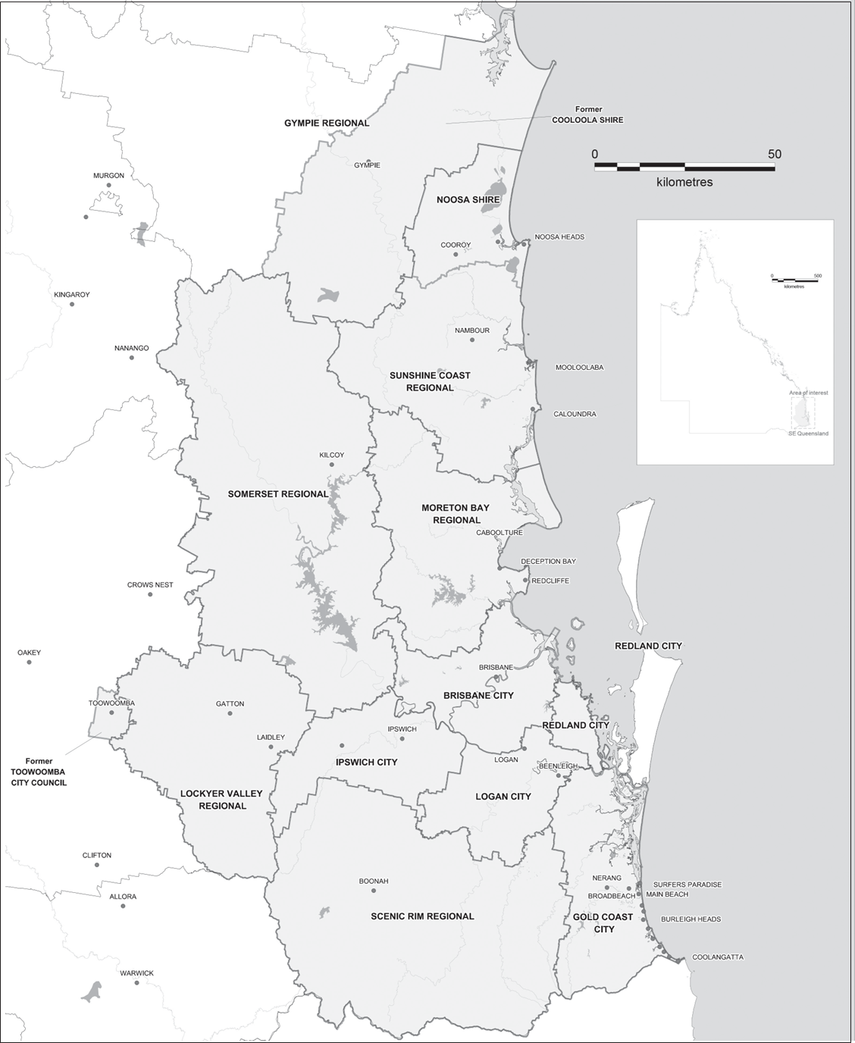
South East Queensland School Transport Zone
While every care is taken to ensure the accuracy of this data no representations or warranties about its accuracy,
reliability, completeness or suitability for any particular purpose and disclaims all responsibility and all liability (including without limitation, liability in negligence) for all expenses, losses, damages, (including indirect or subsequent damage) and costs which you might incur as a result of the data being inaccurate or incomplete in any way or for any reason. Data must not be used for direct marketing or be used in breach of privacy laws. Information is for display purposes only and no responsibility is taken for data accuracy. State Digital Road Network (SDRN) provided with permission of MapInfo Australia Pty Ltd (2010). State Digital Cadastre Database (DCDB) provided with permission of Department of Environment and Resource Management (2010).

