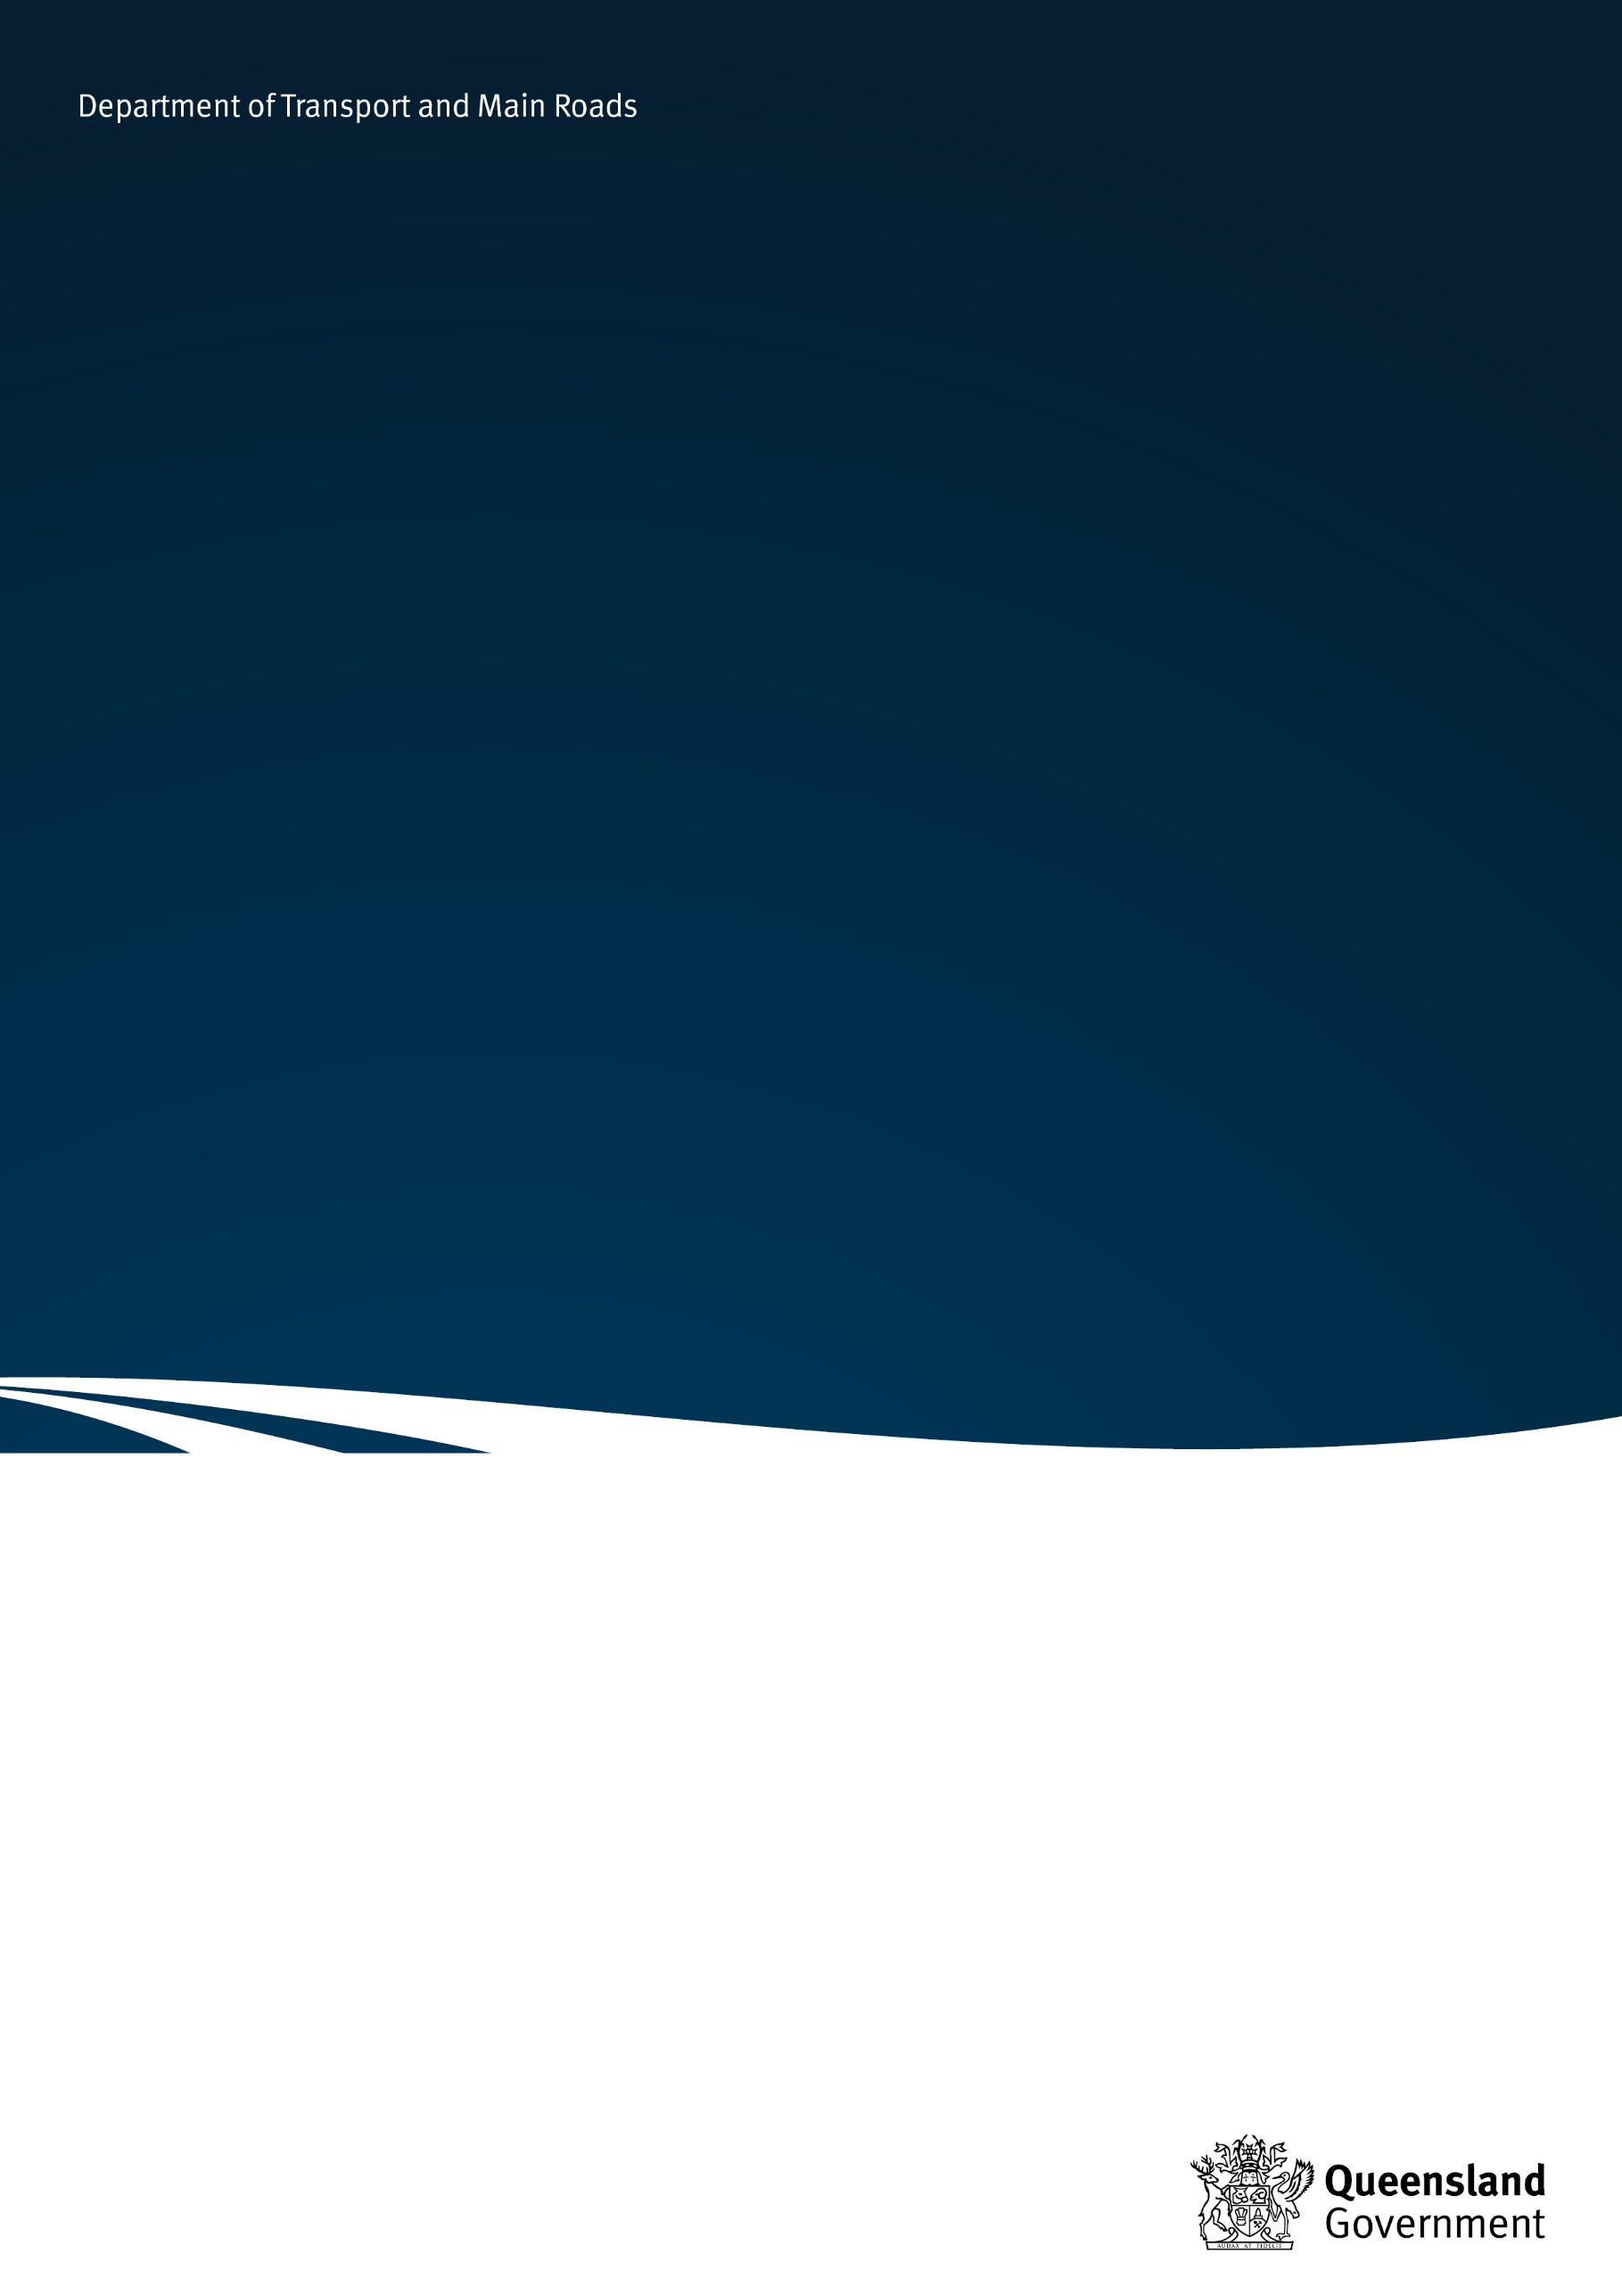
Subsidised school bus services
School Transport Assistance Scheme

May 2025

Contents

1. Foreword 2
2. Background 2
3. Guiding principles 2
4. Eligibility criteria for subsidised services 3
5. Institution of a service 4
6. Payment 5
7. Route 6
8. Monitoring students and reviewing payment 6
9. Closure 7
10. Non-operation of a service 8
11. Approval process 8
12. Agreement 8

Foreword
This document outlines the guidelines for the introduction of subsidised school bus services in Queensland and their administrative requirements.

Background
Across the state, the Queensland Government funds a network of kilometre-based school buses to transport students eligible for assistance under the School Transport Assistance Scheme (STAS) to their nearest school. These services are fully government funded.
A small number of services operate based on only partial funding of the service by government. These services do not meet the requirements for institution as a fully funded kilometre-based school bus service and are known as ‘subsidised school bus services’. They occur due to the following factors:
- extremely long route length
- low number of STAS eligible students
- remote locations
- per capita funding restrictions.
Subsidised school bus services may be provided by a service provider who accepts the level of government funding provided. Any shortfall in funding is generally met by the parents/guardians.
In some cases, parents may form a conveyance committee and elect to provide the service themselves. Payment is made to the committee as the provider of the service.

Guiding principles
The provision of transport assistance to enable students to attend school must be viewed in the overall context of assistance provided by both the Queensland and Federal Governments.
Where sufficient populations of students exist, the Queensland Government may provide a school facility in accordance with approved guidelines. If provision of a school facility is not feasible, a range of transport assistance options is provided to facilitate student access to school.
Distance education is made available to students in remote and isolated areas of the state for students to undertake lessons in their own home.
Assistance is provided by both the Queensland and Federal Governments for students who live away from home in order to attend school.
In this context, subsidised school bus services are targeted at providing an option for those families whose children would otherwise live away from home to attend school, or who would otherwise rely on distance education to fulfil their educational requirements.

Eligibility criteria for subsidised school bus services
A subsidised school bus service may only be instituted in isolated areas as designated by the Director-General, Department of Transport and Main Roads.
Under the School Transport Isolation Package an area is classified as isolated where students:
- reside outside of the south east Queensland school transport zone (refer to School Transport Information Statement 11– School Transport Assistance Scheme Isolation Package);

AND
2a. reside in the seven week vacation zone as defined by the Department of Education;
or
2b. reside more than 50km measured by the shortest trafficable route from the main Post Office in the following centres:
- Atherton | - Ayr | - Bowen | - Bundaberg
- Cairns | - Dalby | - Gladstone | - Gympie
- Hervey Bay | - Home Hill | - Ingham | - Innisfail
- Kingaroy | - Mackay | - Malanda | - Mareeba
- Maryborough | - Mossman | - Proserpine | - Ravenshoe
- Rockhampton | - Sarina | - Stanthorpe | - Toowoomba
- Tully | - Warwick

In addition to the isolated area eligibility criteria, students must:
- reside more than 16km from the nearest state school; and
- reside more than 16km from the nearest approved bus service which can transport the student to school.
The institution of a subsidised school bus service may impact on the following schemes:
- Living Away from Homes Allowance Scheme (LAFHAS) administered by the Department of Education
- Assistance for Isolated Children Scheme (AIC) administered by Services Australia.
Consideration must be given to the implications on the recipients of these schemes prior to recommending the institution of a subsidised school bus service.

Institution of a service
Prior to the institution of a subsidised school bus service consultation will occur with parents, the local school community, the Department of Education regional office and the Isolated Children’s Parents Association (ICPA).
To institute a subsidised school bus service:
- there must be a minimum of seven (7) eligible students from at least three (3) families
- the students must reside more than 16km from the
- nearest state school; and
- the nearest approved bus service which can transport the students to school
- the students must not have access to any other government funded school transport service.
Future student numbers will also be considered as part of the decision-making process.
Once the service is instituted, parents of eligible students may form a conveyance committee if desired, but this is not mandatory. Conveyance committees for subsidised school bus services operate under the same guidelines applicable to kilometre-based school bus services. Information on conveyance committees can be found at tmr.qld.gov.au

Payment
Funding for a subsidised school bus service may occur under the following payment methods, whichever is the lesser:

Fixed and variable payments as per the capital-based kilometric payment model
A subsidised school bus service that meets or exceeds the required student numbers (including families) for the institution of a subsidised service will be paid the NC1 fixed and variable rates from the capital-based kilometric payment model. Subsidised services will only be paid up to a maximum daily distance of 160km (loaded and unloaded distance combined). The variable payment will be adjusted based on any increase or decrease of kilometres that occur. Capital-based kilometric payment rates are adjusted quarterly.
Subsidised school bus services paid under the capital-based kilometric payment model will be reviewed at the beginning of each school year. Services on this payment model will revert to the maximum per student per day model if numbers do not meet the institution criteria at the beginning of a school year.

Maximum per student per day payment model
The maximum per student per day payment model provides funding on the following basis:
- a maximum amount per student per day, reviewed quarterly, for students who reside more than 16km from the nearest state school and more than 16km from the nearest approved bus service which can transport the student to school; and
- a maximum amount per student per day, reviewed quarterly, for students who reside 16km or less from the nearest state school.
No government funding will be provided for students who do not meet the STAS distance eligibility criteria.
Information on the current payment rates applicable to subsidised services is available in School Transport Information Statement 19 – available from your local Translink regional office.

Note:
- Subsidised services funded under the maximum per student per day payment model can only be paid up to the equivalent amount available under the capital-based kilometric system
- The maximum per student per day amounts are payable for students who travel 10 trips per week, that is 100%. Payment will be adjusted for students who travel less than 100%. For example, a student who travels two trips per week will attract funding at 20%.
- Due to the concessionary nature of funding, the level of payment is subject to regular review as detailed in Section 8 – Monitoring students and reviewing payment.

Vehicle Purchase Allowance
Subsidised school bus services do not qualify for capital funding under the School Bus Upgrade Scheme (SchoolBUS). Service providers may however qualify for a vehicle purchase allowance (VPA) subject to meeting relevant guidelines.
Information on the VPA is available in School Transport Information Statement 28B – Vehicle purchase allowance for subsidised school bus services, available from your local Translink regional office.

Route
The initial route design and any variations (extensions or deletions) must be approved by the Department of Transport and Main Roads (TMR). This is to ensure efficiencies in route design, travel time and cost effectiveness are achieved. This generally necessitates that the service area be in the one general direction from the school.
Extensions to subsidised school bus services require advice from the relevant road authority regarding the suitability of the route, and will generally be approved on the following basis:
- services paid under the capital-based kilometric payment model:
- extensions must meet the guidelines applicable to kilometre-based school bus services
- services paid under the maximum per student per day payment model:
- extensions (at no cost) are approved if supported by the operator and if applicable, the conveyance committee.

Monitoring students and reviewing payment
The number of students travelling impacts the level of subsidy paid by TMR. It is therefore necessary to monitor the number of students and review the service on a regular basis.
Student numbers are monitored by way of the:
- kilometre exception report completed each pay period;
- school verification reports; and
- applications submitted for new students using the service.
Where it is identified that adjustments to the level of subsidy are required the following will occur:
- services paid under the capital-based kilometric payment model
- services on this payment model will revert to the maximum per student per day model if eligible student numbers do not meet the institution criteria at the beginning of a school year.
- services paid under the maximum per student per day payment model
- any decrease will occur from the start of the following semester
- increases will apply from the date of commencement of travel by the student involved.

Closure
Closure of a subsidised school bus service will occur when the number of students accessing the service falls below a level at which service viability cannot be sustained.
TMR will review a subsidised school bus service when the number of eligible students falls to five (5). This will usually occur at the end of a school semester. The local Translink regional office of TMR must obtain approval to close a subsided service from the Regional Manager.
Student numbers will be assessed each year by TMR on 1 July. Contact will be made with the service provider and if applicable, the conveyance committee, regarding student numbers for following years in cases where concern is held regarding the ongoing viability of the service.
In some instances, the service provider may apply to close a subsidised service because student numbers are at a level where government funding becomes insufficient to maintain viability of the service.
The local Translink regional office will communicate advice of closure of a subsidised school bus service to relevant stakeholders, including the local school community and the ICPA.

Non-operation of a service
The following payment arrangements will apply in instances when a subsidised school bus service does not operate, for example due to flooding, student-free days or local show holidays:
- services paid under the capital-based kilometric payment model
- will receive payment of the NC1 fixed rate only.
- services paid under the maximum per student per day payment model
- the lesser of the following amounts will be paid of:
    - the per student per day payment calculation; or
    - the equivalent NC1 fixed rate.
No payment will be made for services that do not operate in the final weeks of the school year due to the additional week school vacation for western or remote areas, or because the service only transports year 11 and 12 students.

Approval process
The Regional Manager must endorse any proposal to institute a subsidised school bus service. Thorough investigation of all aspects of the proposal must be undertaken before a proposal is submitted for approval by the Director (Regional Operations).

Agreement
A letter of agreement outlining the administrative and funding arrangements for a service will be entered into by the service provider and TMR.

